**Java Basics – OOPS**

After taking this course, you will be able to:

* Define and explain the fundamental basics of the Java language and concepts of object-oriented programming
* Use principal programming elements, such as variables, statements, conditional expressions, loops, and methods
* Use different data types: primitives, objects, arrays, strings
* Create classes in Java with a correct description of fields and methods
* Apply the principles of encapsulation, inheritance, and polymorphism in practice
* Use the class Object and the methods contained therein
* Work with strings in Java using the classes String, StringBuilder and StringBuffer, and their methods
* Correctly handle exceptions, as well as create your own exceptions
* Correctly document your code using javadoc
* **JDK** — the Java Development Kit, a set of developer's tools.
* **JRE** — the Java Runtime Environment, the execution system of Java. It is used to organize the processes for running programs.
* **JVM** — the Java Virtual Machine. This is a virtual computing machine that has a set of commands and a memory controller.

The process of using the Java platform tools is shown in the image below. According to it, the original Java program should be first transformed by the compiler into an executable program in the form of bytecode. After that, the bytecode of the Java program can be run in the JVM, i.e., the bytecode is interpreted/transformed into the machine code of the platform where the JVM is used. To write programs in Java, you do not need to know the specifics of bytecode. But understanding bytecode as well as the processes of its generation helps Java programmers in their work.

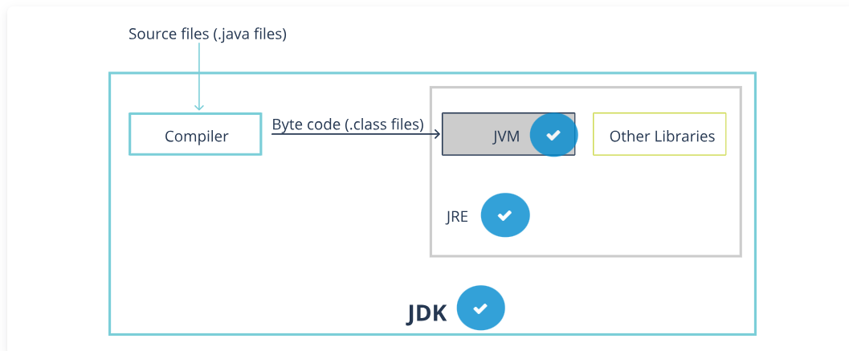

**JVM**

The JVM is the main part of the Java runtime system. The JVM provides a platform-independent way to run code. Programmers may write code without thinking about where it will be run.  
The JVM performs the following tasks: loads, verifies, and runs code.

**JRE**

The JRE is the minimum implementation of the virtual machine required to run Java programs. The JRE has no compiler or other development tools. It consists of a virtual machine and libraries of the Java classes. The JRE is part of the JDK; thus, to run a Java program, you first need to install the JDK.

**JDK**

The JDK is a Java language tool kit for programmers. It includes a compiler, standard libraries of the Java classes, examples, documents, various utilities, and the JRE runtime system. It is free and is freely available from Oracle

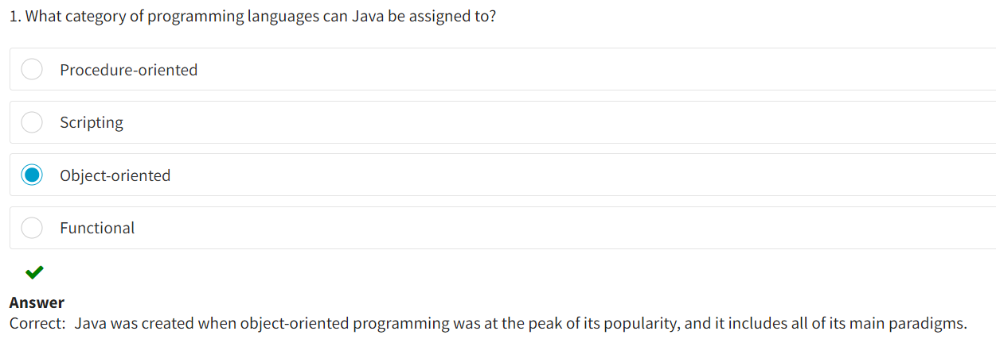

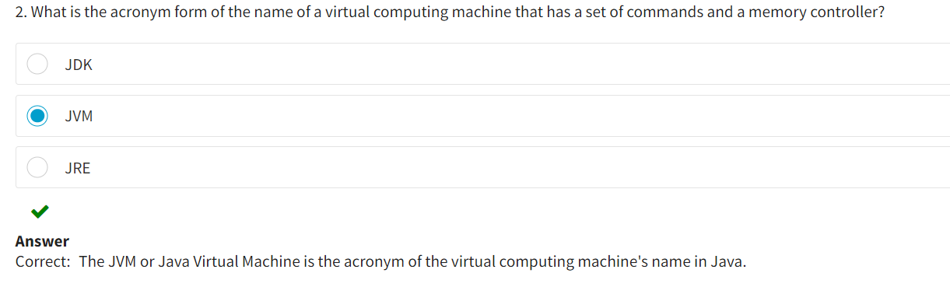

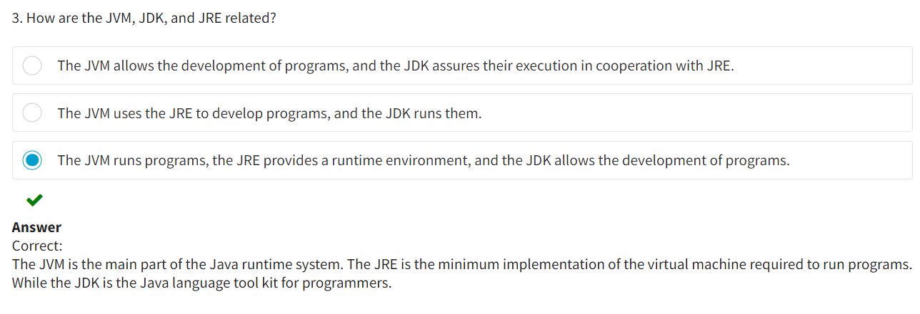

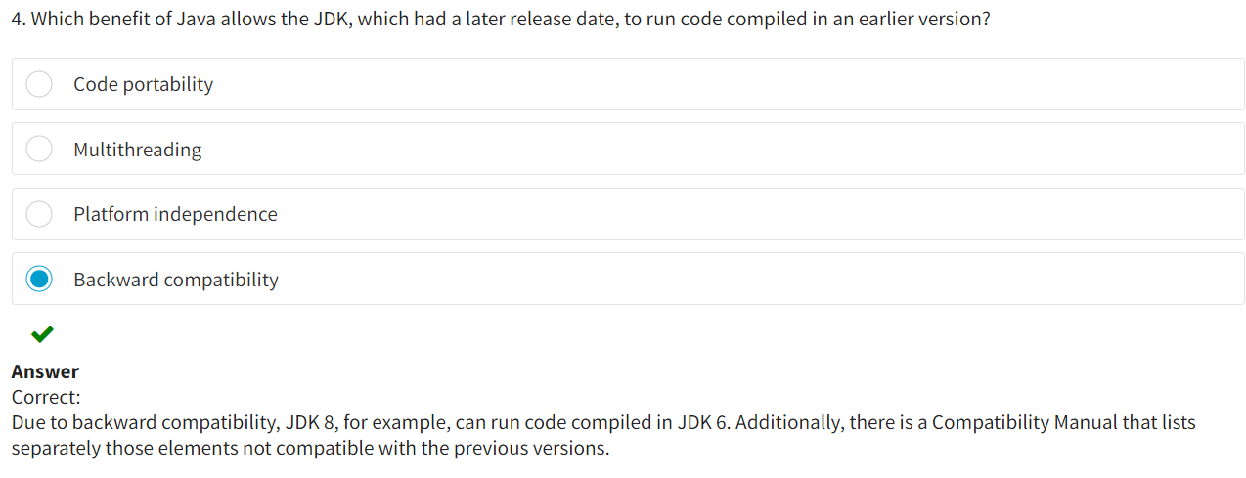

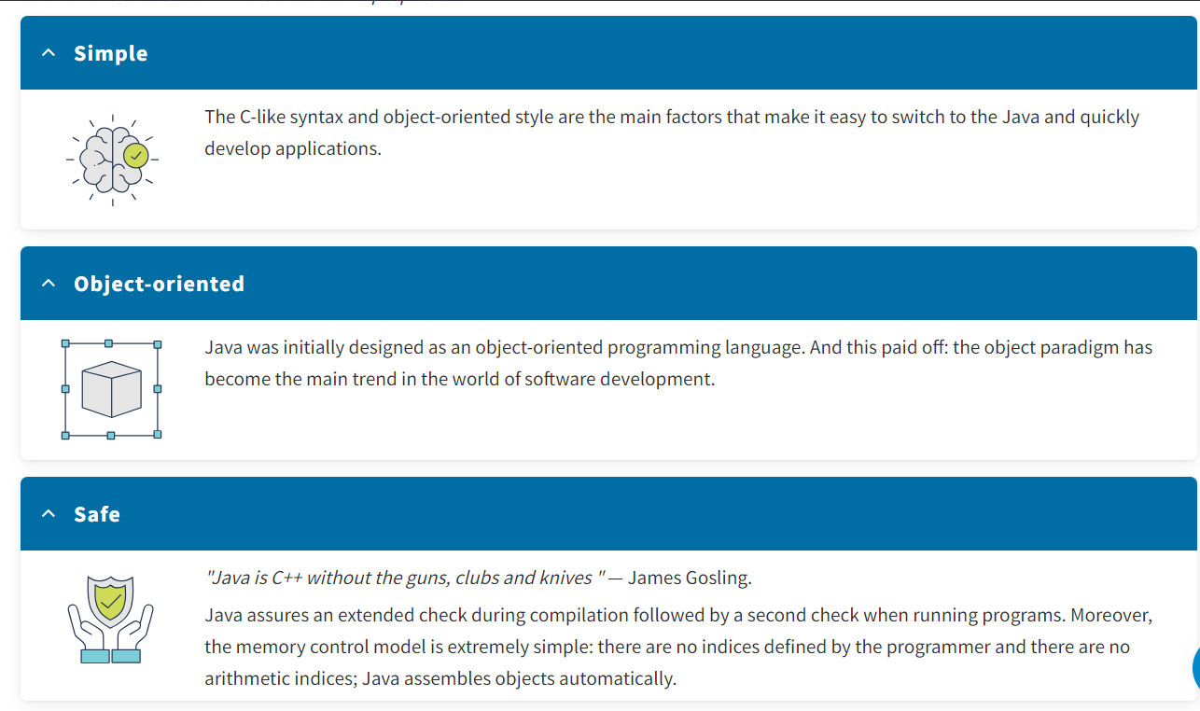

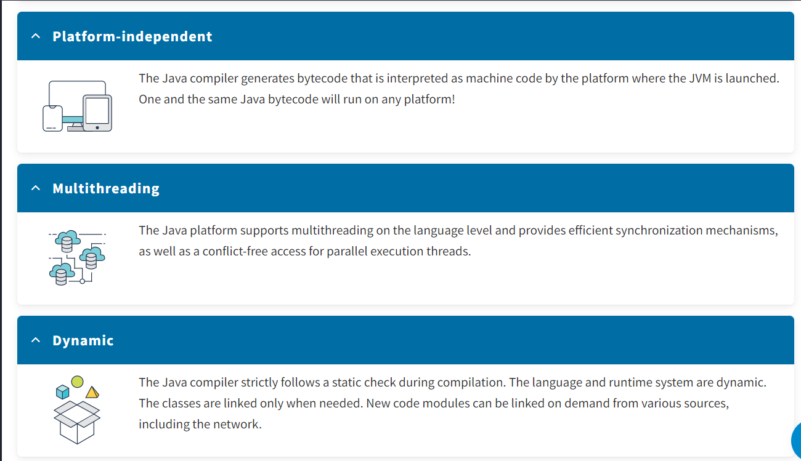

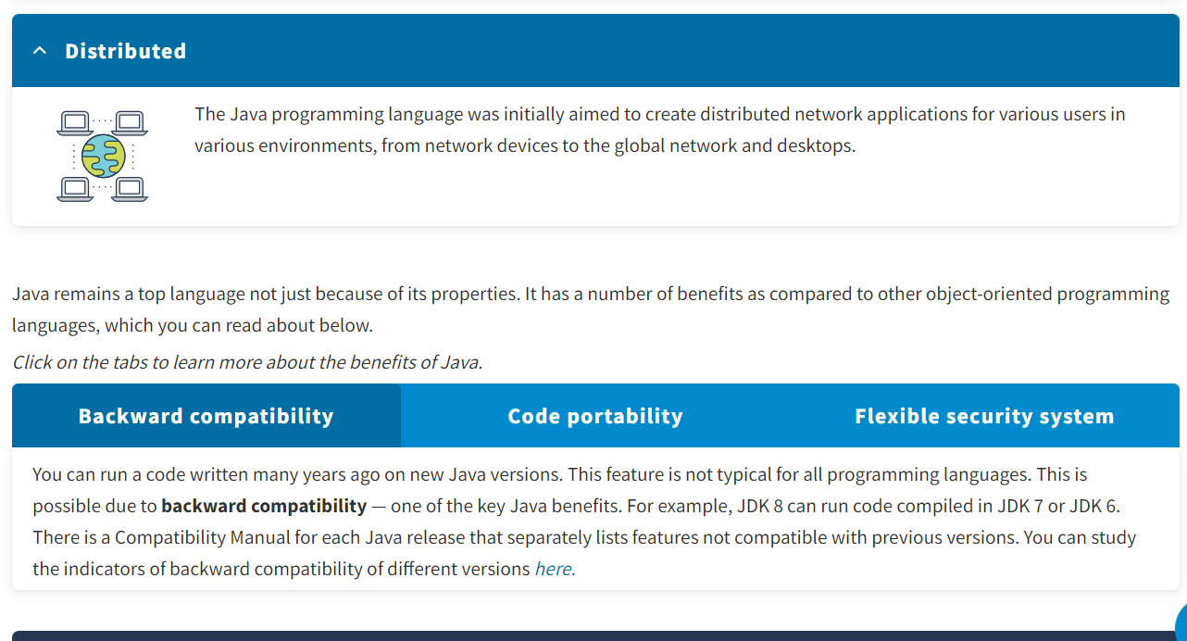

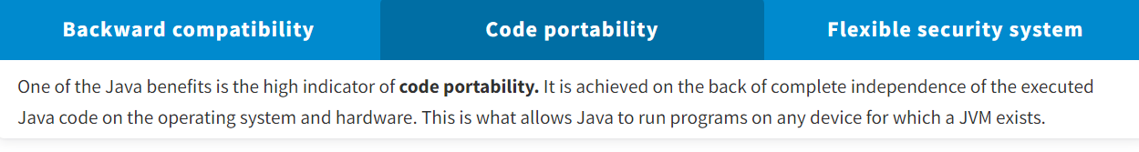

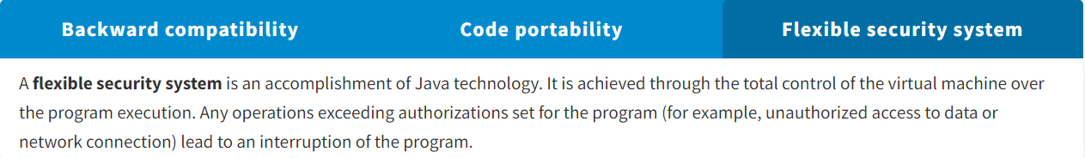

* The Java platform is a set of software products and specifications that together provide a system for application software development.
* Java is used on a variety of devices: from mobile phones and embedded systems to large corporate servers and supercomputers.
* The Java platform is not specialized for just one processor or operating system. The virtual machine and interpreter with a set of libraries are implemented for different platforms. This is done so that Java programs can run everywhere consistently.

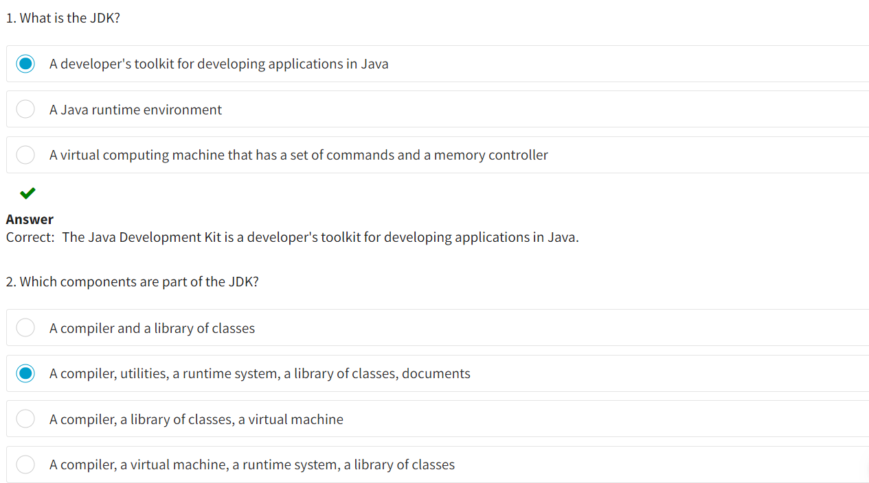

* Keywords in java :

In their classic meaning, **keywords** are tokens used by the programming language:

* To denote primary types, algorithmic branching and looping constructs, access modifiers
* To declare, import, create, return, and open methods
* In case of multithreaded programming

Keywords exist in all programming languages and are constantly updated.

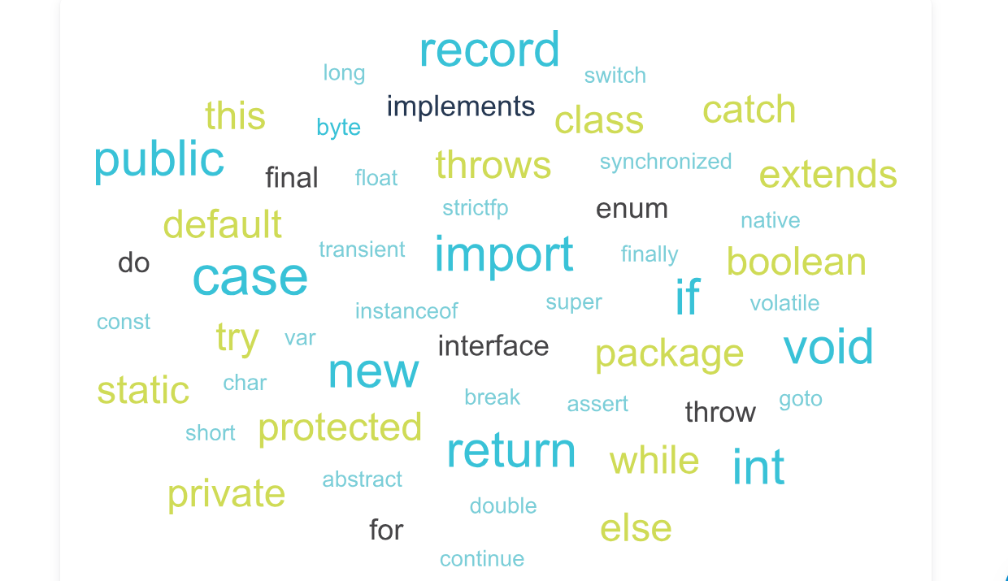

Keywords may not be used as identifiers: names of variables, classes, or methods.

Pay attention to two keywords: **goto** and **const**. These words are reserved but are not used. If you try using them, you will get a compilation error.

Another interesting keyword is **var**; it was added in the Java 10 version. It is used to denote a variable that will receive its data type only after the assignment operator (=) is executed. The variable type depends on the value to the right of the assignment operator.

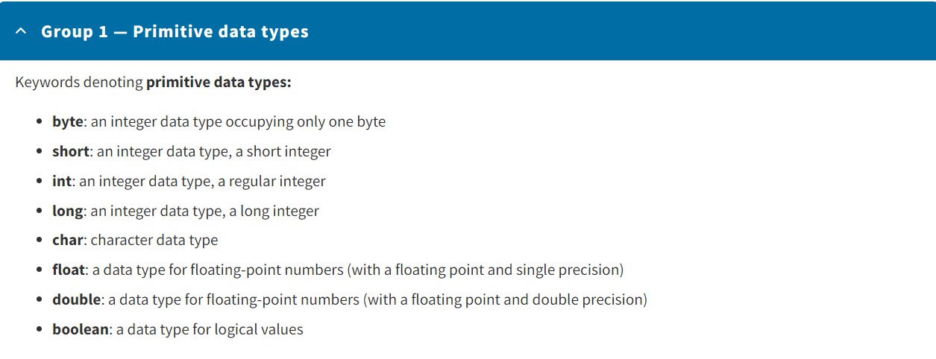

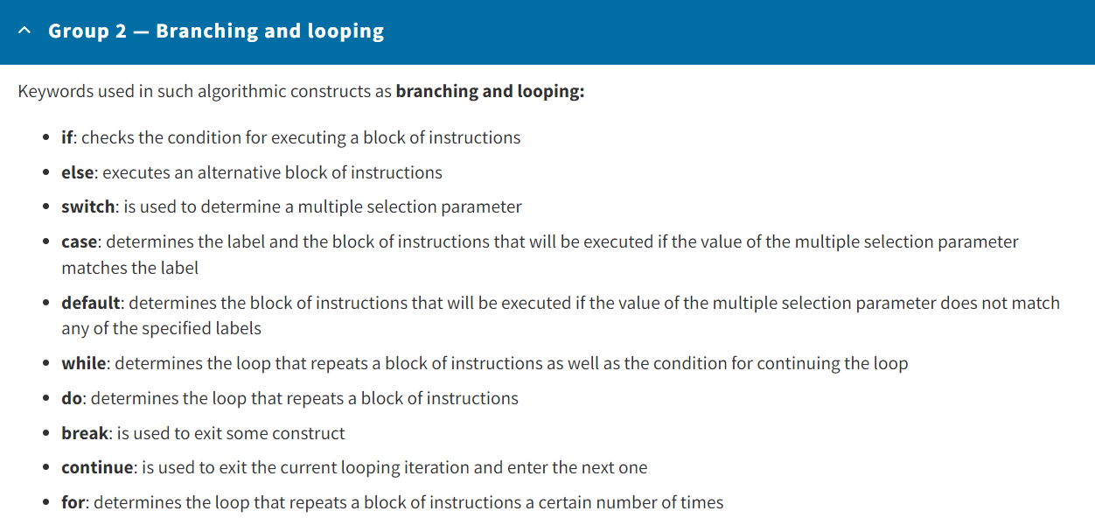

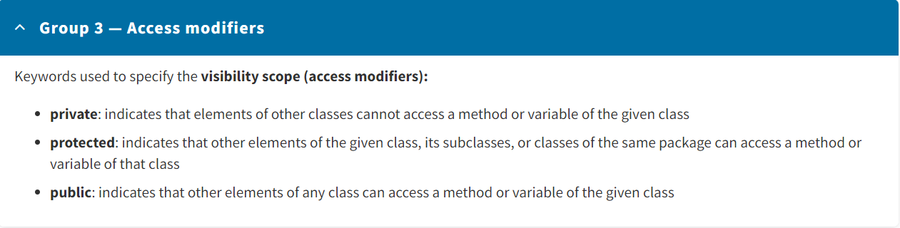

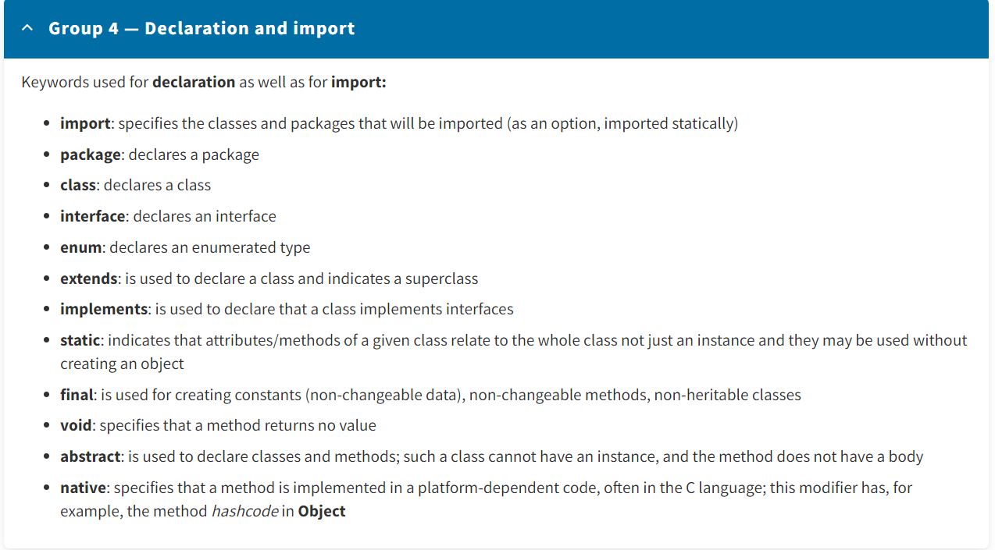

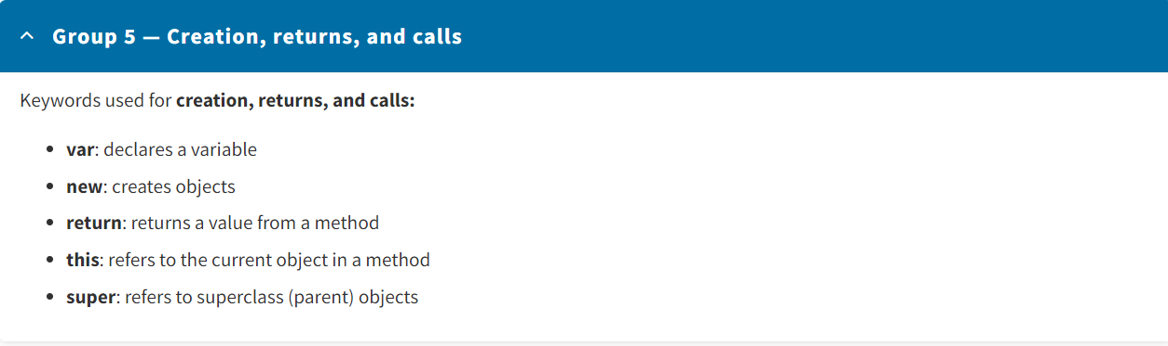

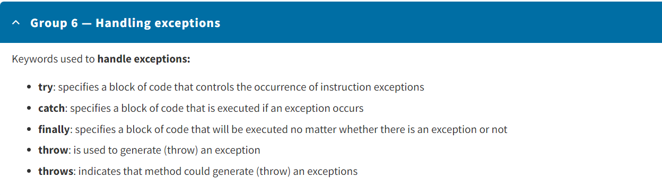

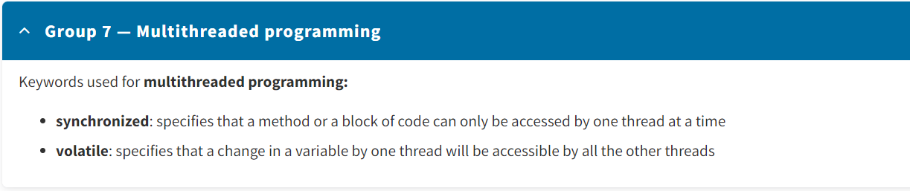

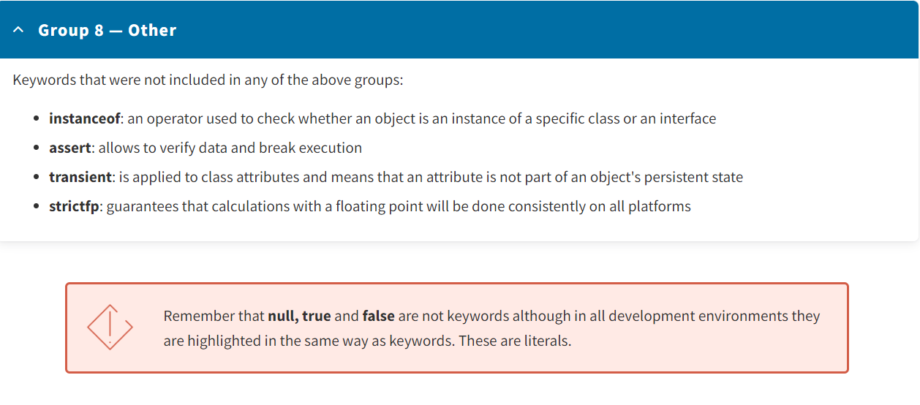

Most used keywords :

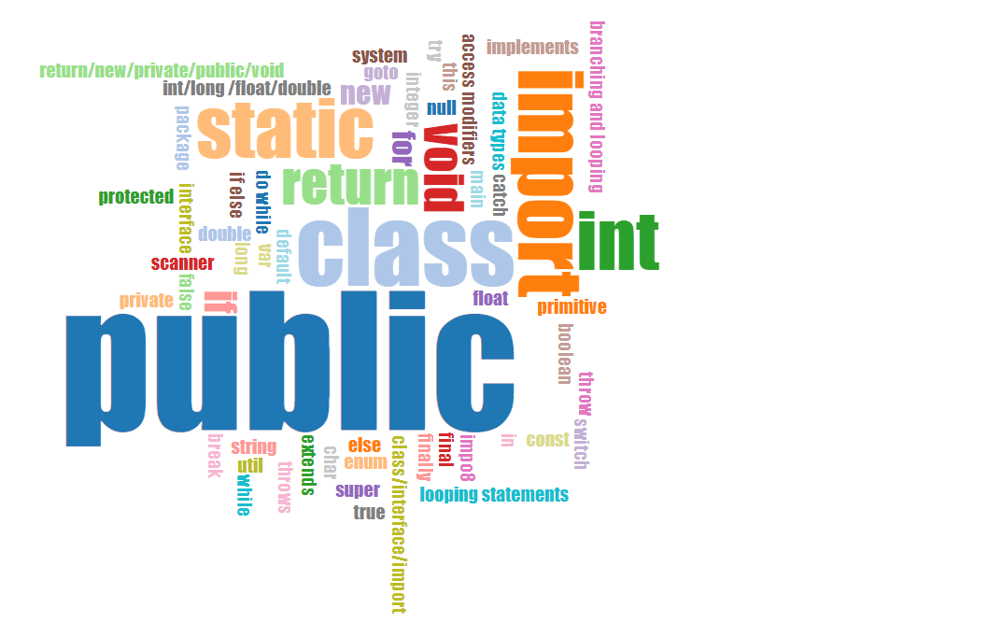

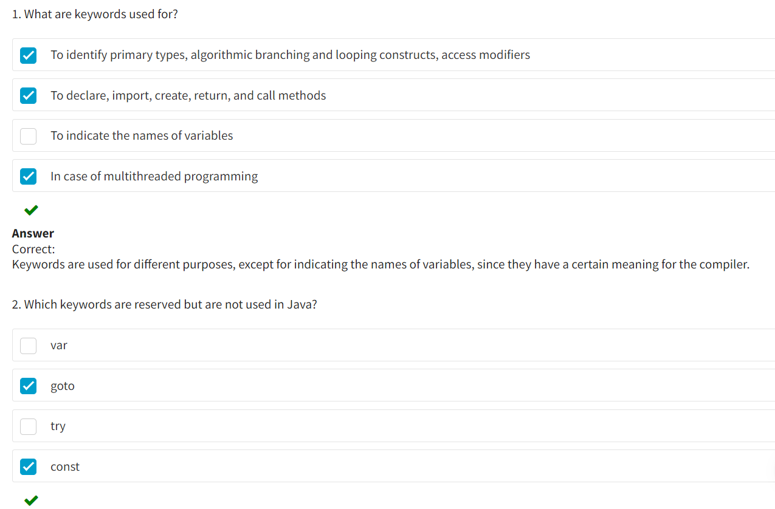

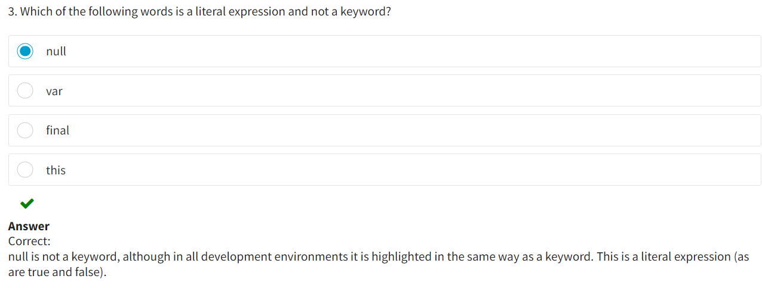

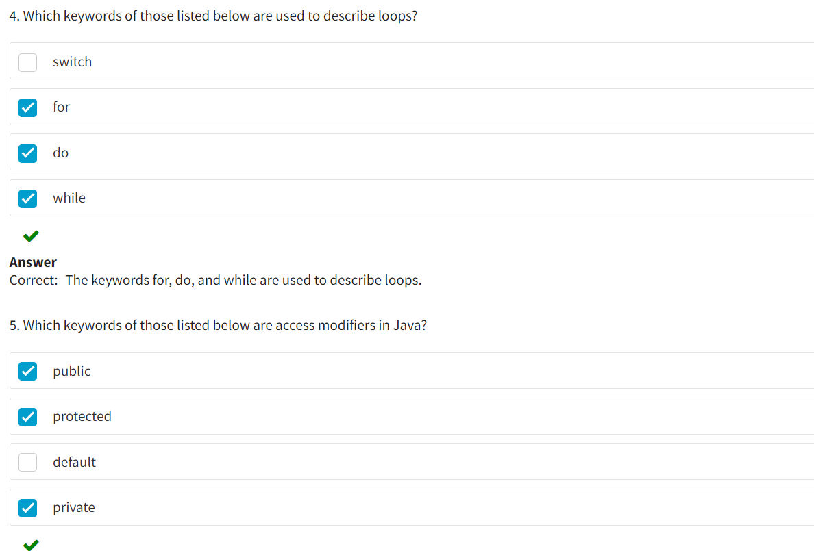

Compile through notepad + command line :

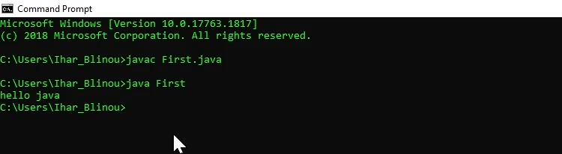

* According to the Java Code Convention, the names of all classes should start with a capital letter.
* According to the TitleCase notation, if the name uses two or more words, then each subsequent word is written without a space and is capitalized.
* One of the Java rules: the class name should match the file name.

The naming rules in Java will be described in more detail in the later lesson.

If you are not very confident with using the command line interface, please make sure that the .java file you created is in the same directory you work with in the command line (In the terminal, this is specified to the left of the > character). If it isn't, you can switch the current working directory in the command line using the "cd" (change directory) command or by using the absolute path to the .java file.

Each time you change the source code, you need to recompile the application before launching it.

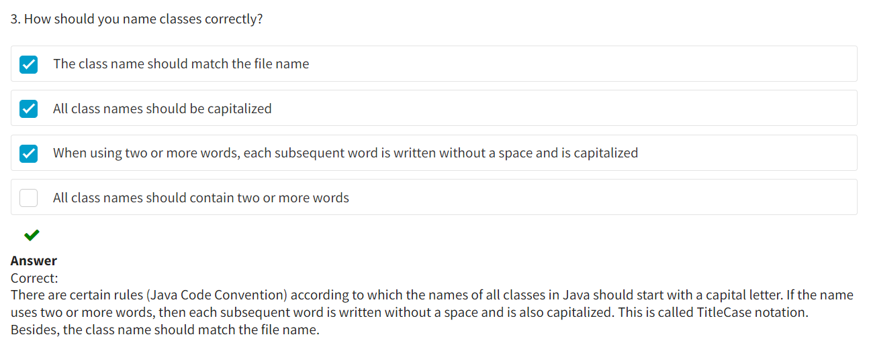

IDE :

An **IDE** (Integrated Development Environment) is the environment that provides functions to create applications. On the surface, the integrated development environment looks like a code text editor and assures the following:

* Highlights code fragments
* Highlights errors (contains a base of language syntax)

Any modern IDE contains tools for compilation, execution, assembly automation, code debugging, etc.

Unlike many basic text editors, the IDEs can support full-fledged projects and not just process separate source code files. They can support the creation of a project that includes a group of files, as well as define specific parameters for the project. For instance, such parameters may include:

* Links to the necessary external libraries (third-party software products)
* Editor settings
* Support for versioning
* Debugging settings

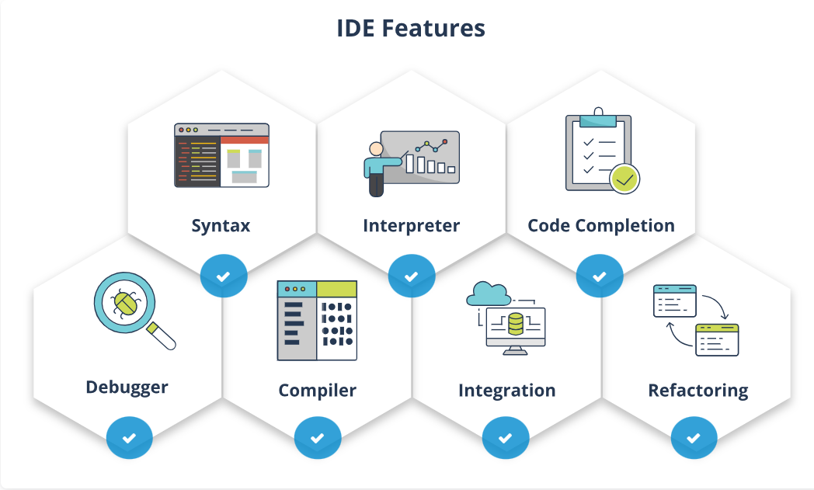

**Syntax**

Provides support for various programming languages.

**Interpreter**

Performs line-by-line analysis, processing, and program execution.

**Code completion**

Provides automated code completion.

**Debugger**

A tool that allows one to monitor program behavior during its execution and detect problems and errors.

**Compiler**

A special program that transforms the source code of a program in a specific language (Java, C#) into a set of machine codes executed directly by the processor.

**Integration**

Provides integration with versioning control systems (SVN / Git) – the ability to store multiple versions of the same file and be able to go back to earlier versions, see any changes, and much more.

**Refactoring**

Provides a process to improve the quality of code, without writing new functionality.

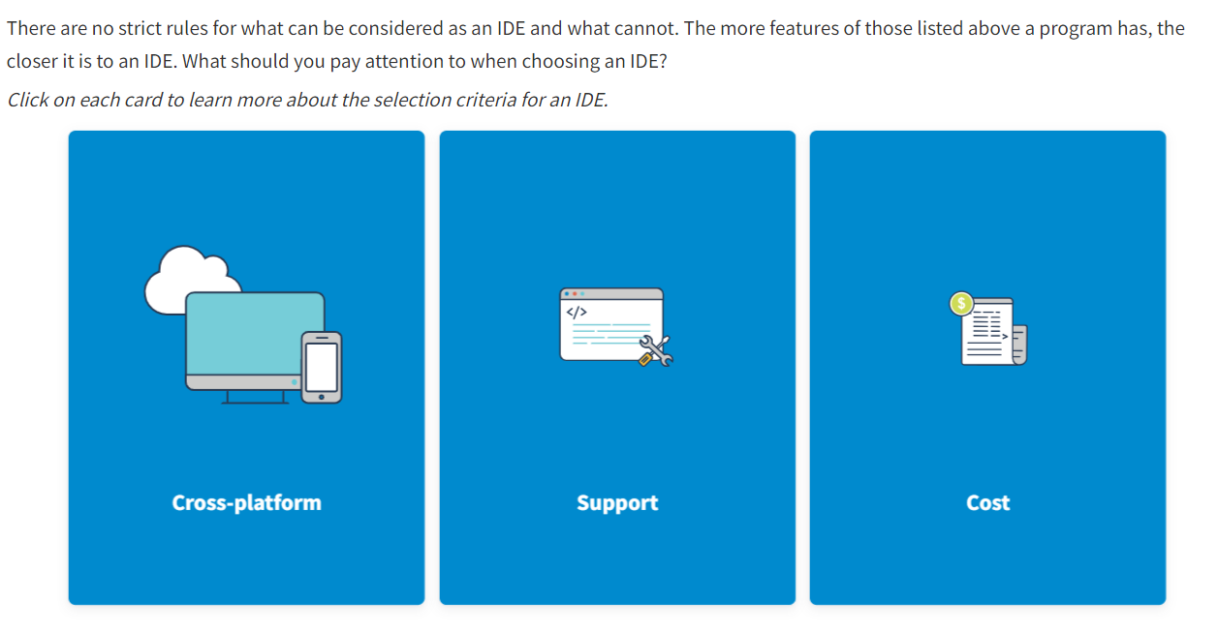

The integrated development environment should be able to operate on different devices and in different operating systems.

The IDE should be supported/maintained by its developers and regularly updated in line with modern technologies. This selection criterion is one of the most important ones.

There are both commercial and free development environments. It is recommended to first try using free IDE versions.

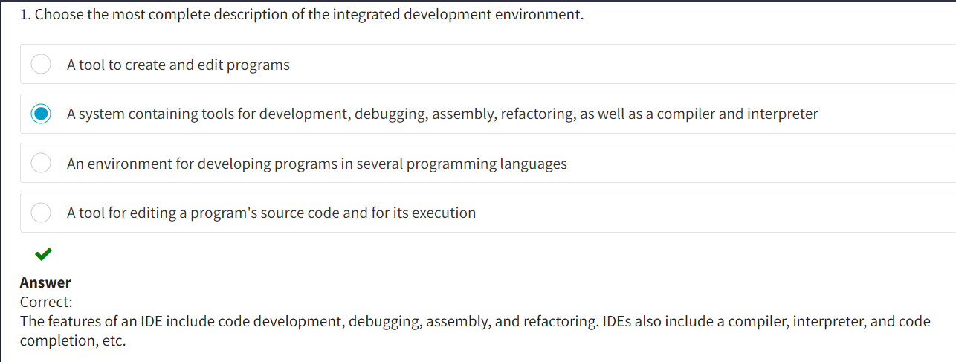

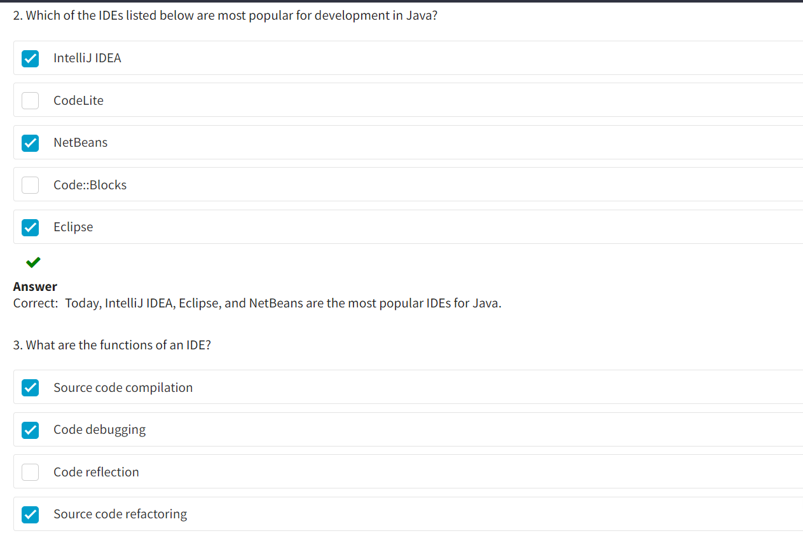

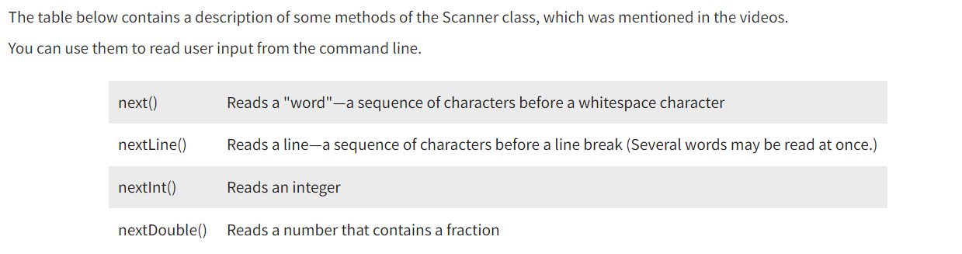

* Datatypes in Java :
* Create variables
* Use numeric and string literals
* Determine the place of data storage depending on their type
* Correctly use different operators
* Describe the process of typecasting
* Name various elements according to the recognized conventions

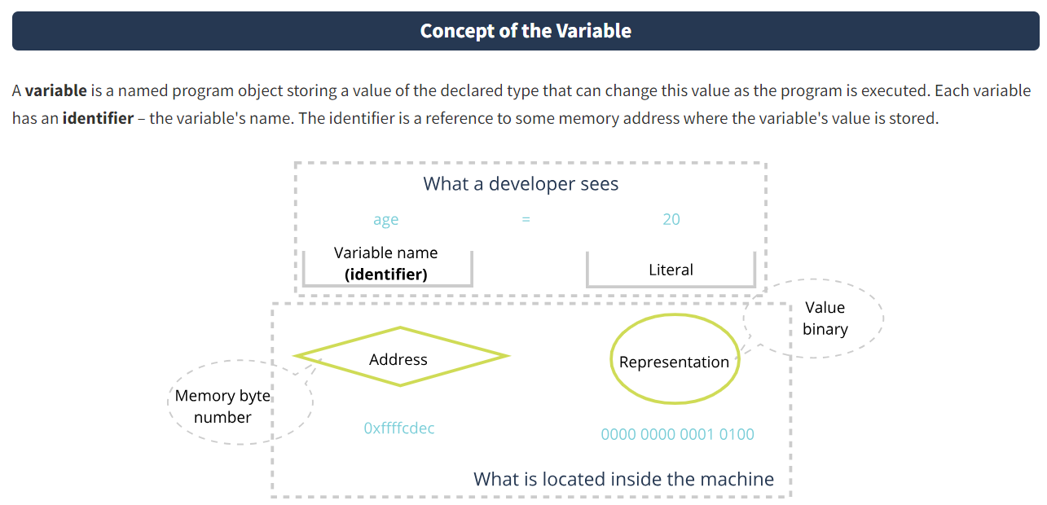

In Java, variables can be located in the class body (be its element) or in the method body:

* A variable declared in the class body stores a zero value of the relevant type by default.
* A variable declared in the method body must be initialized before it can be used. These variables are local and are not initialized with zero values by default.

The visibility scope and lifetime of a variable are limited by the code block where it is declared. A **code block** means a part of code placed in curved brackets.

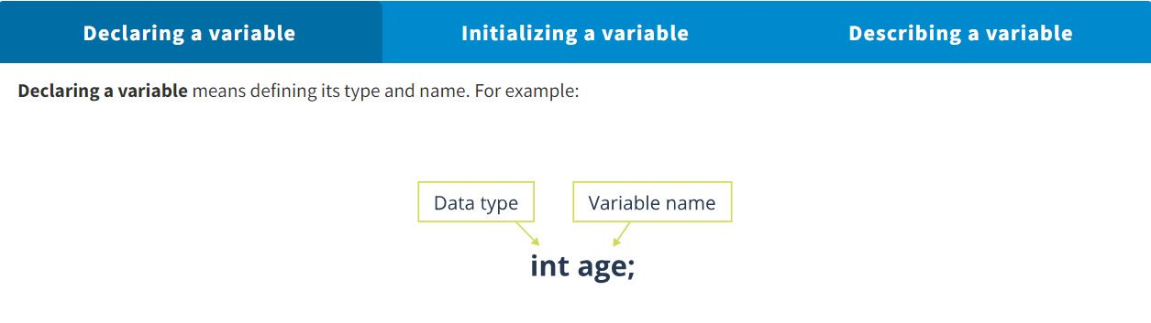

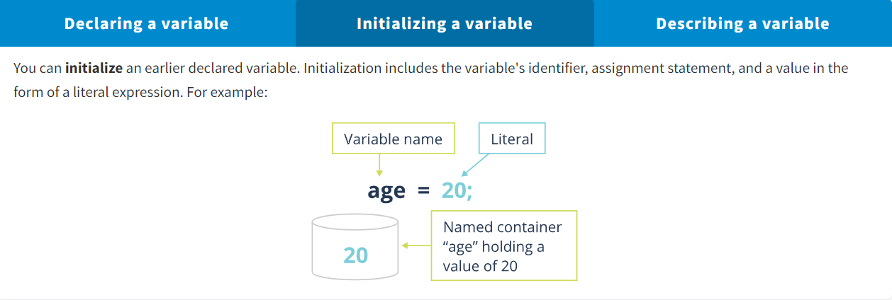

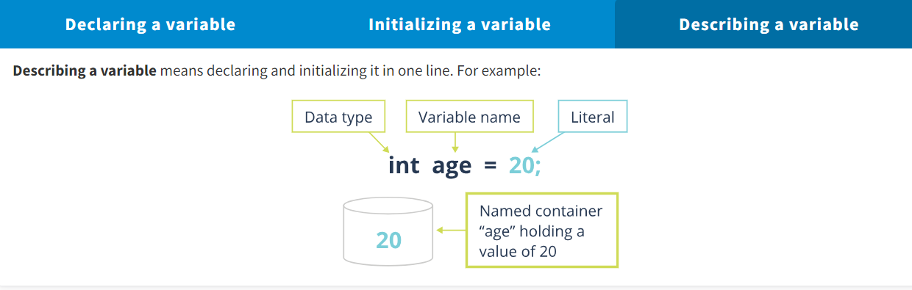

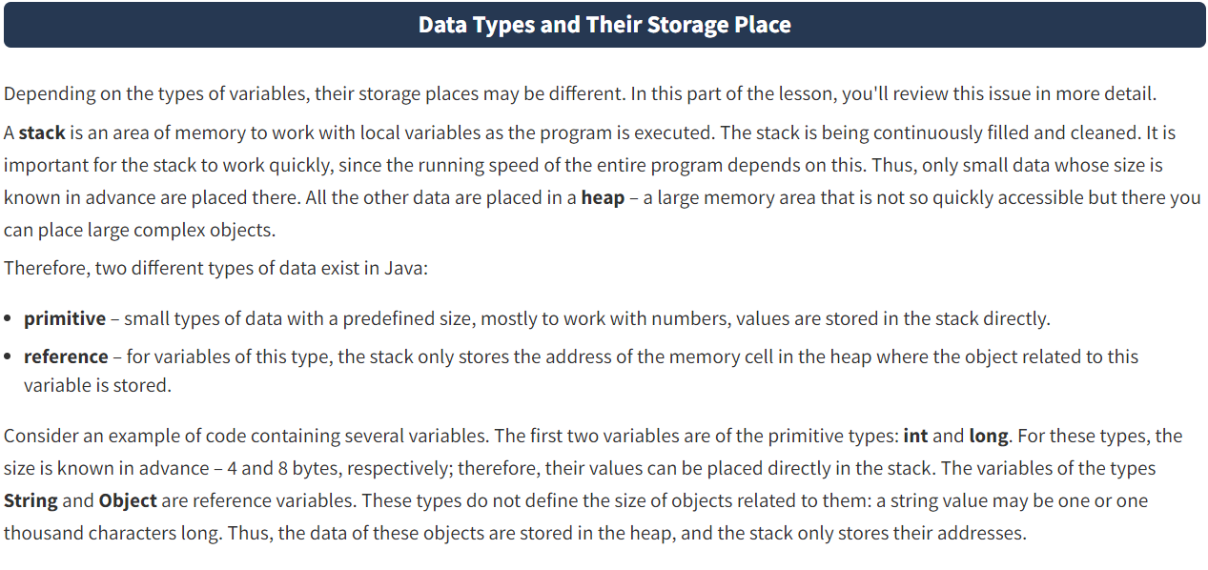

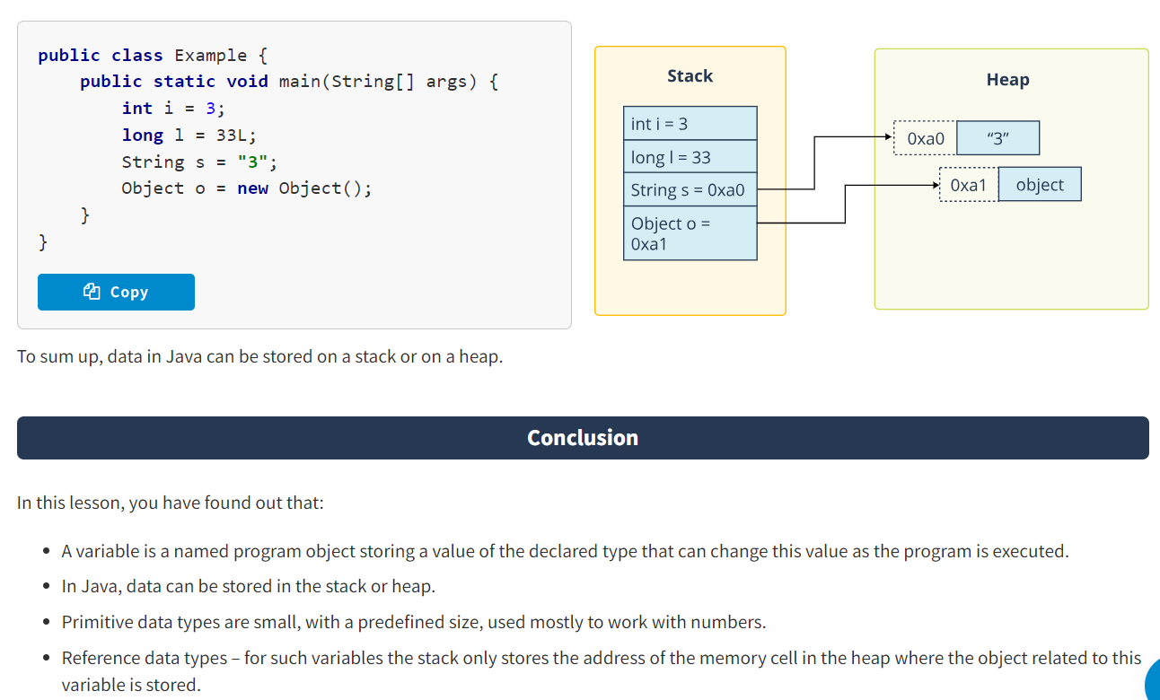

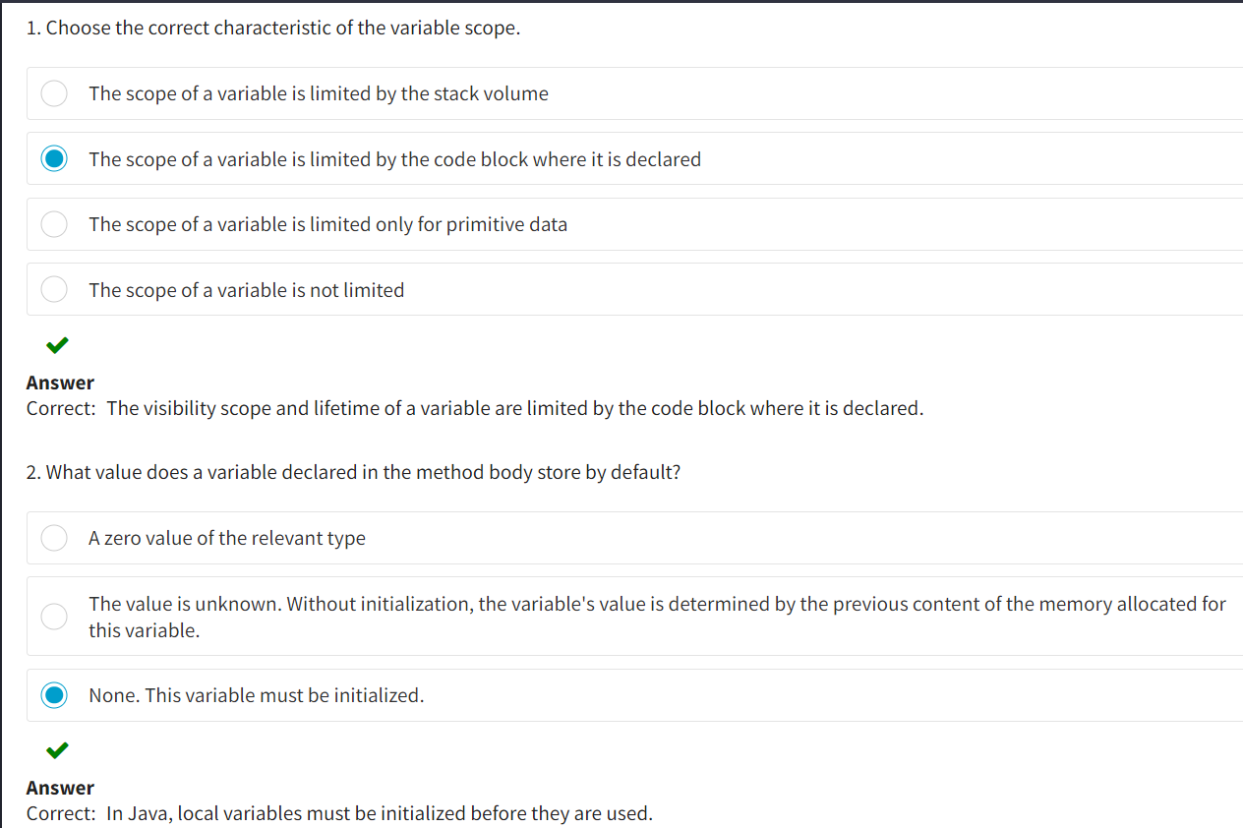

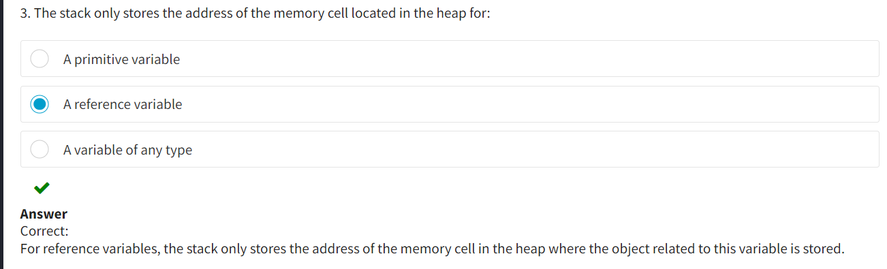

Primitive Data types :

Although Java is an object-oriented programming language, not all data in it are objects. The language also uses primitive (or basic/predefined) data types. This was done to increase performance, since the values of primitive data types are placed in the stack memory. This memory is more readily accessible than the area of object storage.

Any data processed by the program are part of some type.

Pursuant to standard [*IEEE Std 1320.2-1998*](https://ieeexplore.ieee.org/document/761916), **a data type (type)** is a set of values and operations with these values. You can also say that the **data type** is a fundamental concept in the programming theory. The data type not only determines the range of possible values and set of operations performed with these values but also the method of storing the values and performing operations with them.

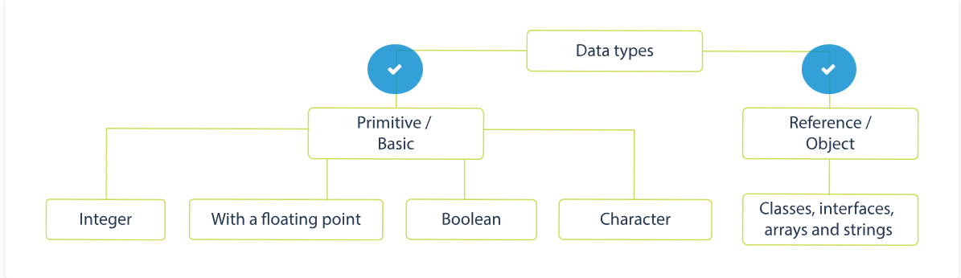

**Primitive data types**

Primitive data types often use small and simple data. Depending on the type, they take one to eight bytes of memory.

**Reference data types**

Reference data types are used to point at objects. In other words, an object's name is a reference to this object that contains the memory address where the object is stored. You cannot manipulate a reference, i.e., perform operations with it.

To support the object-oriented concept for each primitive data type, wrapper classes were created that encapsulate data of the primitive types into objects. Such objects are placed in the dynamic memory (heap).

Java has eight primitive data types for numeric, alphabetic, and logical values. The amount of memory taken by the values of primitive types is fixed and does not depend on the platform.

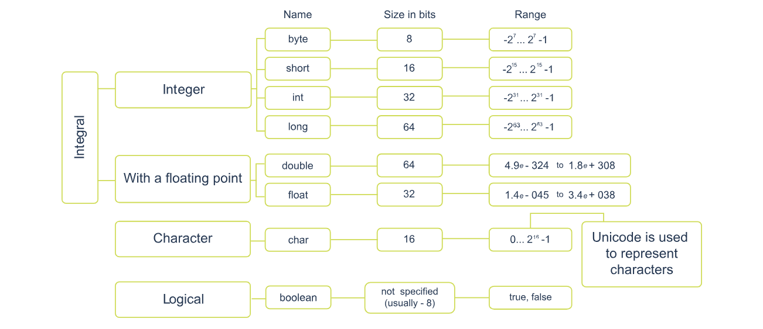

In Java, there are no unsigned data types. Each data type clearly defines a set of values and the method of their representation in the memory. Each type uniquely defines the set of operations with the values of this type.  
Now it is high time to find out what literals are.

Literal Expressions :

**Literal expressions** are clearly defined values of a certain type in the program code. You could say that literal expressions are a representation or reflection of a variable's value.

A literal expression has a type in Java.

* 1. Integer Literals :

To represent integer values, various computing systems use an integer literal that has the type **int**. For example:

*Hover the mouse cursor over the info icon to see the explanation for the code.*

**byte** var1 = -35;

**short** var2 = 0b1011;

**int** var3 = 0x51b;

**int** var4 = 071;

If you need to define a long literal of the type **long**, at the end specify the letter (suffix) L or l. For clarity, it is recommended to use an uppercase letter. For example:

*Hover the mouse cursor over the info icon to see the explanation for the code.*

**long** var5 = 12345L;

**long** var6 = 0xffffL;

Starting from Java 7, for easier readability of long literals (large numbers), you can add an underscore ("_") to separate digits. This style can also be used for numbers with a floating point. For example, instead of:

**int** var7 = 7000000;

You can write:

**int** var8 = 7_000_000;

Specifics of using the underscore symbol:

* It may only be used between digits.
* You can use any number of underscores between digits.

The underscore symbol cannot be placed at the following places:

* Before the first and after the last digits of the literal
* Before the suffix or prefix

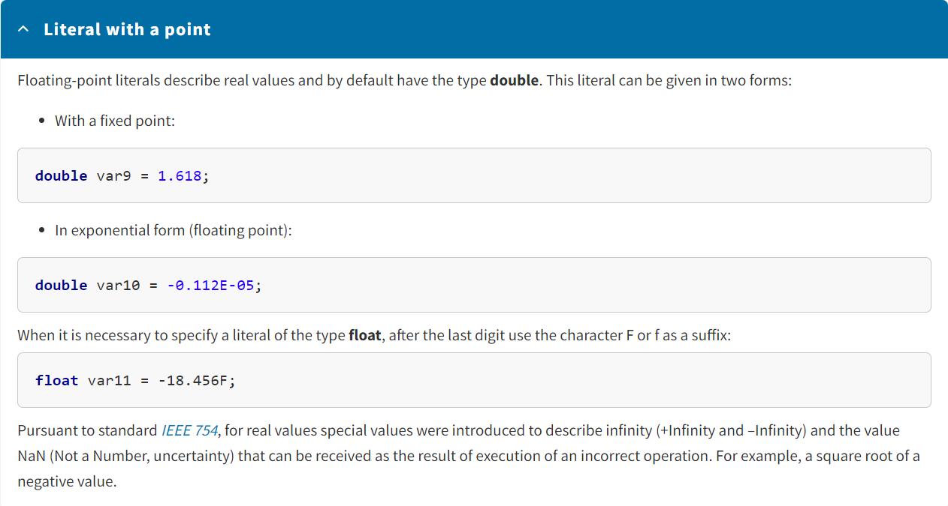

3)

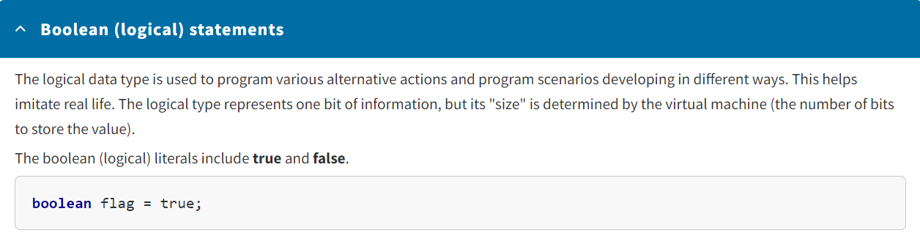

* 1. Character Literals :

The description of a character literal is always enclosed in single quotes, for example: 'a', '\n', '\141', '\u005a'. A character literal has two forms: the first in the form of a graphic image of the character in single quotation marks, and the second one in the form of '\ucode' according to which two bytes are allocated for each character:

* The first byte contains the code of the control character or alphabet.
* The second byte corresponds to the specification of the character in the standard of the ASCII code.

Unicode is mostly used for control characters that have no graphical image:

* '\n' - new line
* '\r' - transition to the beginning of the current line
* '\f' - new page
* '\t' - tabulation
* '\b' - backspace
* '\uxxxx' - hexadecimal Unicode character
* '\ddd' - octal character

Here are some examples of character literals:

*Hover the mouse cursor over the info icon to see the explanation for the code.*

**char** ch1 = '3';

**char** ch2 = 'g';

**char** ch3 = '(';

**char** ch4 = '\u0034';

**char** ch5 = '\u002e';

**char** ch6 = '\t';

**char** ch7 = '\n';

**char** ch8 = '\r';

**char** ch9 = '\b';

5)

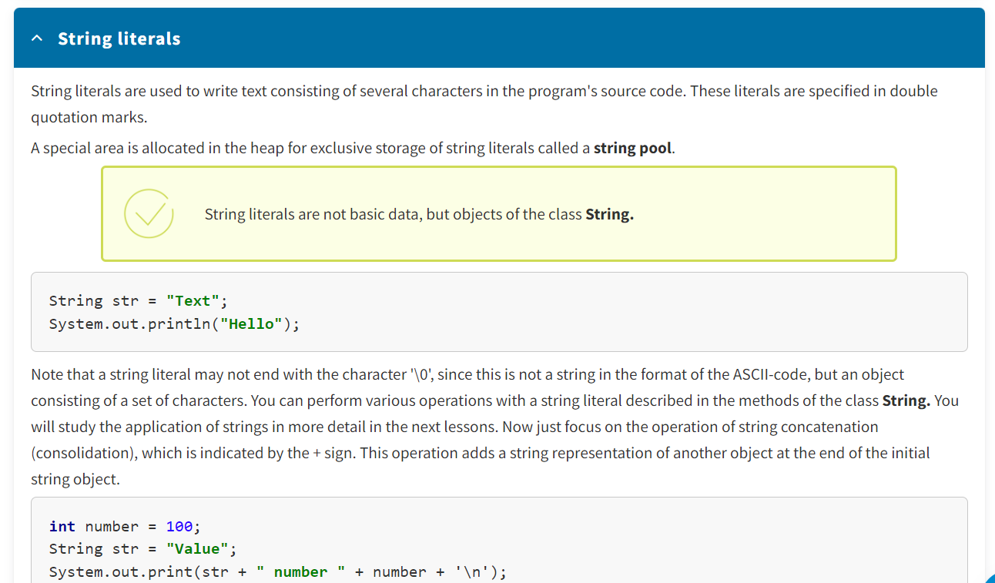

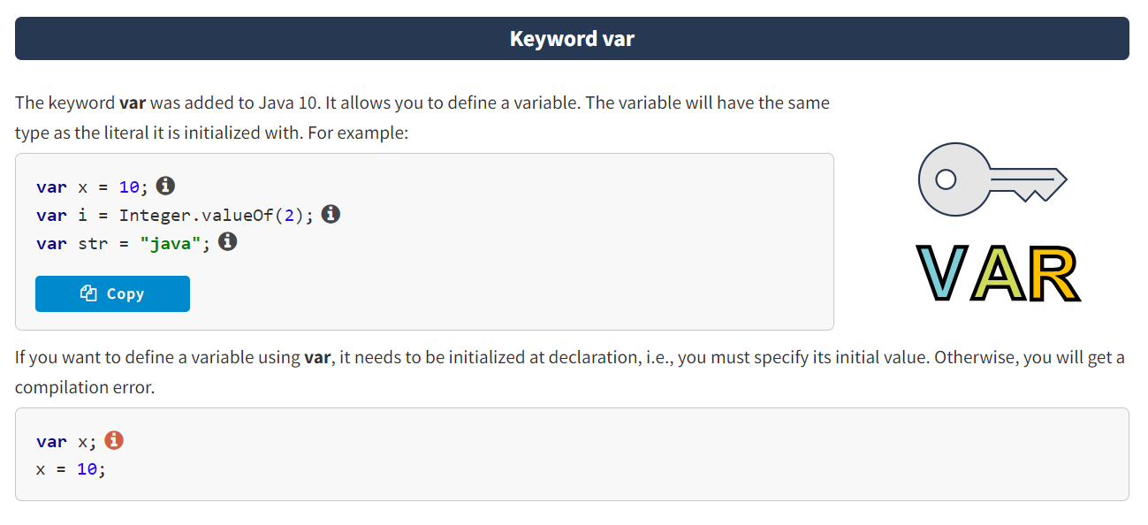

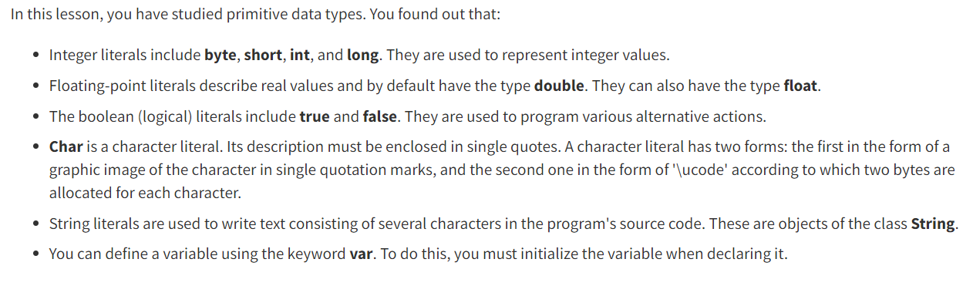

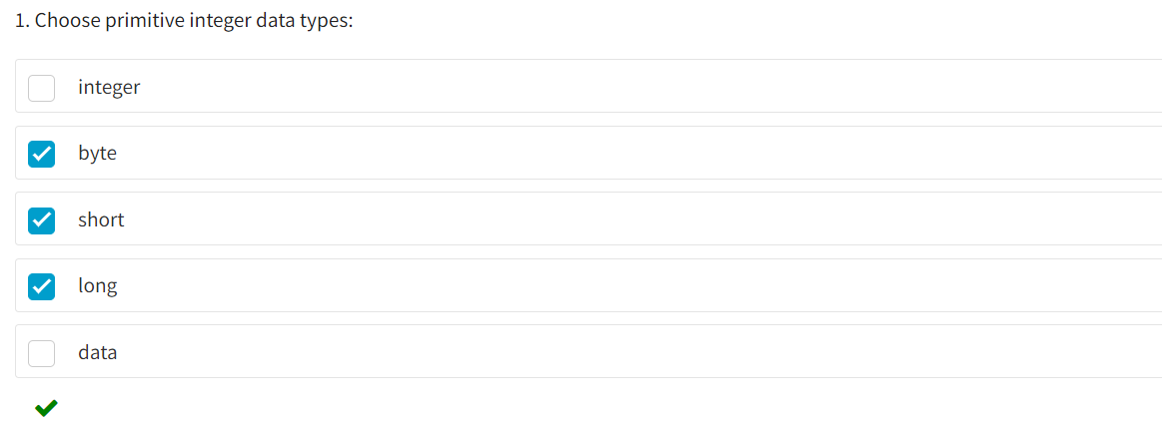

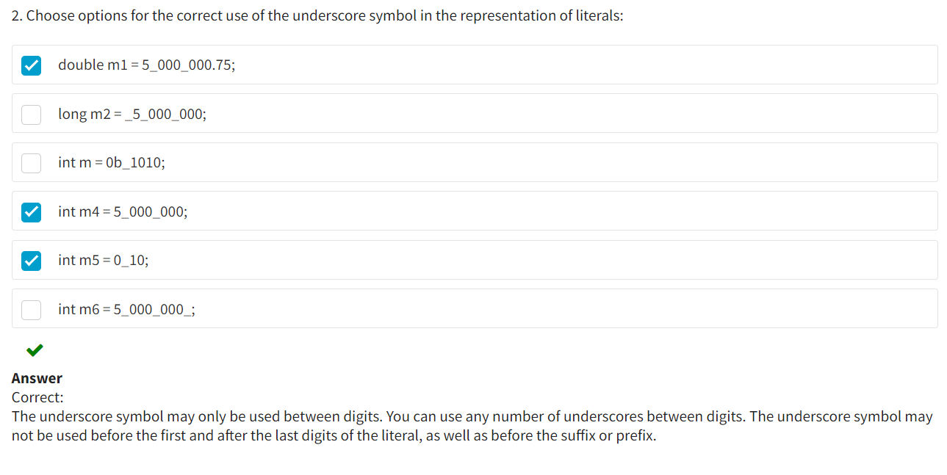

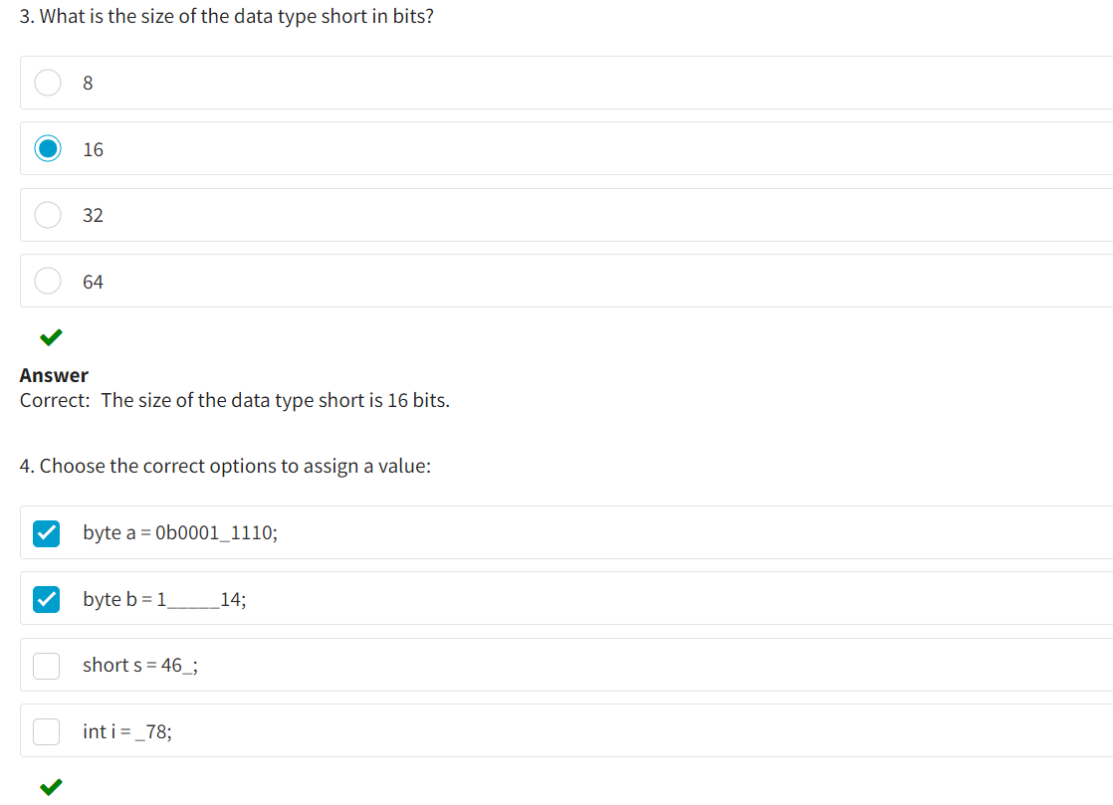

* Operators :

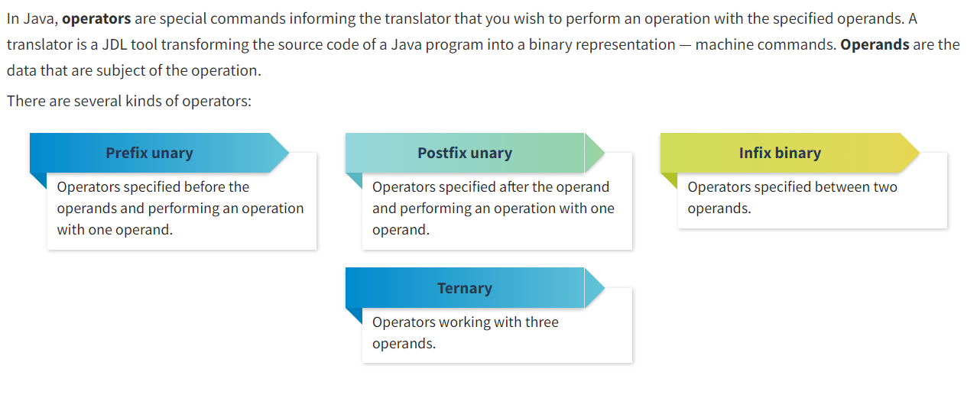

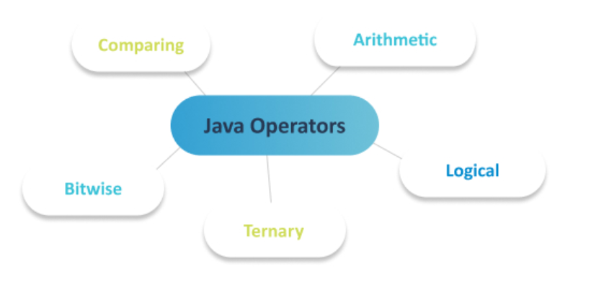

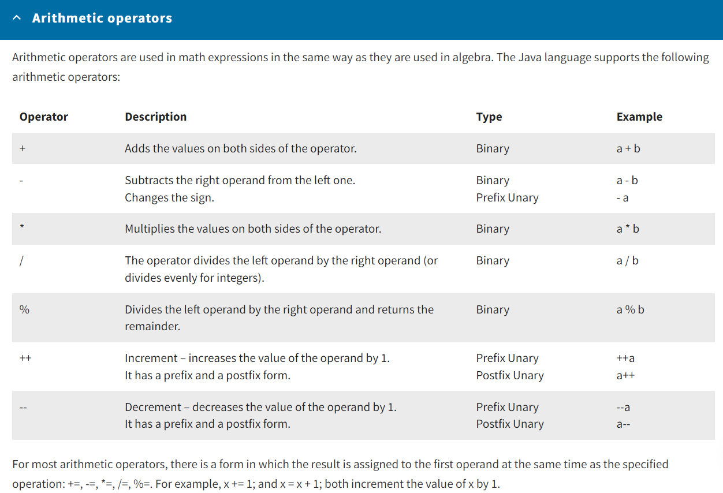

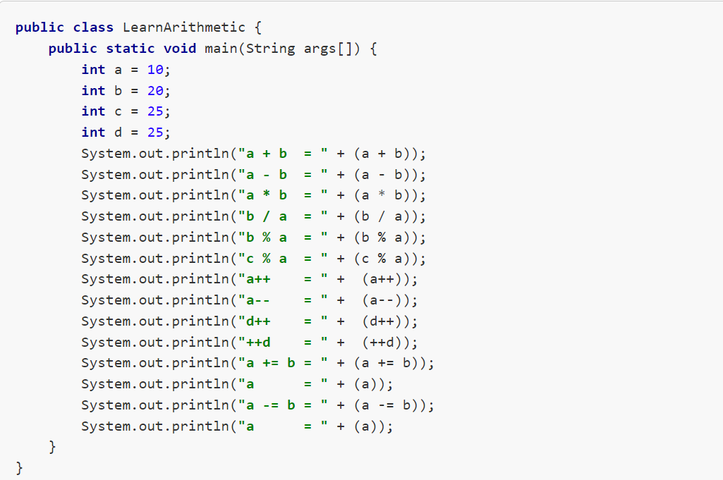

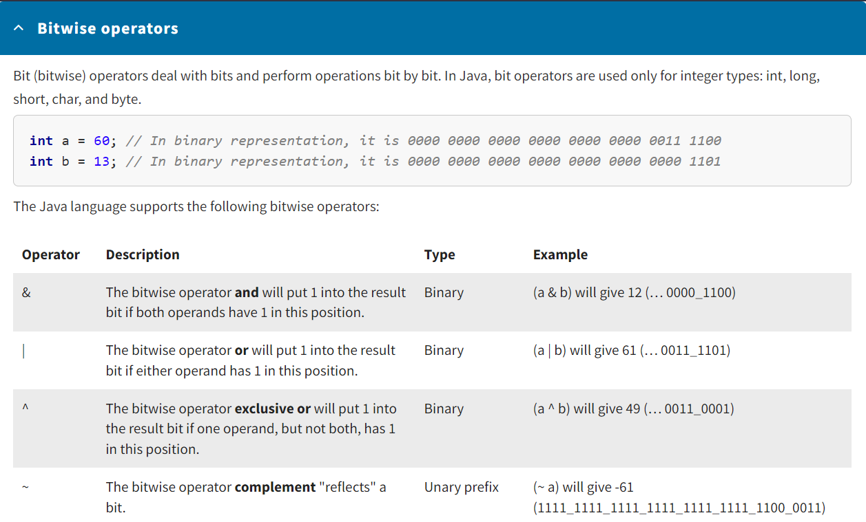

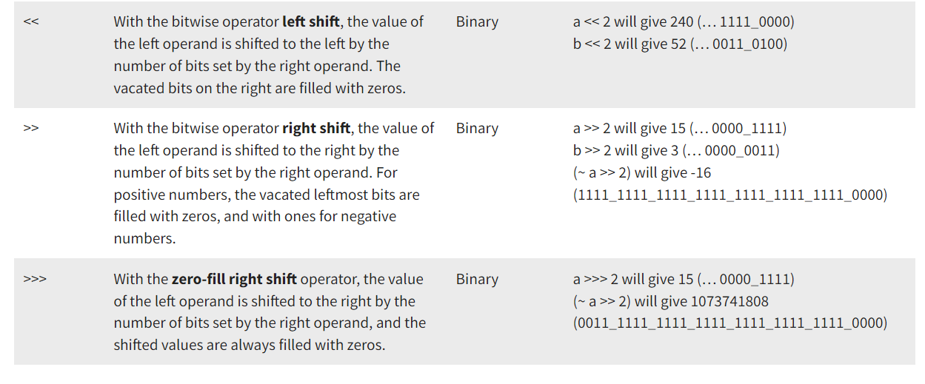

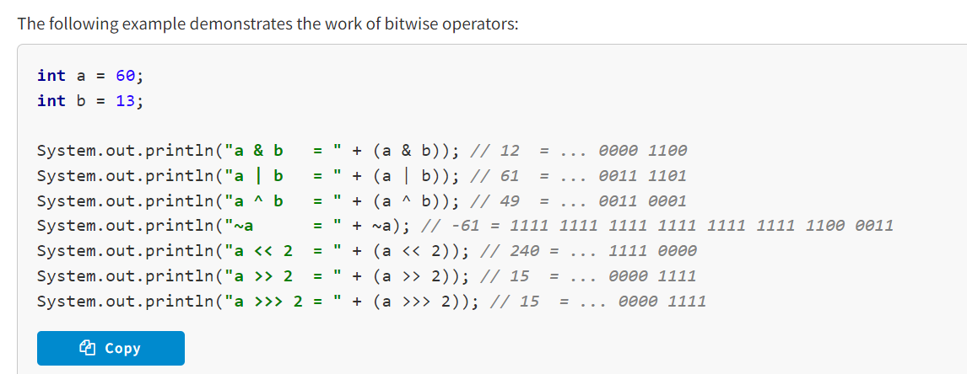

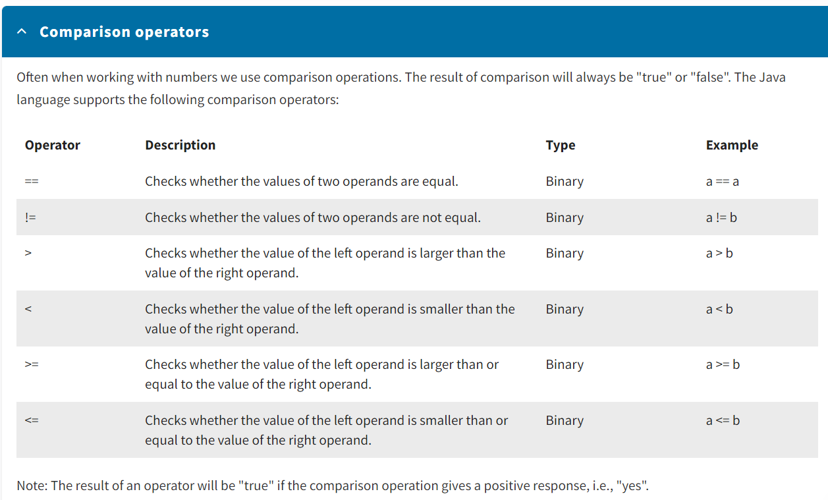

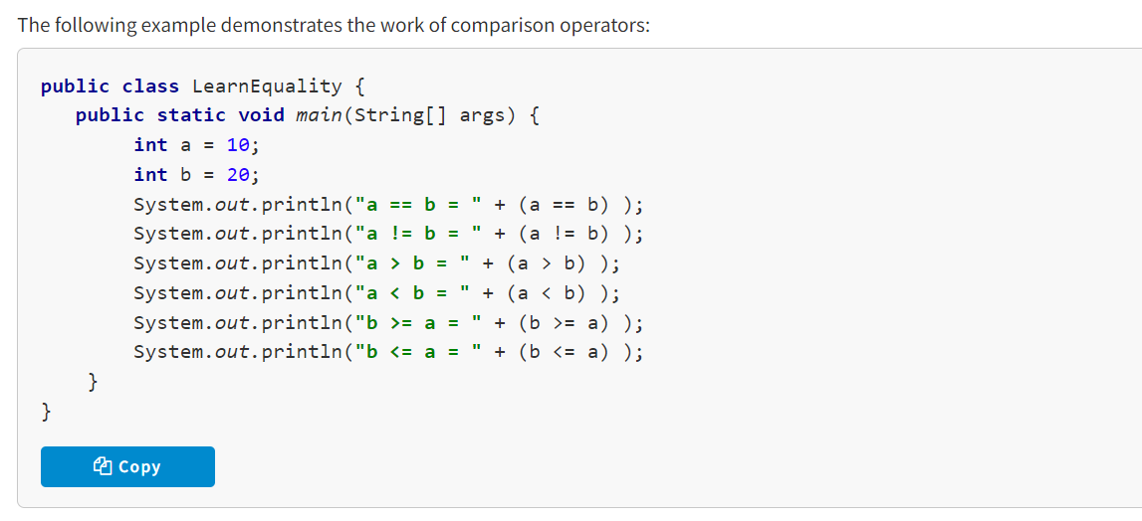

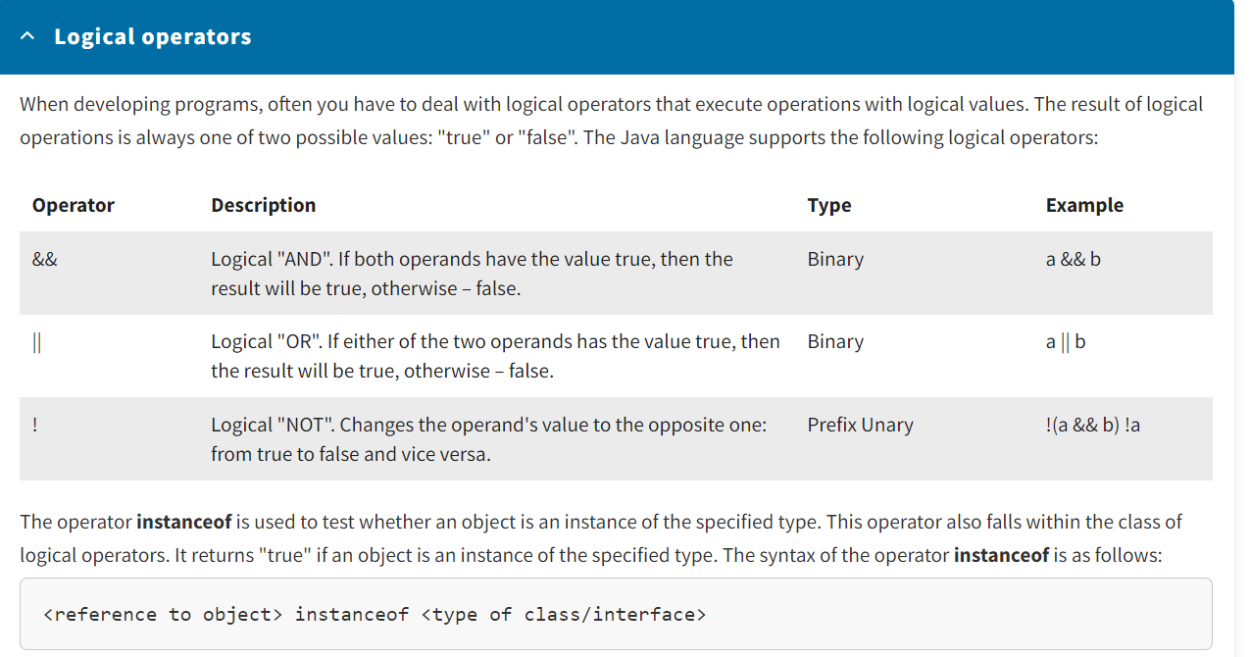

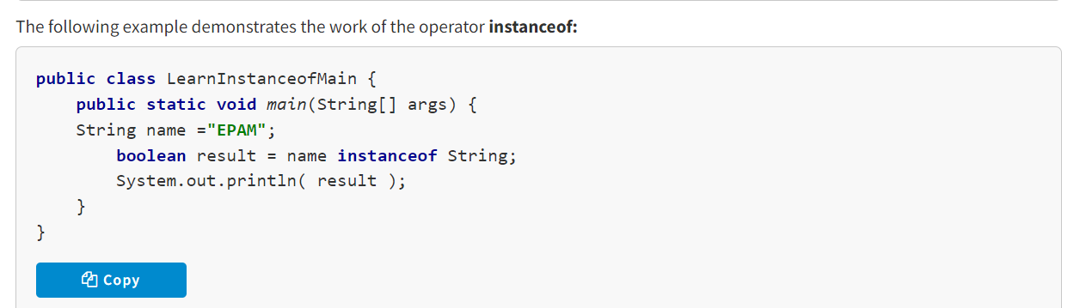

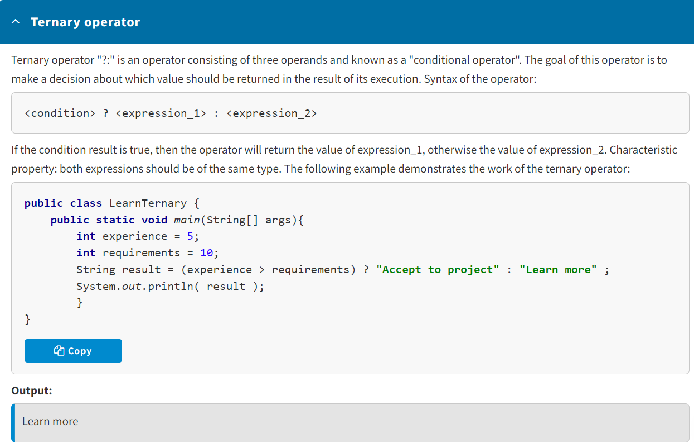

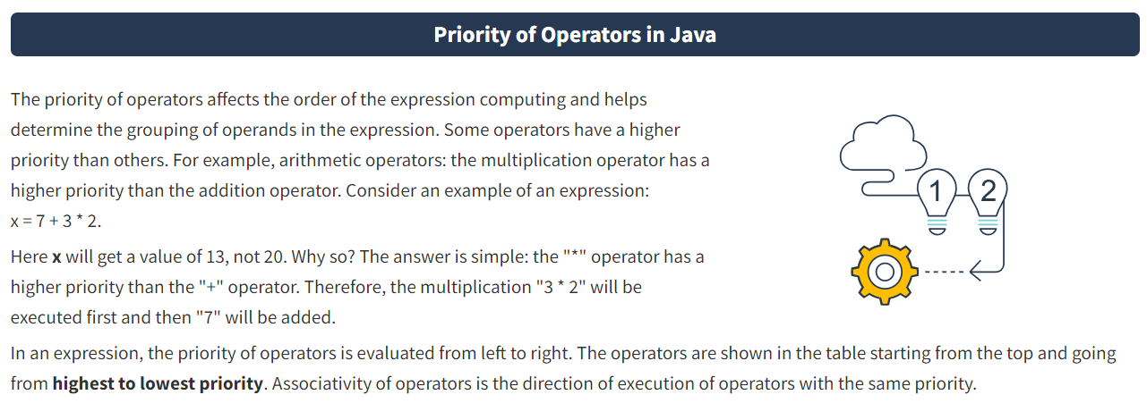

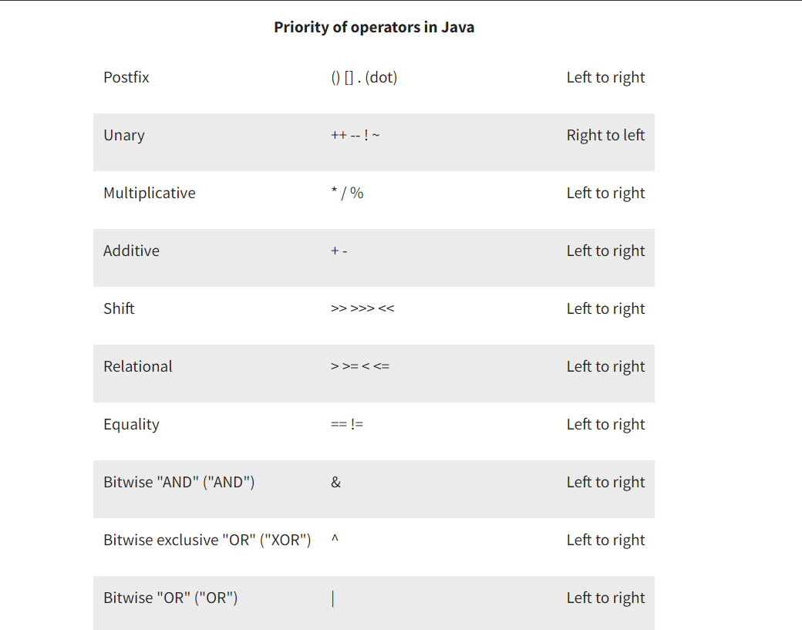

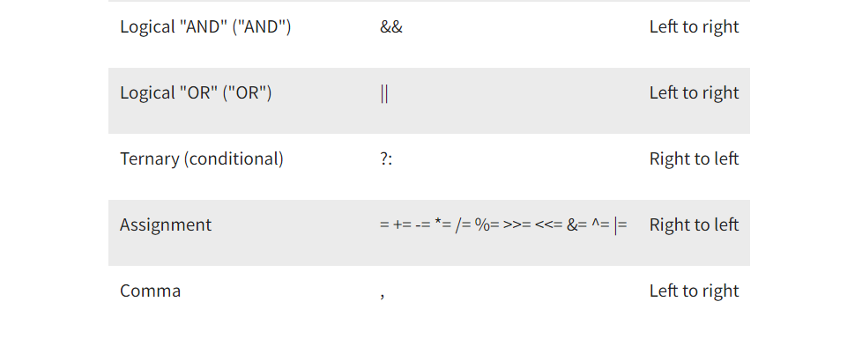

* Methods of Class Math :

The class **Math** contains constants and methods to work with math functions. You can call these methods using the class name, a dot after the name, and then specifying parameters for the method in round brackets separated by a comma. For example:

int max = Math.max(3, 4);

The class **Math** contains approximated values of mathematical constants – the numbers "PI" and "E":

* PI // 3.14159265358979323846
* E // 2.7182818284590452354

Set of basic **math methods**:

* abs – returns the modulus of a number: Math.abs(-4) // 4;
* max – returns the larger of two numbers: Math.max(1, 2) // 2
* min – returns the smaller of two numbers: Math.min(1, 2) // 1

A set of **trigonometric functions** that accept angle values in radians:

* sin – returns the sine of an angle: Math.sin(0) // 0
* cos – returns the cosine of an angle: Math.cos(0) // 1
* tan – returns the tangent of an angle: Math.tan(0) // 0
* asin – returns the arcsine of an angle: Math.asin(0) // 0
* acos – returns the arccosine of an angle: Math.acos(1) // 0
* atan – returns the arctangent of an angle: Math.atan(0) // 0

There are also some convenient methods to **convert degrees to radians** and vice versa:

* toRadians: toRadians(1) // 0.017453292519943295
* toDegrees: toDegrees(1) // 57.29577951308232

Methods to work with **powers**:

* exp – returns *e* to the power of x: Math.exp(1) // 2.7182818284590452354
* log – returns the natural logarithm (base *е*): Math.log(Math.E) // 1
* log10 – returns the base 10 logarithm of a value: Math.log10(100) // 2
* sqrt – returns the square root of a value: Math.sqrt(16) // 4
* cbrt – returns the cube root of a value: Math.cbrt(-8) // -2
* pow – returns the result of a value raised to some other value: Math.pow(2, 4) // 16

Major **rounding** methods:

* ceil – rounding up: Math.ceil(3.3) // 4
* floor – rounding down: Math.floor(5.7) // 5
* round – rounding pursuant to the standard math rules: Math.round(5.8) // 6

Method to **get a random value**:

* random – returns a random value of the type double within the limits of [0;1)

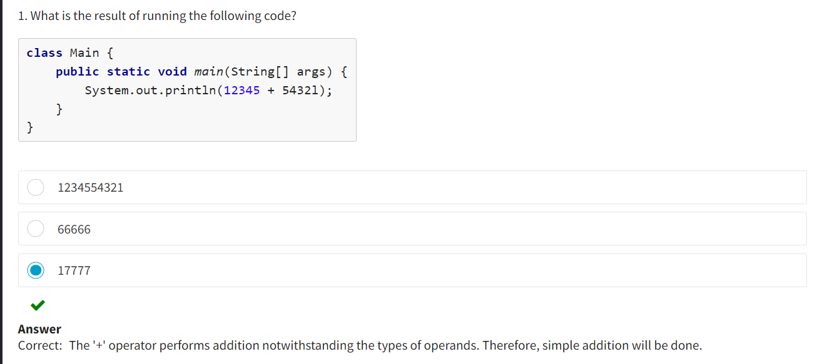

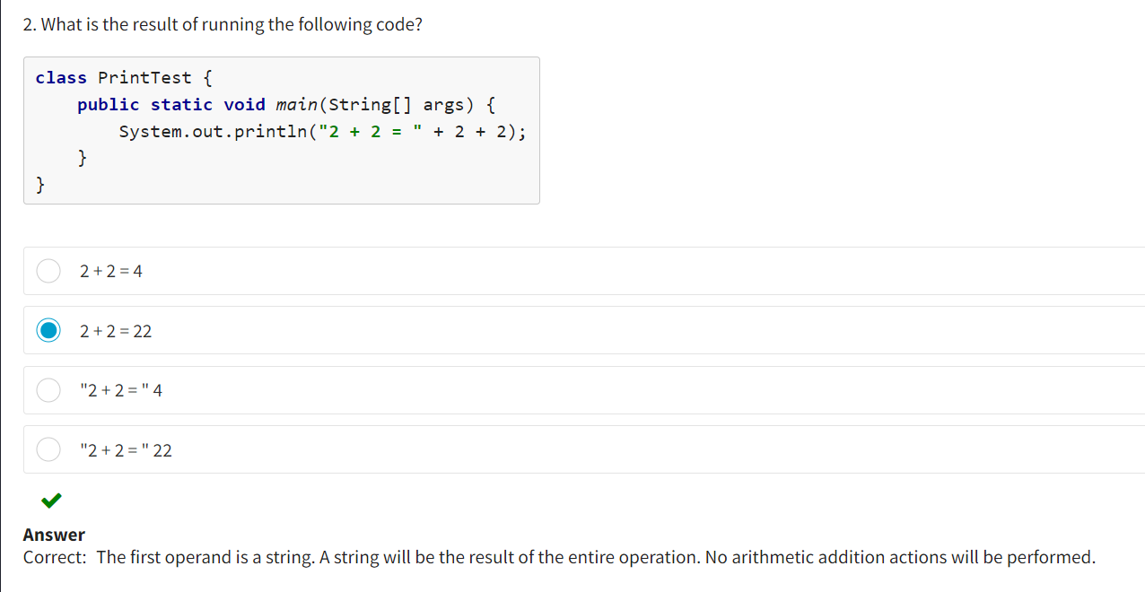

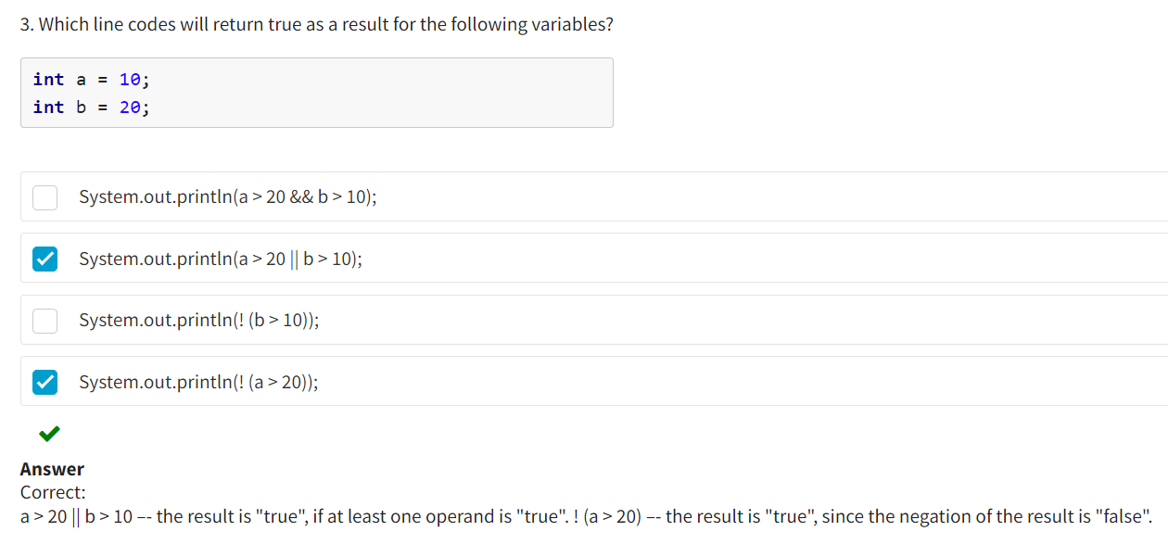

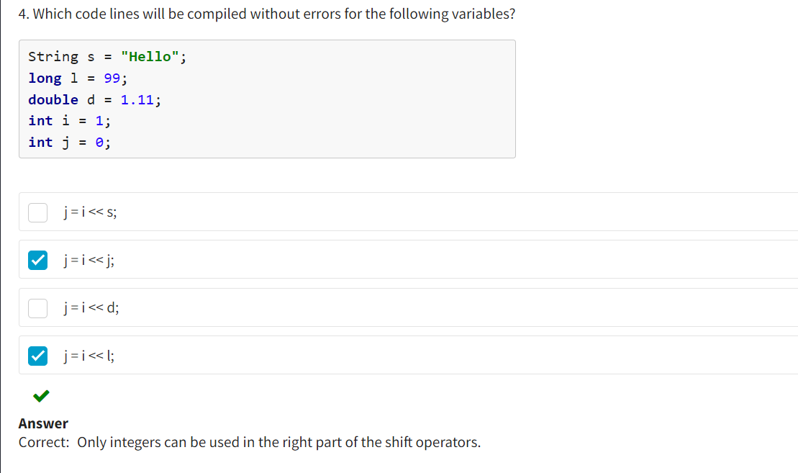

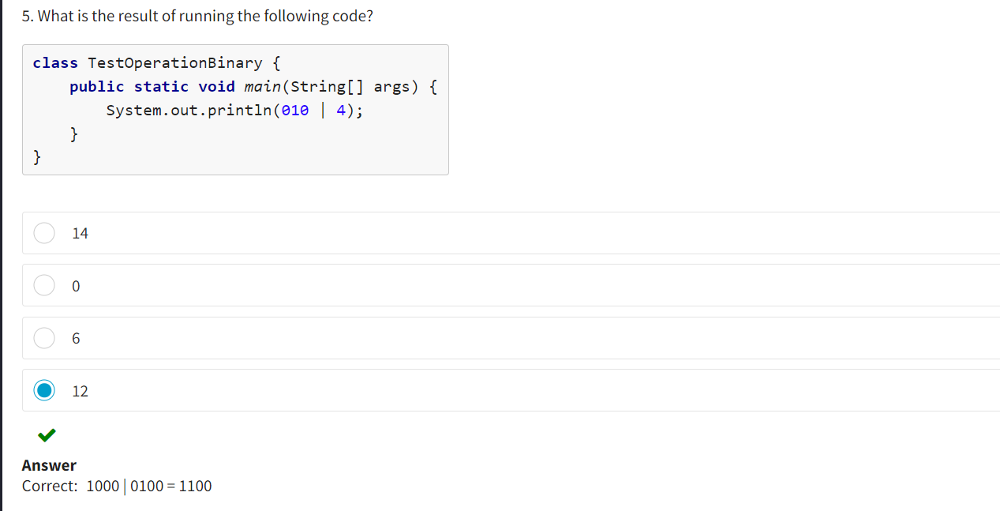

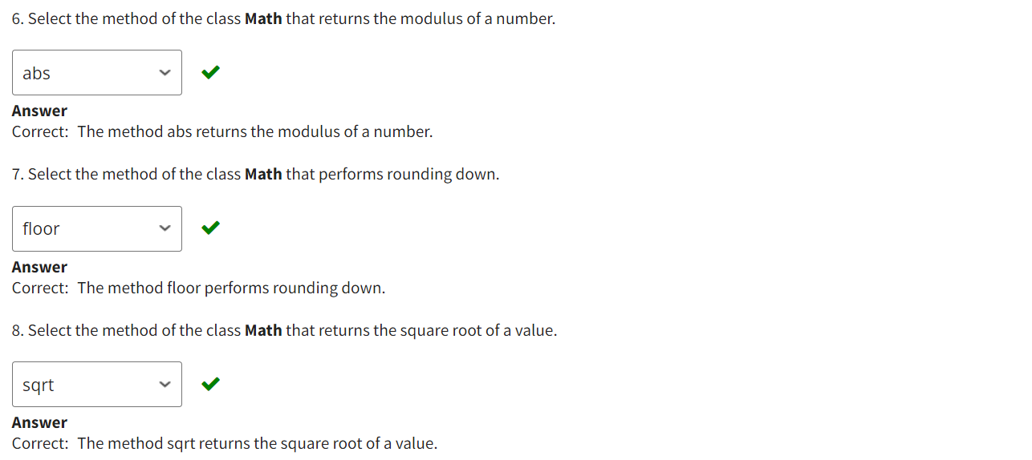

* TypeCasting :

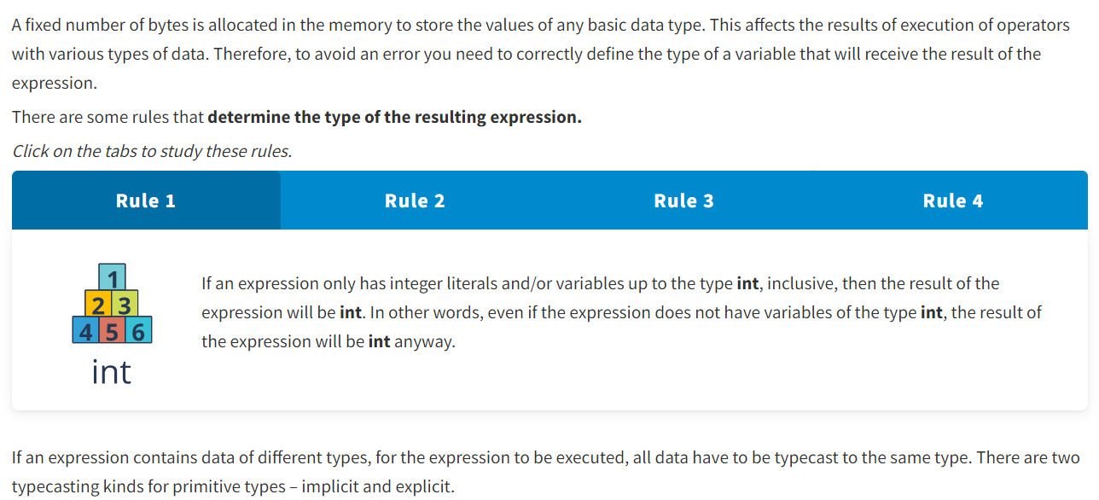

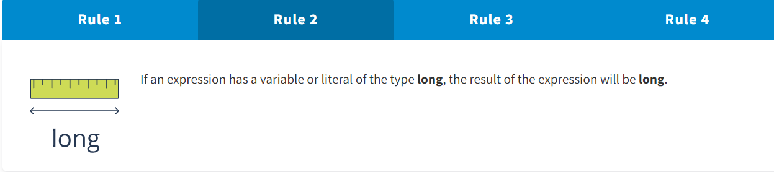

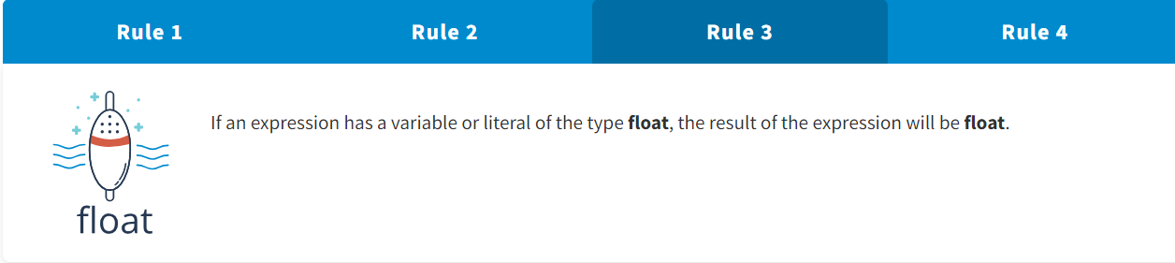

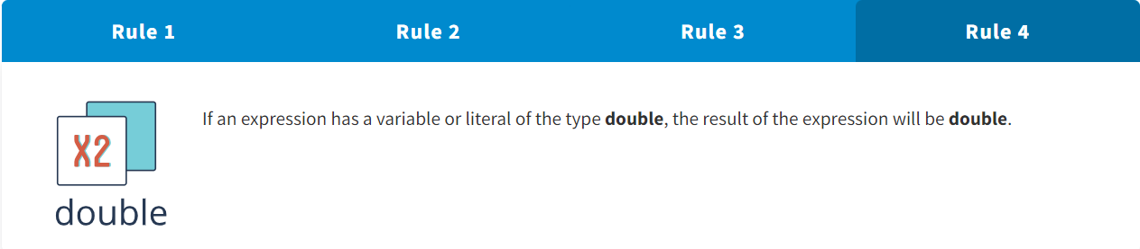

If an expression contains data of different types, for the expression to be executed, all data have to be typecast to the same type. There are two typecasting kinds for primitive types – implicit and explicit.

Implicit typecasting :

Only widening typecasting can be performed implicitly. This typecasting allows not to lose information about the value of a numeric expression. Java performs this typecasting automatically.

Explicit typecasting :

Narrowing typecasting is done explicitly. At that, the information about the value of the numeric expression, as well as precision and range, may be lost. This operation is performed by the developer.

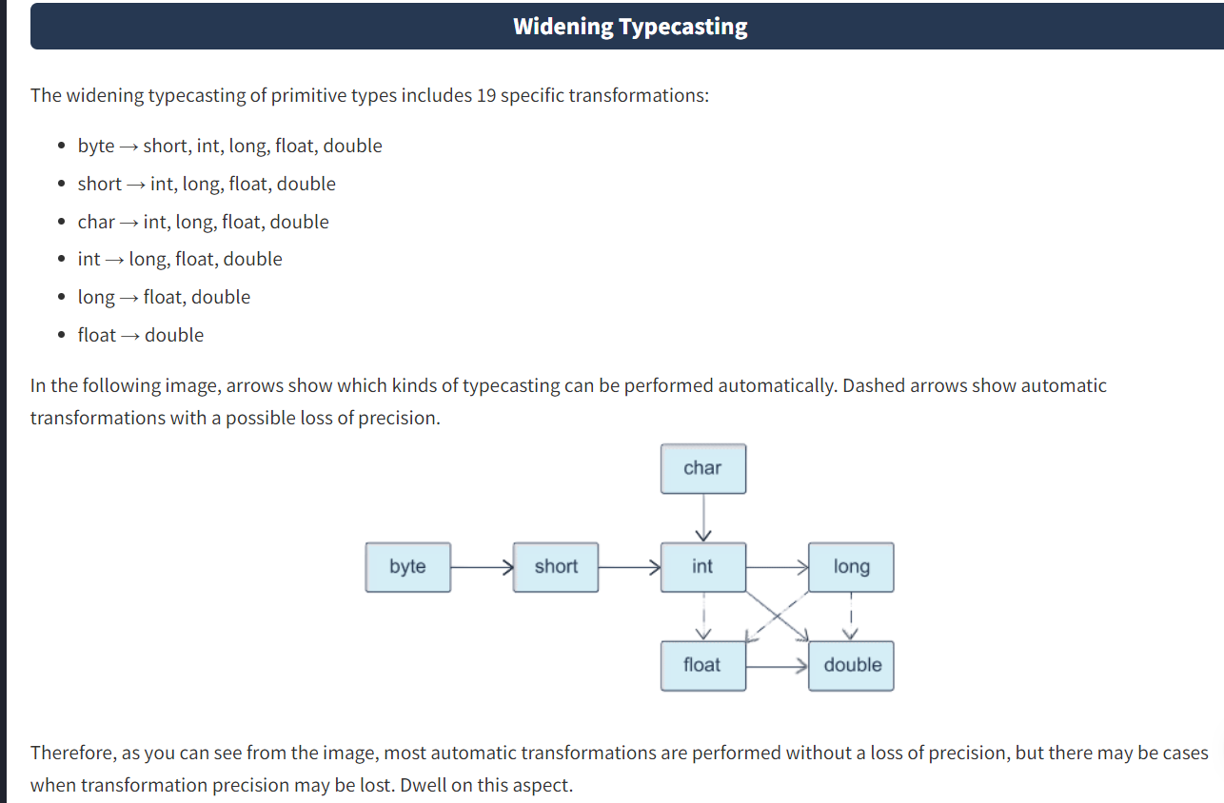

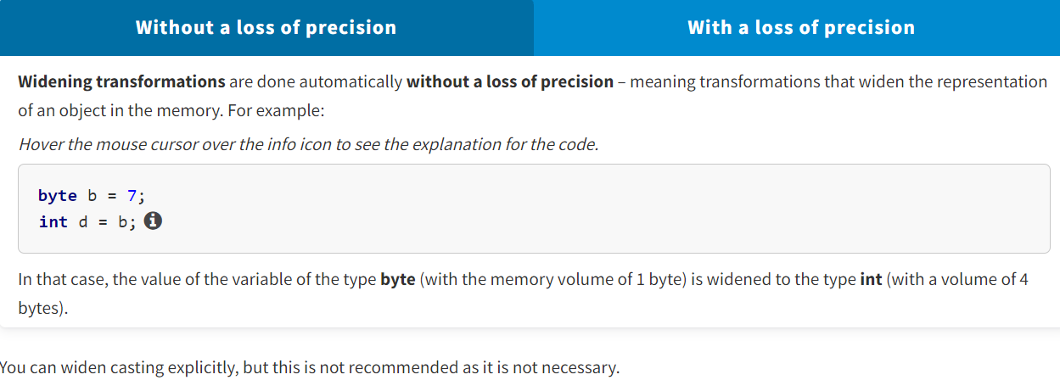

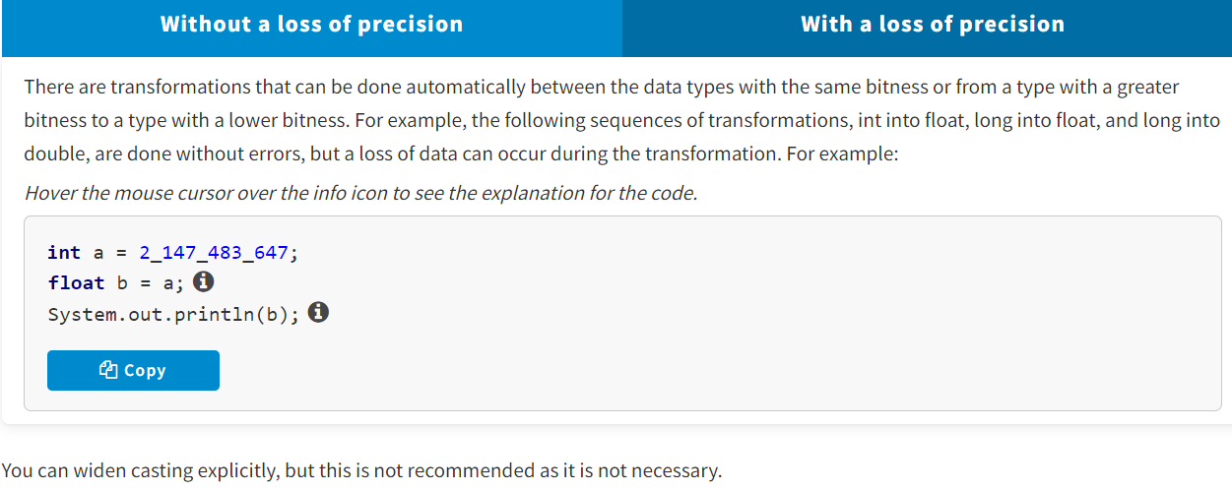

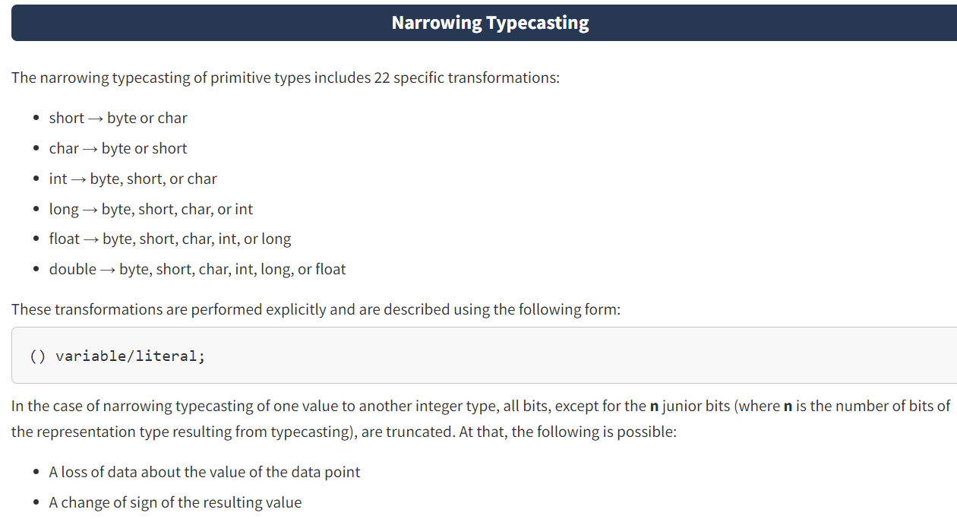

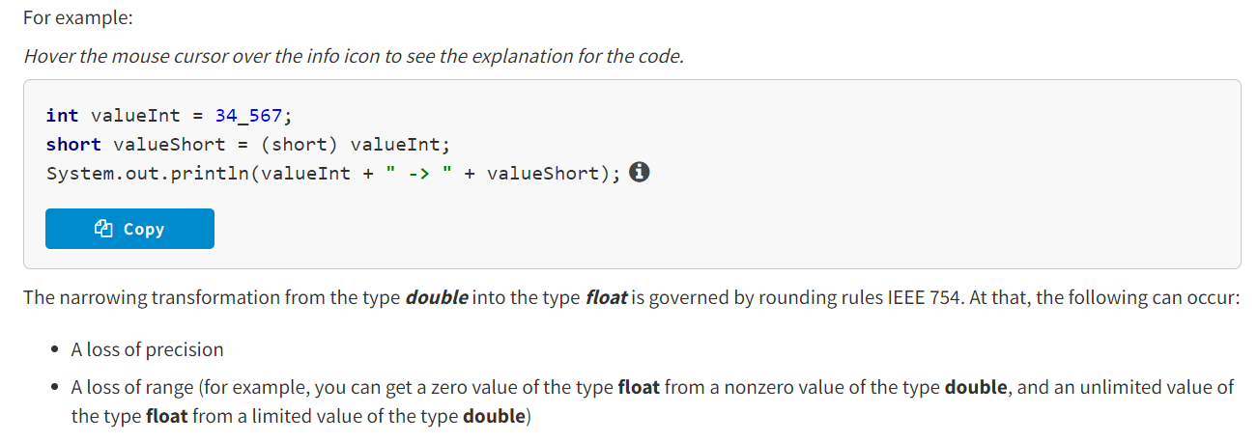

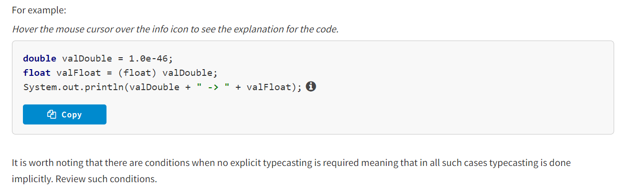

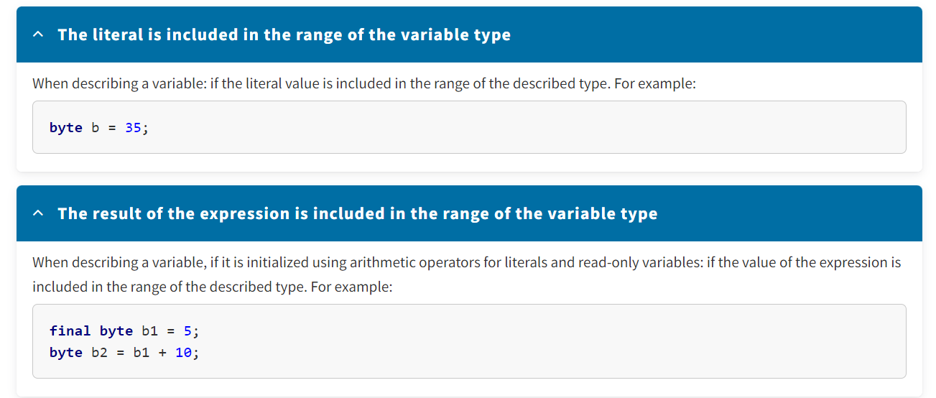

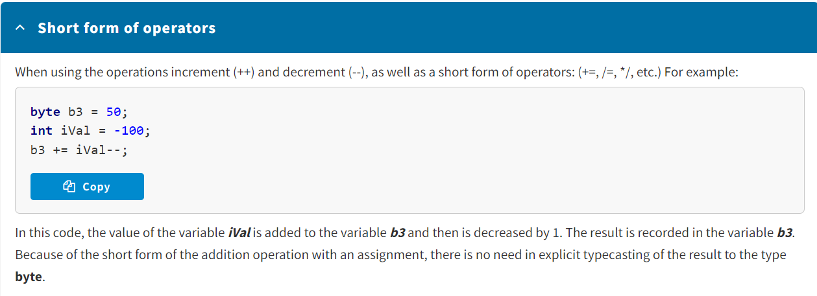

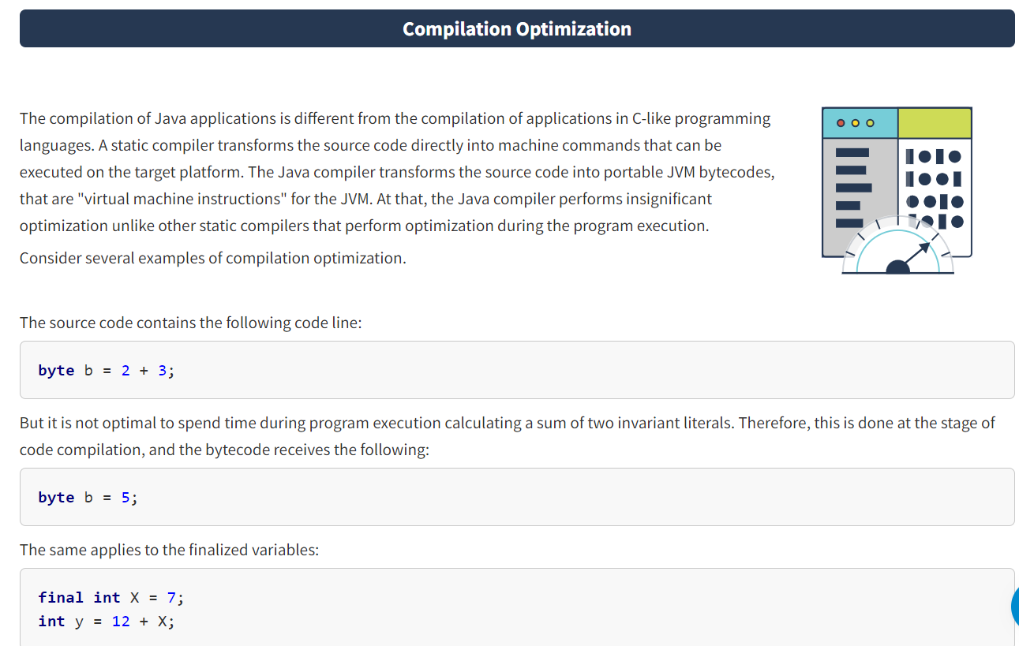

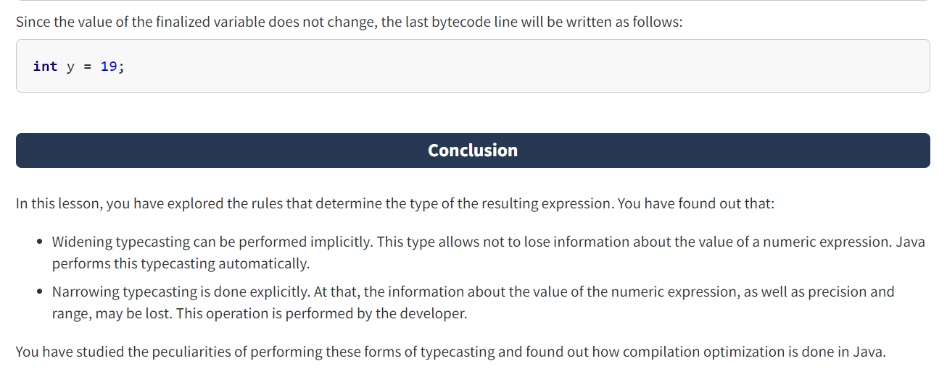

* Reference types :

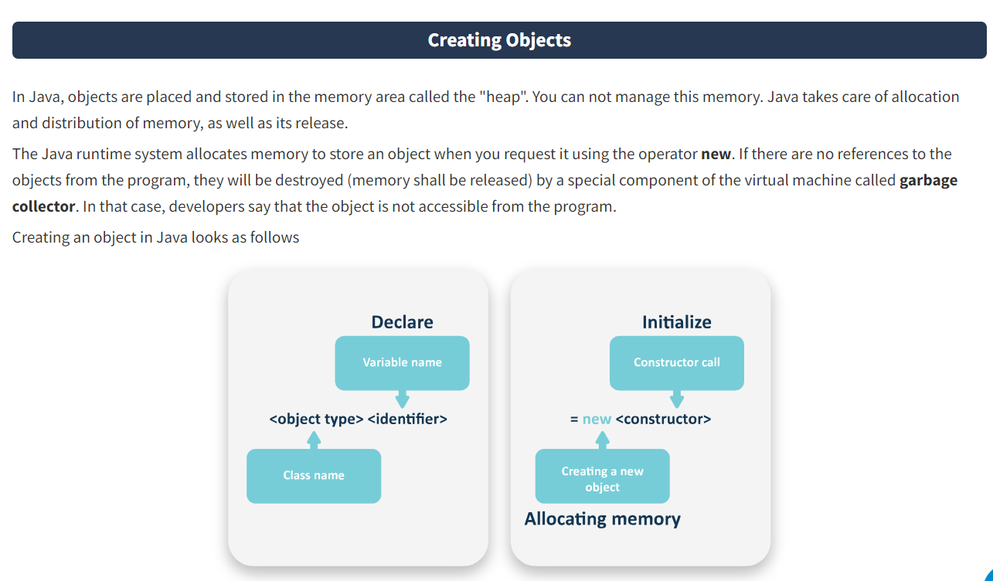

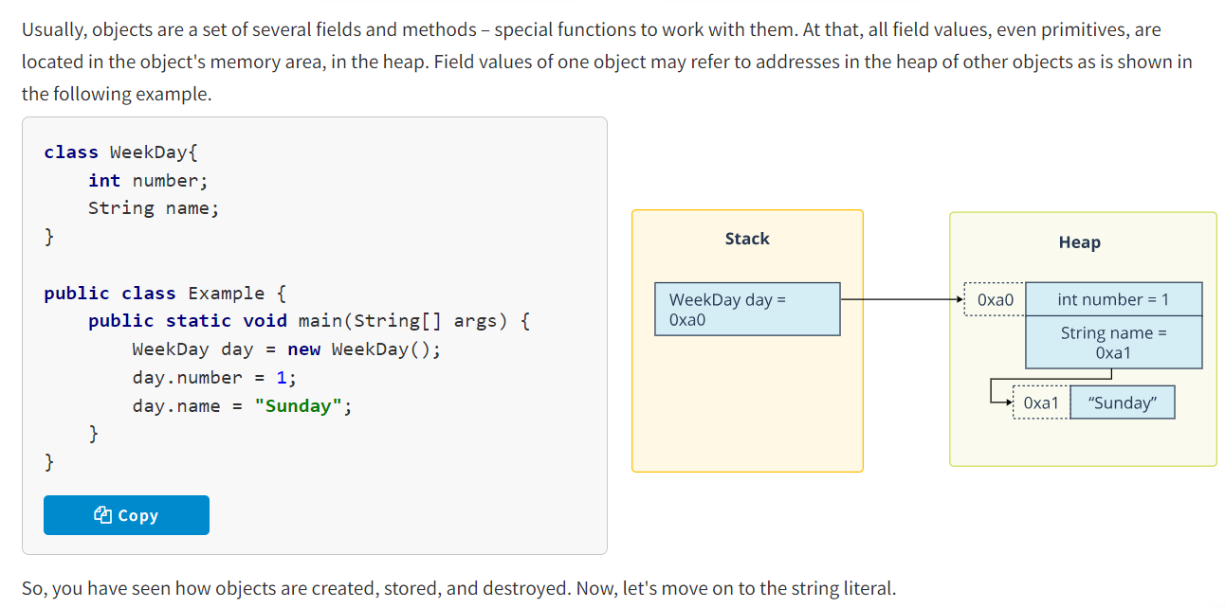

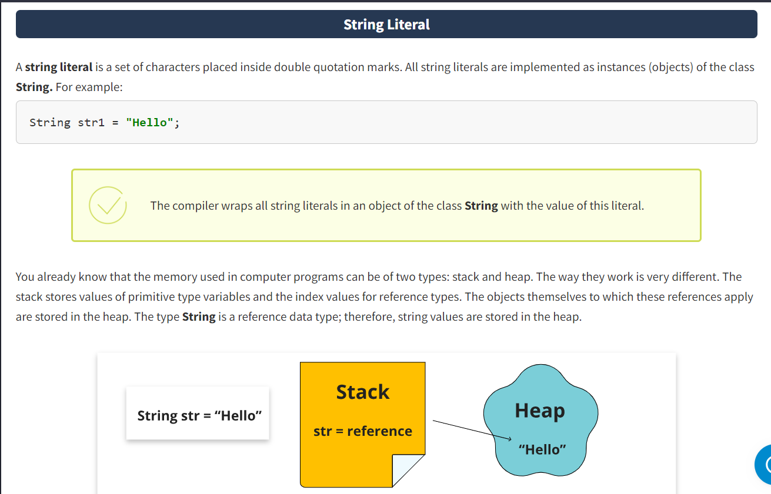

When you create an instance of the class **String** initializing it with a string literal (a value enclosed in double quotation marks), this object will be saved in the **string pool**. This is a specialized memory area in the heap that is a collection of references to the objects of the class**String** and is used to optimize memory.

What else does it give? If you create another string object initialized with the same literal, then an attempt to add it to the string pool again will return a reference to the existing literal. This way values of literals in the memory will not be duplicated. A similar situation will occur if the literal can be calculated. For example, for the compiler the literals "Java" and "J+ava" are equivalent. If the literal you are searching for is not found in the pool (i.e., when creating a string using a truly new literal), then a new string will be added to the pool and a new reference will be returned.

The storage of the string pool is illustrated in the following image.

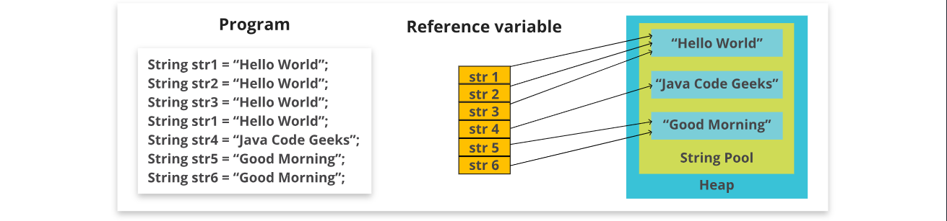

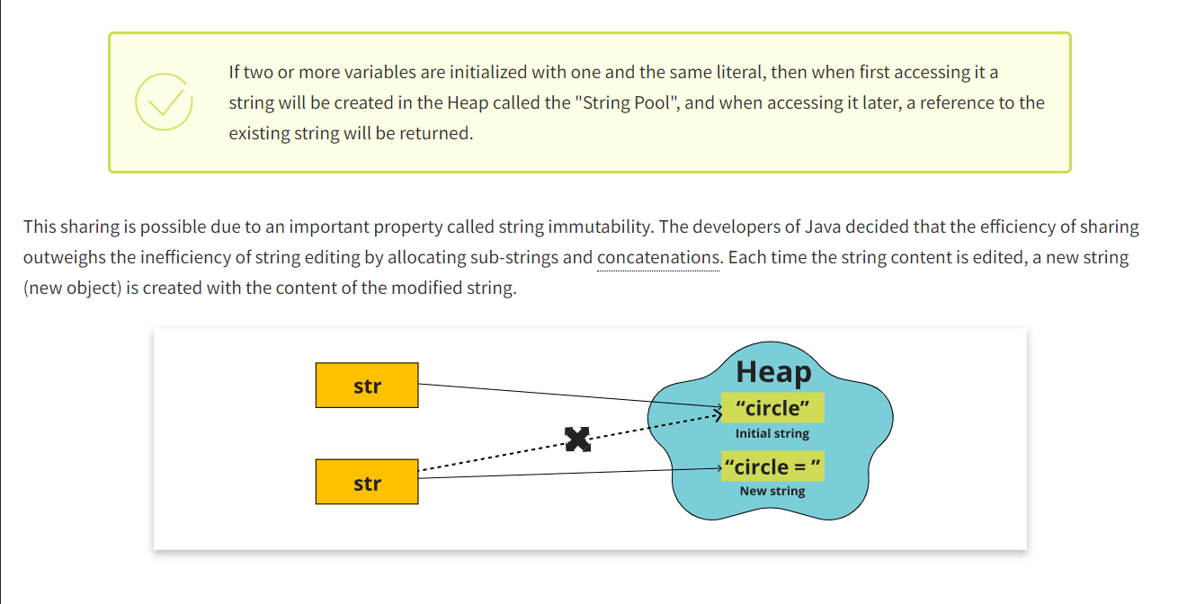

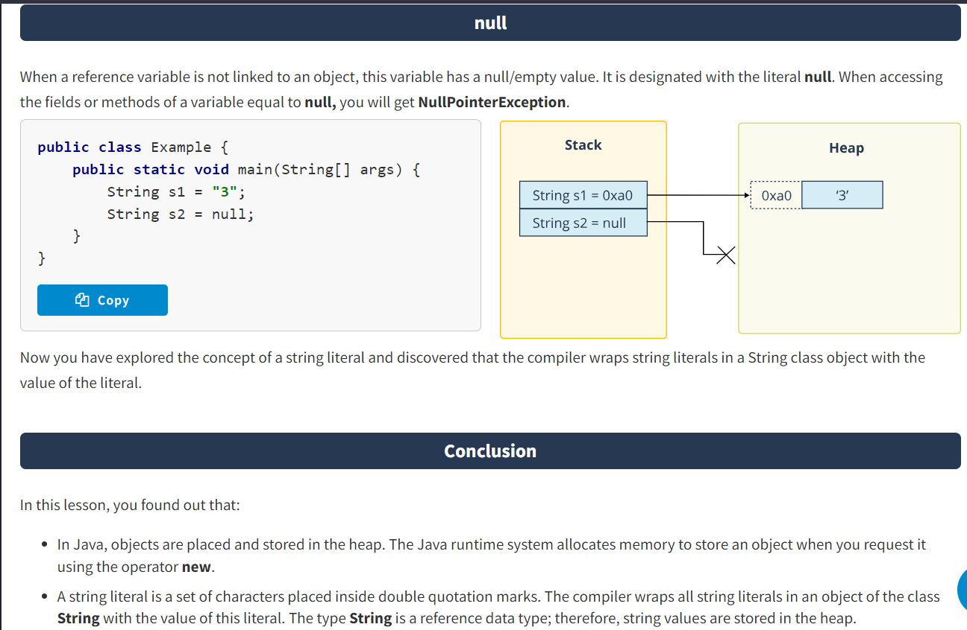

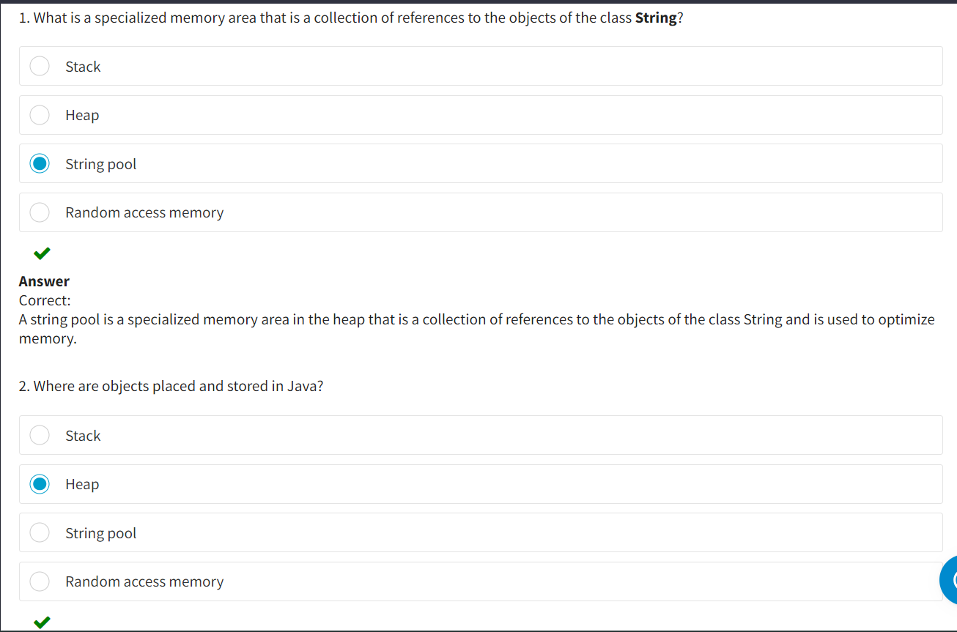

* Naming Conventions in java :

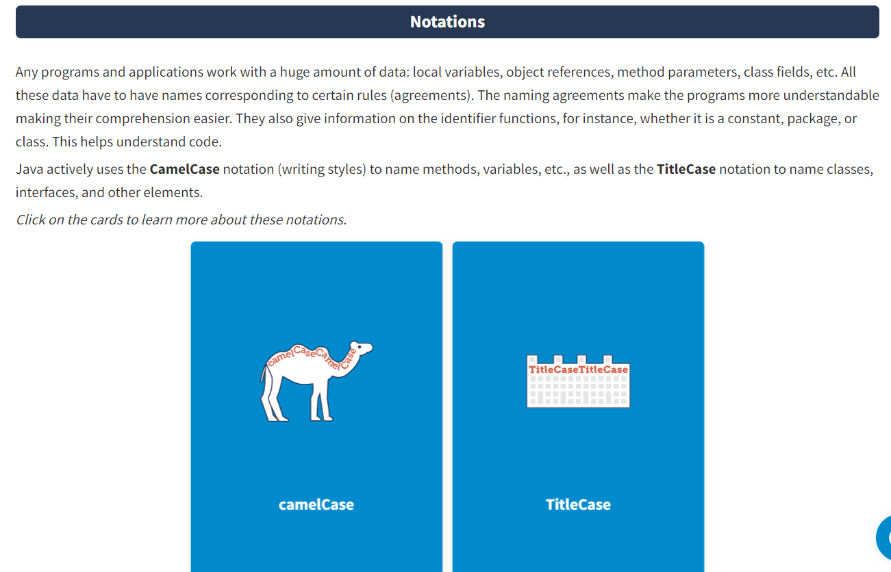

**CamelCase** is the practice of writing names consisting of several words where the words are written without spaces and separators; the first word starts with lower case and each subsequent word starts with a capital letter.

**For example:** iPhone, eBay, javaFundamentalsCourseContent, exampleTwo.

**TitleCase** is the practice of writing names consisting of several words where each word starts with a capital letter and there are no separators between the words.

**For example:** ImageSprite, TestExampleOne.

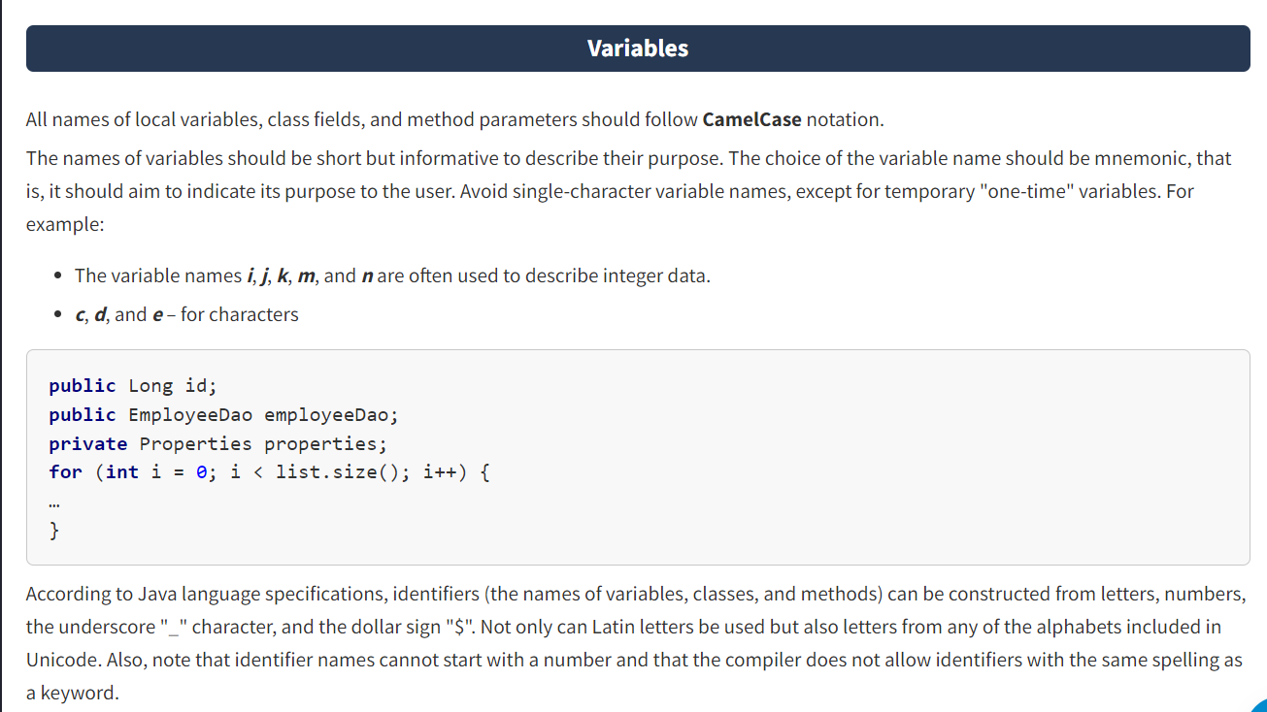

It is not recommended to start the variable name with the underscore symbol "_" or dollar sign "$", although both these symbols are permitted in the syntax and do not lead to compilation errors. Although they are used by Java itself in automatic naming.

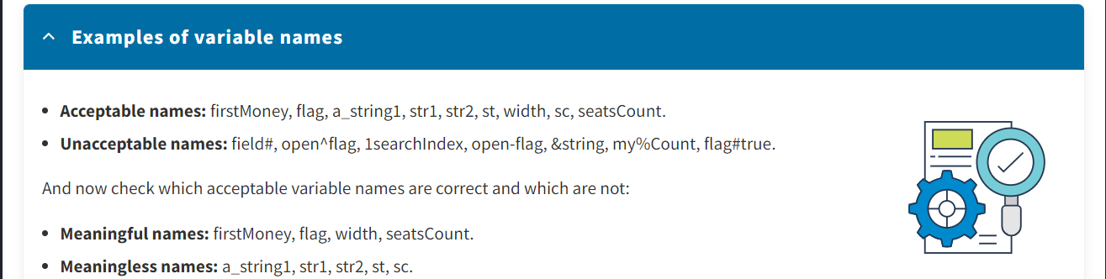

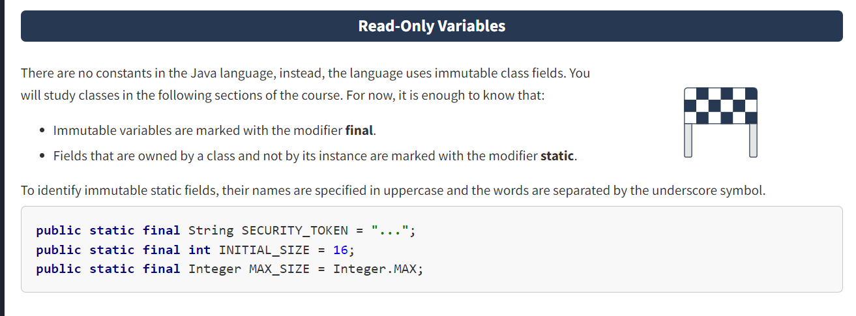

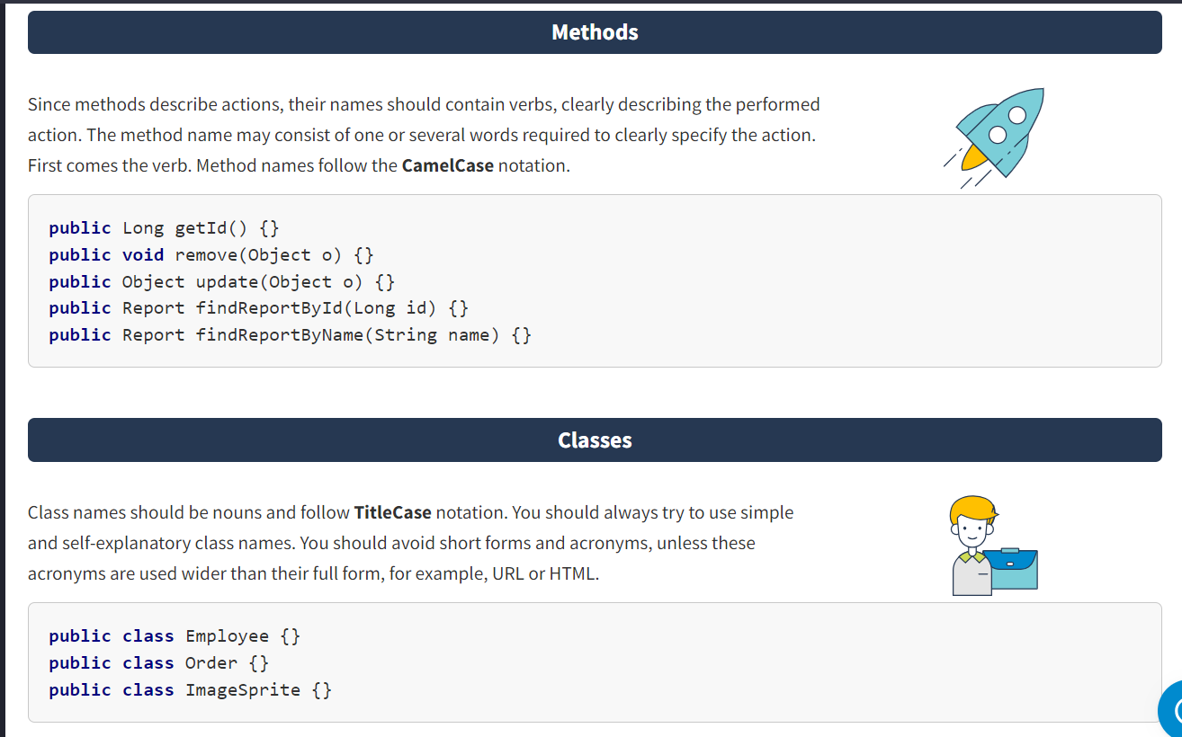

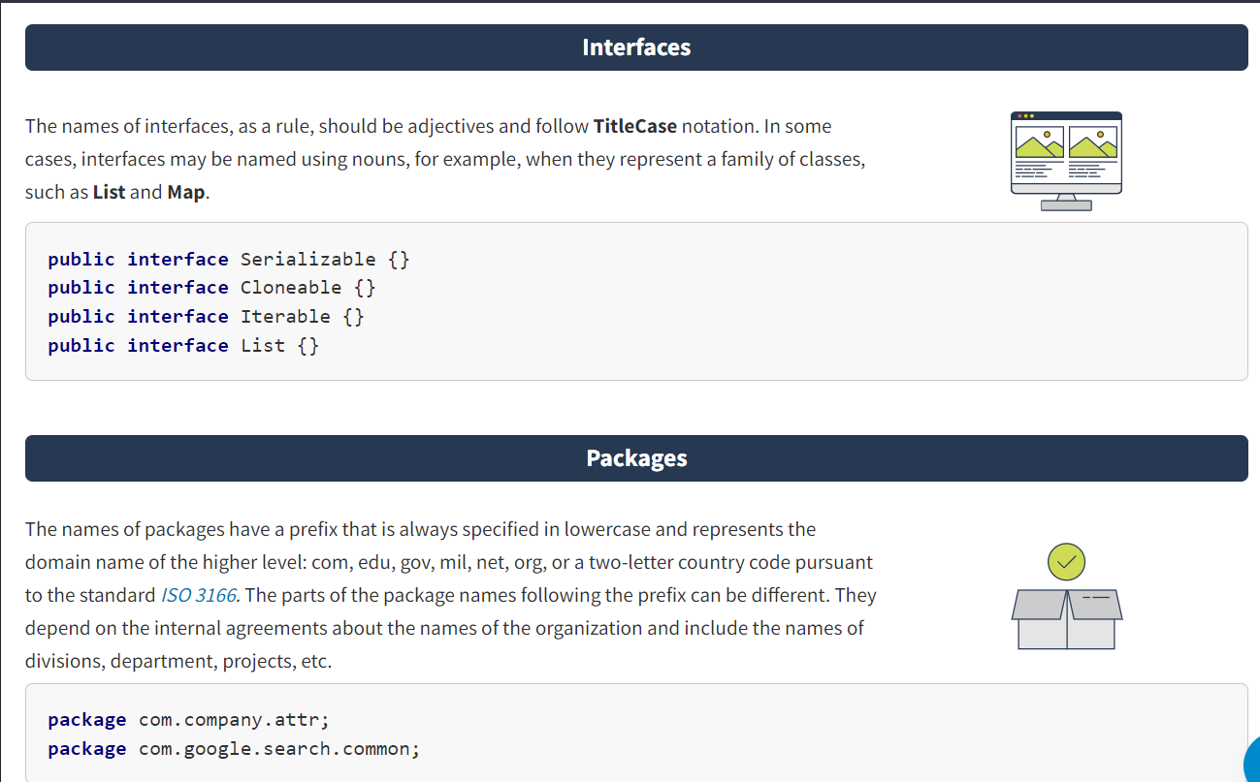

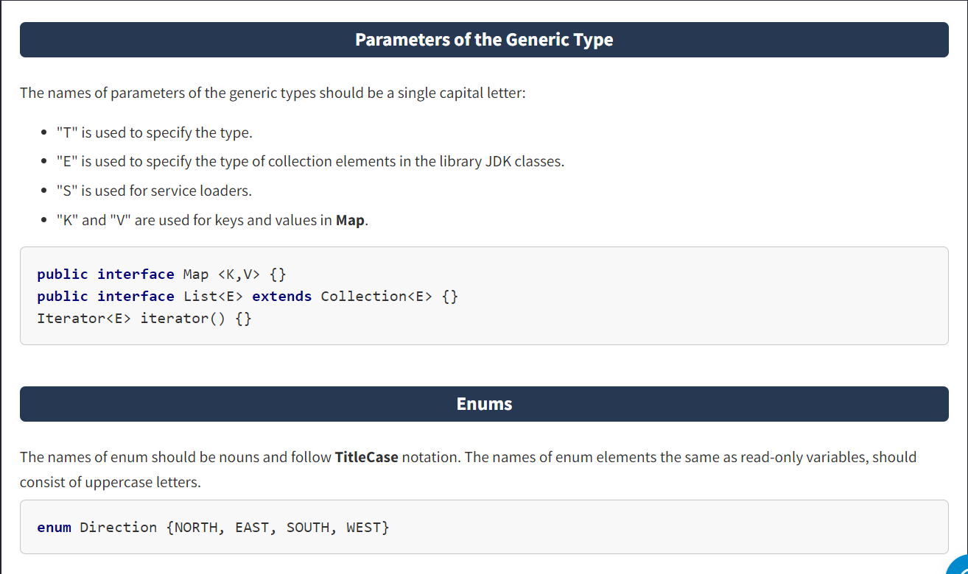

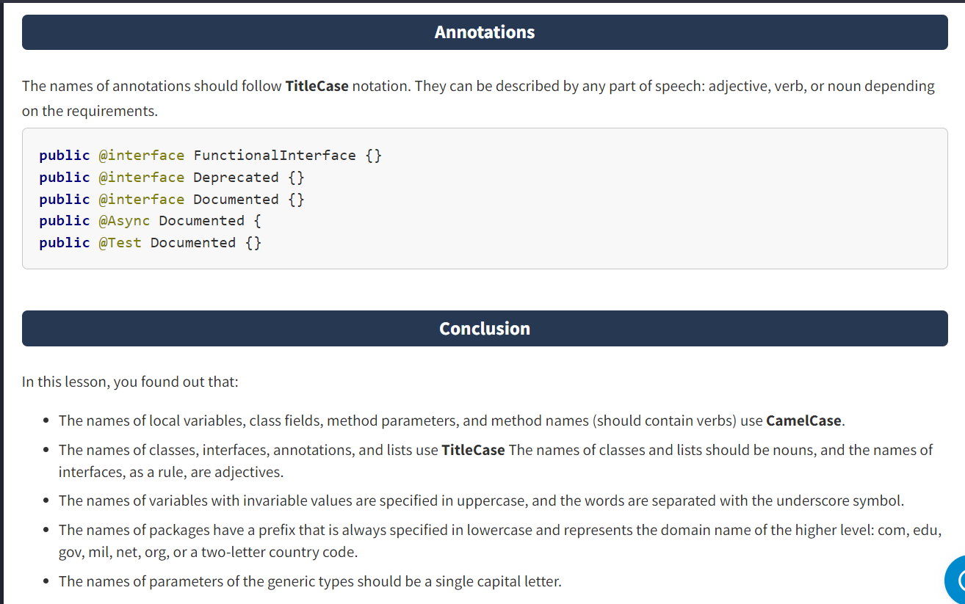

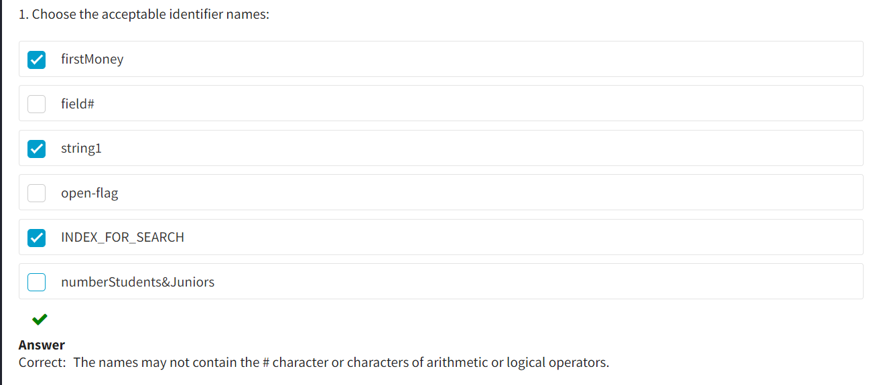

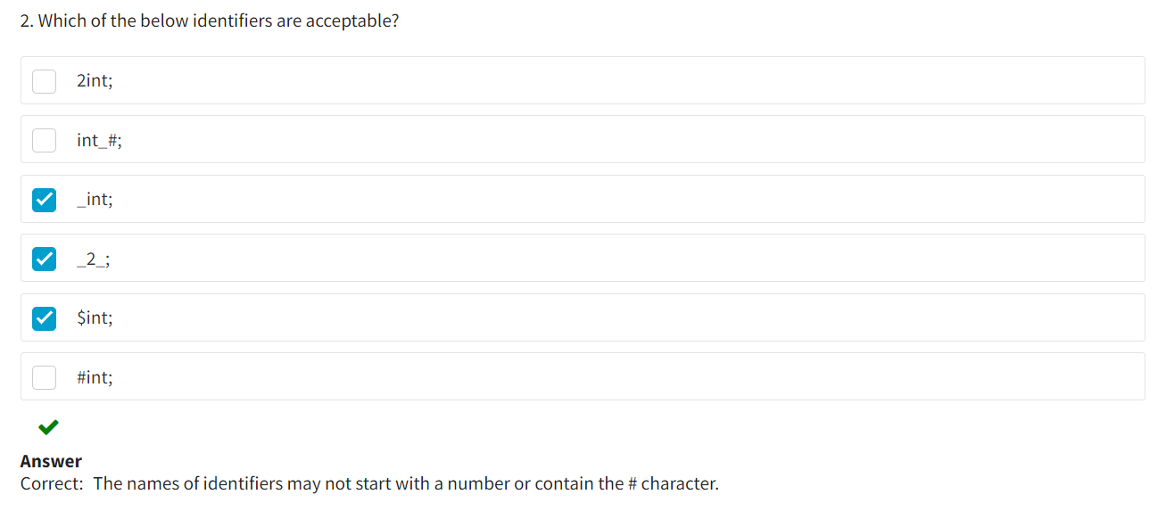

* Conditions and Loops :
* A **variable**is a named memory cell storing data (certain values). When developing, the developer has the opportunity to use any number of variables required to solve the task at hand. The main purpose of variables is to store interim program data and results.
* Any variable declared in a program has two main properties.

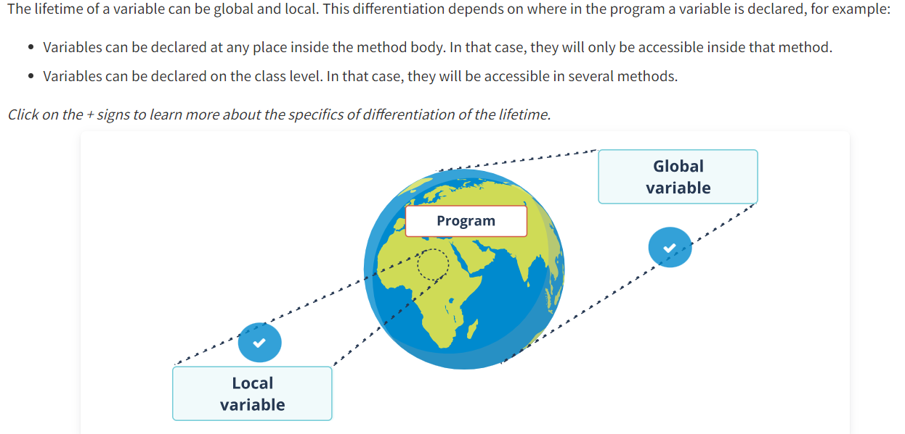

**Local variable**

A**local variable** is a variable that is described in a block of code, and is created when the program execution enters a block and is destroyed as soon as the execution exits the block.

**Global variable**

A **global variable** is a variable that is created when the program is launched for execution and lives until the program completes.

A code block means a part of the program placed in curly brackets.

The Java language is special in that variables cannot be declared outside of a code block. For example, the body of the method main, as well as the class body, is a code block. This means that the lifetime of variables is related to the block where they are declared. In that case, the concept of a global variable will be considered based on its declaration in the class body but outside of the body of methods of this class. A local variable is treated as such when it is declared in the body of a class method.

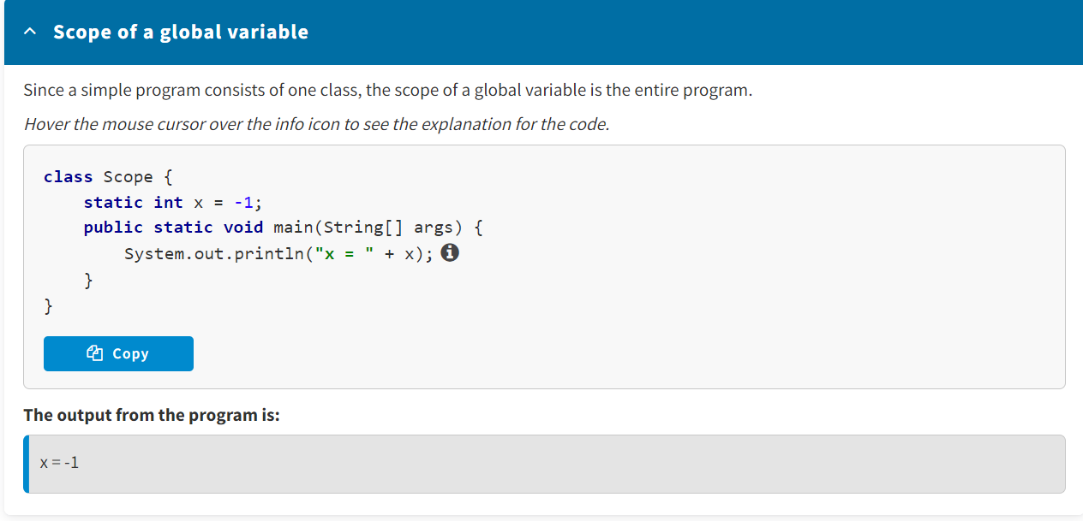

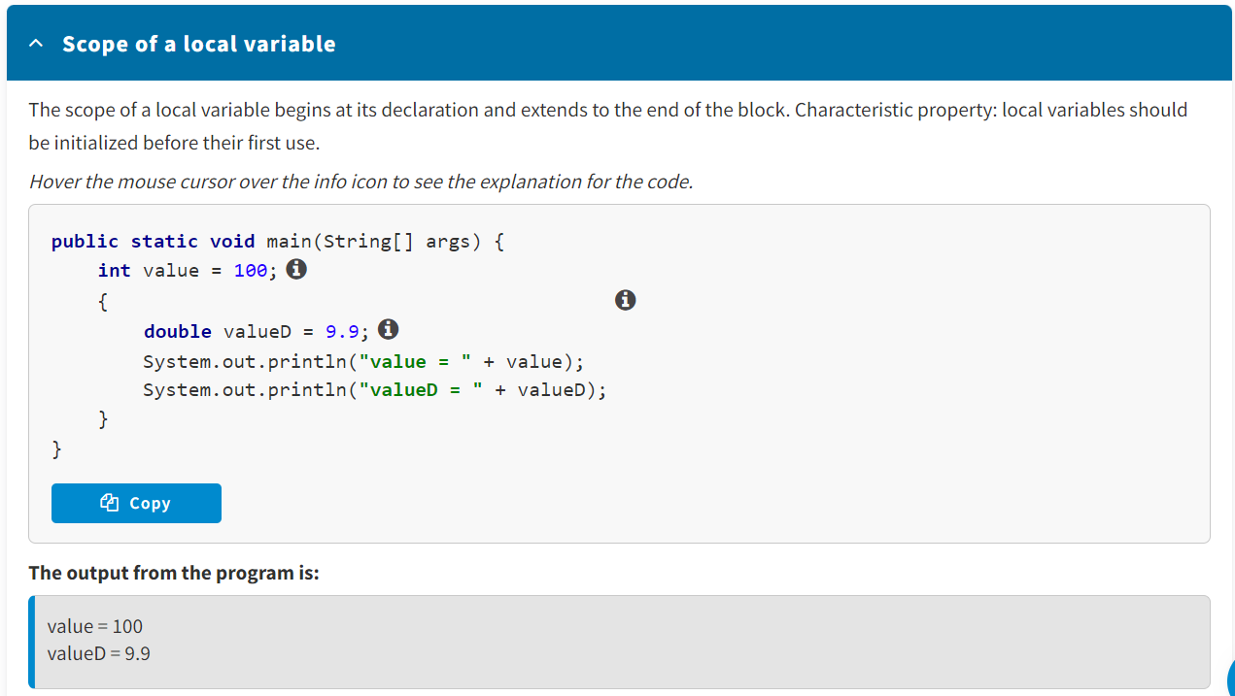

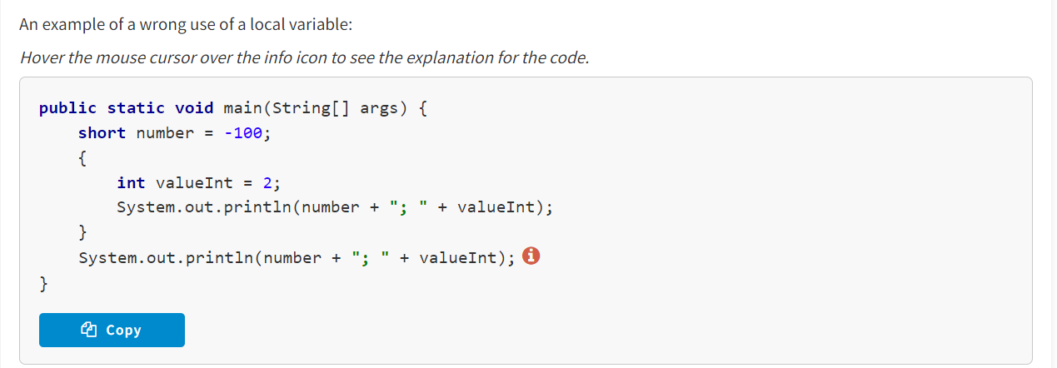

You cannot declare two or more variables with the same name (identifier) in the same code block.

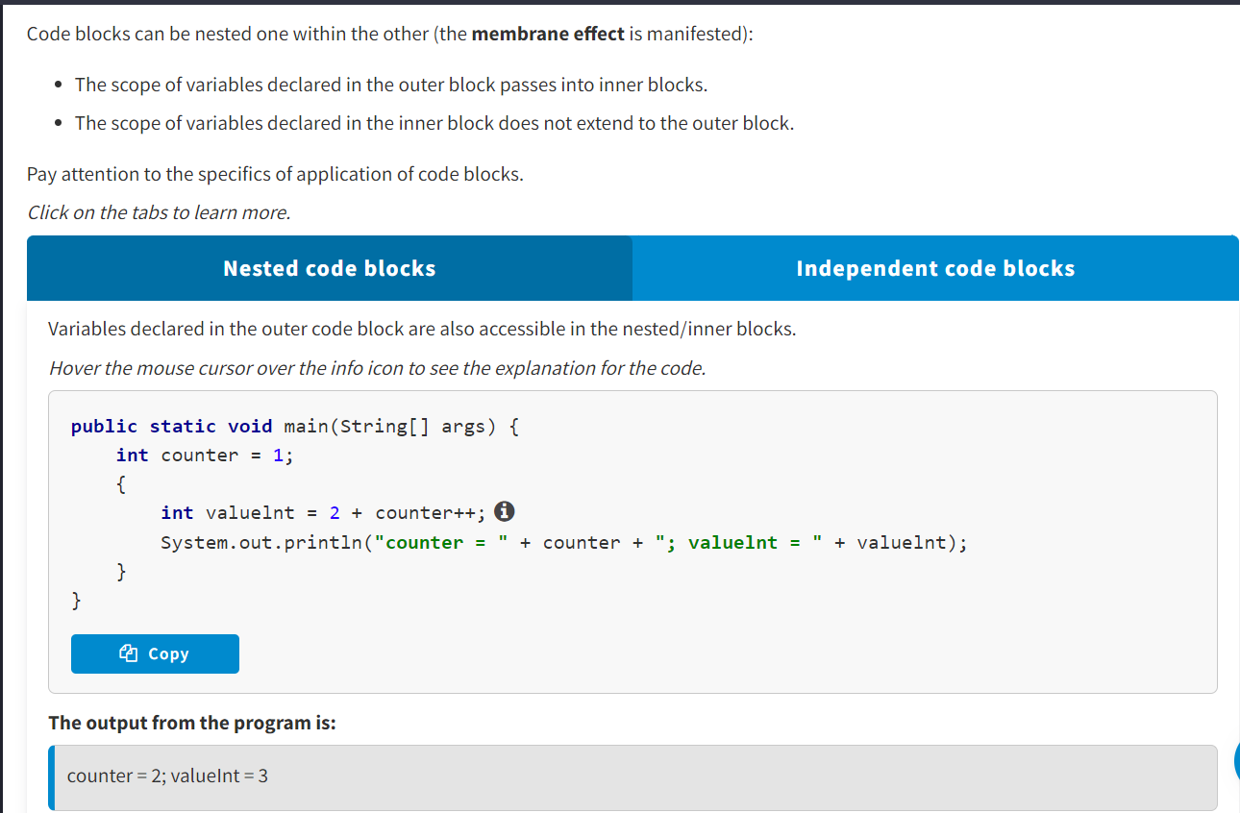

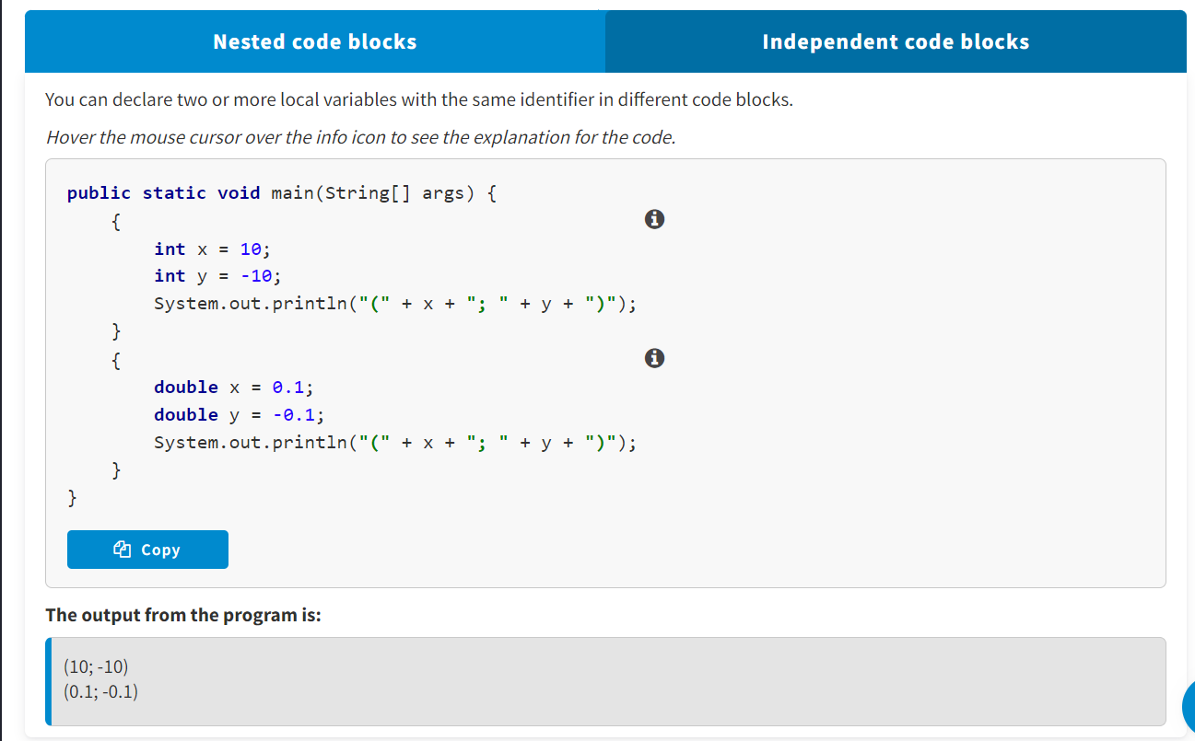

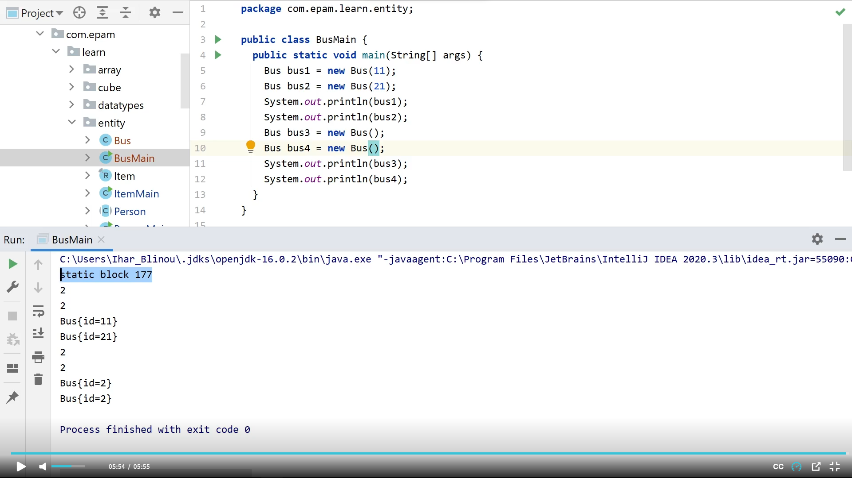

* A variable is a named memory cell storing data.
* A code block means a part of the program placed in braces.
* You cannot declare two or more variables with the same name in the same code block.
* Code blocks can be nested one within the other.

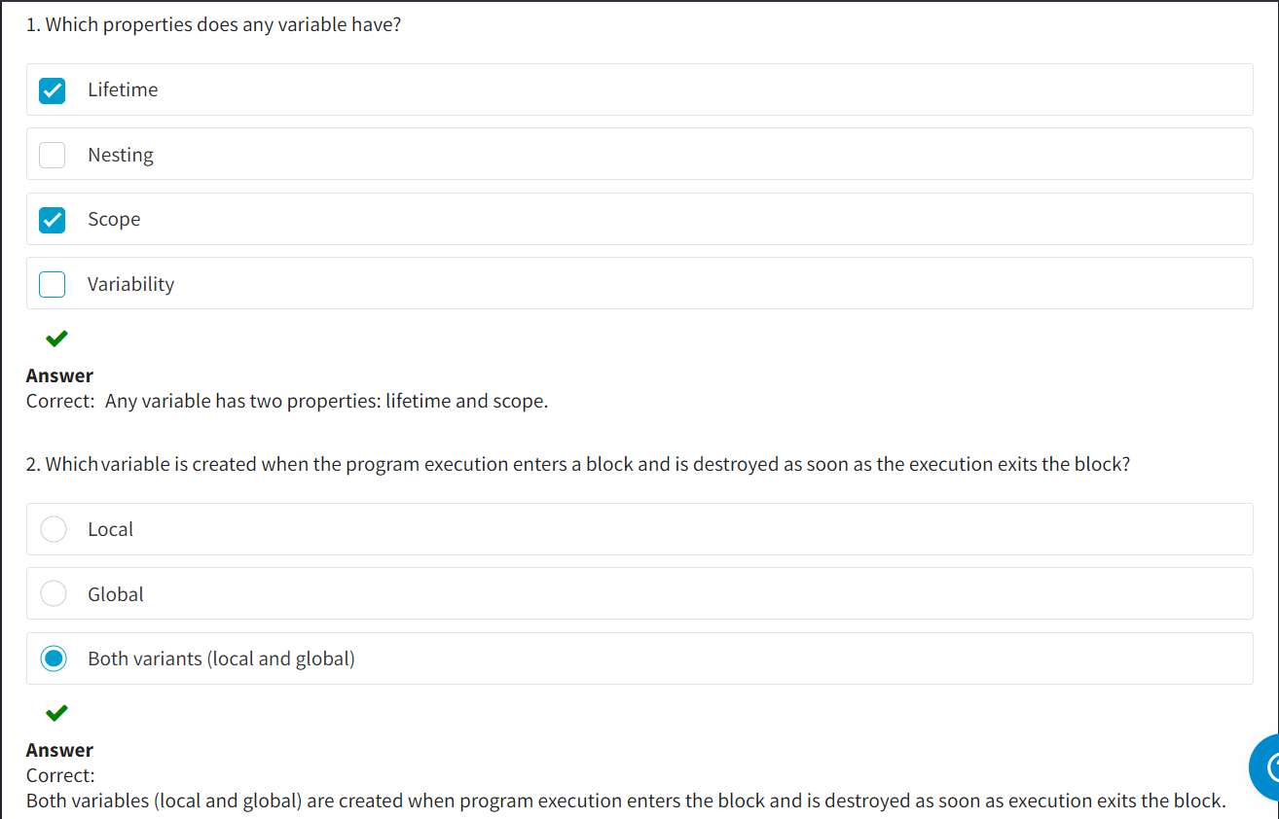

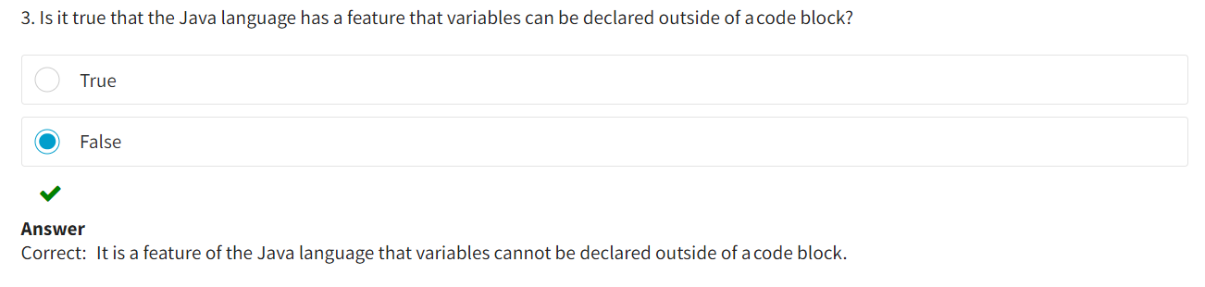

Conditional Statements :

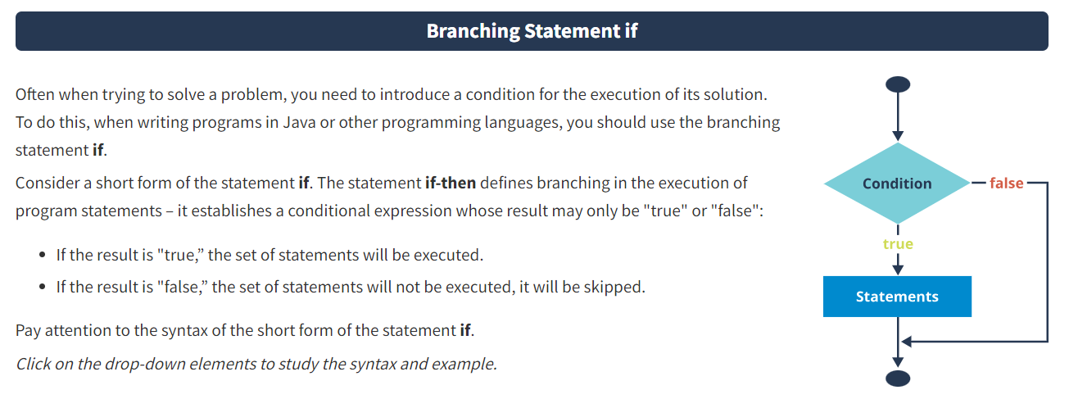

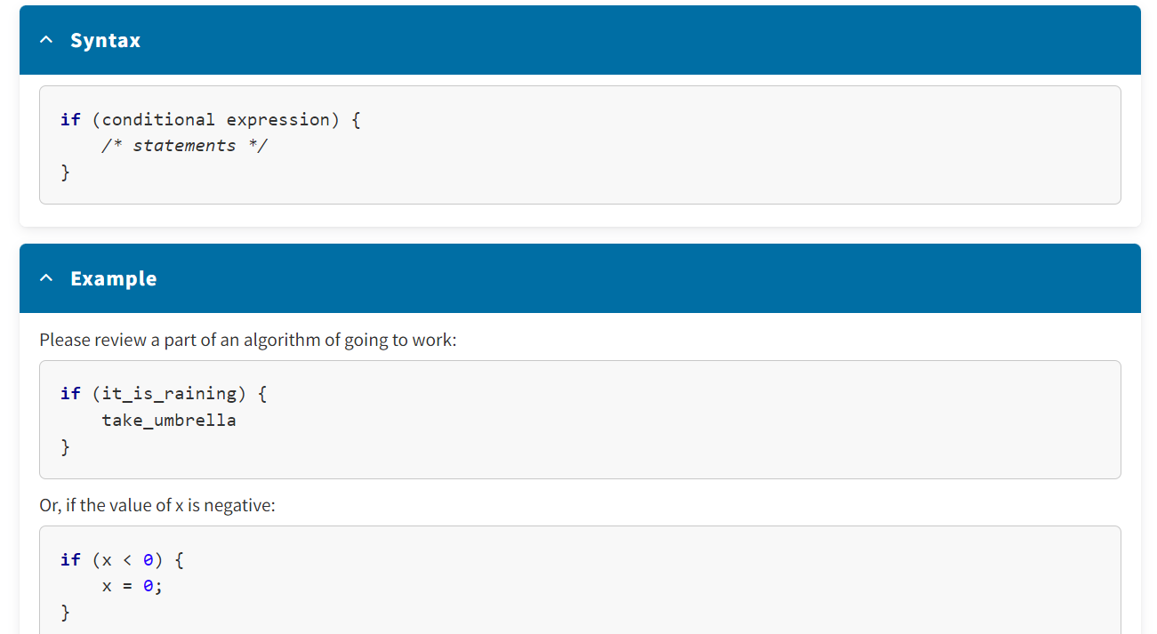

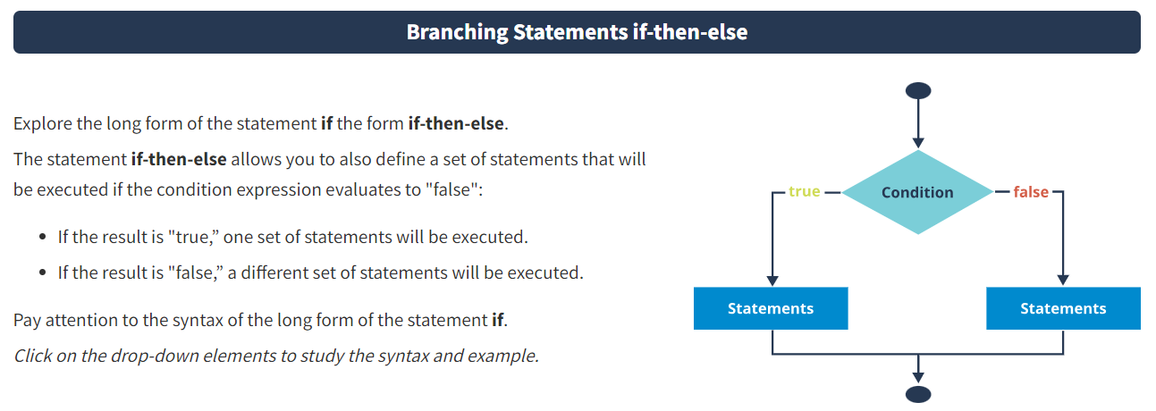

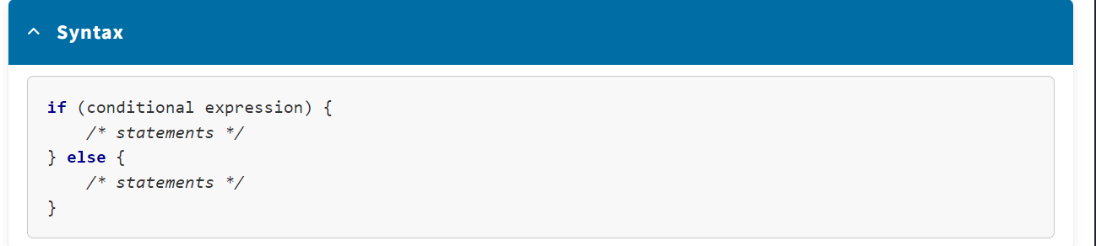

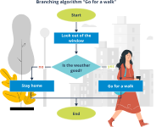 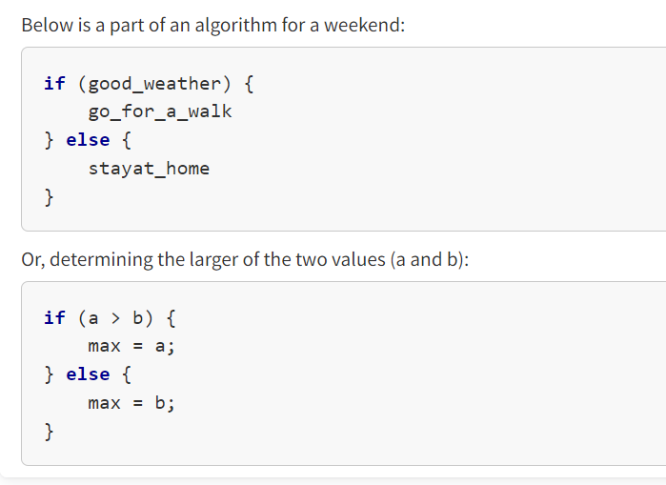

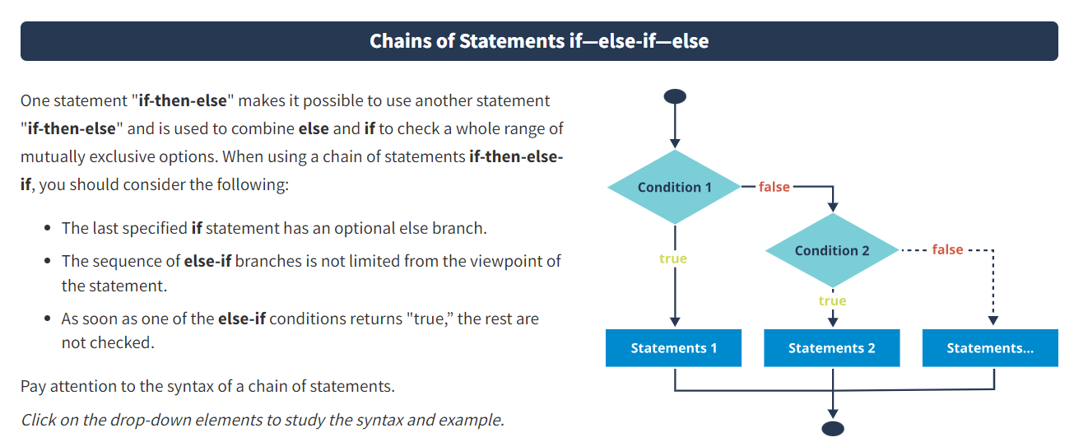

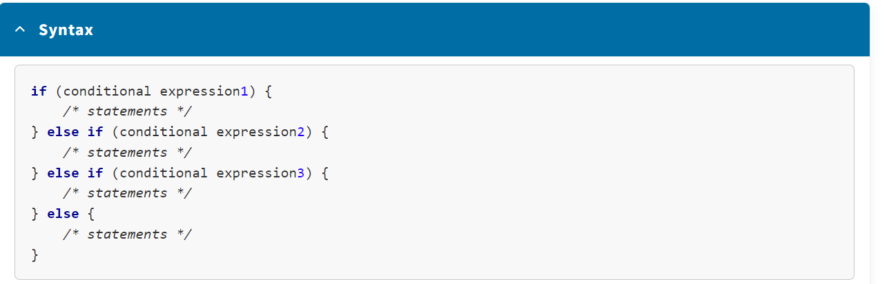

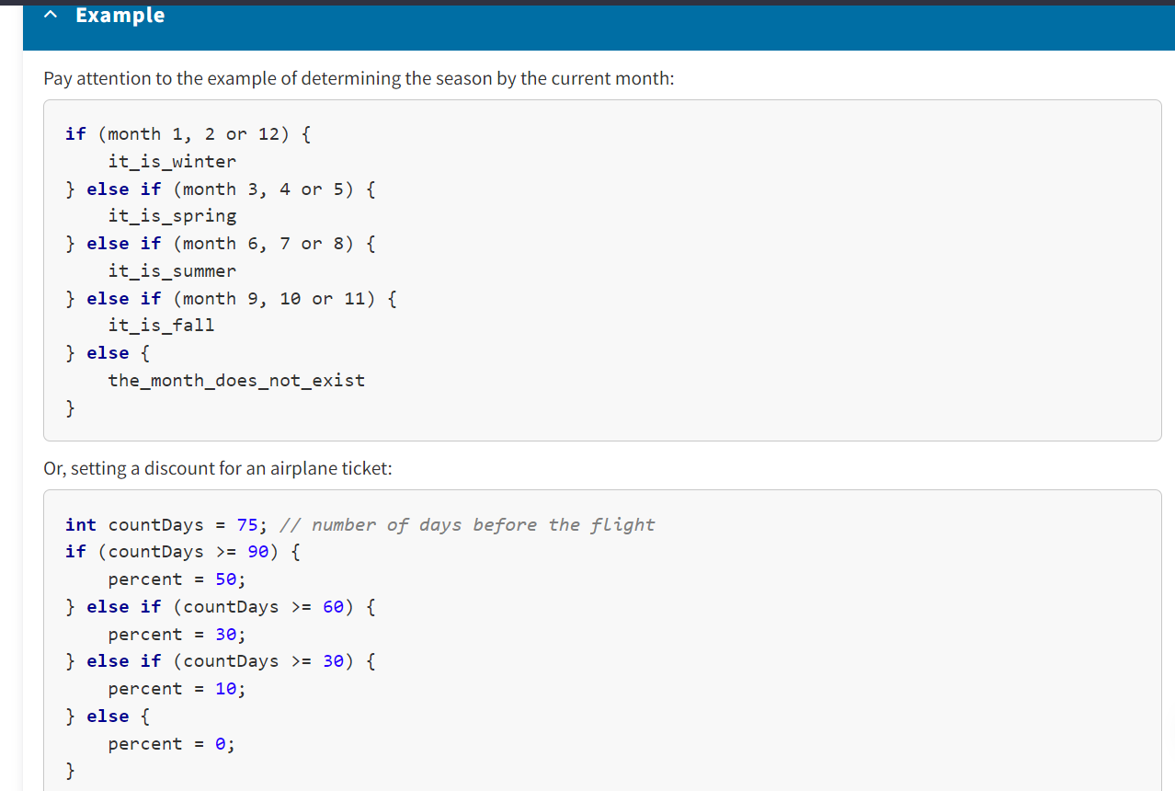

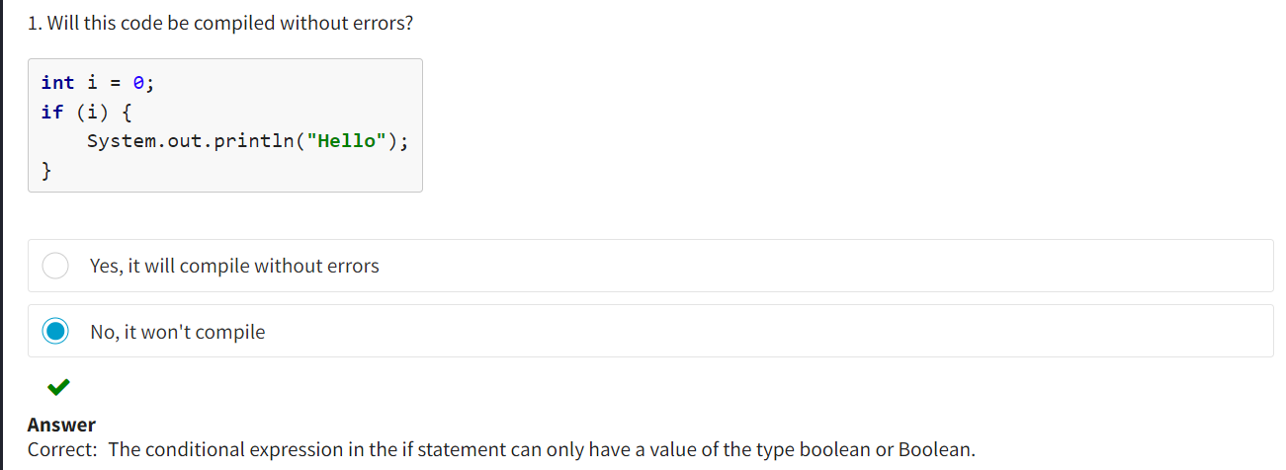

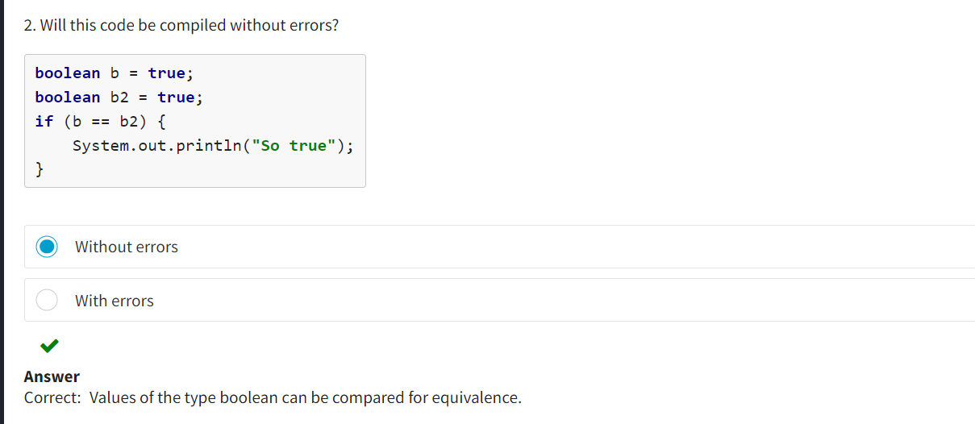

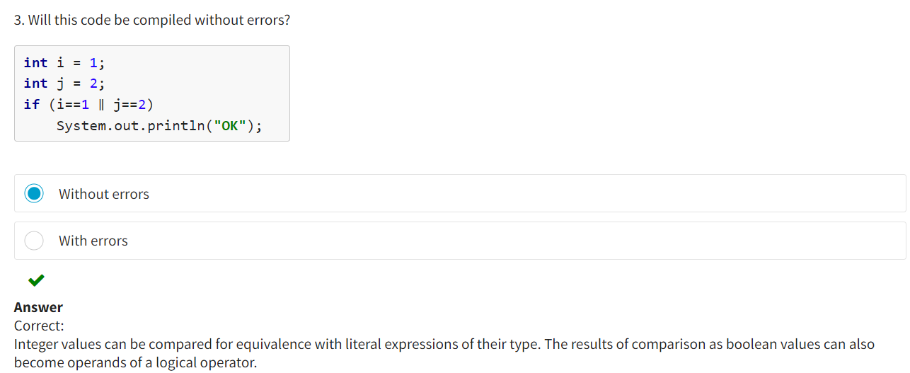

Selection Statement :

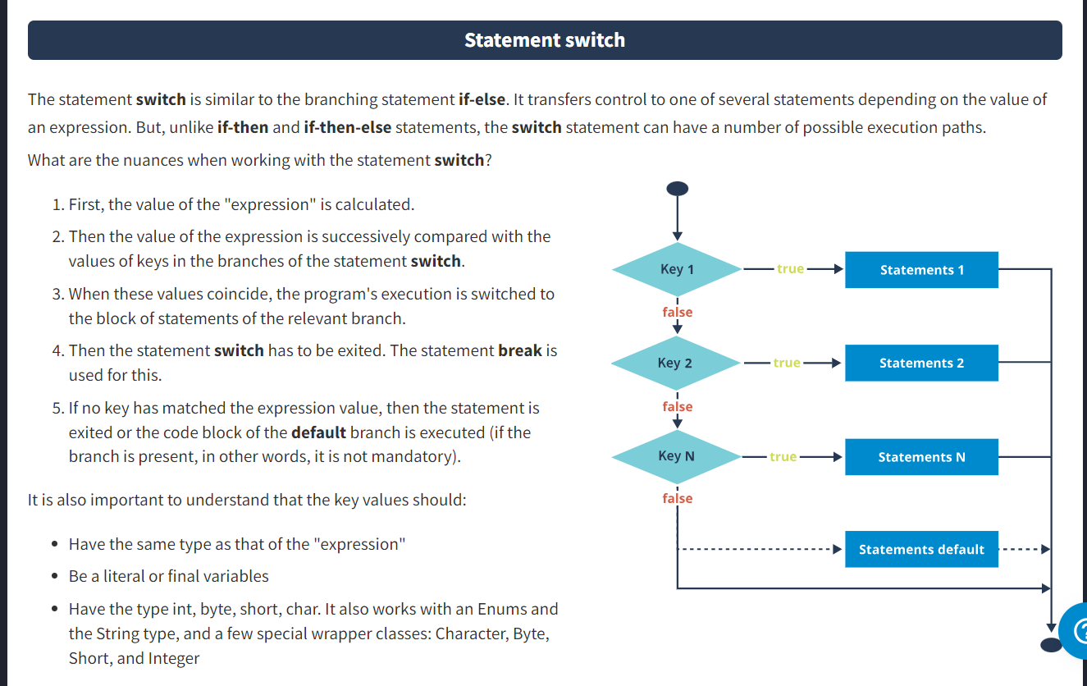

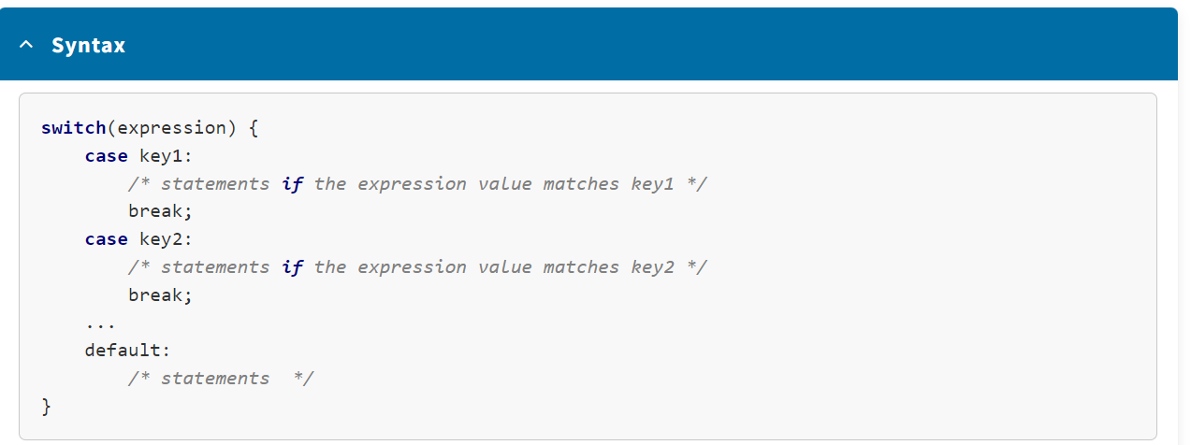

As you will see further, in some cases using the statement **switch** gives a more concise program code compared to the statement **if-then-else**. For example, if you have a structure with a chain of statements **if-then-else** implying a large number of conditional branching, they can be very bulky. Therefore, in cases when the chain of statements **if-then-else-if** checks the value of the same variable, there is a different solution – the statement **switch**.

Note that in Java 14, new forms of the statement **switch** were added that:

* Do not require the statement **break**
* Allow you to combine labels through commas for the same actions
* Apply a special expression syntax
* Allow you to use the statement in the form of a method

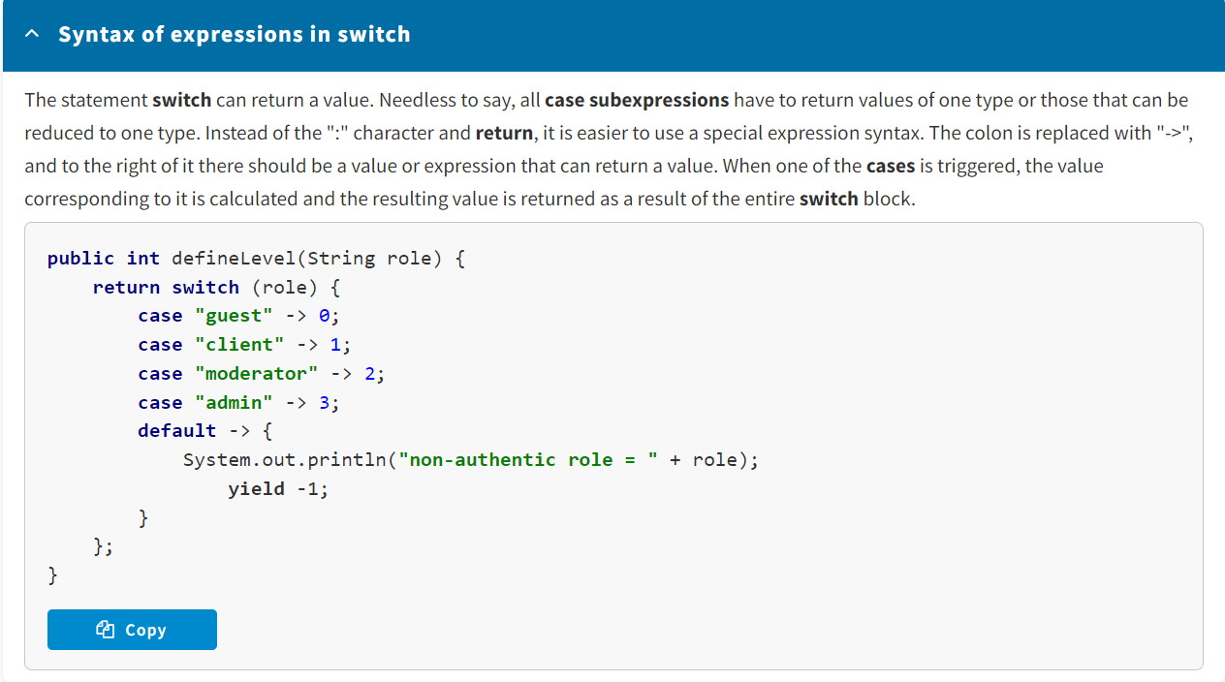

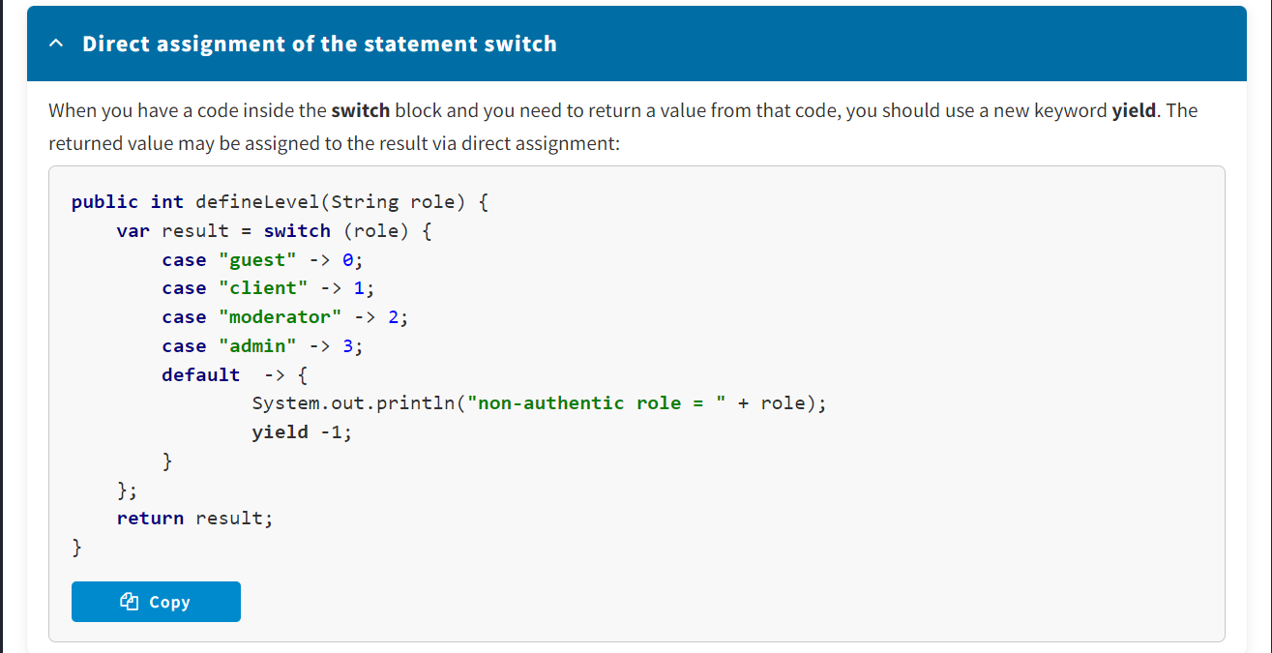

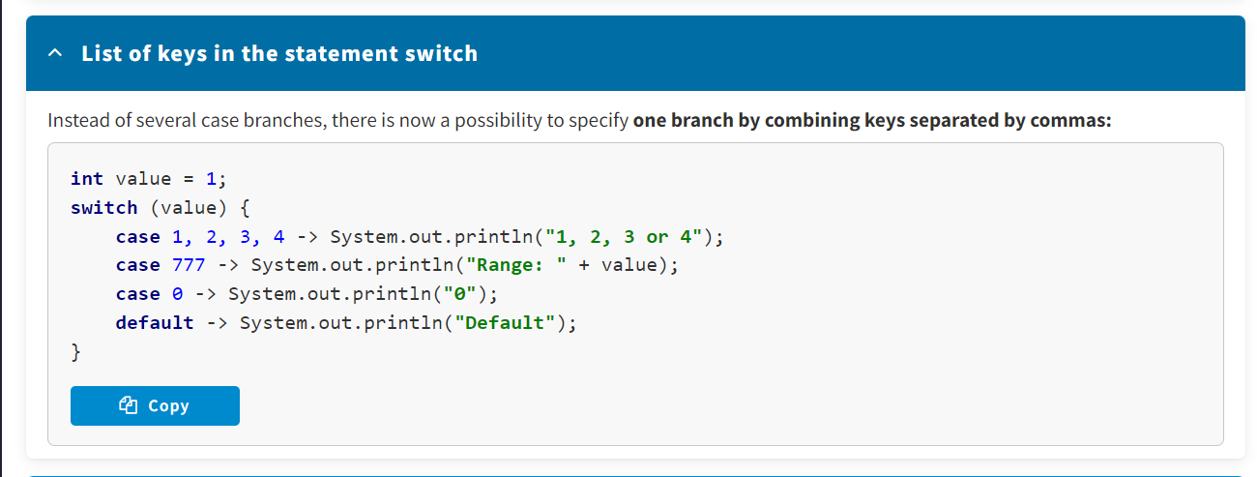

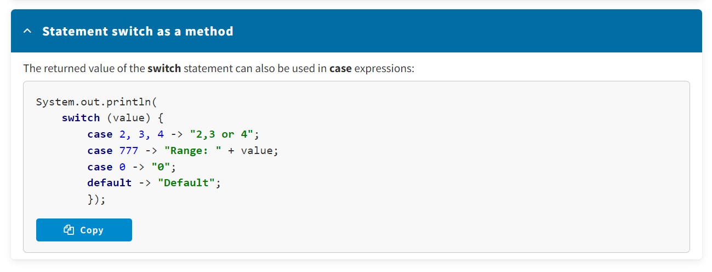

Statement Switch :

* To switch to the statement branch, the statement only checks whether the expression value matches the branch key value.
* The expressions and keys may be enums, strings or integers, with the exception long.

Statement If :

* To switch to the branch, the conditional expression may have any complexity and produce only logical type values.
* The data participating in the calculation of the expression may be of any type.

Note that when the statement **switch** is used, then in two different branches the keys cannot have the same value. The keys may have the same values only when these branches are placed on different nesting levels (in case of nested statements **switch**).

<https://docs.oracle.com/javase/tutorial/java/nutsandbolts/switch.html>

* The statement switch is similar to the branching statement if-then-else. It also allows you to organize branching of the program execution process.
* The statement switch may be applied only to a known number of possible situations.
* When the statement switch is used, then in two different branches the keys cannot have the same value.

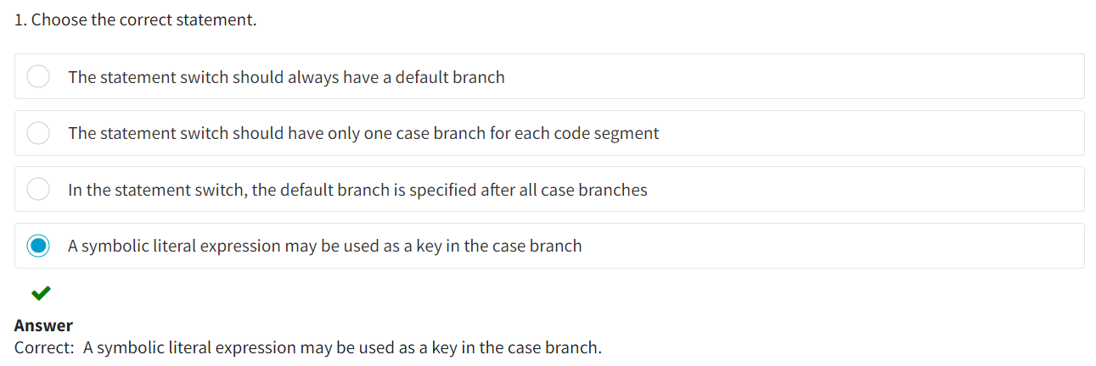

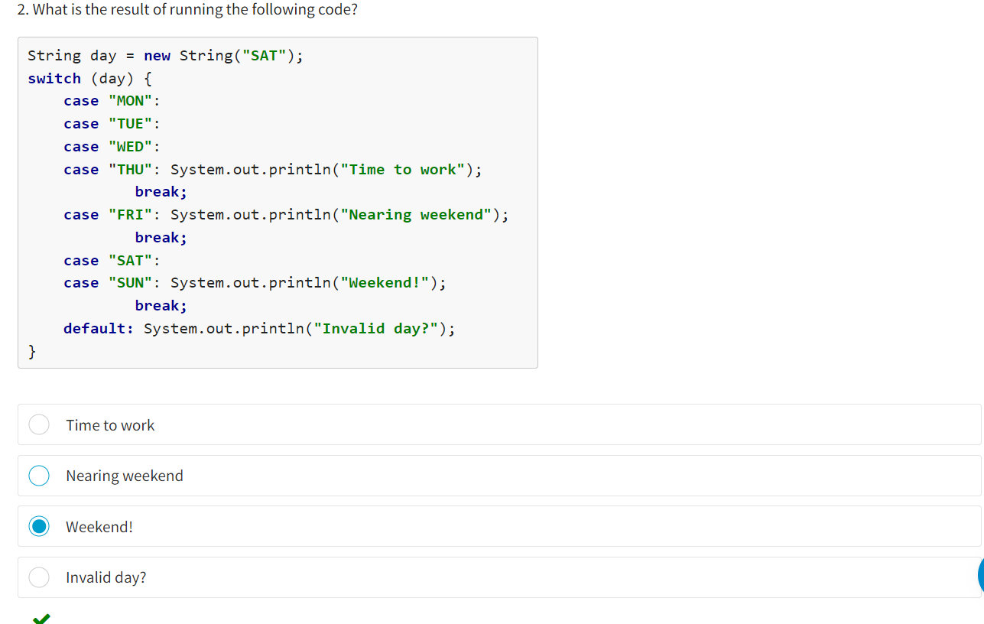

**The while and do-while Statements**

When implementing the logic of a program, very often you need to execute one and the same sequence of actions (statements) many times. At that, the number of repetitions might not be known in advance and depends on certain data (entered by the user, received interim results, etc.).  
To enable the repetition of actions, the Java programming language has **looping statements**. The sequence of statements that have to be executed a specified number of times is called an **iteration**.

There exist the following looping statements:

* **while** — with a pre-condition
* **do-while** — with a post-condition

The execution of a **while** loop can be described as follows:

1. One or several variables used in the "conditional expression" are initialized before the looping statement (such variables are called *iterative*).
2. The "conditional expression" is calculated, and if its value is "true," the loop body is executed; otherwise, the program execution does not enter the loop body.
3. After that, in the body of the **while** statement you need to change the values of one or several variables that are part of the "conditional expressions" (the "conditional expression" should get the "false" value to end the loop).
4. If the value of the condition does not change, you will get an endless loop. To exit such a loop, you need to use the statement **break**.

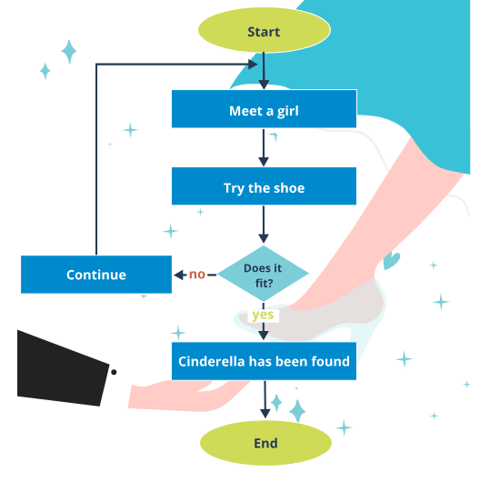

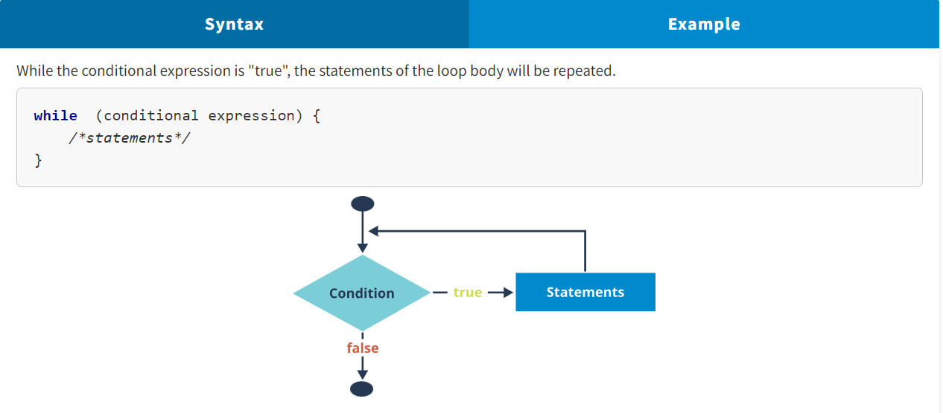

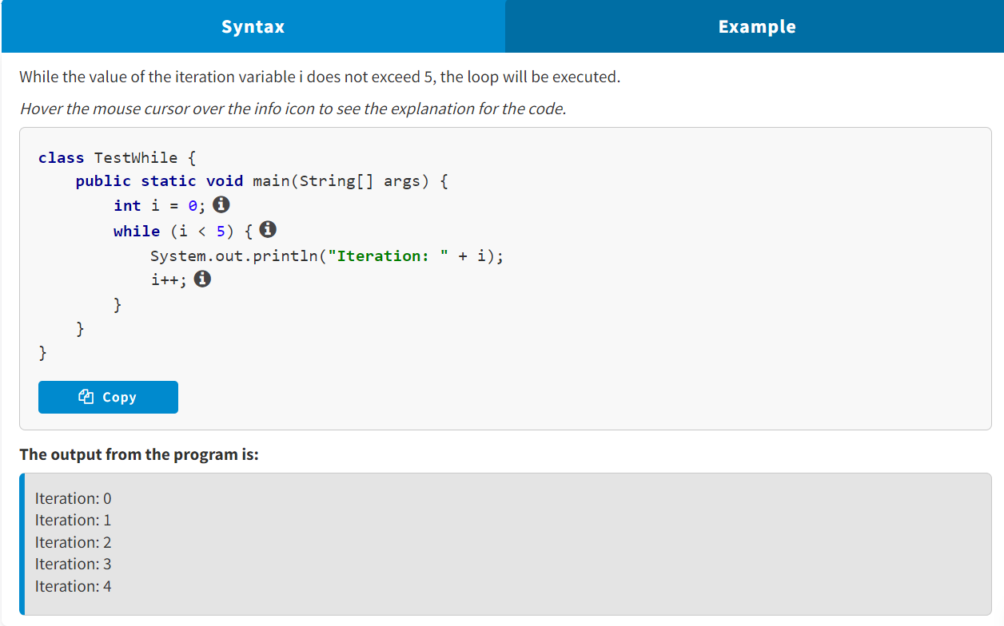

The description of the **do-while** loop execution looks as follows:

1. One or several iterative variables are initialized before the looping statement.
2. The loop body is executed where the values of one or several iterative variables have to be changed.
3. The "conditional expression" is calculated and if its value is "true," the loop body is executed again. Otherwise, the loop is exited. Unlike the loop **while**, this loop will be executed at least once, while the body of the **while** loop might not be executed at all.

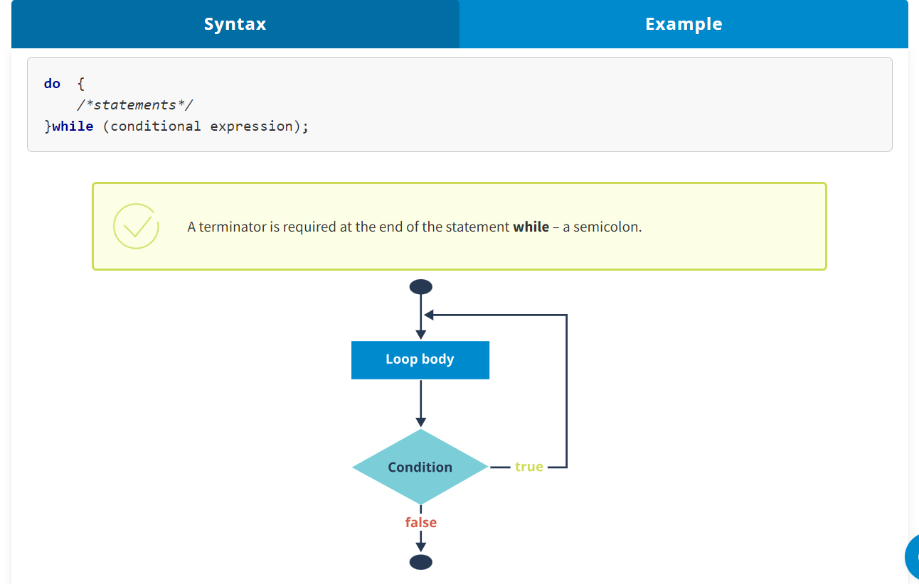

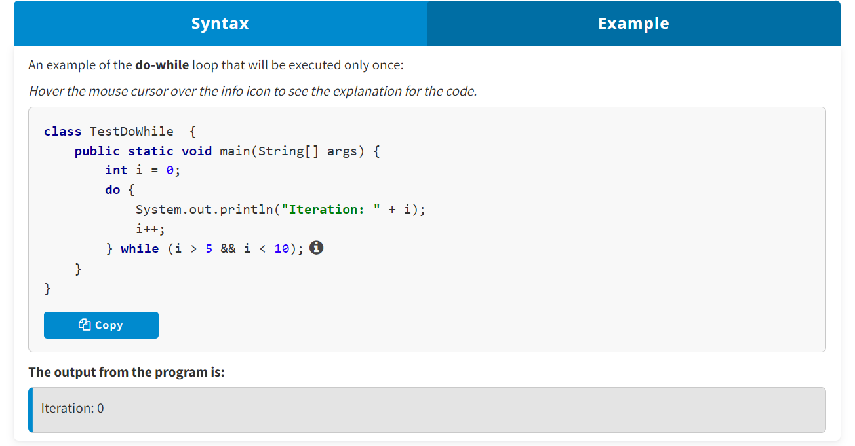

It is worth noting that using the statements **while** and **do-while** is useful when it is necessary to repeat certain actions and the number of repetitions is unknown and depends on a certain condition. The main difference between the statements **while** and **do-while** is that the body of the loop **while** might not be executed at all, while the body of the loop **do-while** will always be executed at least once.

It is possible to create infinite loops, if the "conditional expressions" in these loops always have the value **true**. To exit such a loop, you can use the branching statement **break** that will be discussed further.

**Branching Statements break and continue**

**Branching statements** are statements that make it possible to go from the point where the statement is used to a different part of the program. Branching statements:

* **break** is used to exit a loop or the statement **switch**.
* **continue** is used to go to the next loop iteration.

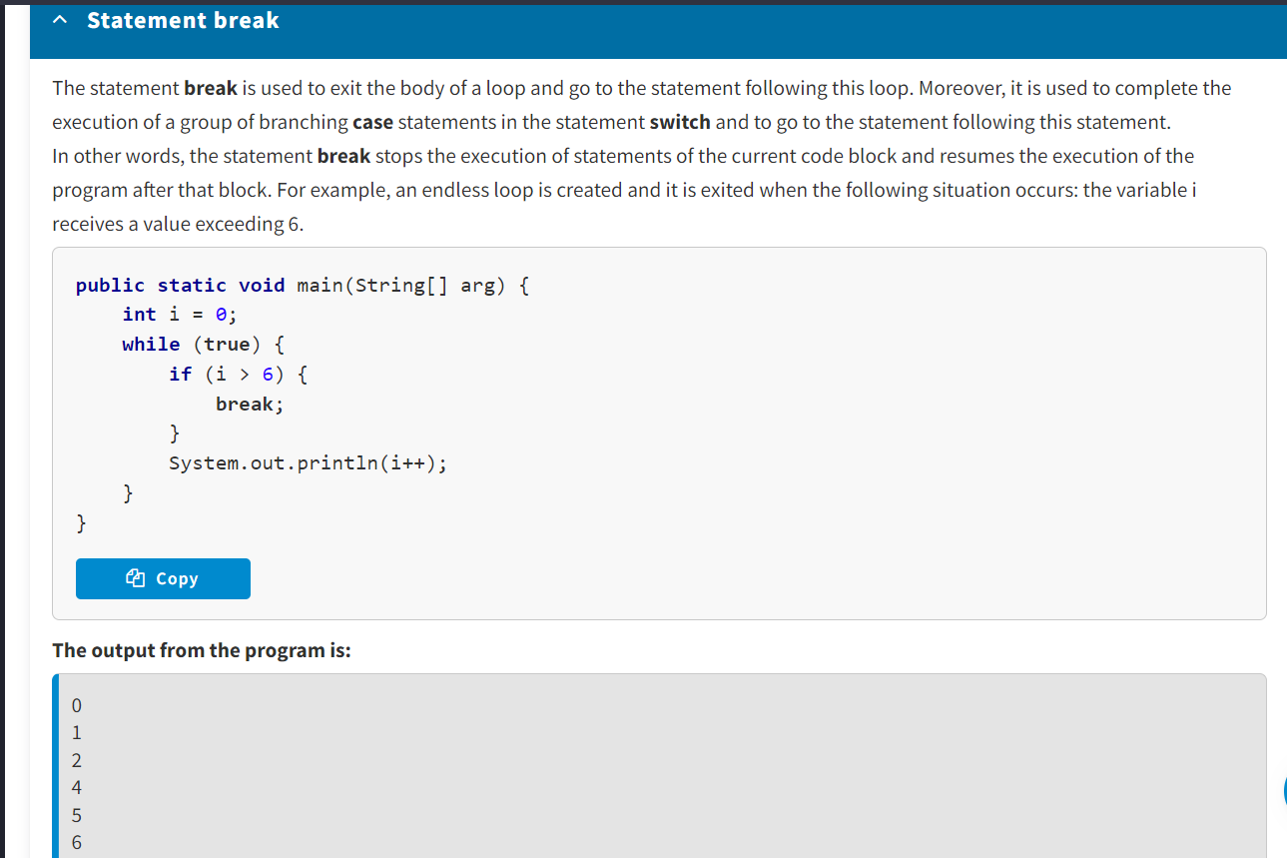

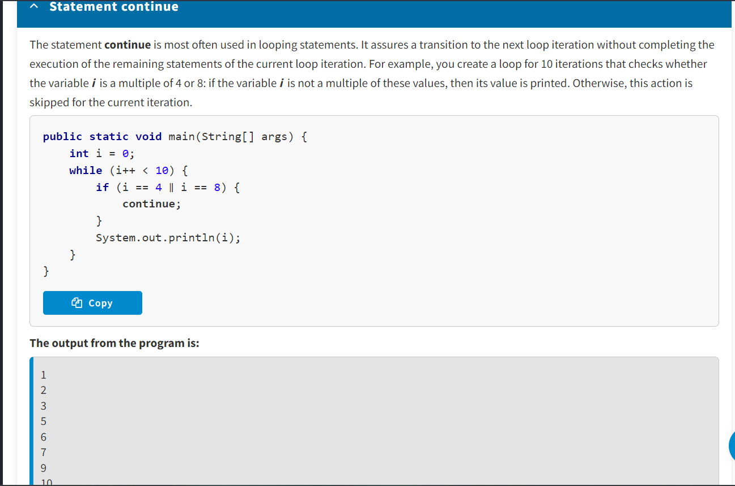

**Statements break and continue with a Label**

The statements **break** and **continue** in the Java language are special because they can be used with a label.

A **label** is a legal identifier that can be used to mark looping statements. In that case, the label is separated from the statement with a colon. The statements **break** and **continue** with a label can be used only when the program has nested loops.

The statement **break** with a label is used in nested loops and exits the loop that is marked with the specified label.

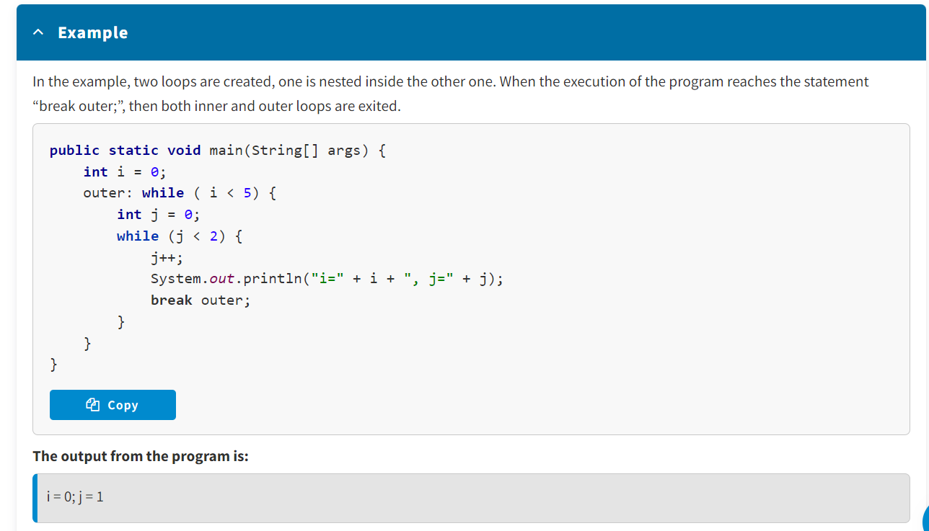

The statement **continue**with a label is used in nested loops. This statement breaks the execution of the current iteration of the nested loop and goes to the next iteration of the outer loop marked with the specified label.

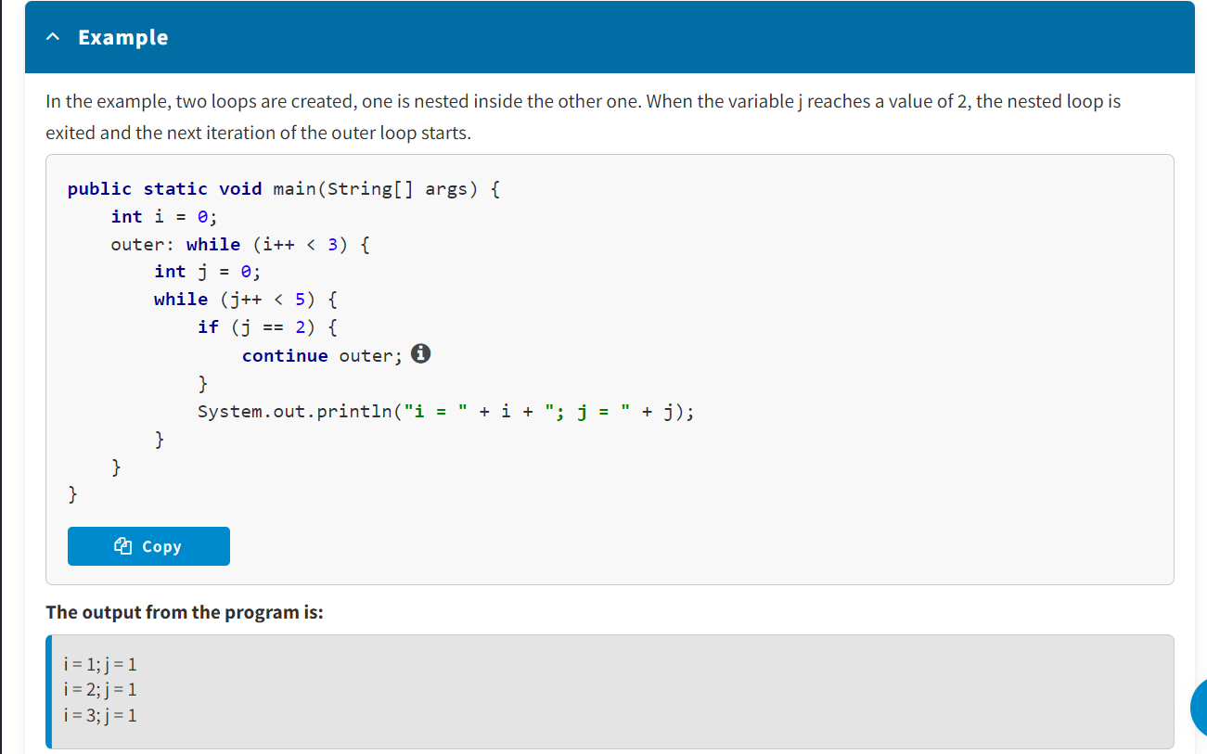

The benefit of using **break** and **continue** is that, in case of a looped process, there is no need to execute extra iterations, if the target value has been found or the target result has been reached. This increases the speed of execution of the program, and the code structure is not deformed in case of an early termination of the loop process.

**Looping Statement for**

The **for** statement is the most often used loop in programming. It is convenient to use when the number of iterations is known. Pay attention to the syntax, specifics, and use case for the **for** statement.

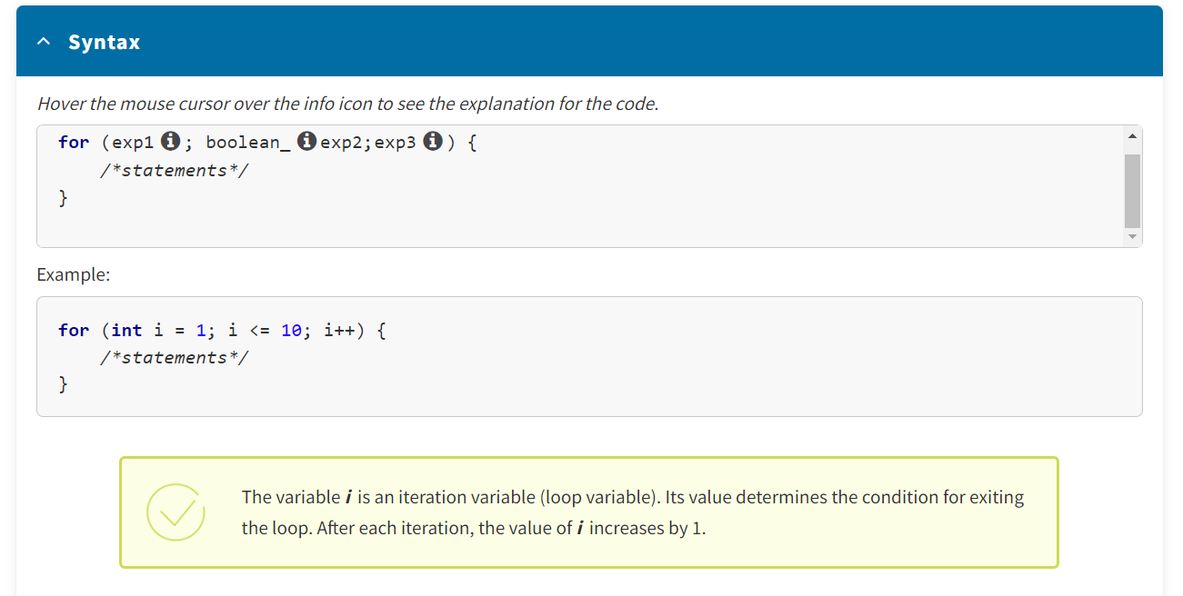

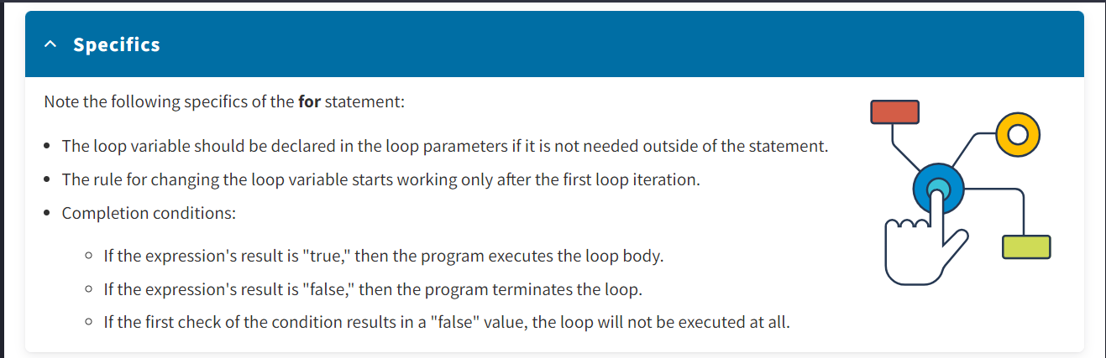

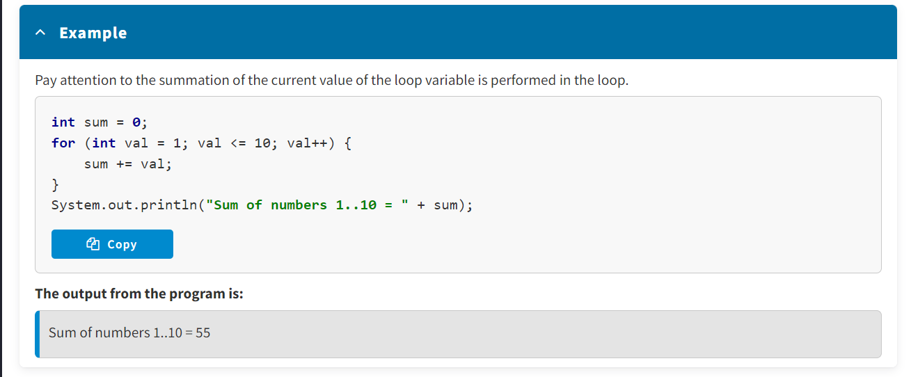

The syntax of the looping statement **for** is not limited by a loop with an only iteration variable. Both in the "initialization" expression and in the "change rule" expression, you can use a **comma** to separate several variables:

**for** (exp1, exp2, …, expN; boolexp; exp10, exp11, …, expM ;) {

*/*statements*/*

}

Pay attention to the following example. Two variables (*a* and *b*) are initialized in the loop parameters. The number of loop iterations depends on their values. After each iteration, the values of the *a* and *b* variables change. When their values cross, the loop will be terminated.

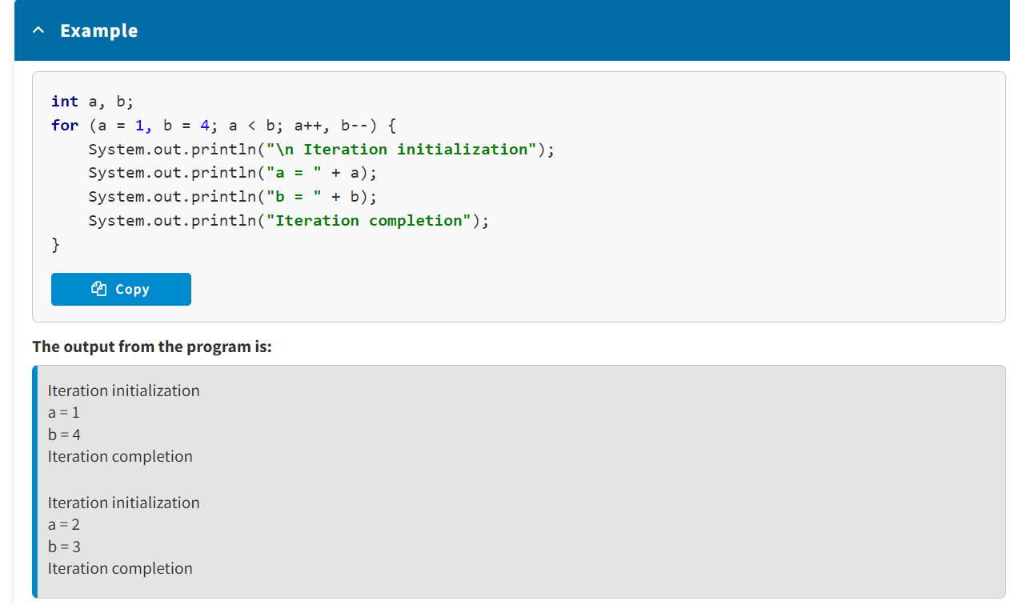

Pay attention to the examples of working with one and several iteration variables, as well as with and without the statements **break** and **continue**.

* Using the statements **while** and **do-while** is useful when it is necessary to repeat certain actions and the number of repetitions is unknown and depends on a certain condition.
* Branching statements (**break, continue**) are statements that make it possible to go from the point where the statement is used to a different part of the program.
* It is convenient to use the **for** loop when the number of iterations is known.

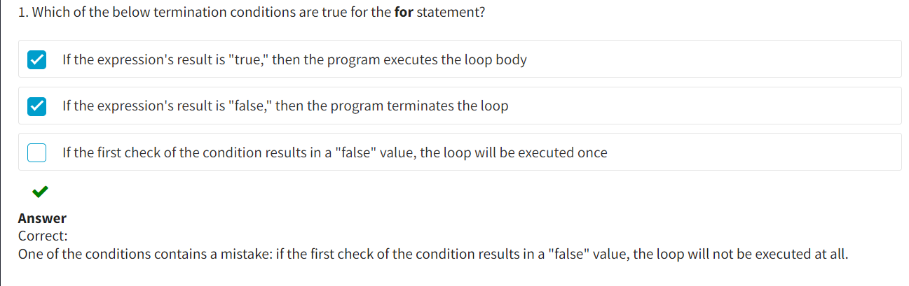

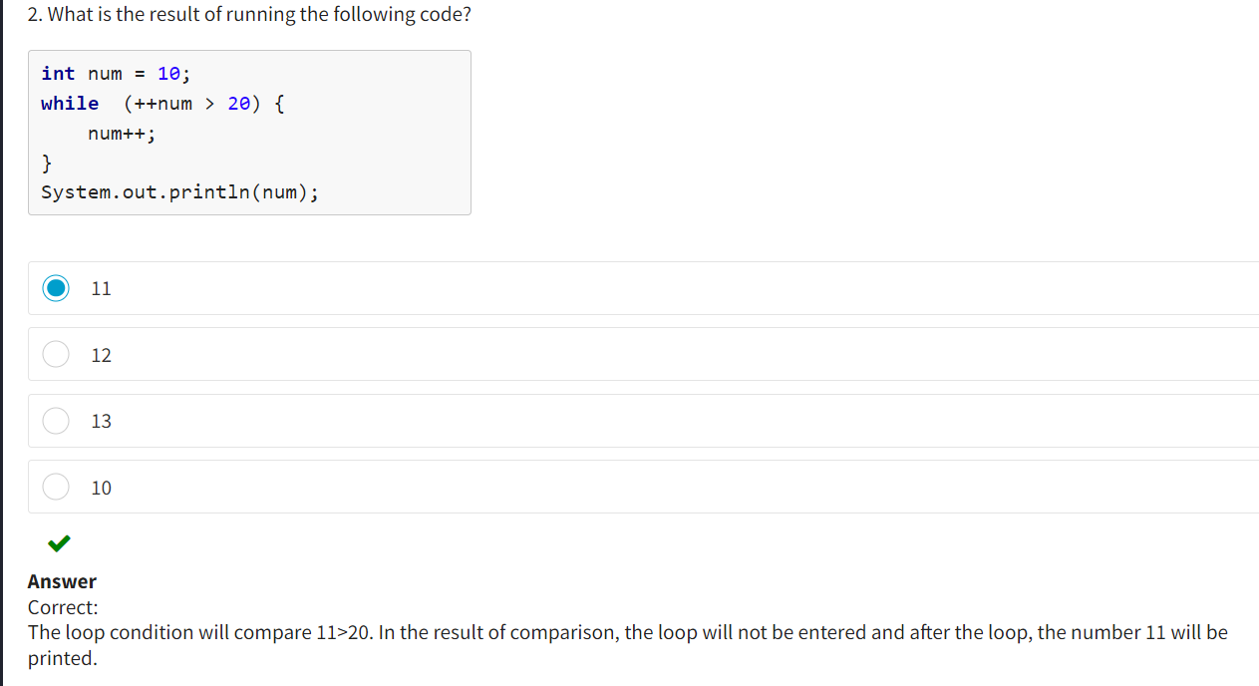

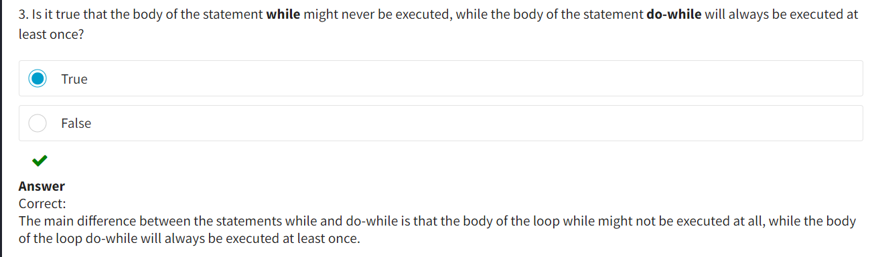

**Arrays :**

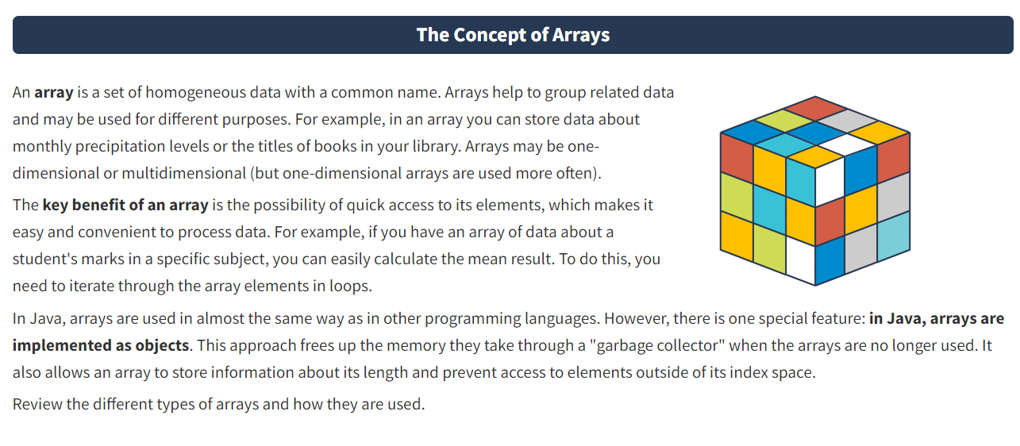

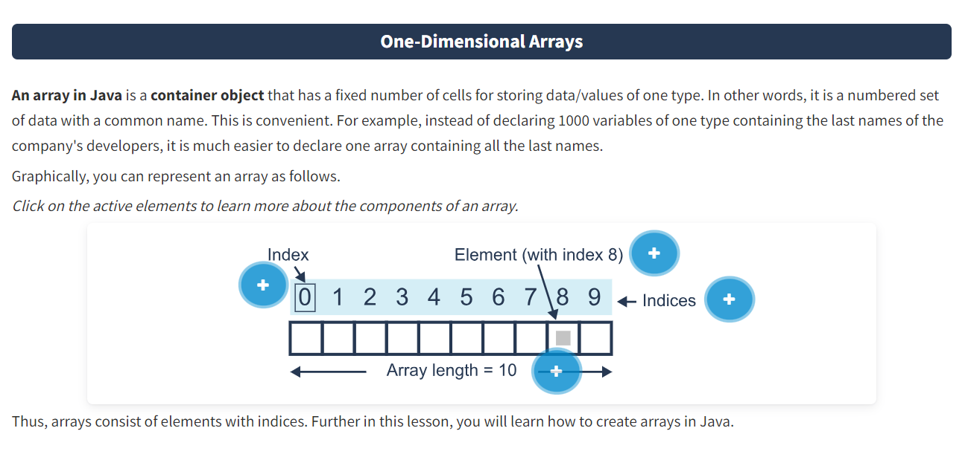

**Index**

Indexation of array elements **starts from zero.**

**Array length**

The size of an array is defined and fixed when it is initialized. After an array has been initialized, you cannot change its length.

**Element**

A piece of data in an array is called **an element.**

**Indices**

Every piece of data has its own position — **the index.**

**Creating an Array**

To create an array, you need to:

1. Declare an array
2. Allocate memory for the array
3. Initialize the array

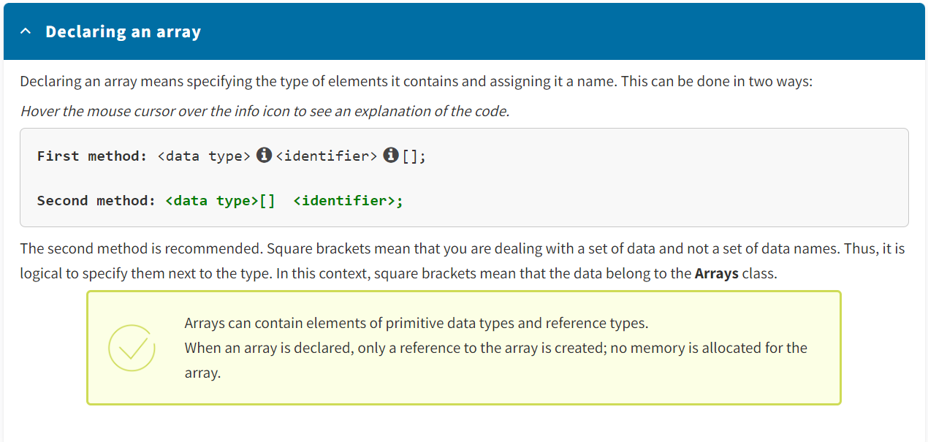

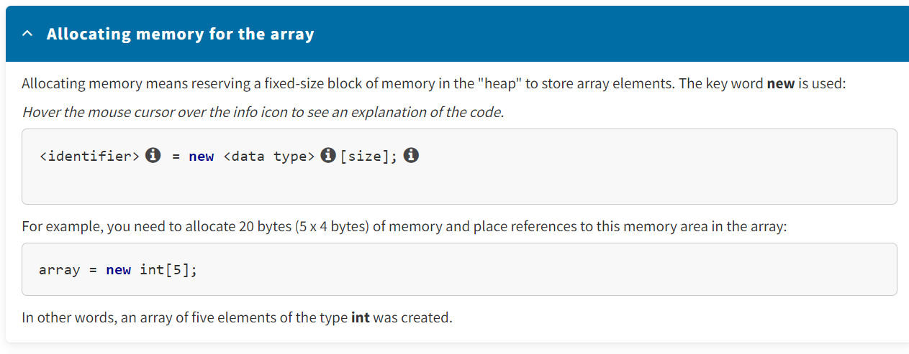

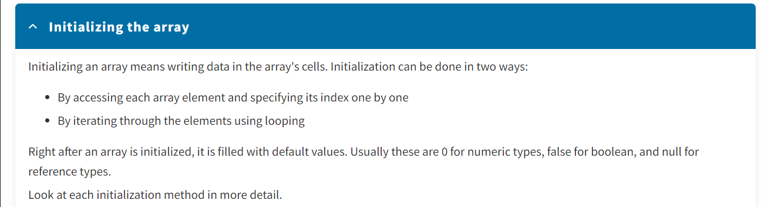

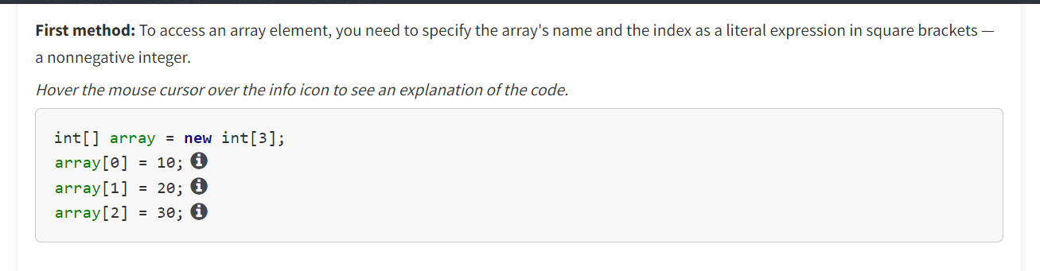

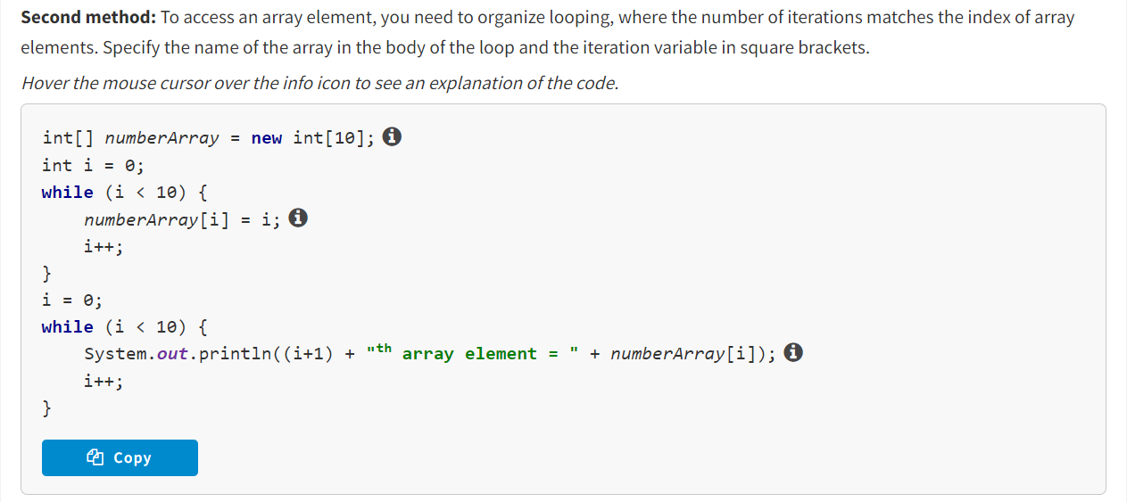

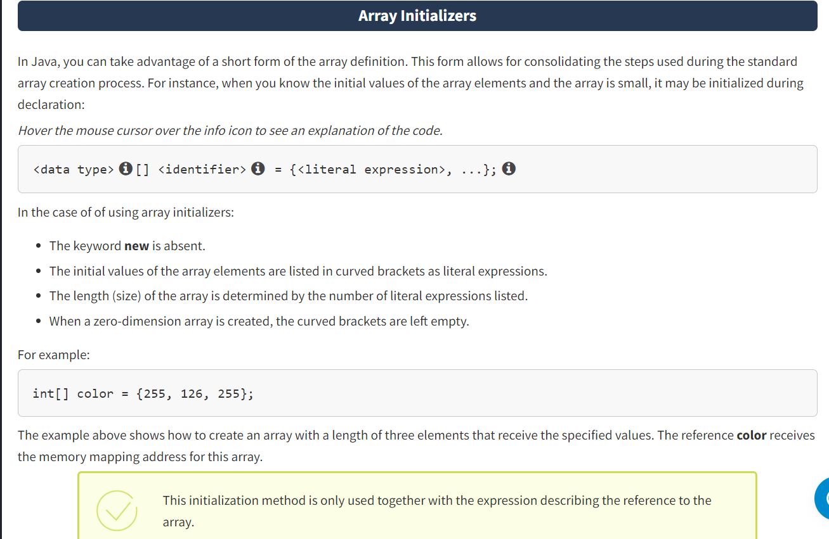

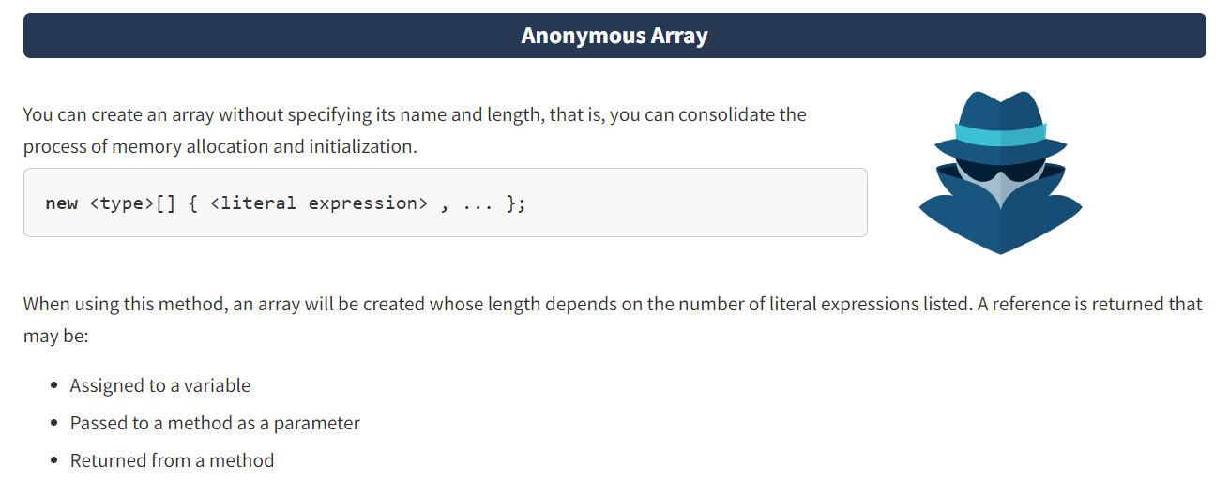

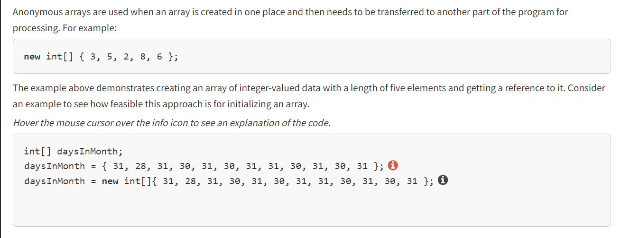

* An array is a set of homogeneous data under a common name in Java in the form of a container object.
* The data in an array is called elements, each of which has its own index and position.
* To create an array, you should declare it, allocate memory for it, and initialize it.
* If the array is small and the initial values of the array elements are known, it may be initialized during declaration.
* You can create an anonymous array, i.e., an array whose name and length are not specified.

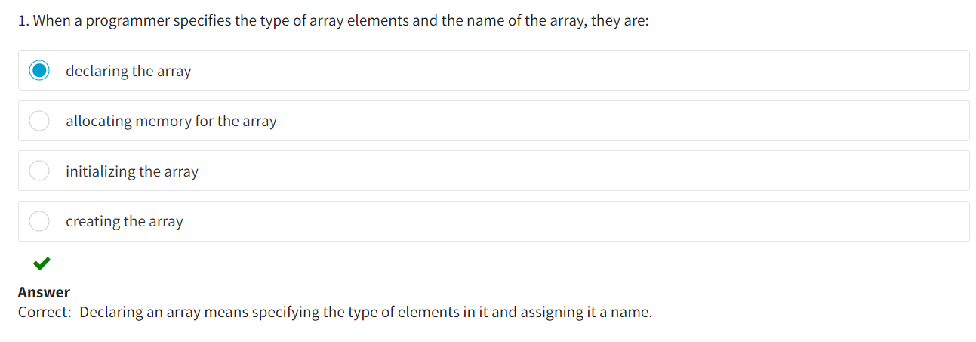

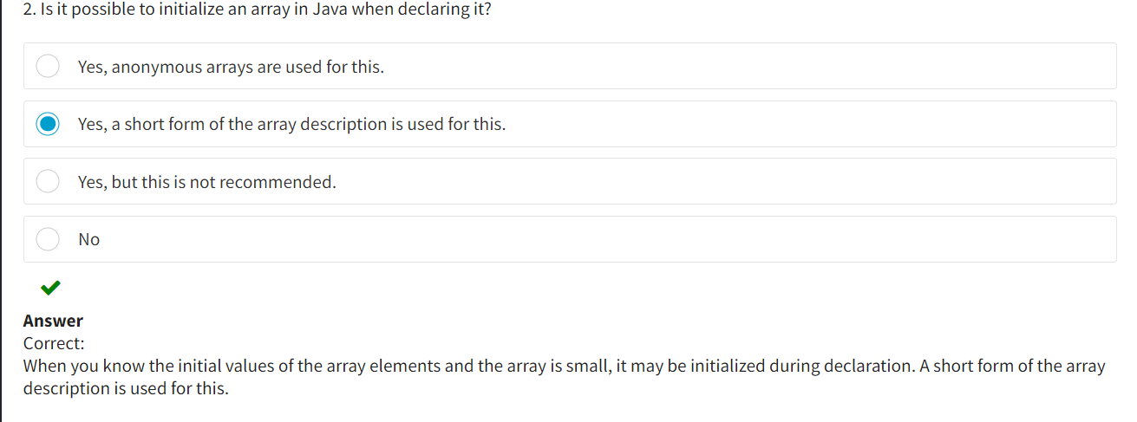

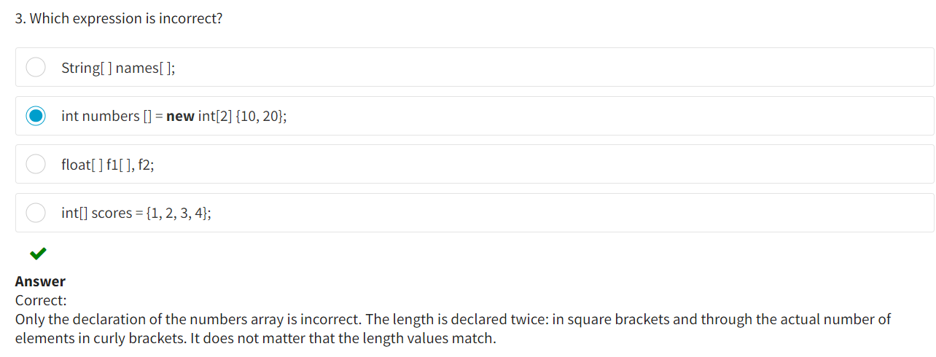

**The Length Property**

You may have noticed that when you access an array, its length is not always evident. Thus, the length of an array (or the number of elements) is stored in its properties—the *length* field. You can access this field through the array's name.

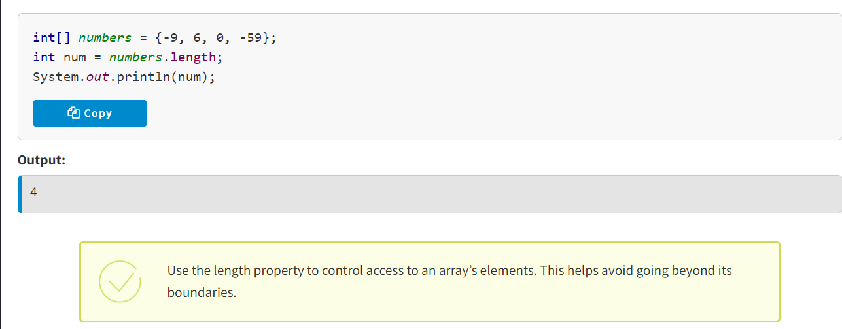

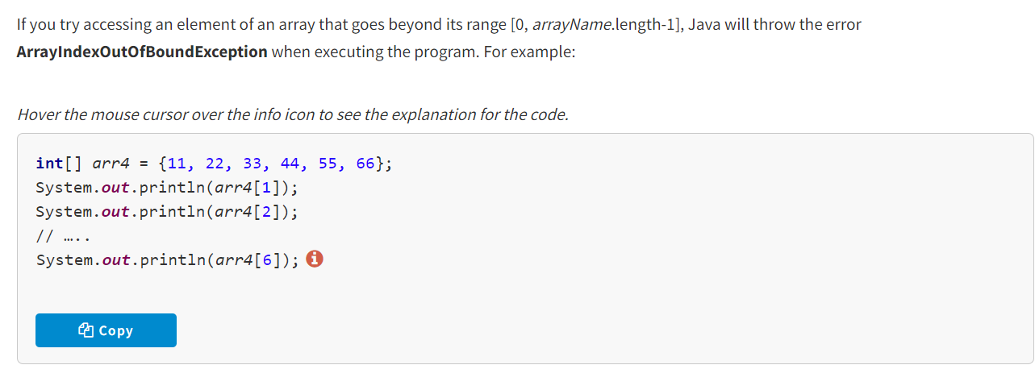

* Found out that information about the amount of elements an array has is stored in the array's length property
* Copied part of one array into another array using the *System.arraycopy()* method
* Changed the length of an array by reinitializing the reference to it

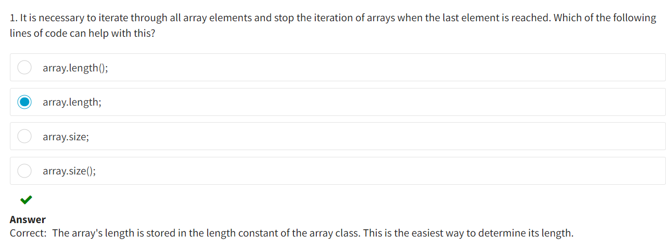

**The for-each Looping Statement**

You already know that the **for** loop is the most used loop in programming. It is convenient to use when the number of iterations is known.

The **for** statement can be used to iterate over the array since:

* It is a compact way of describing the **while** statement
* Loop control is not part of the loop's body

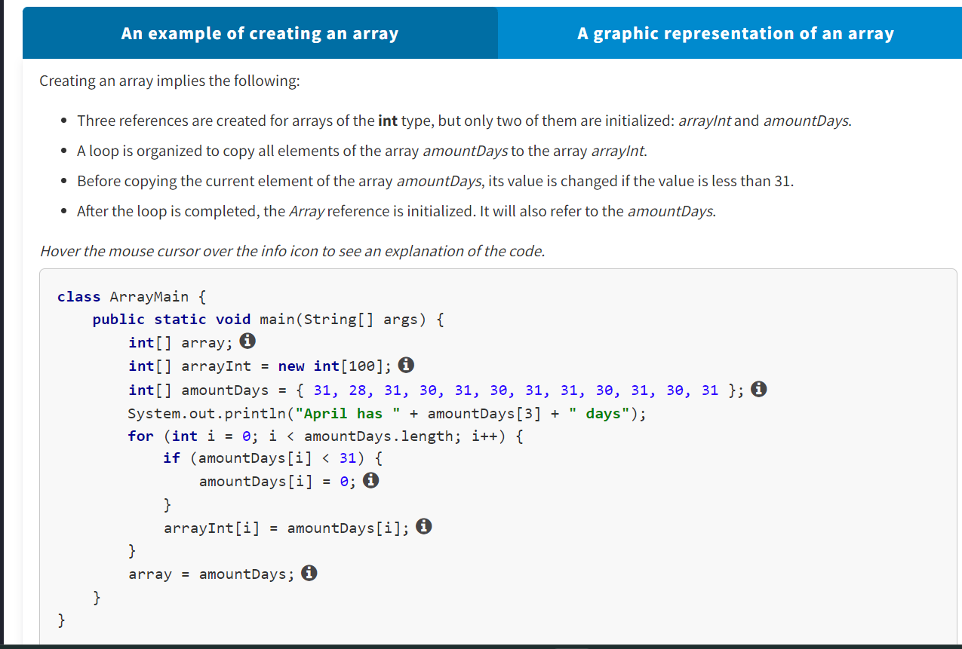

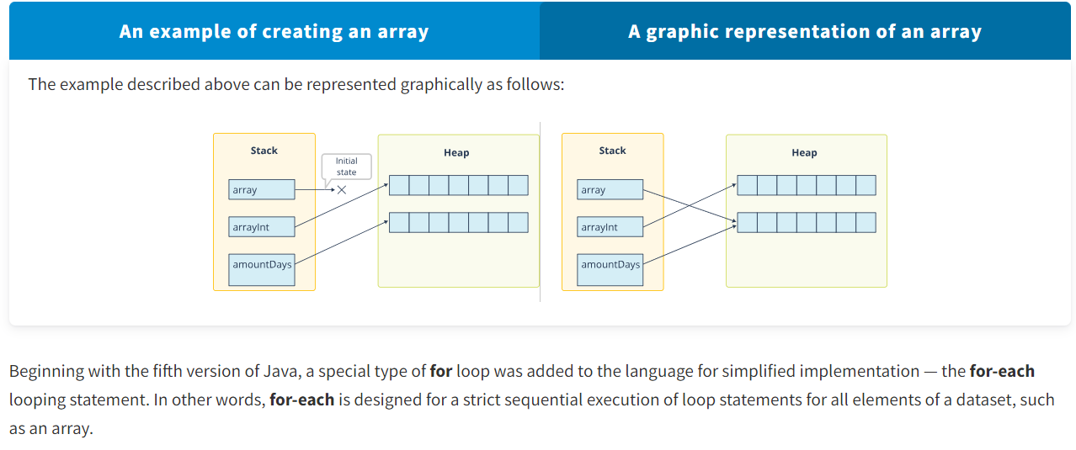

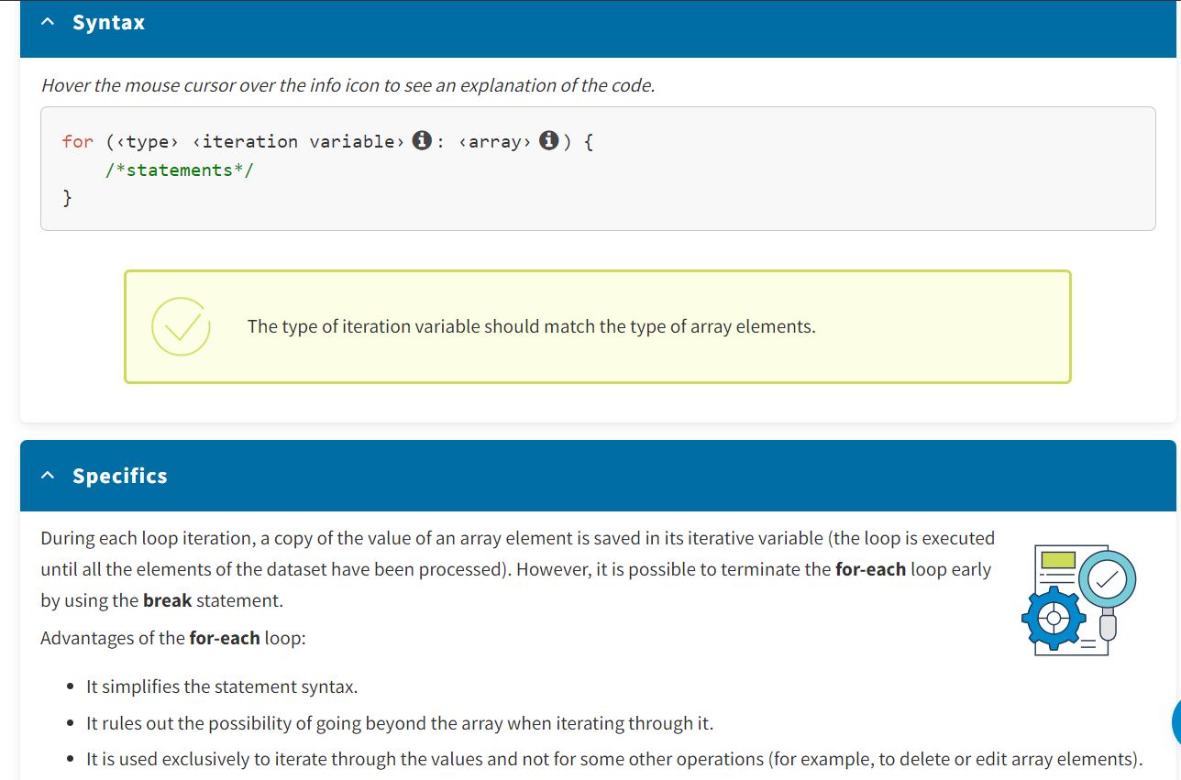

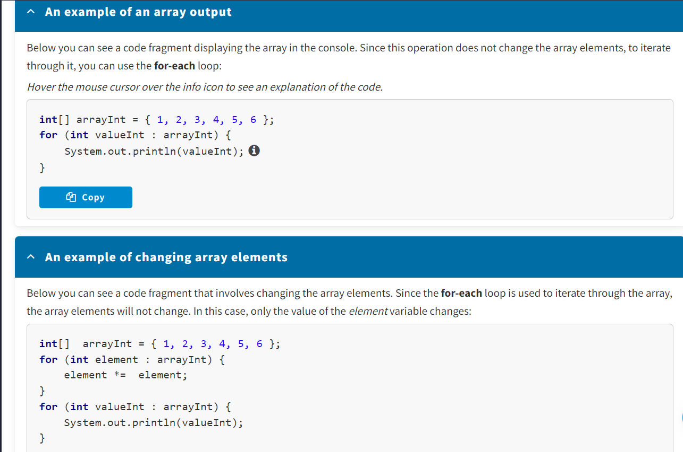

**Output:**

1

2

3

4

5

6

**1**

**2**

**3**

**4**

**5**

**6**

The changes work only for reference variable data types.

There are certain specifics when processing arrays using the **for-each** loop. You will see similar features when using the **for-each** loop with collections.

**Advantages of for-each loop :**

The **for-each**loop has the following advantages:

* simplified representation,
* no need to introduce an additional loop variable or set its initial value and conditions for loop termination,
* no need to index the array.

**Disadvantages of for-each loop :**

The **for-each**loop has the following disadvantages:

* lack of flexibility when manipulating the iteration variable,
* the inability to change the value of the array elements (for primitive and immutable reference data types).

**Using the for and for-each Loops**

The following example will help you understand how you should use the **for** and **for-each**loops.

**Problem:**Find the maximum value in the array and replace the negative elements in this array with this value.

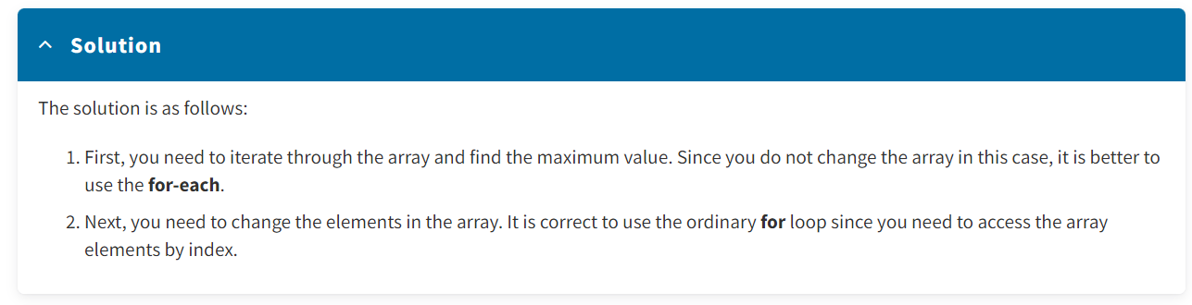

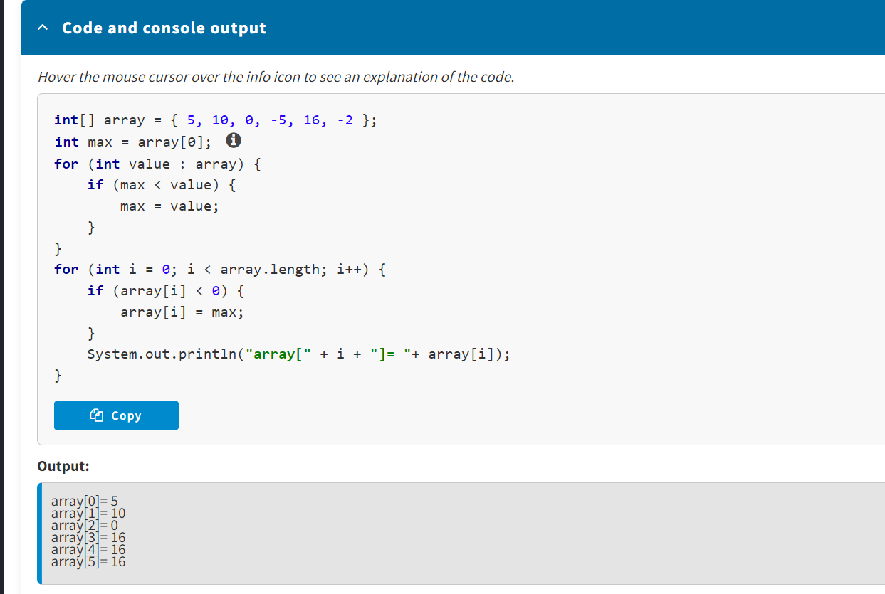

* The **for** loop is convenient when the number of iterations is known.
* The **for-each**loop is designed for strict sequential execution of loop statements for all elements of a dataset.

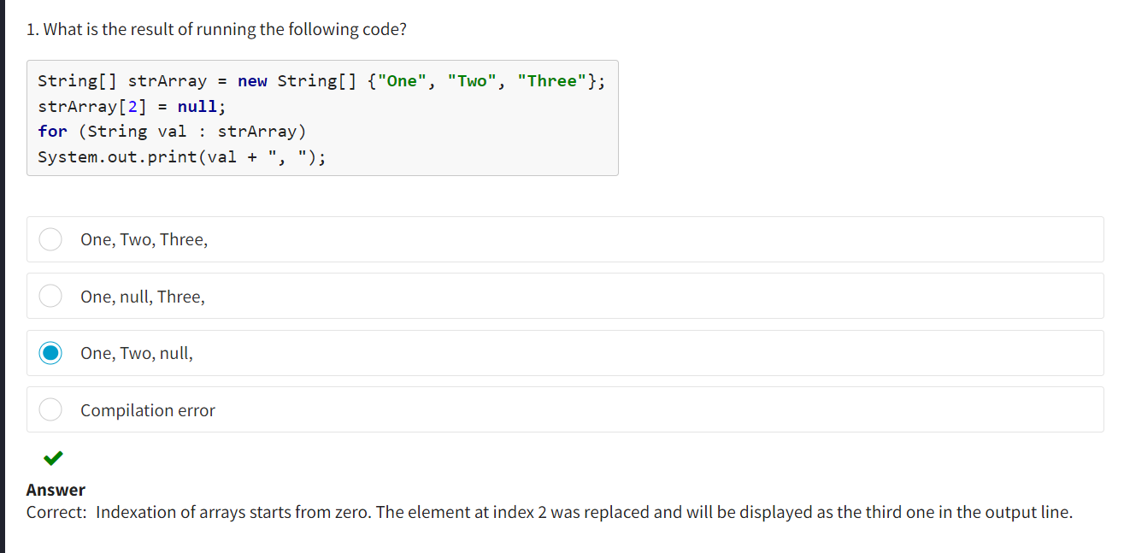

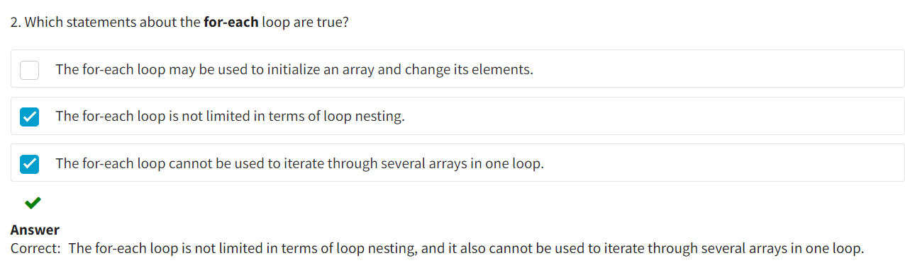

**Introduction**

You have already found out about one-dimensional arrays, and it's now time to explore two-dimensional arrays. In this lesson, you will study the concepts of two-dimensional and multidimensional arrays, including how they are organized and the tools for creating them, and then you will delve into the subject of jagged arrays.

**The Concept of a Two-Dimensional Array**

In Java, **multidimensional arrays** are arrays of arrays, that is, sets of one-dimensional arrays, references to which are stored in other one-dimensional arrays.

Multidimensional arrays may be two-, three-dimensional, etc. A separate set of square brackets is used to specify each additional dimension. The simplest multidimensional arrays are **two-dimensional** (see example on the picture).

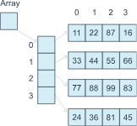

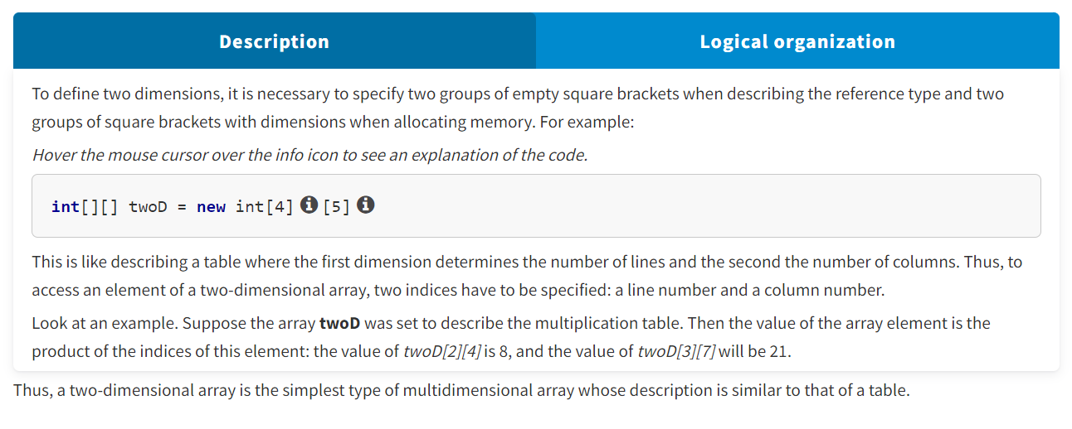

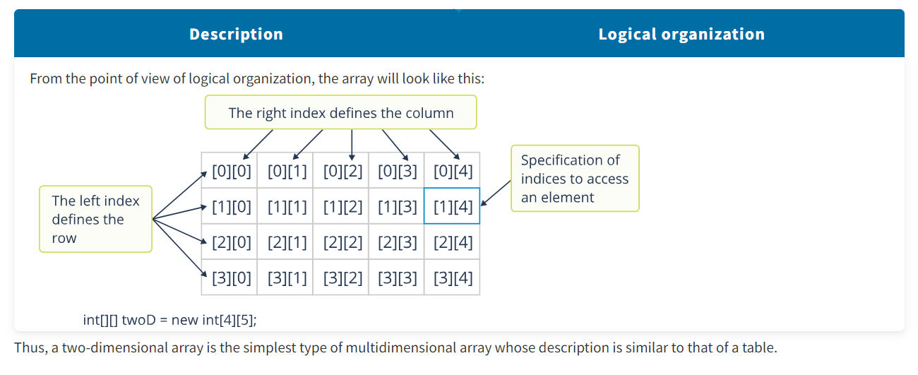

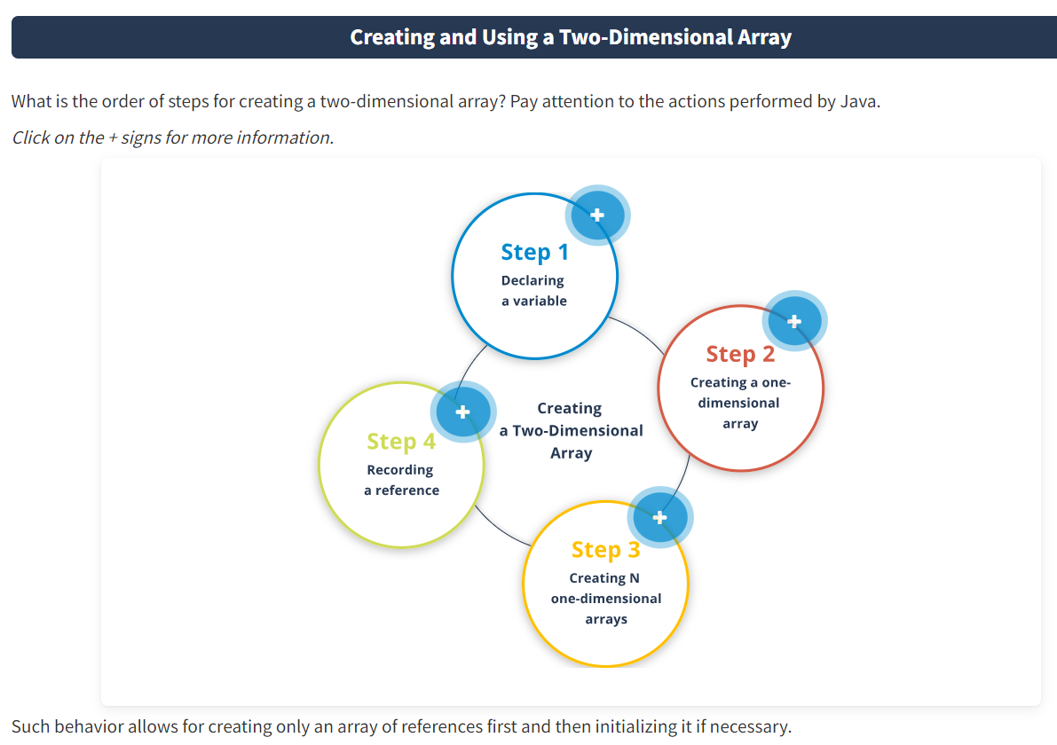

**Step 1. Declaring a variable**

Java declares a variable that will contain a reference to an array of references. The elements of this array will refer to one-dimensional arrays of the type that was declared.

**Step 2. Creating a one-dimensional array**

Java creates a one-dimensional array with dimension ***N*** specified by first index (the array of references is filled by default values, i.e., ***null***).

**Step 3. Creating *N* one-dimensional arrays**

Java creates ***N*** one-dimensional arrays of the type that was declared, each containing ***M*** elements specified by second index (by default, each of these arrays is filled with null values).

**Step 4. Recording a reference**

Java records references to each of these new arrays in the array created during Step 2.

In this code fragment, when describing the array, only the first dimension is specified. Thus, the process looks like this:

* An array of arrays with a dimension of five elements is created. The array is displayed to the standard output.
* One-dimensional arrays are created, references to which are stored in the first array.
* A two-dimensional array is displayed in the console (for a better understanding of the mechanism for creating a two-dimensional array).

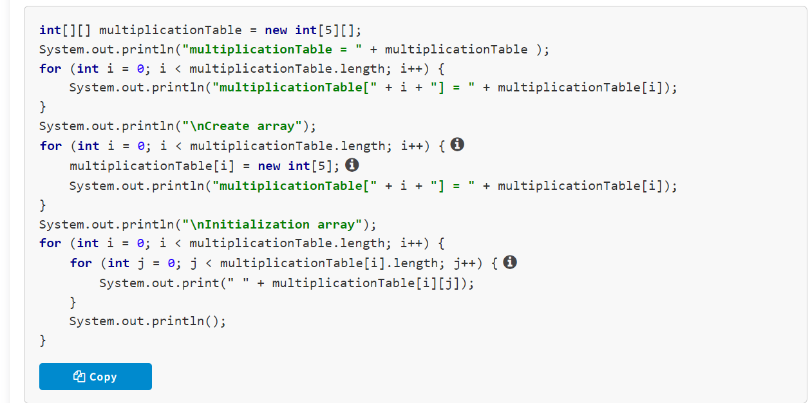

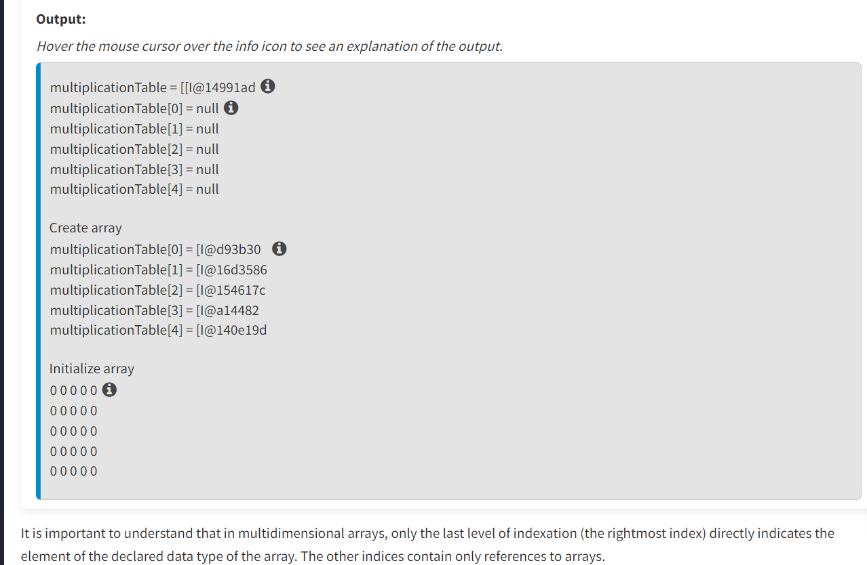

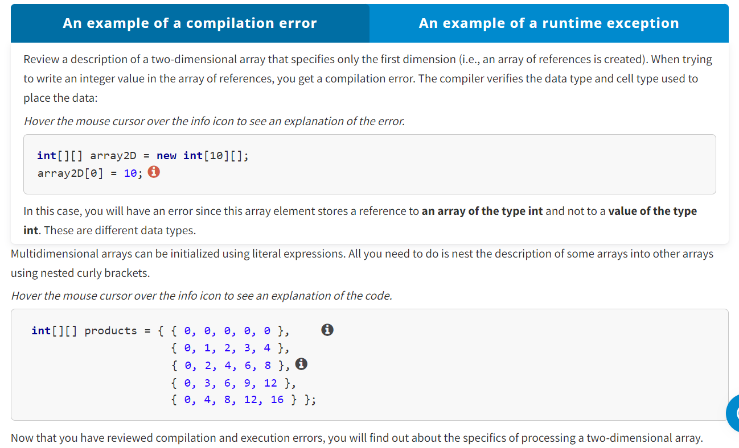

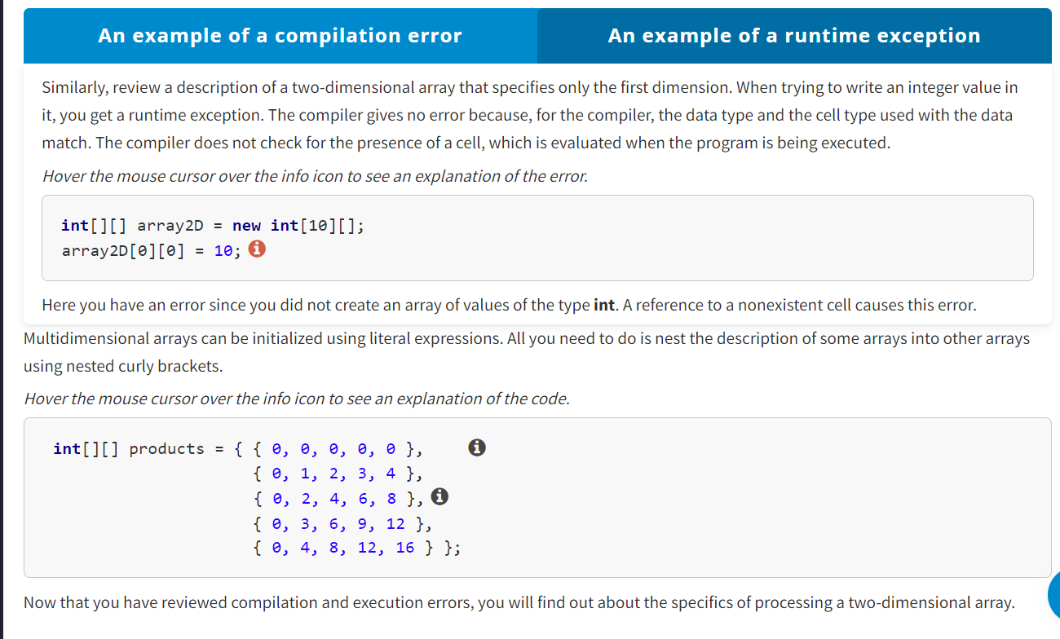

**Processing a Two-Dimensional Array**

The problem below will help you understand how to process a two-dimensional array.

**Problem:** Find the sum of the elements of a two-dimensional array.

What solution would you propose?

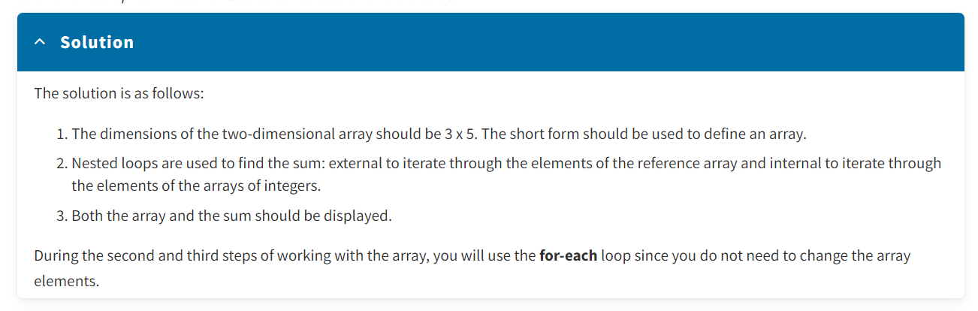

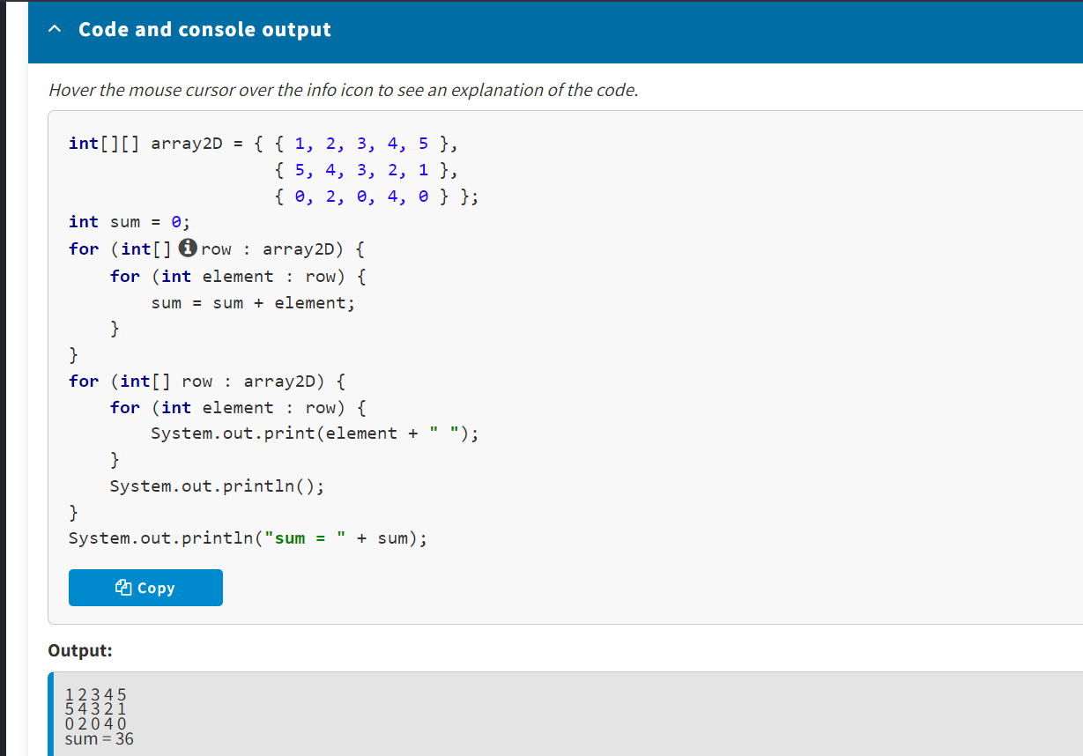

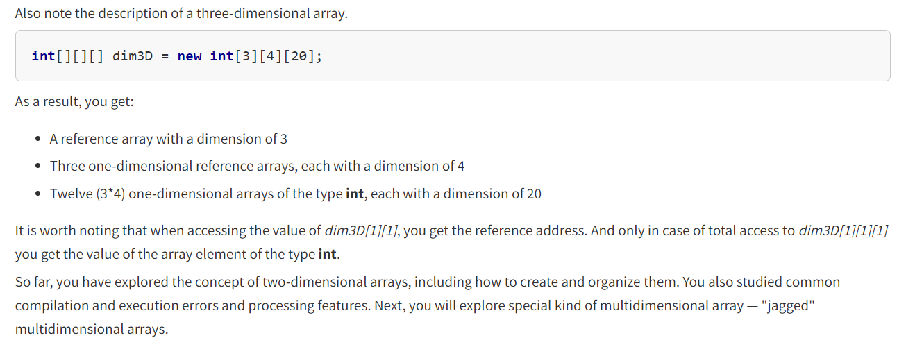

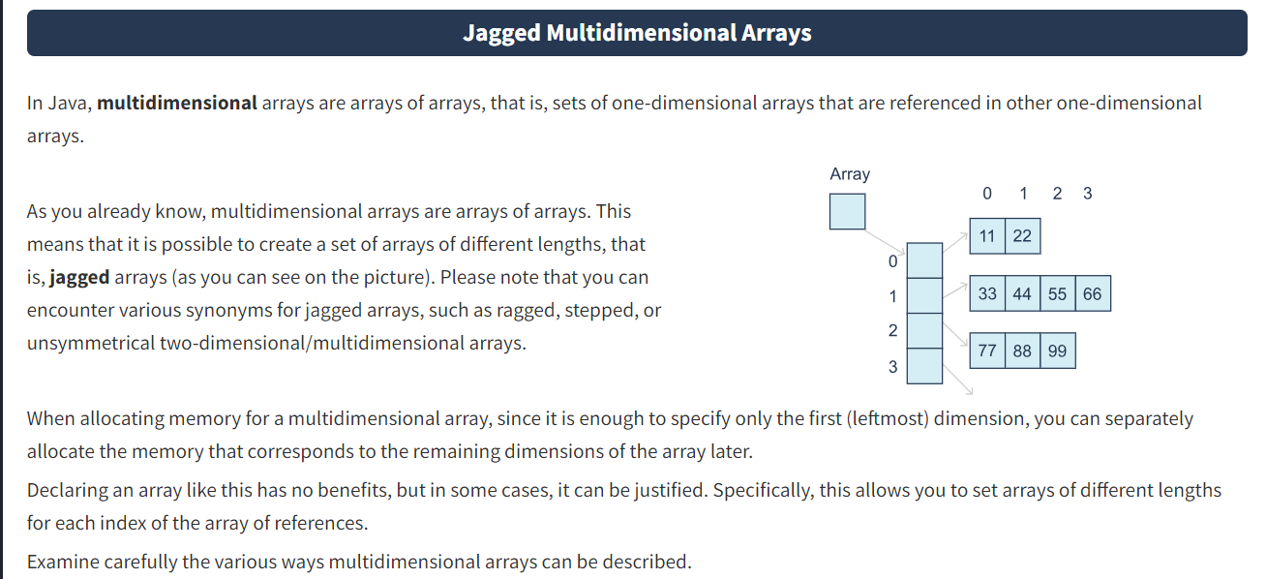

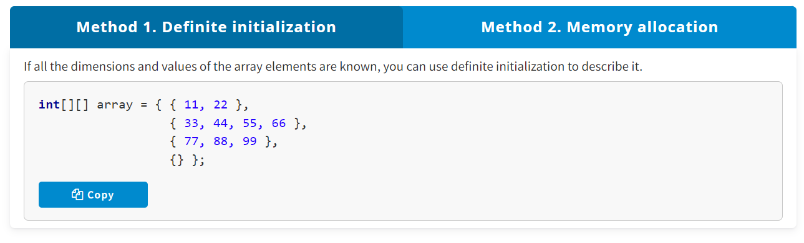

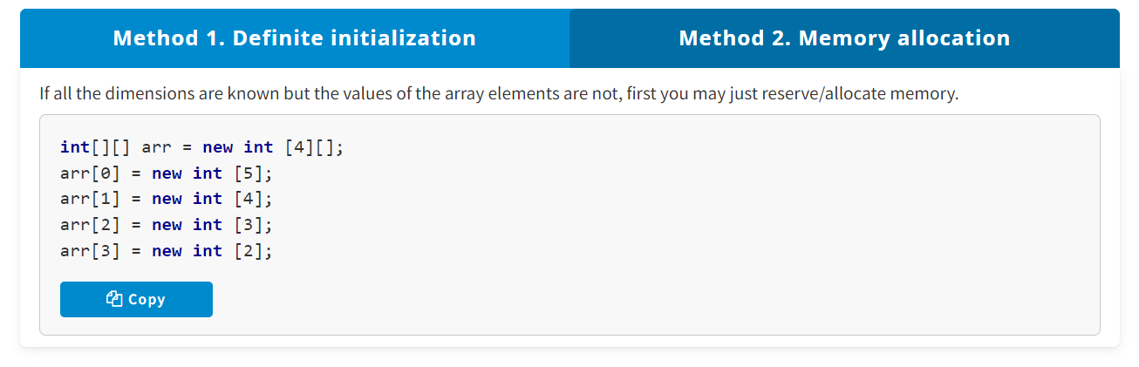

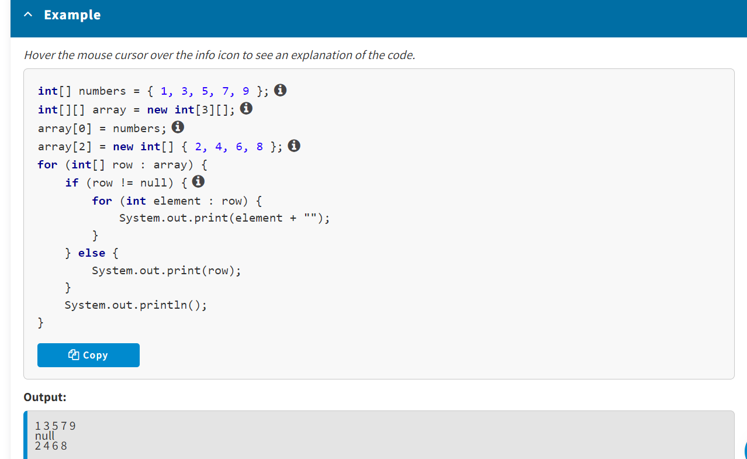

For most applications, it is not recommended to use jagged arrays since this makes it difficult for other developers to read the code. However, in some cases, these arrays are quite acceptable and may boost a program’s performance significantly. Thus, if you need to create a large two-dimensional array where not all elements are used, a jagged array will save you a substantial amount of memory.

* Established that multidimensional arrays (arrays of arrays) are sets of one-dimensional arrays, references to which are stored in other one-dimensional arrays
* Declared, initialized, and used multidimensional arrays with various dimensions
* Created sets of arrays of different lengths, that is, jagged arrays

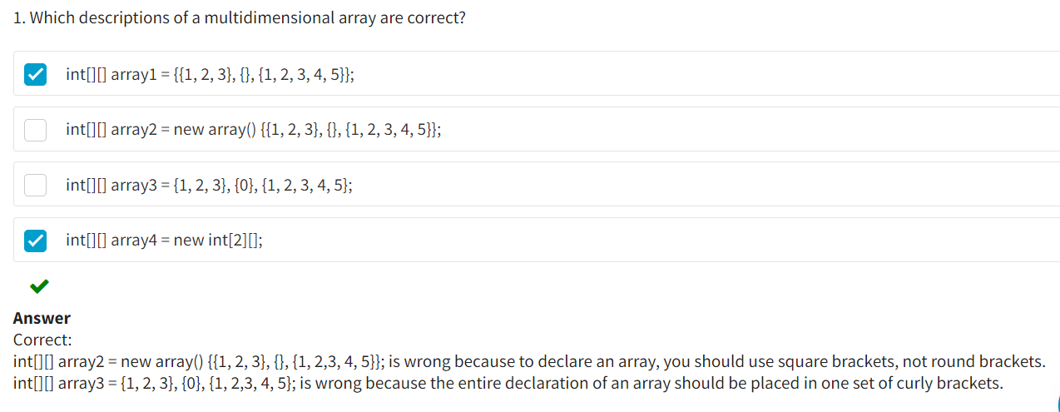

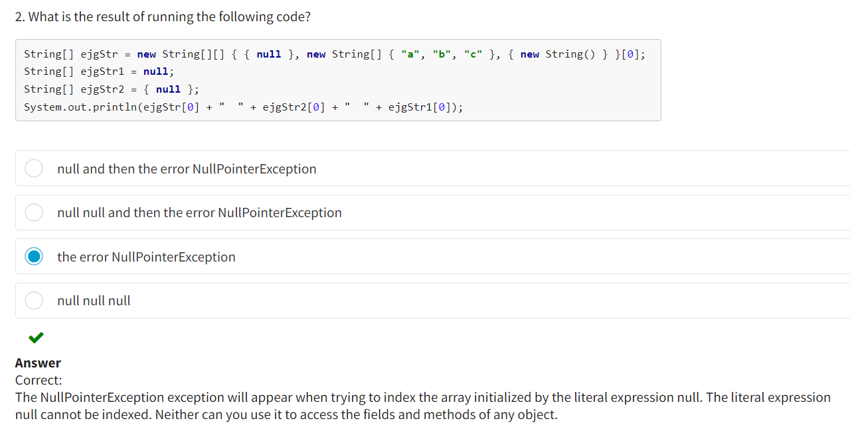

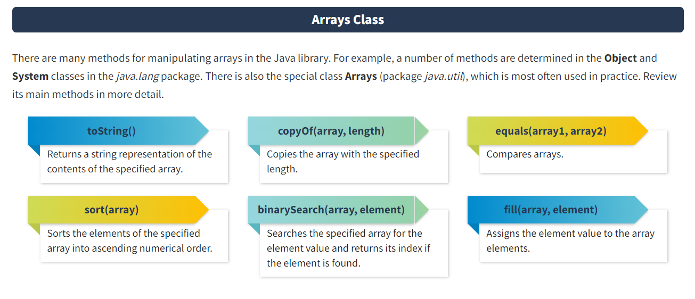

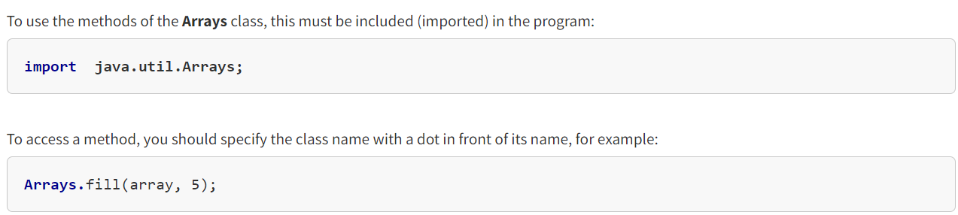

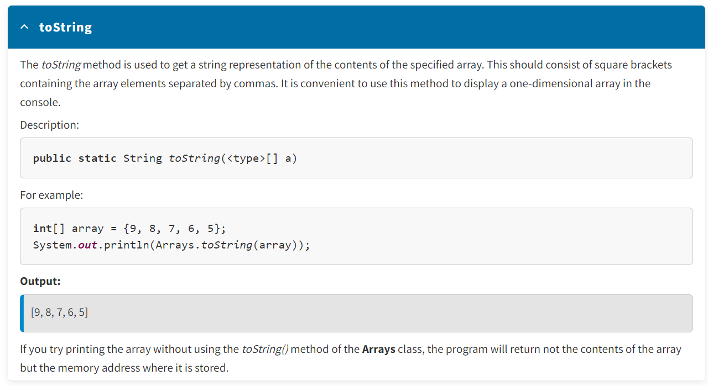

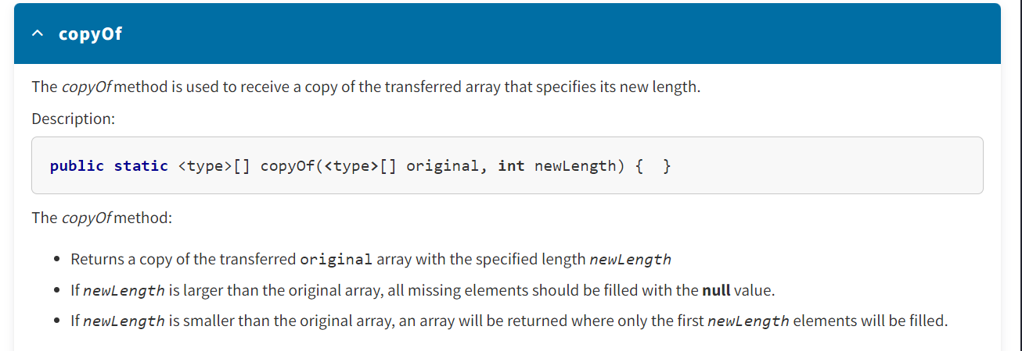

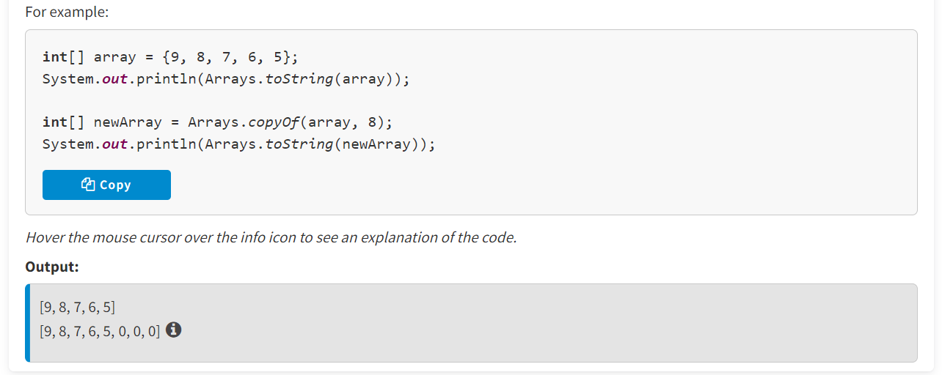

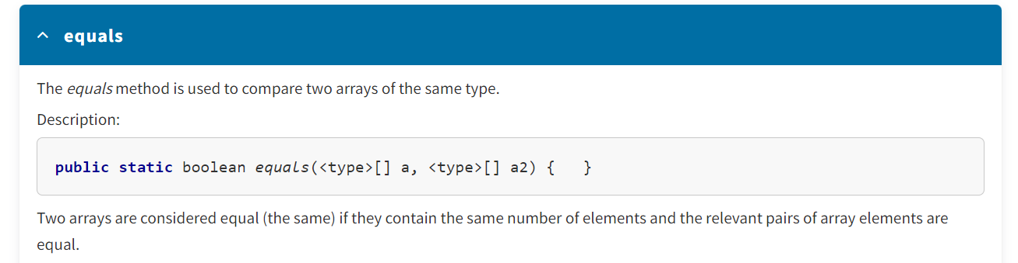

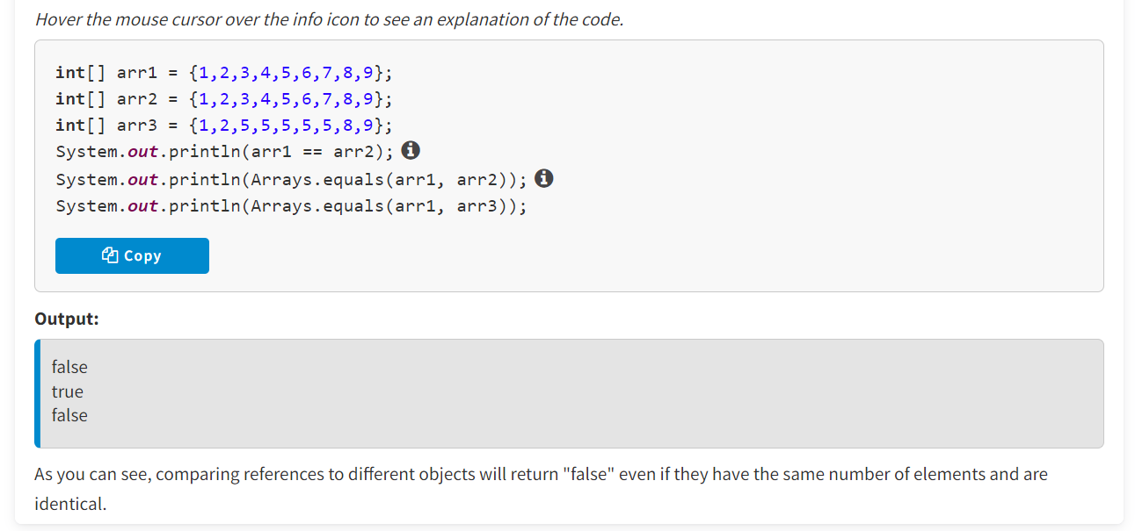

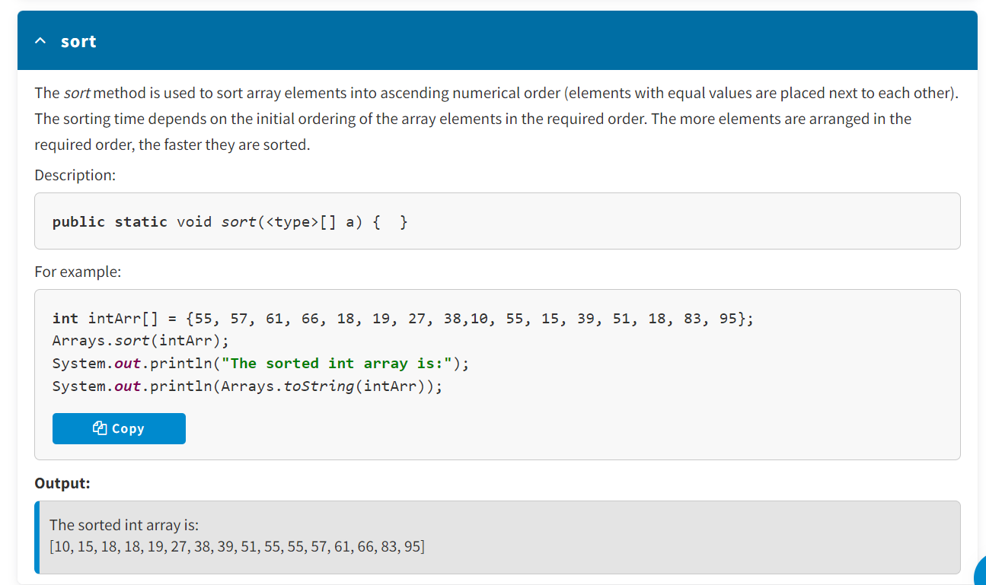

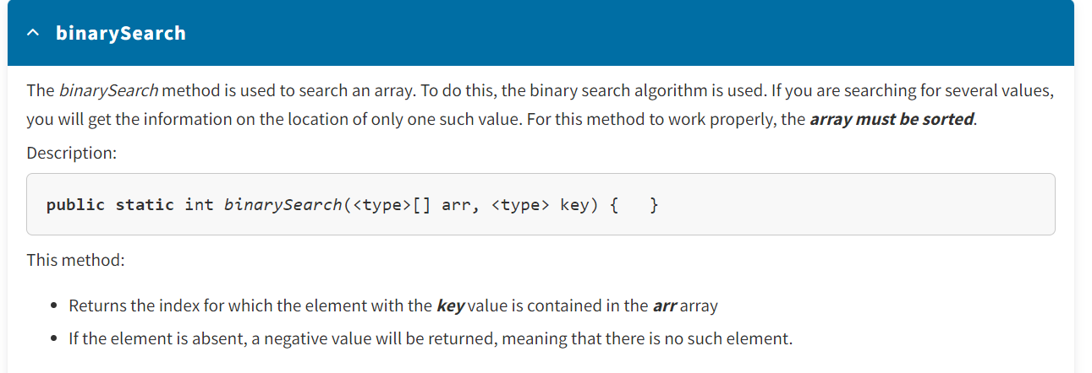

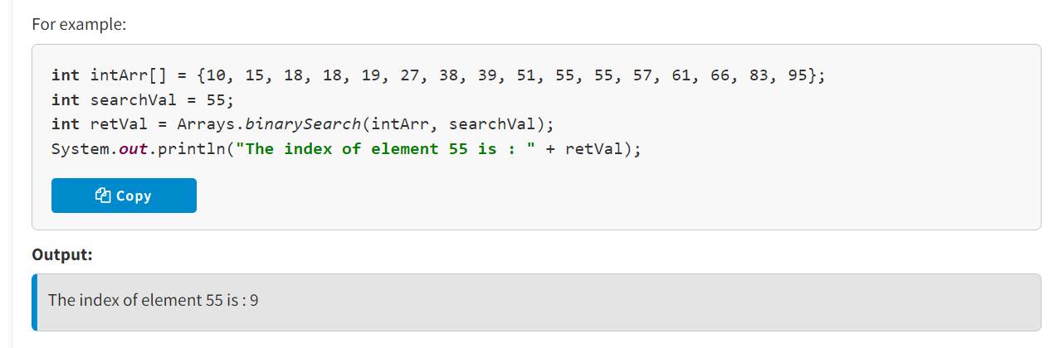

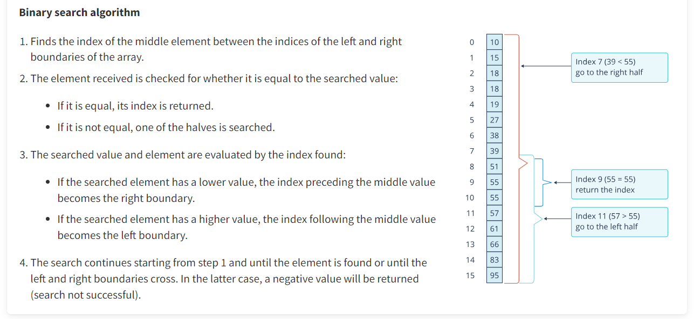

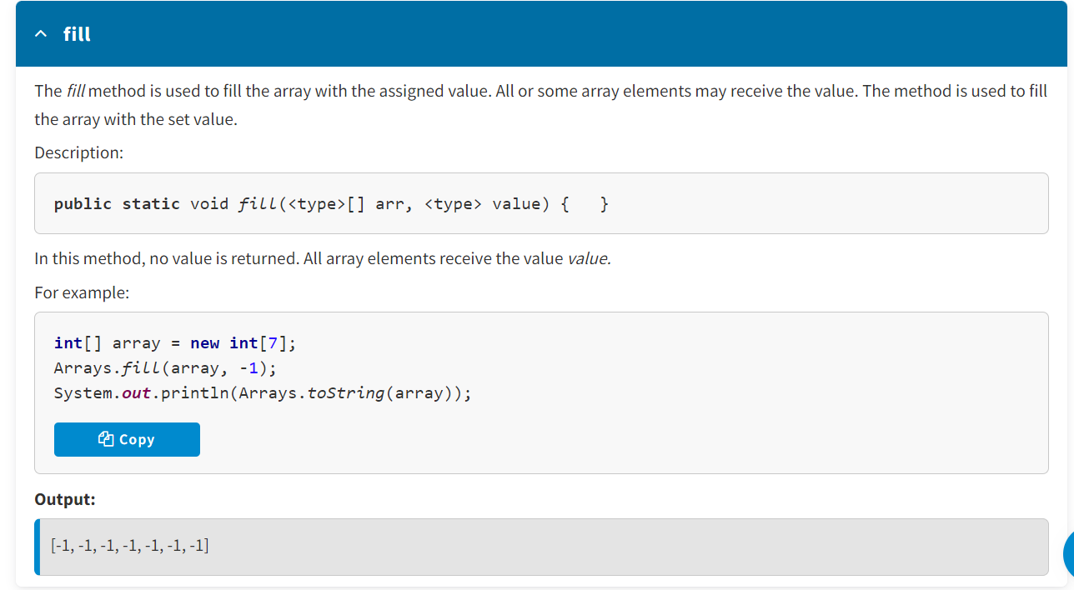

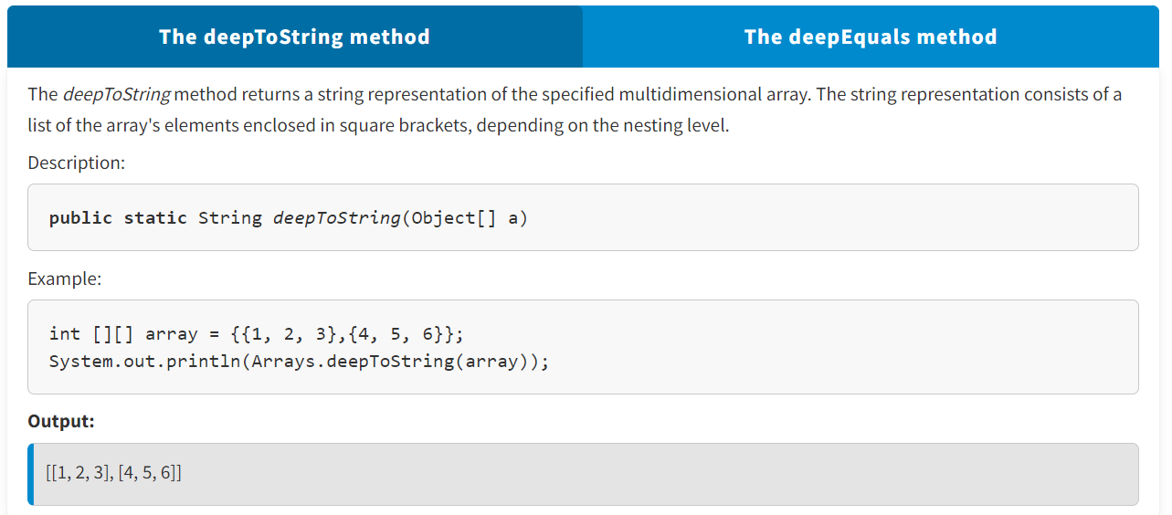

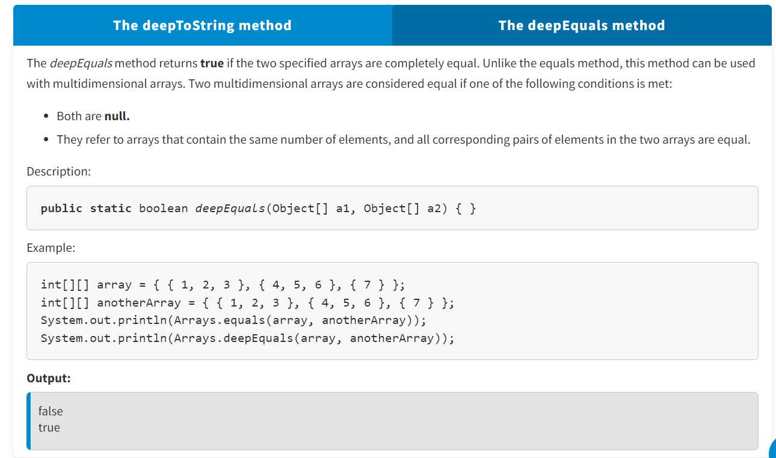

In this lesson, you studied the **Arrays** class and the following methods:

* *toString(array)* — returning a string representation of an array.
* *deepToString(array)* — returning a string representation of a multidimensional array.
* *copyOf(array, length)* — copying an array with a specific length.
* *equals(array1, array2)* — comparing arrays.
* *deepEquals(array1, array2)* — comparing multidimensional arrays.
* *sort(array)* — sorting the elements of a specific array into ascending numerical order.
* *binarySearch(array, element)* — searching a specific array for the element value and returning its index if the element is found.
* *fill(array, element)* — filling array elements with the value element.

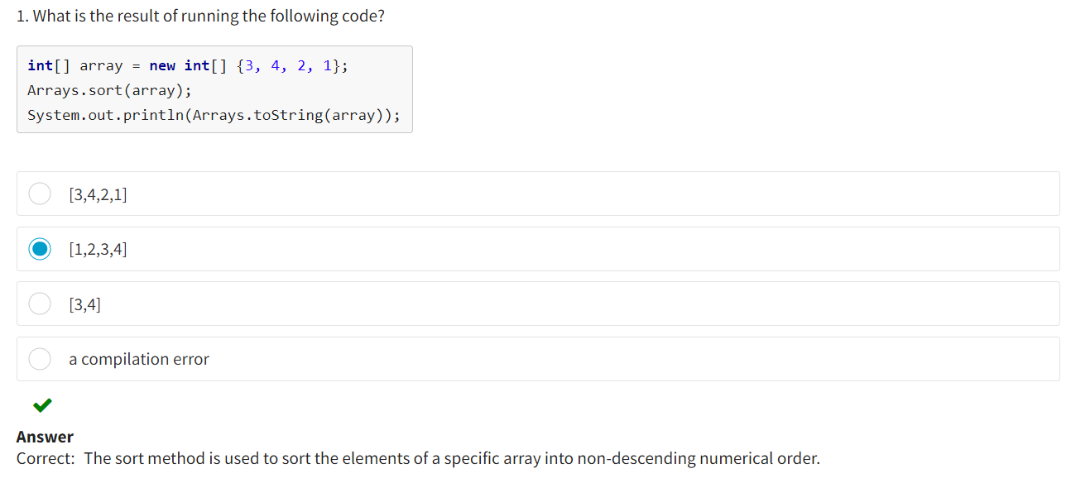

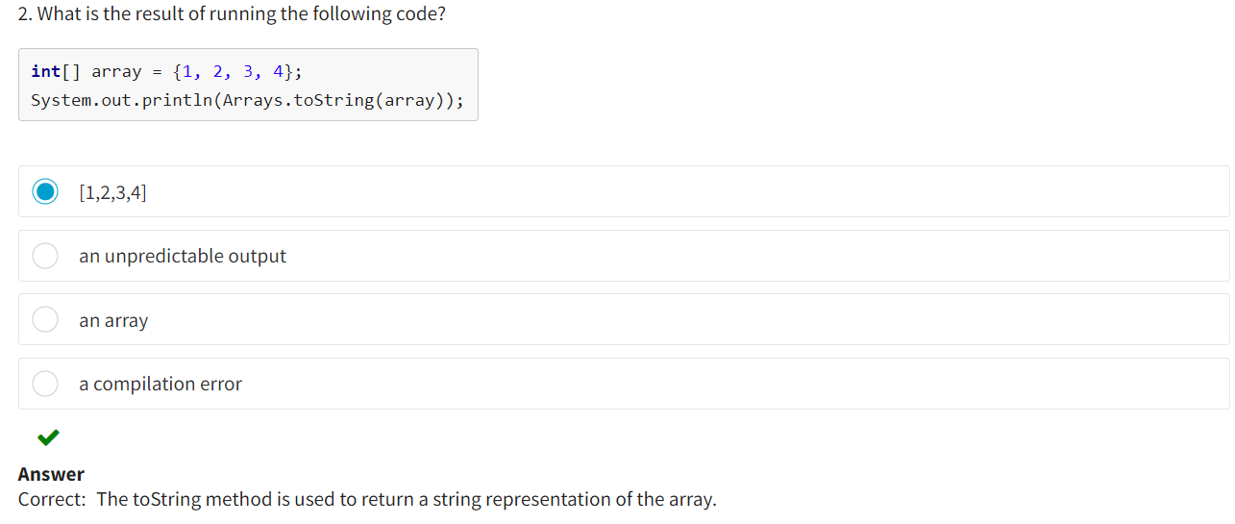

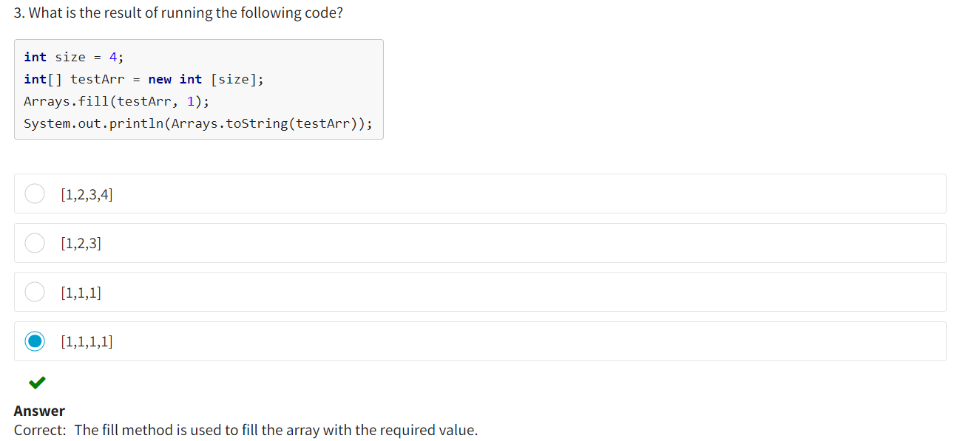

**CLASSES IN JAVA :**

**Concept of OOP**

As computers become more and more integral in all areas of society, software systems are becoming simpler for users but more complex in terms of their internal architecture.

Programming has become a team matter:

* A small project now means a project carried out by a team of 5–10 specialists in 6 months or more.
* A large project means a project that lasts for years and can be executed by hundreds of developers from around the world.

Modern information technologies and methodologies such object-oriented programming (OOP) and functional programming (FP) have become the main methods for creating complex software products.

First, let’s look at OOP in more detail.

**OOP** is an approach to software development based on the representing of a program as a collection of objects, where each object is an instance of some class, forming hierarchical structures. For example, a hierarchical structure of transportation would look like the following:

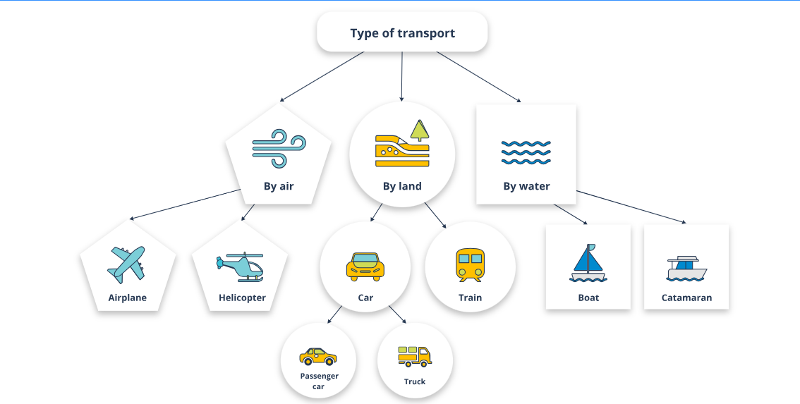

**History of OOP Development**

Let’s look at the two key stages that led to the rise of OOP.

The foundation for OOP was laid in the early 1960s. The first programming language to work with objects was **Simula 67,** which was developed to create simulations of marine vessel explosions. The authors grouped marine vessels into various categories and assigned classes to them. Thus, Simula not only introduced the concept of class but also presented a working model of OOP. Simula 67 was an innovative system that later became the basis for the development of a large number of other programming languages, including Pascal and Lisp.

OOP gained popularity in the second half of the 1980s. The term itself was first used by Xerox PARC in the programming language **Smalltalk** to denote the process of using objects as a basis for computing. The developers designed their language to be dynamic: Objects could be modified, created, or deleted, distinguishing it from the static systems that were popular at the time. This programming language was also the first to use the concept of *inheritance.*

According to many experts, the object-oriented approach will remain the primary paradigm in programming development in the decades to come.

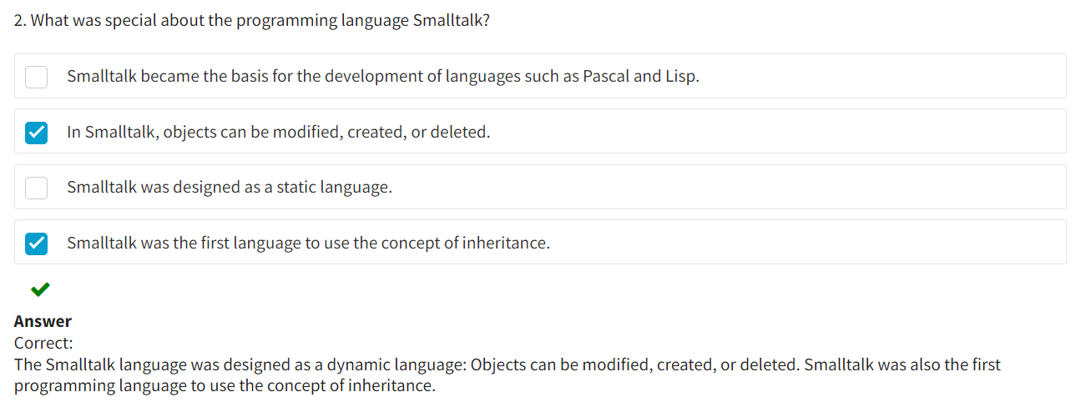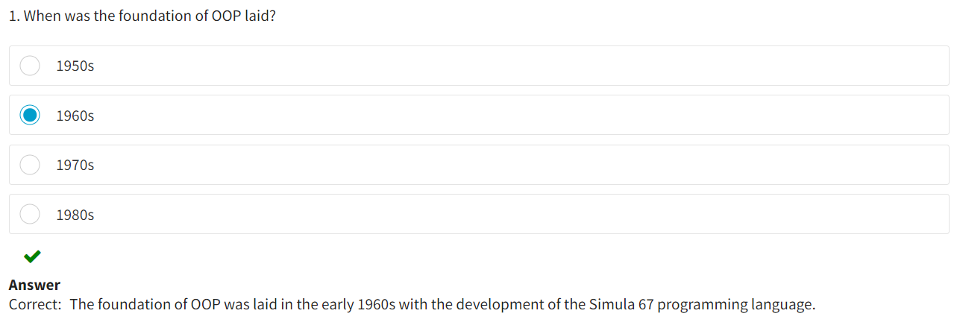

**Classes and Objects**

Classes may be viewed as certain descriptions, schemes, or drawings according to which objects are created. In one class, you can create an unlimited number of objects, each with the same behavior and set of features.

For example, if you have a schematic (class) of a bicycle, you can create different bicycles (objects) with the same number of wheels and a similar rotating pedal mechanism and brake system.

**Class**  
A **class** is a template describing multiple similar objects in the real world or in a virtual world. This set of objects should have the same set of characteristics (fields/properties) and the same set of actions that can be performed with these objects by changing their internal state. For example, changing the positions of a bicycle's pedals sets it in motion. In other words, the mechanism of pedal rotation is the method of the class.

**Object**  
An **object** is an instance of a class. For example, each bicycle has its own color, weight, and different components. These are its features/characteristics. For each created object, these characteristics have their own values that are specific to the object.

When creating an object, you consider mechanisms to teach the object to perform various operations. You can teach a bicycle to analyze its surroundings, make decisions, and perform certain actions communicated by the bicyclist. Now imagine that you have created a description of that object as a template. Using this template, and with the help of the program, you have made 500–600 such "bicycles." Each "bicycle" has a set of parameters: a certain number of wheels, a handlebar and two pedals, and the ability to switch gears. By placing them in certain circumstances, you can set them in motion. And here you should mention the fundamental difference between a class and an object:

A class is a description, while an object is a materialization.

In other words, a **class** is an abstract type of data type that determines the form and behavior of an **object** with the help of fields and methods:

* Fields are properties (data, attributes) that represent the content and the state of an object.
* Methods are functions that determine an object’s behavior. They describe operations performed with data.

The briefest description of an object is offered by Grady Booch: "An object has a state, behavior, and identity."

Let's sum up what classes are and also try to answer several questions:

* What groups of classes exist?
* How can you create a class?
* What do classes of different groups contain?
* What has to be considered when designing classes?

**Describing a Class**

When defining a class, you declare its specific form and behavior. To do this, you specify the fields it contains as well as the methods used to operate these fields. The simplest classes may contain only methods or only fields, but most real classes contain both.

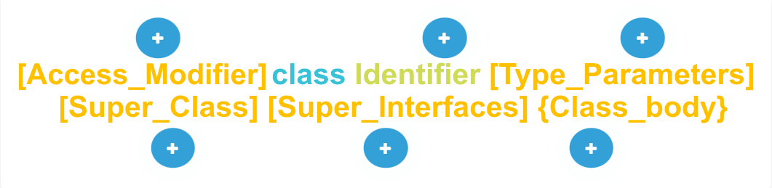

**Access_Modifier**  
**Access_Modifier** establishes the rules for using a class (visibility scope).

**Identifier**  
**Identifier** is the name of a class (that is, the data type).

**Type_Parameters**  
**Type_Parameters** determine the generality of the class data.

**Super_Class**  
**Super_Class** defines a class’s parent class.

**Super_Interfaces**  
**Super_Interfaces** determine a class’s additional behavior.

**Class_body**  
**Class_body** determines the fields and methods of a class.

Most of the aspects of declaring a class will be discussed later in the course.

A correctly constructed class should determine one and only one logical entity. For example, a class that stores a user's personal data usually does not contain data about the equity market, average precipitation, sunspot cycles, or other irrelevant information. Thus, a correctly constructed class should group logically related information. If unrelated information is placed inside a class, the code structure is quickly broken.

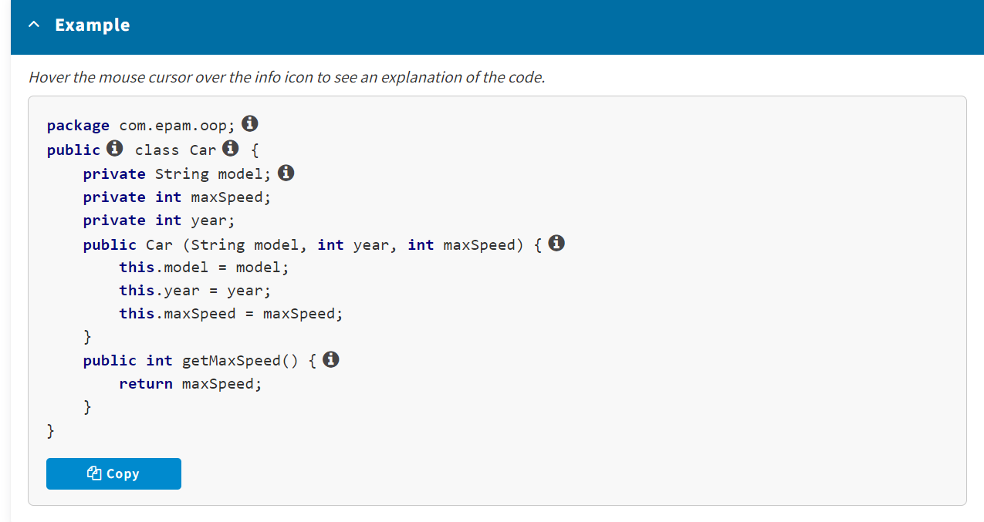

Thus, when declaring a class, you should declare its specific form and behavior. To do this, specify the fields it contains and the methods used to operate these fields.

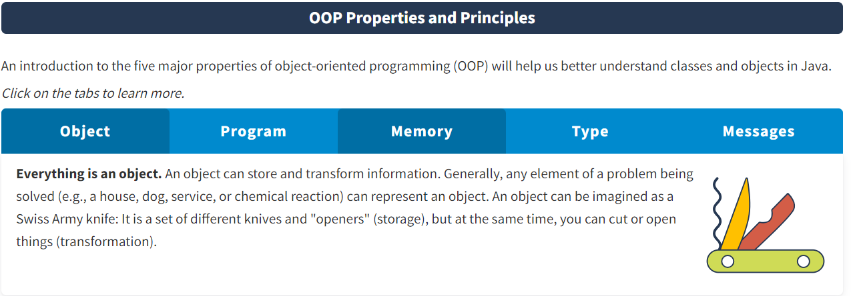

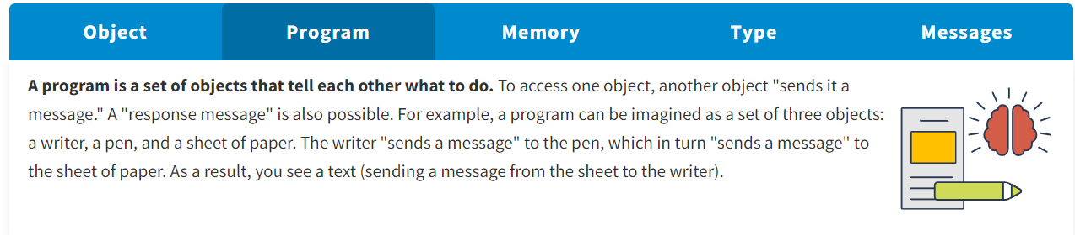

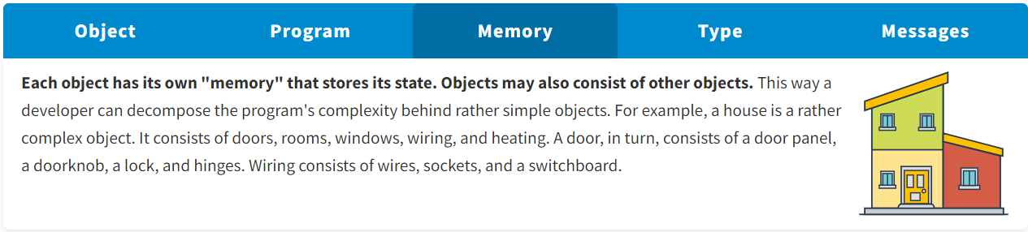

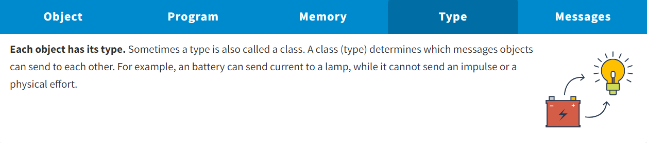

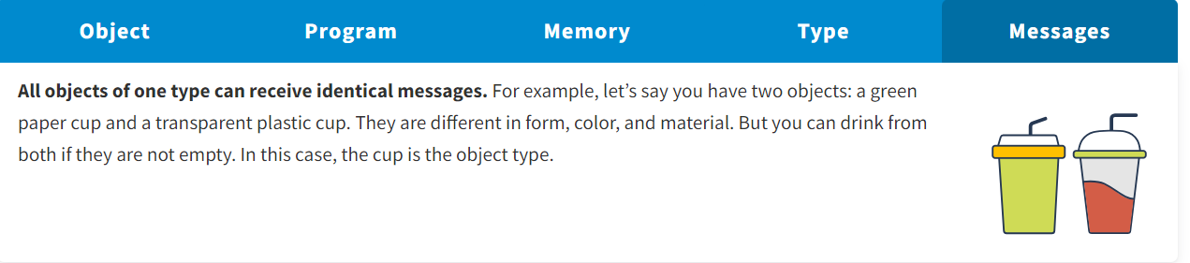

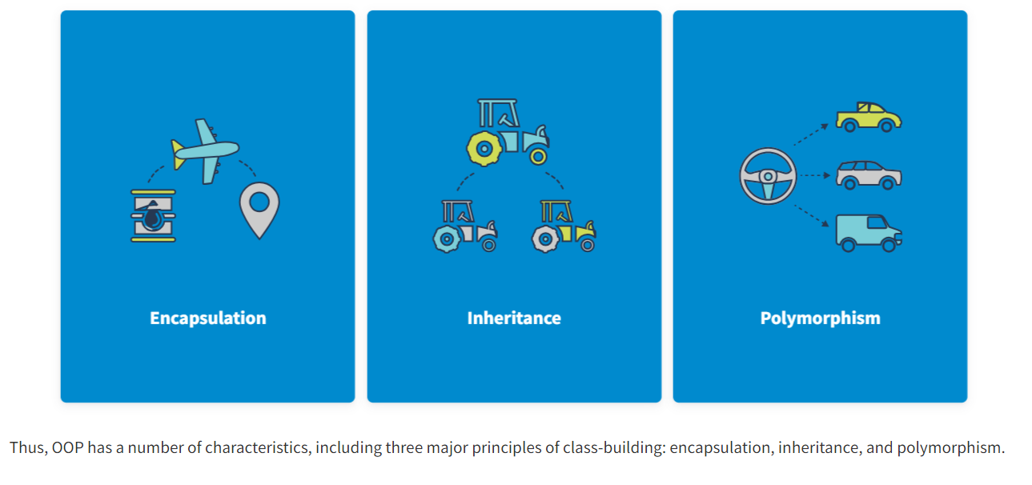

**Encapsulation** is a property that allows data—and the methods used to work with it—to be consolidated in a class while hiding the implementation details from users.

**Inheritance** is a property that allows a new class to be created based on an existing one, and in which the properties of the parent class will be assigned to the child class.

**Polymorphism** is the ability to provide a single interface to entities of different types.

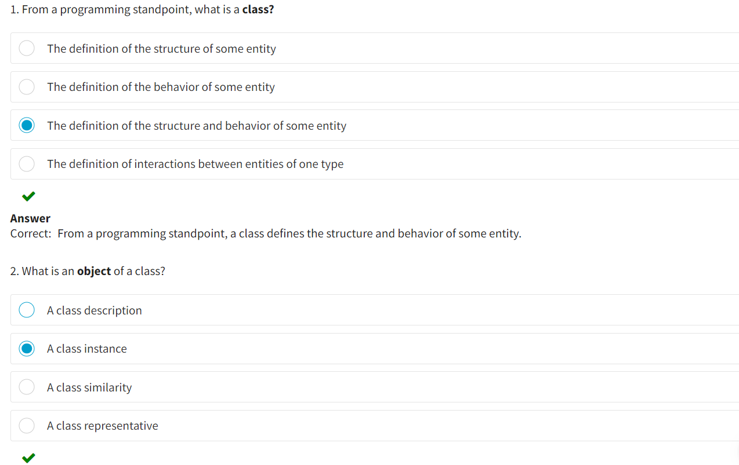

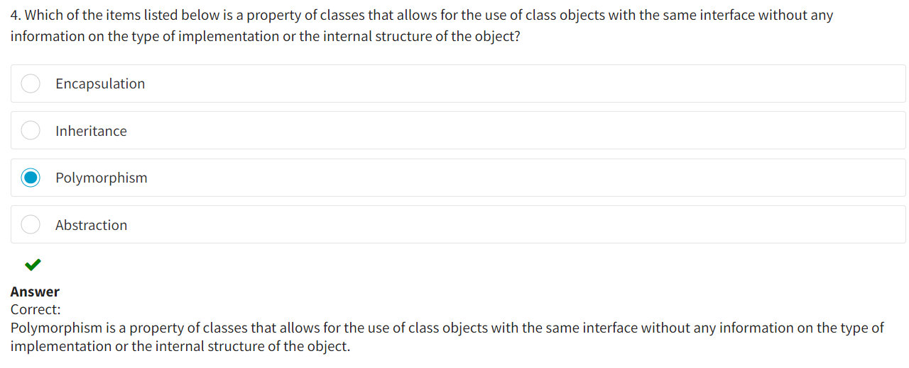

**The Concept of a Field**

You already know that when declaring a class, you should declare its specific form and behavior. To do this, you specify the fields it contains as well as the methods used to operate these fields. So, what exactly is a field? A **field** is a declaration or description of a variable.

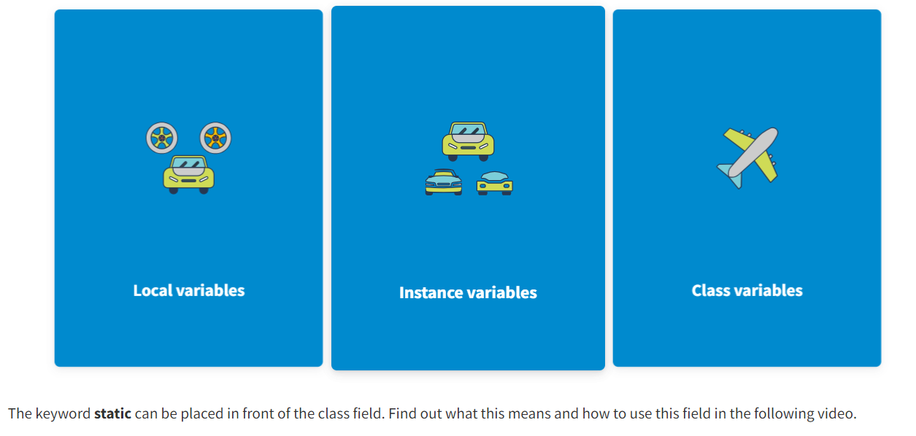

**Local variables** are defined inside methods, constructors, or blocks. They are declared and initialized in these constructions and destroyed upon exiting them.

**Instance variables** are defined within a class but outside of methods. They are initialized when a class object is declared. These variables are available inside a method of the instance, constructor, or block of the initialization.

**Class variables** (static variables) are declared in the class body outside of a method using the keyword **static.** They are initialized when a class is formed and available in all methods, constructors, and blocks of the initialization.

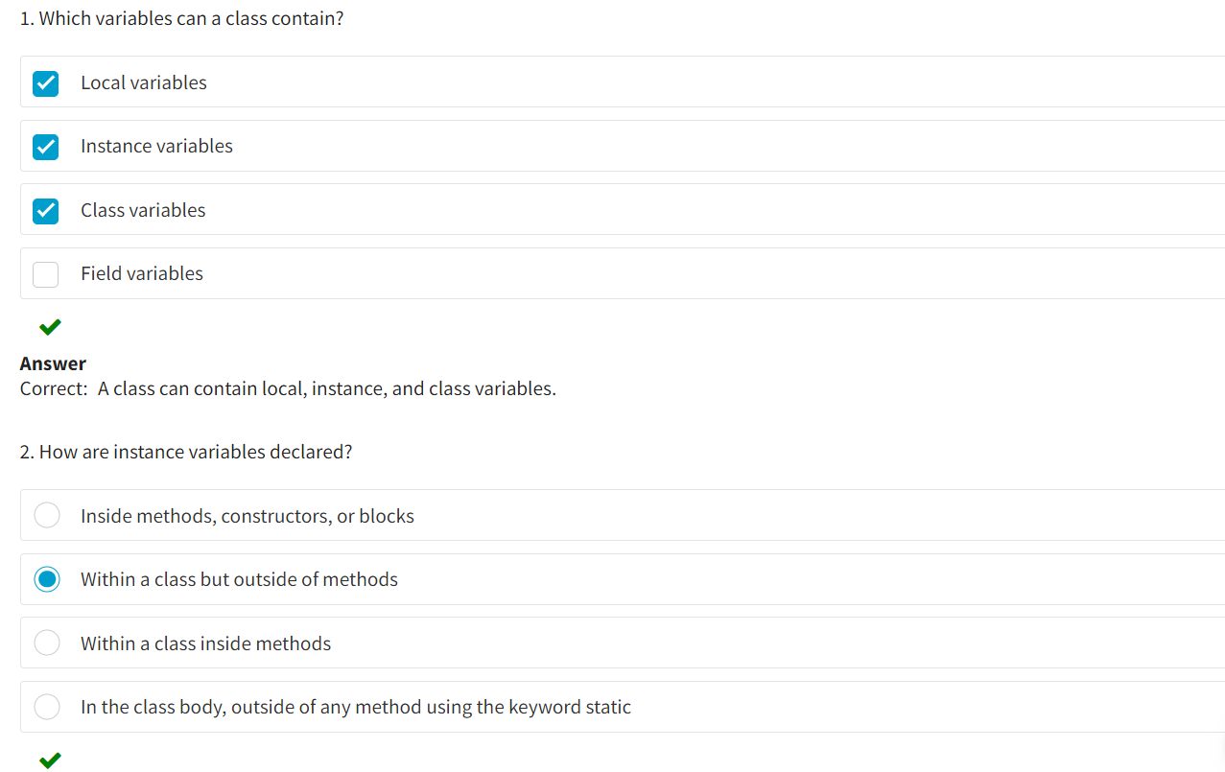

**Methods**

**Methods**are functions that are declared within a class. They are used to execute actions with class data (fields) and give access to this data. They contain declarations of parameters, local variables, and Java statements that are executed when a method is called. Methods can also return the result of their work to the code calling them. They can also accept parameters (arguments) that are values provided by the code that called the method.

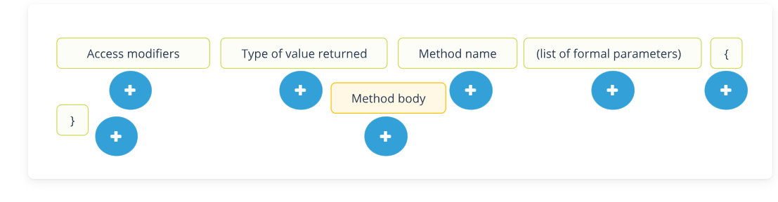

**Access modifiers**

Access rule (optional code element).

**Type of value returned**

Methods can return the result of their work or not return this result (a mandatory code element).

**Method name**

Method identifier (mandatory code element).

**(list of formal parameters)**

The data to be processed is passed via a list (The data itself may be absent, but the round brackets are mandatory).

**{**

A method body is opened (block starting).

**}**

A method body is closed (block completion).

**Method body**

Statements that solve the problem (method body can be empty).

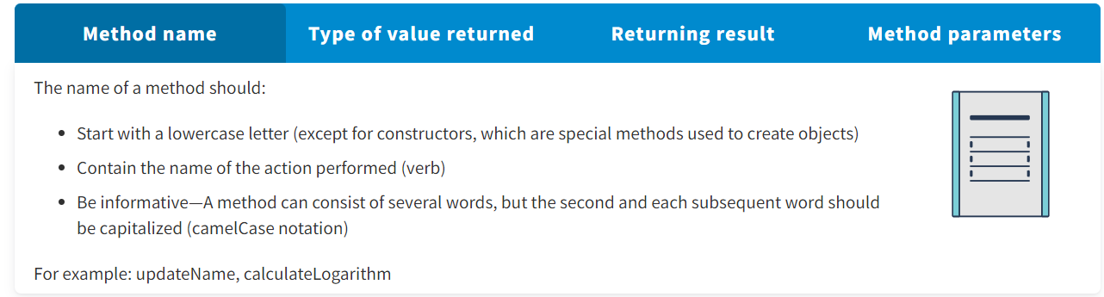

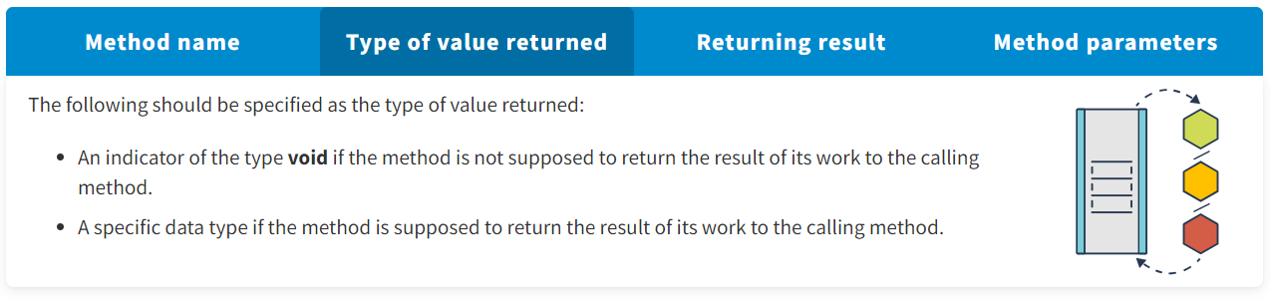

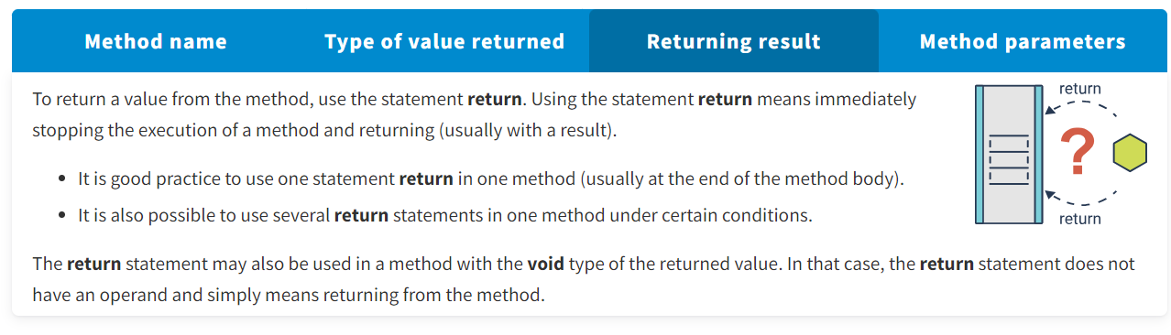

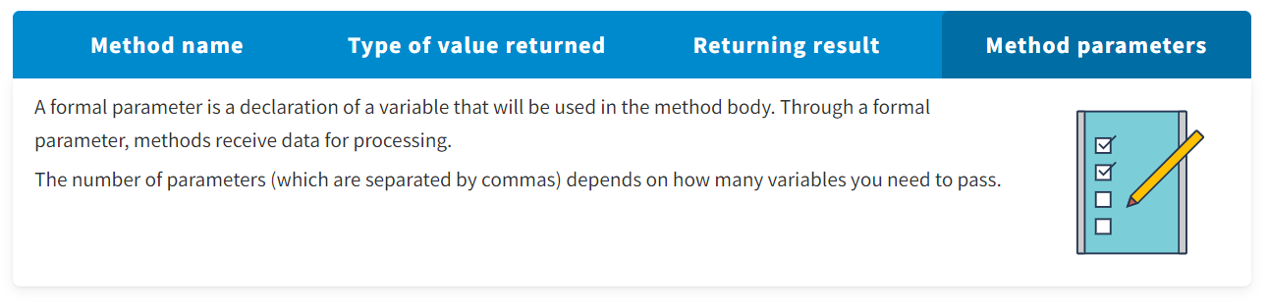

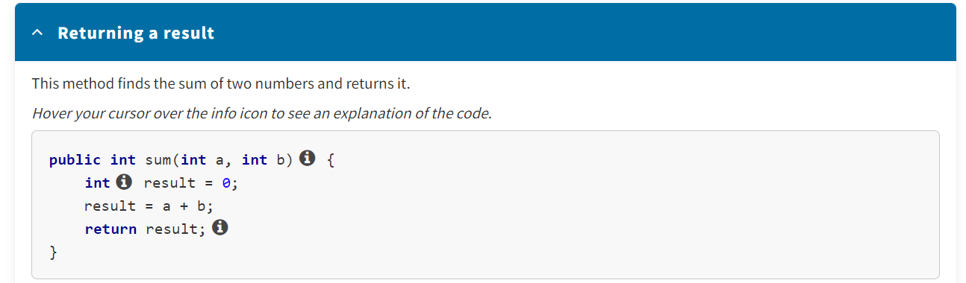

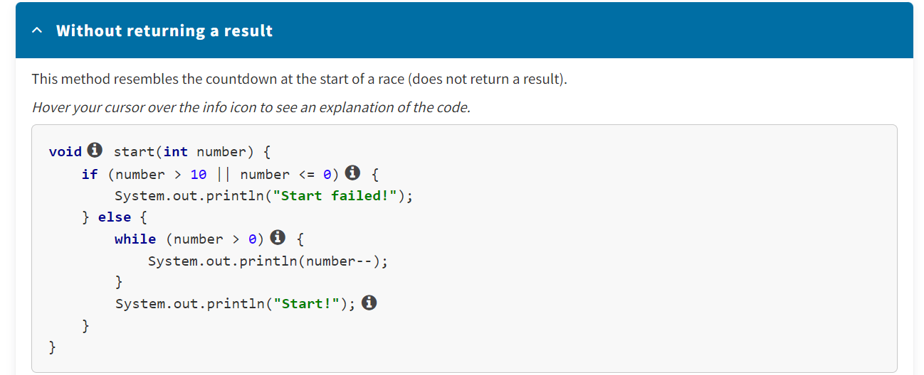

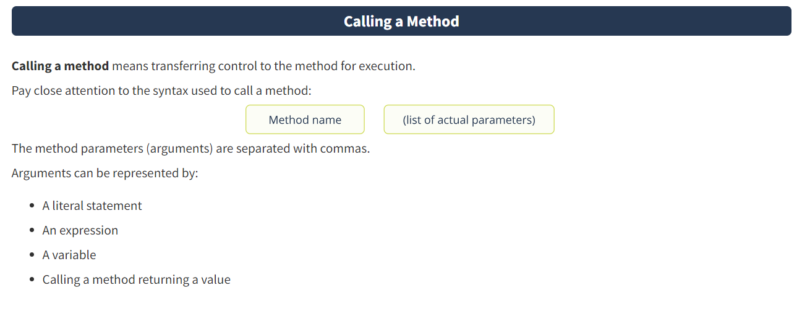

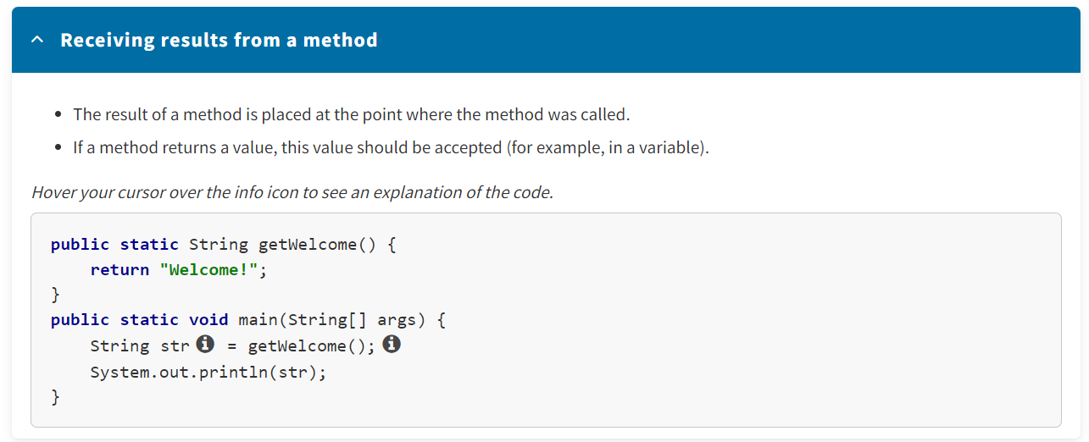

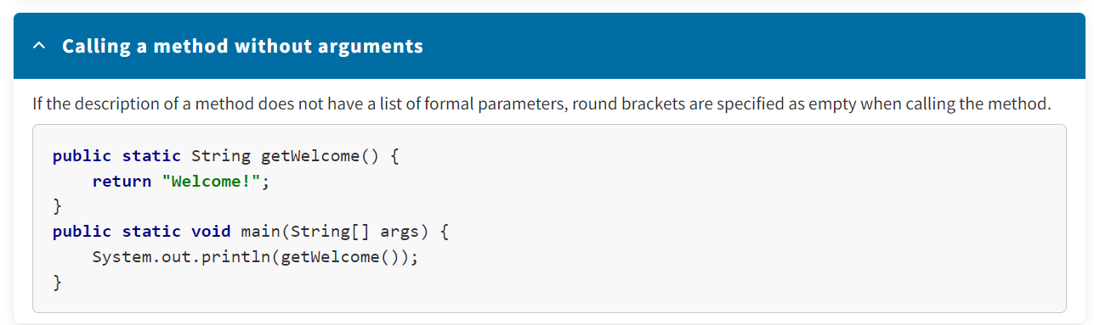

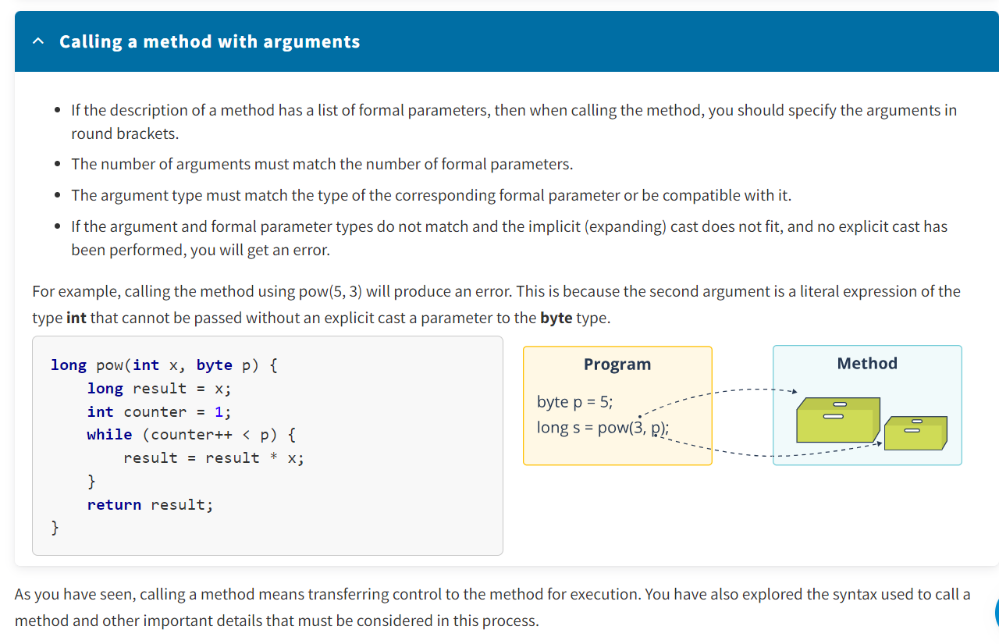

**Ways to Pass Arguments to Methods**

To do its job, a method may require some data.

* A value passed to a method is called an **argument**.
* The variable that receives the argument is called a **formal parameter** or simply a **parameter**.

Parameters are declared in round brackets after the method name. The syntax for declaring parameters is the same as for variables. The scope of parameters is the method body. Multiple parameters can be defined in a method, and they are separated with commas.

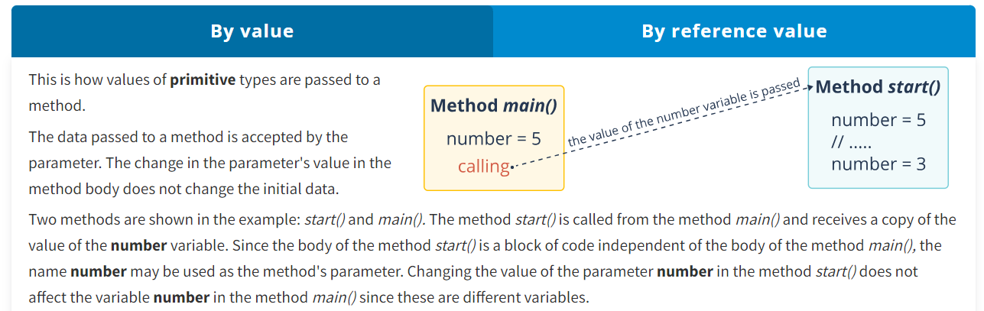

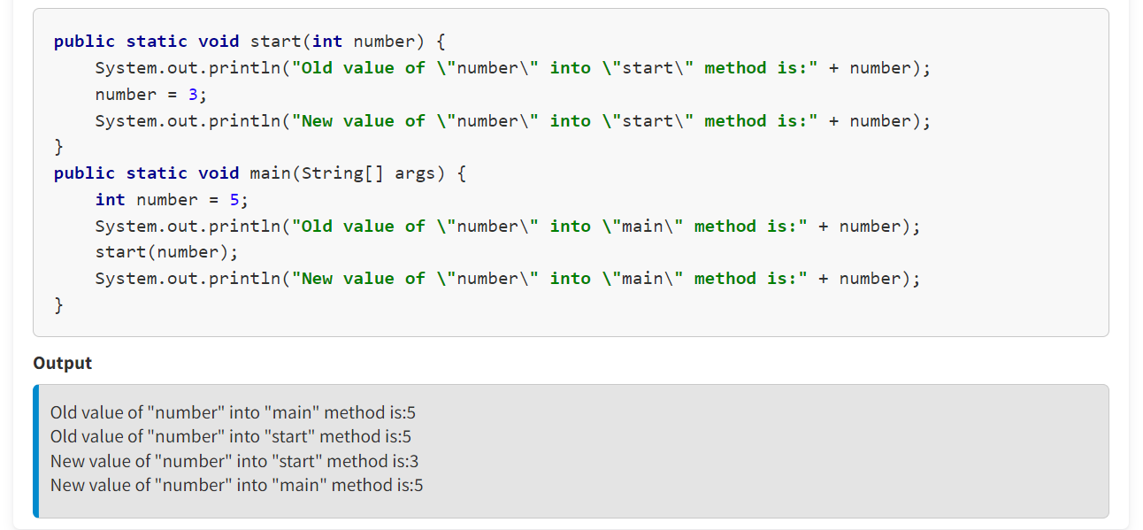

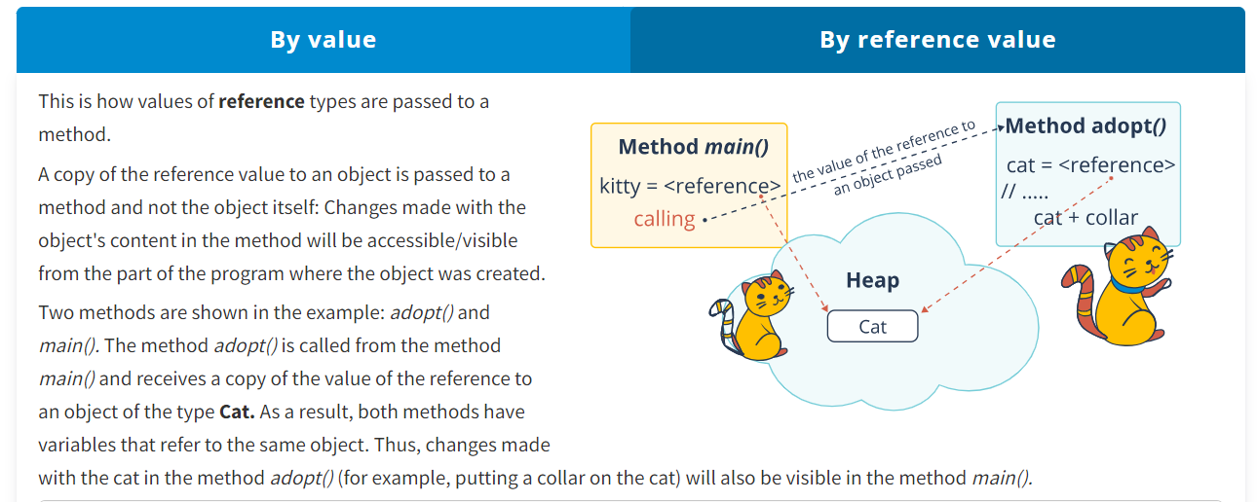

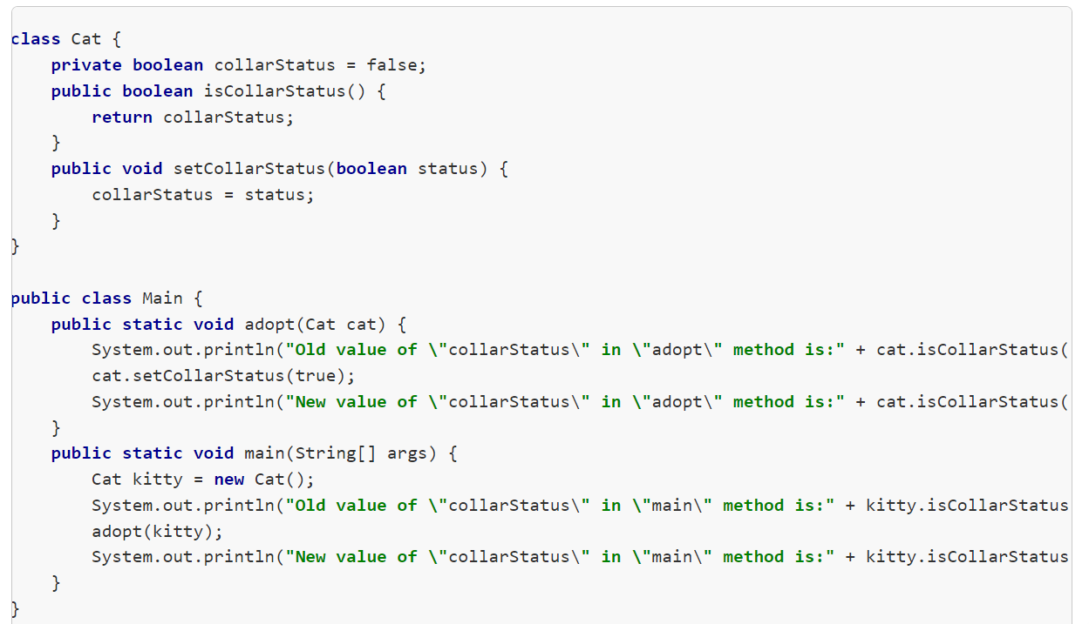

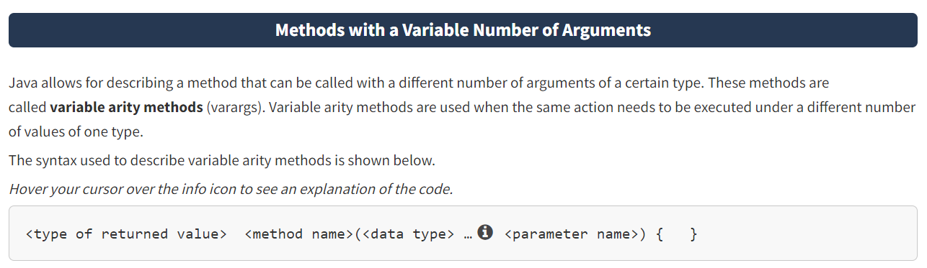

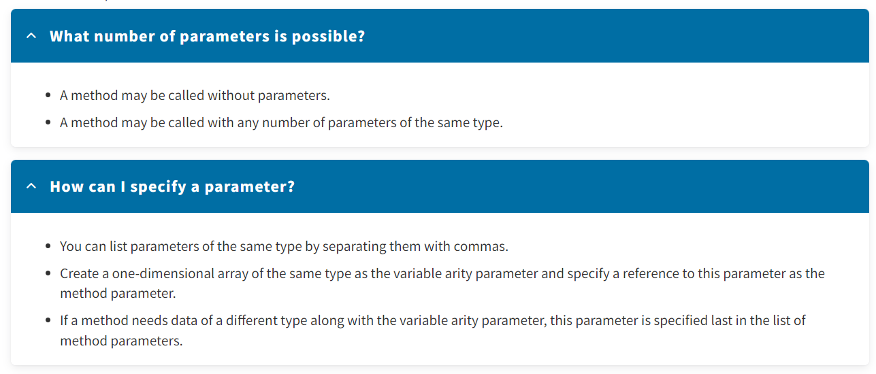

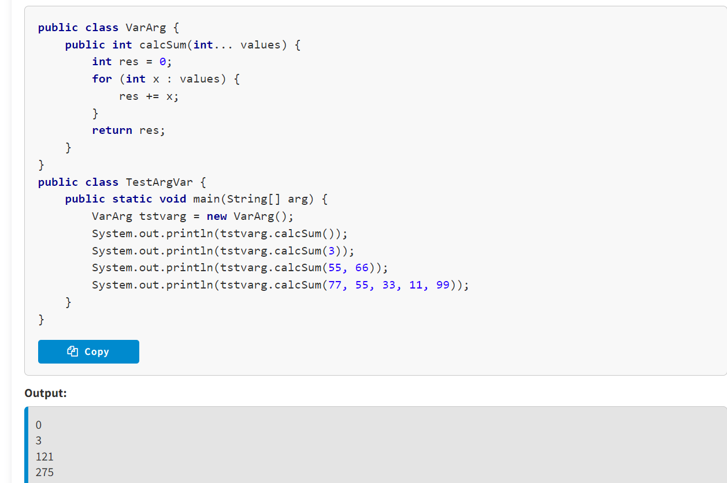

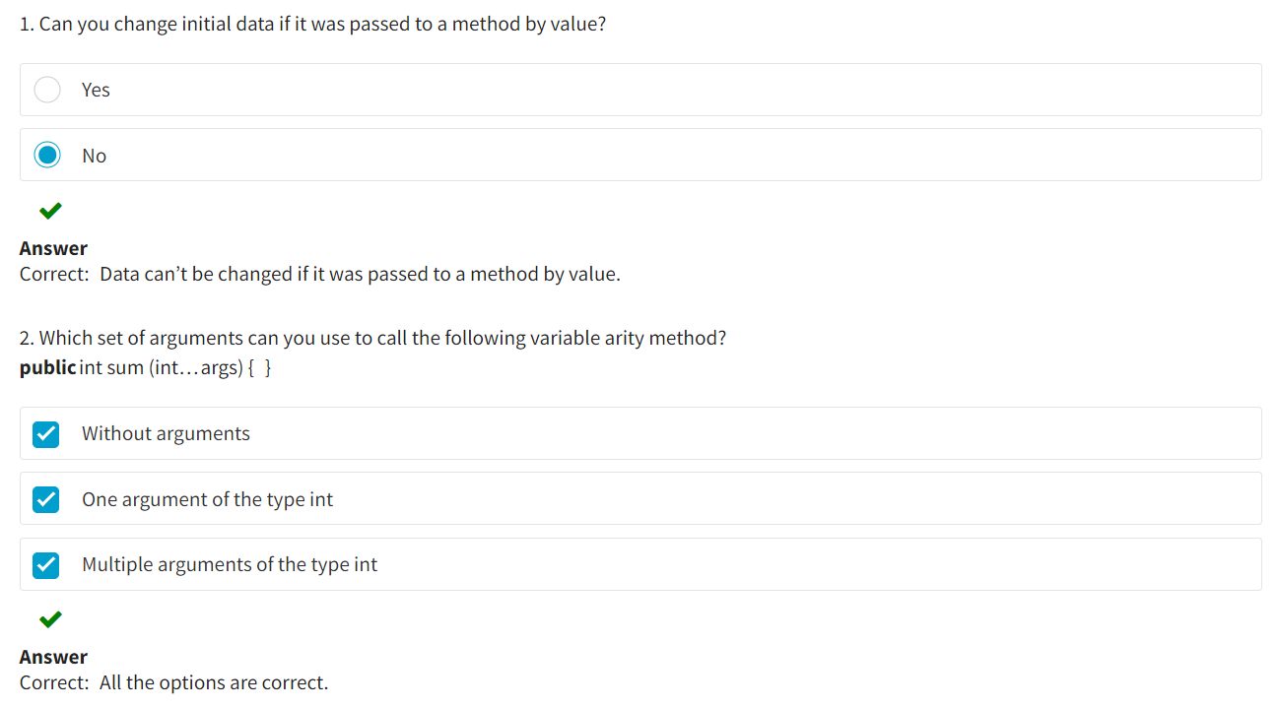

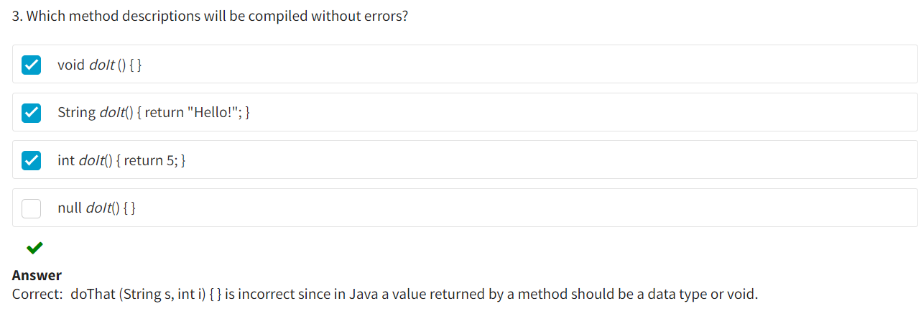

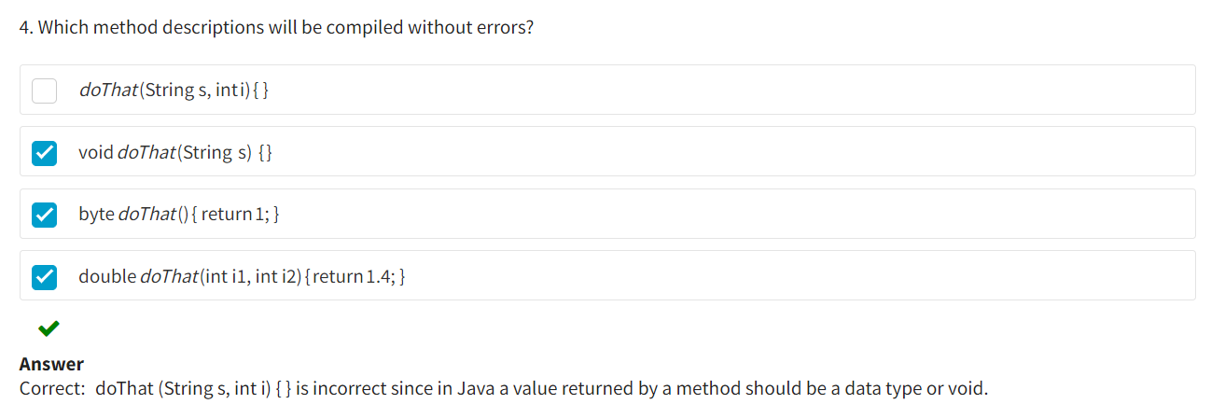

**The Keyword *this***

As you already know, you can create several objects of the same type. Each object will contain its own copy of fields with its own values. However, methods are not duplicated, which raises a question: How can a method understand with which set of field values (objects) it is being executed at a given time? In other words, a method needs information on the object that called it.

The keyword **this** is a reference to the current object inside a class, that is, the object for which a method or constructor is being executed. The word **this** is used to access any member of the current object inside the instance method or constructor.

For example, suppose you have the class **Car**. This class has a field with the name **speed**, and the method *setSpeed()* has a parameter with the name *speed*. Inside this method, the parameter overlaps with the field's visibility scope. To signify a reference to the current object, the reference **this**  is added before it (accessing the current object's field).

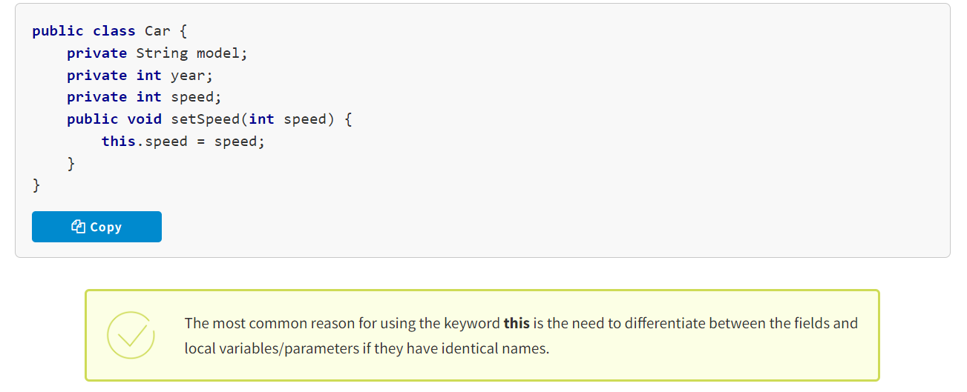

**Methods for Accessing Closed Class Fields**

There are special methods for accessing closed class fields:

* A **getter** is a method for receiving the value of a field. The method name starts with the verb **get** and then follows the name of the field in camelCase style.
* A **setter** is a method used to set the value of a field. The method name starts with the verb **set** and then follows the name of the field in camelCase style.

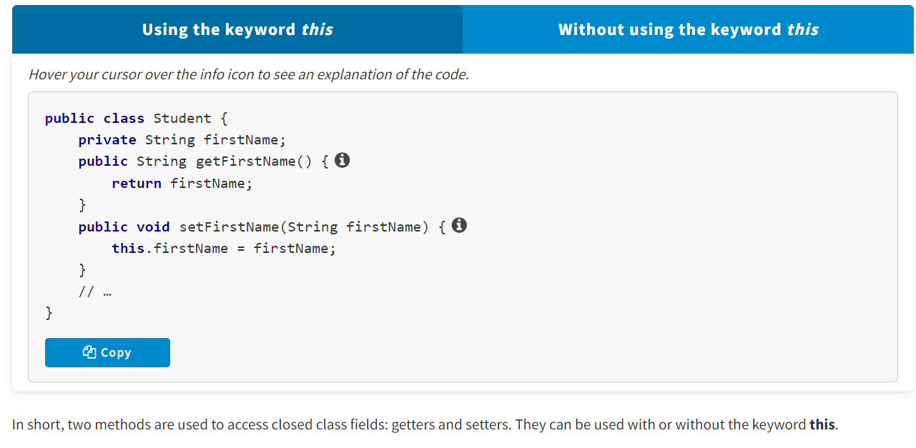

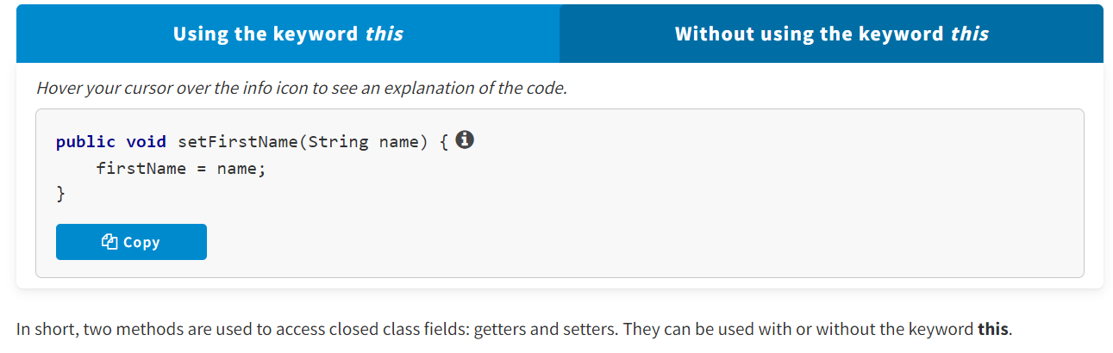

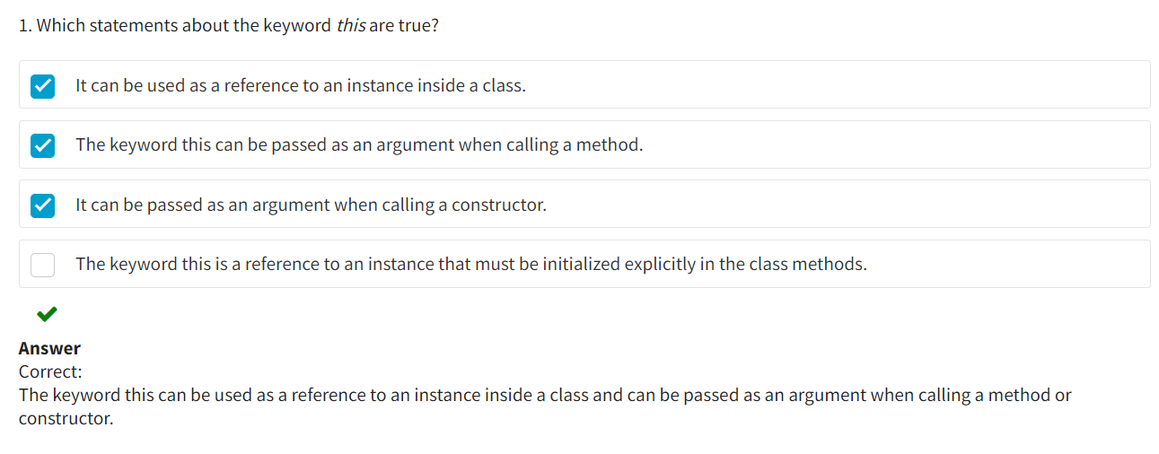

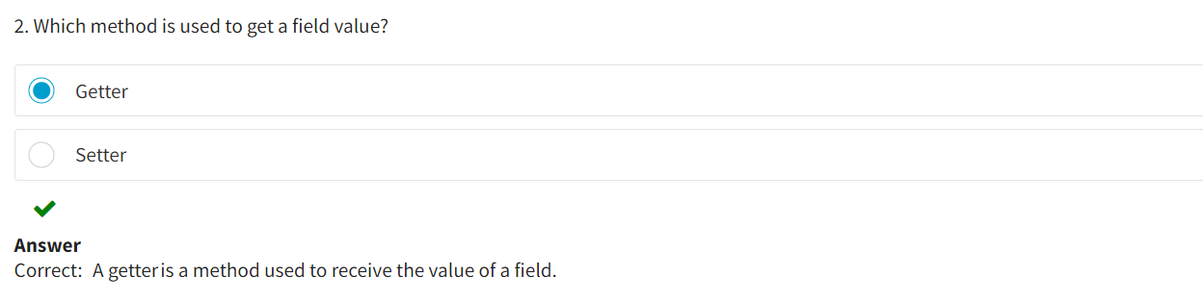

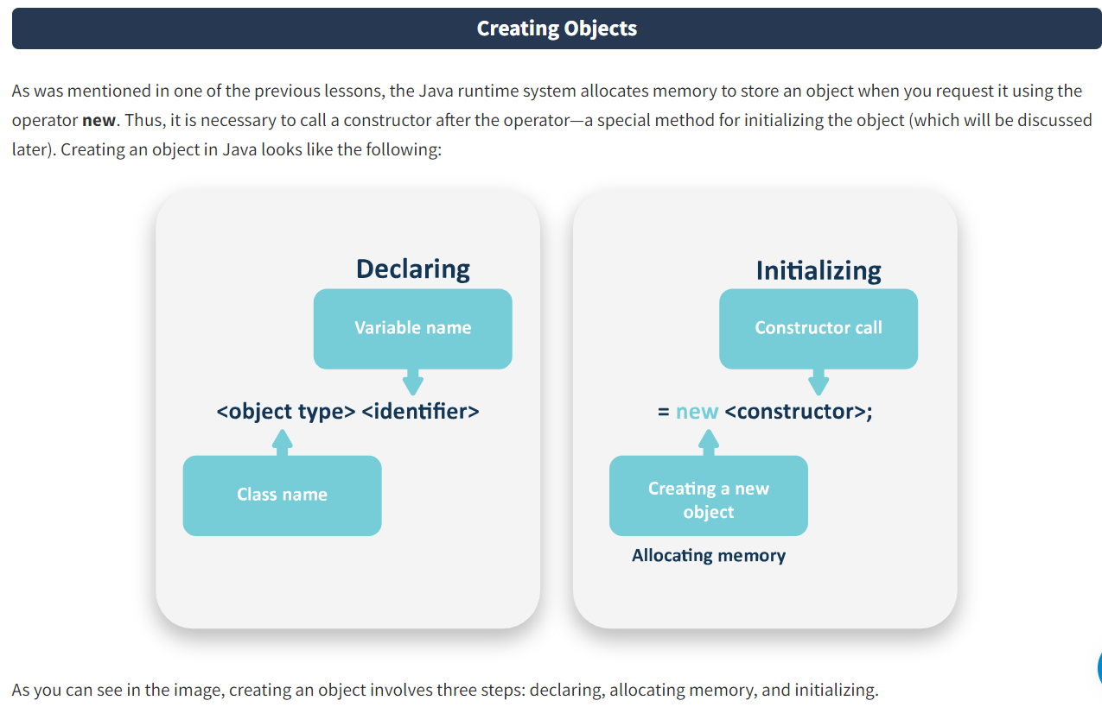

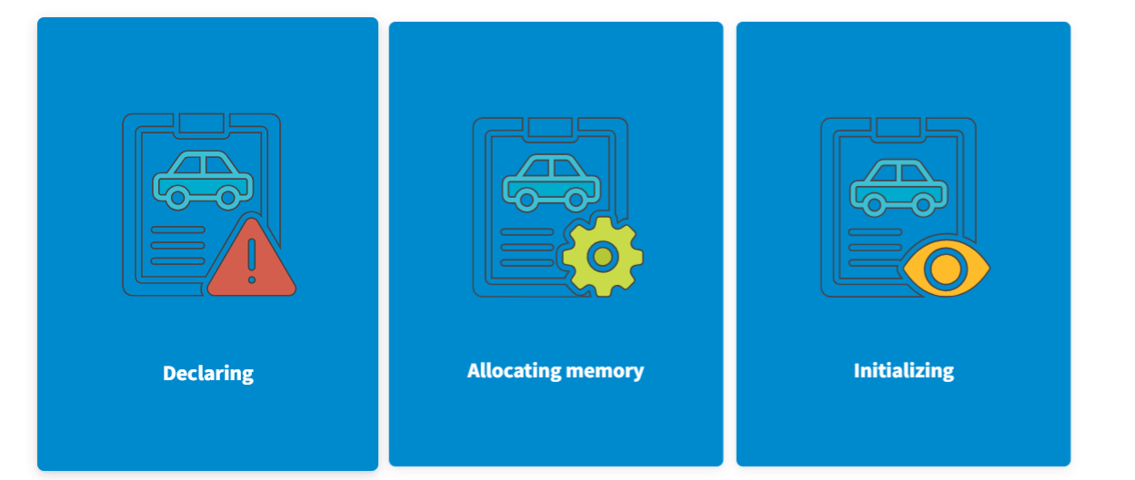

Linking the name of a variable with the object type—that is, creating a reference variable to store the memory address where the object is placed.

A request to allocate memory to store the object (which is always done using the operator/keyword **new**)

Calling a constructor whose task it is to initialize the object being created (which comes paired with **new**).

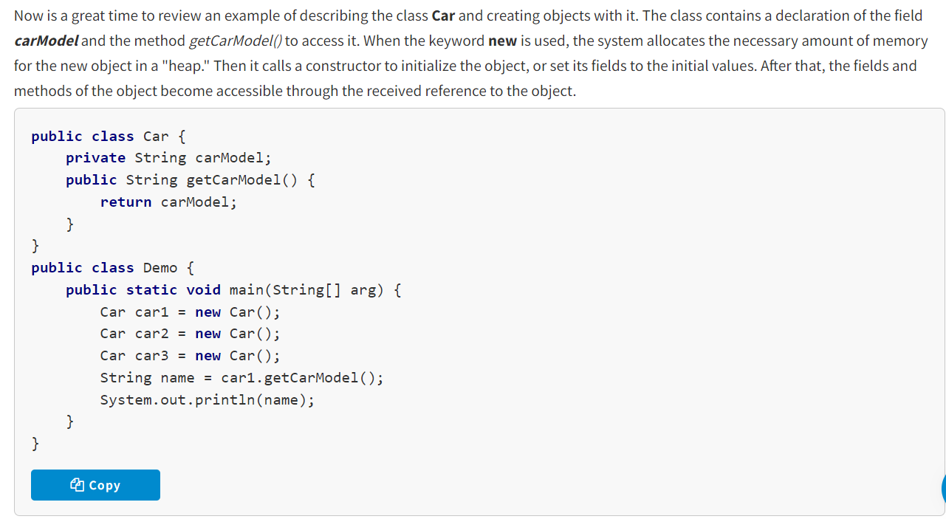

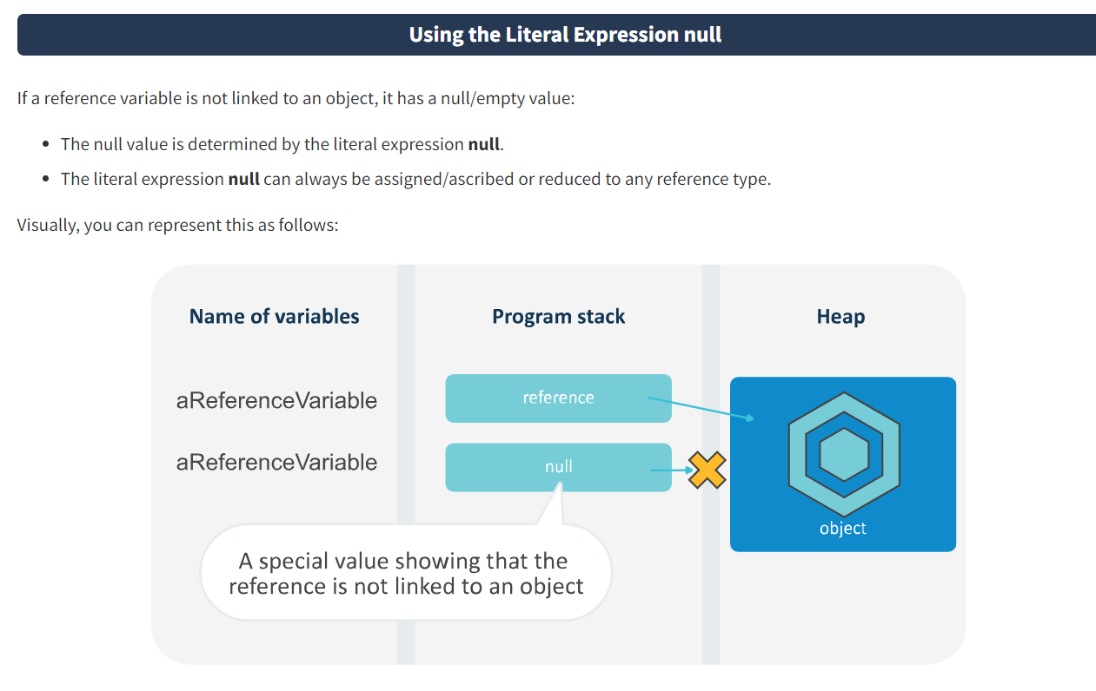

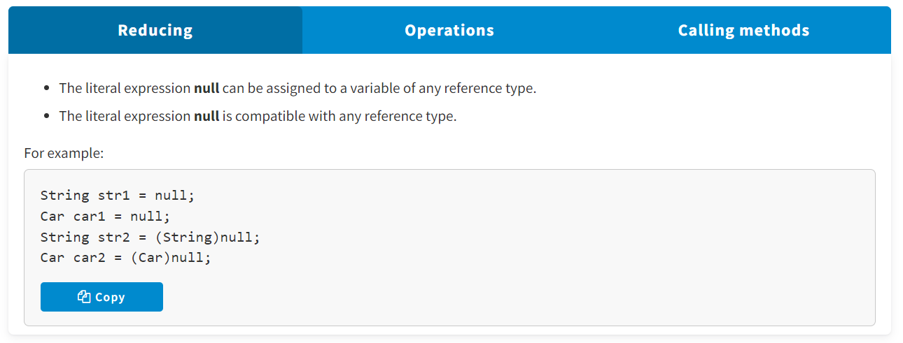

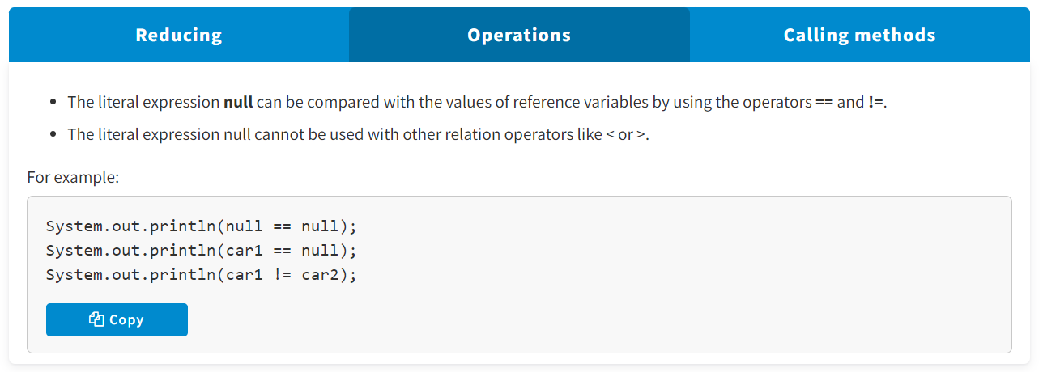

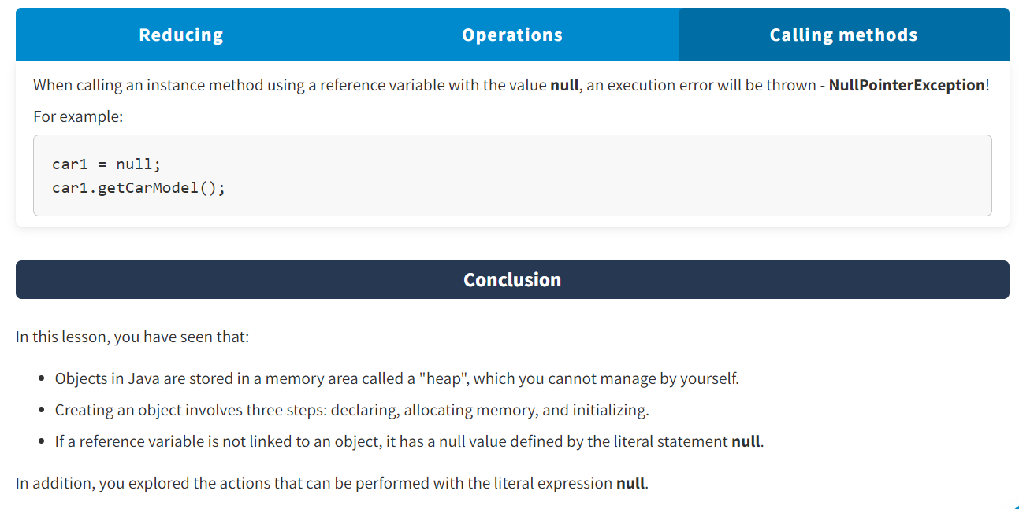

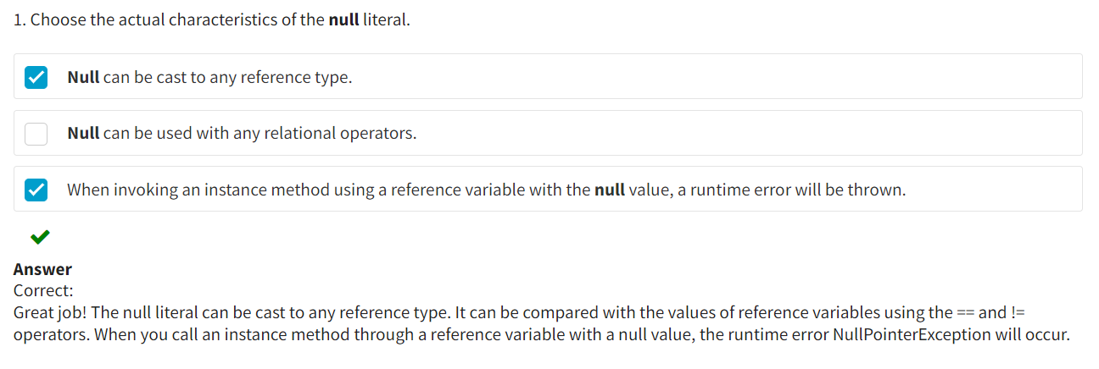

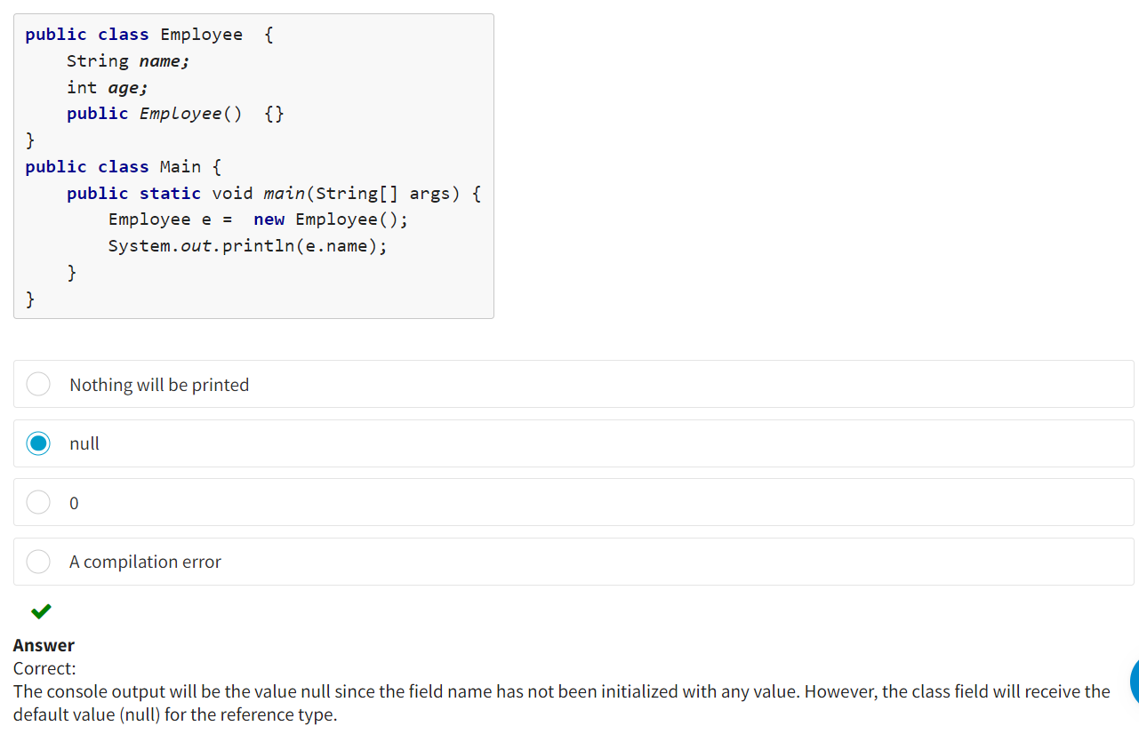

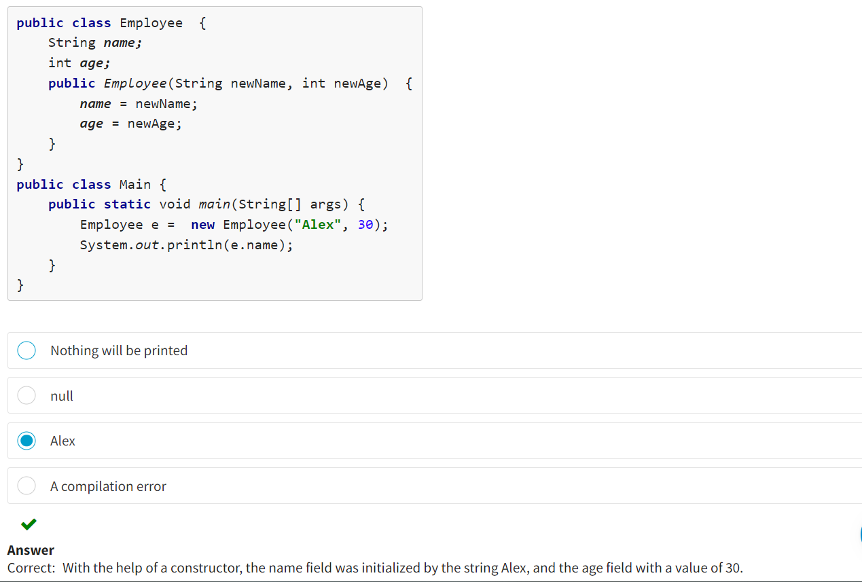

**What Are Constructors?**

**Constructors** are special methods that initialize fields with initial values and implicitly return an object of the class where they are defined. Constructors accept data used to initialize an object.

Constructors are used to initialize an object when it is created. As a rule, they are used to specify initial values for an object's fields specified in a class or to perform any other actions required to create a fully formed object.

Java provides constructors automatically. Thus, all classes have constructors, regardless of whether you define them in the class body explicitly. A constructor initializes all fields of an instance/object with its default values:

* For most data types, the default value is zero.
* For the Boolean type, the default value is **false**.
* For the reference type, the value is **null**.

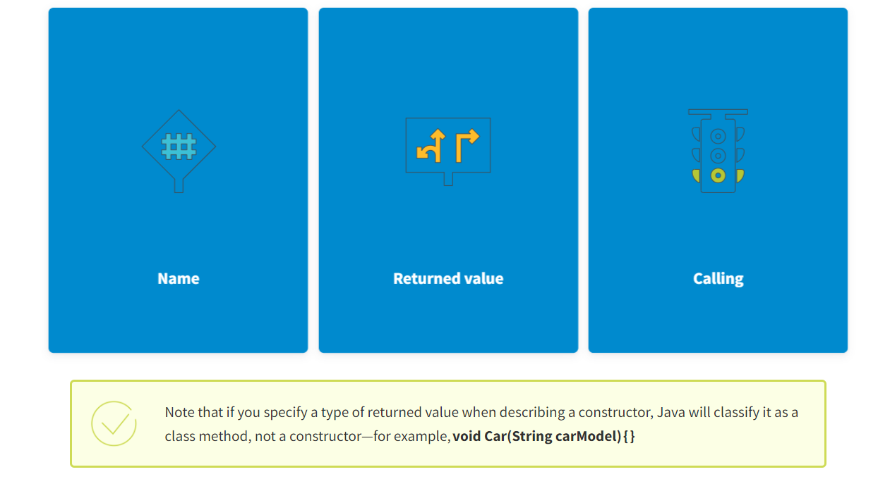

A constructor’s name matches the class name, including the letter case. In terms of syntax, a constructor is similar to a method without a returned value.

A constructor has no explicitly specified type of returned value since it always returns a reference of its own class.

Outside of a class, a constructor can only be called using the operator **new**.

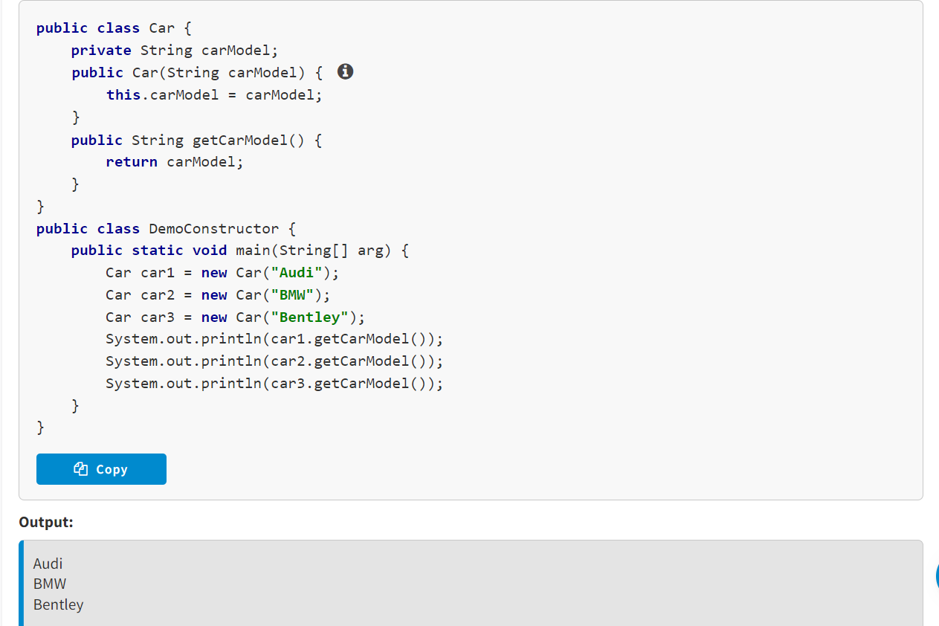

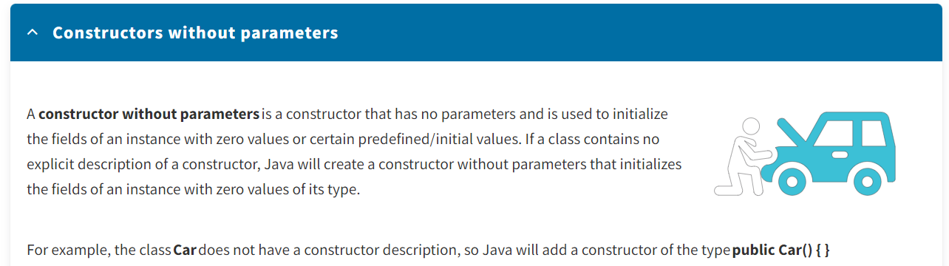

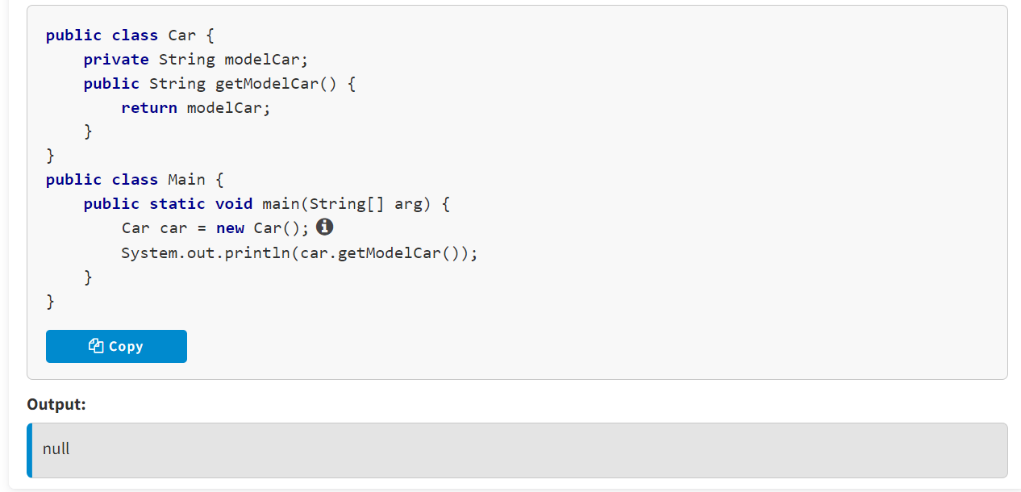

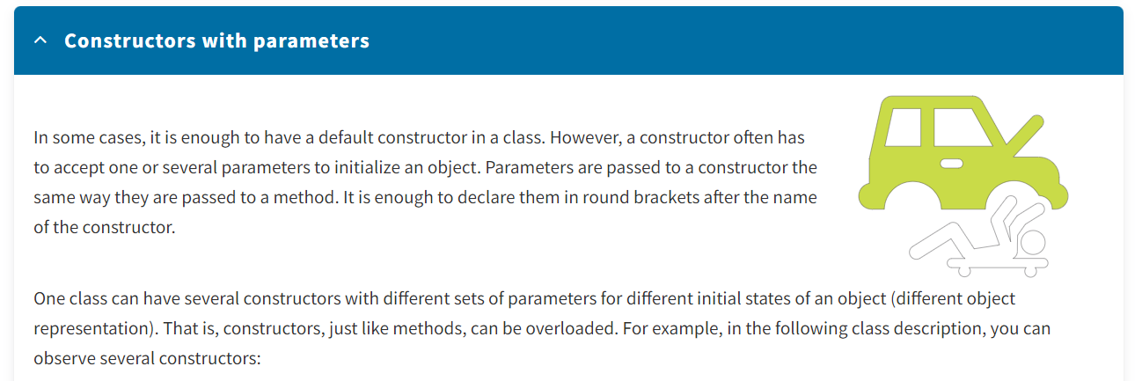

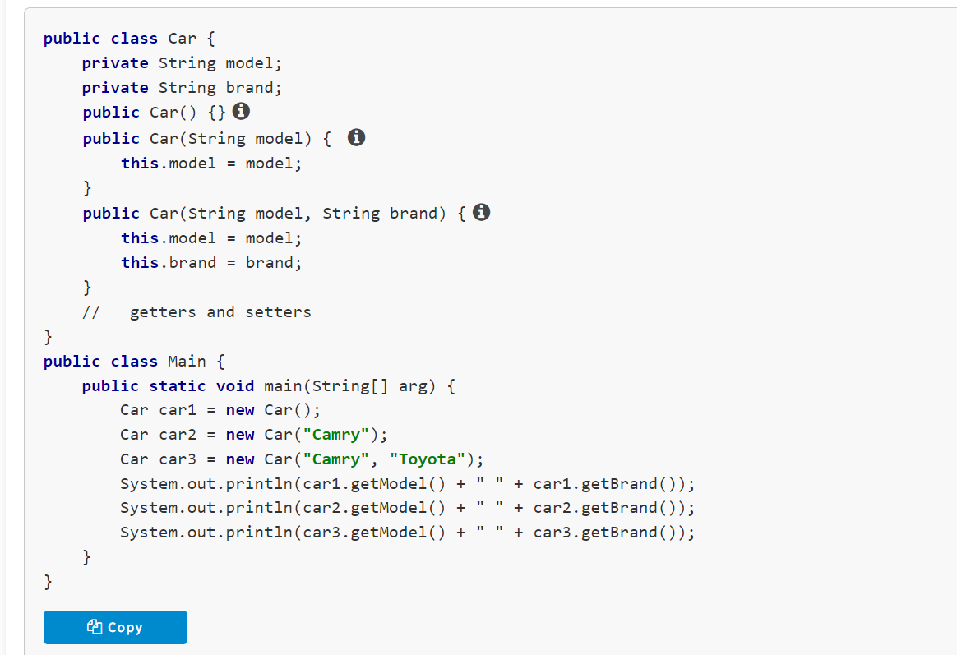

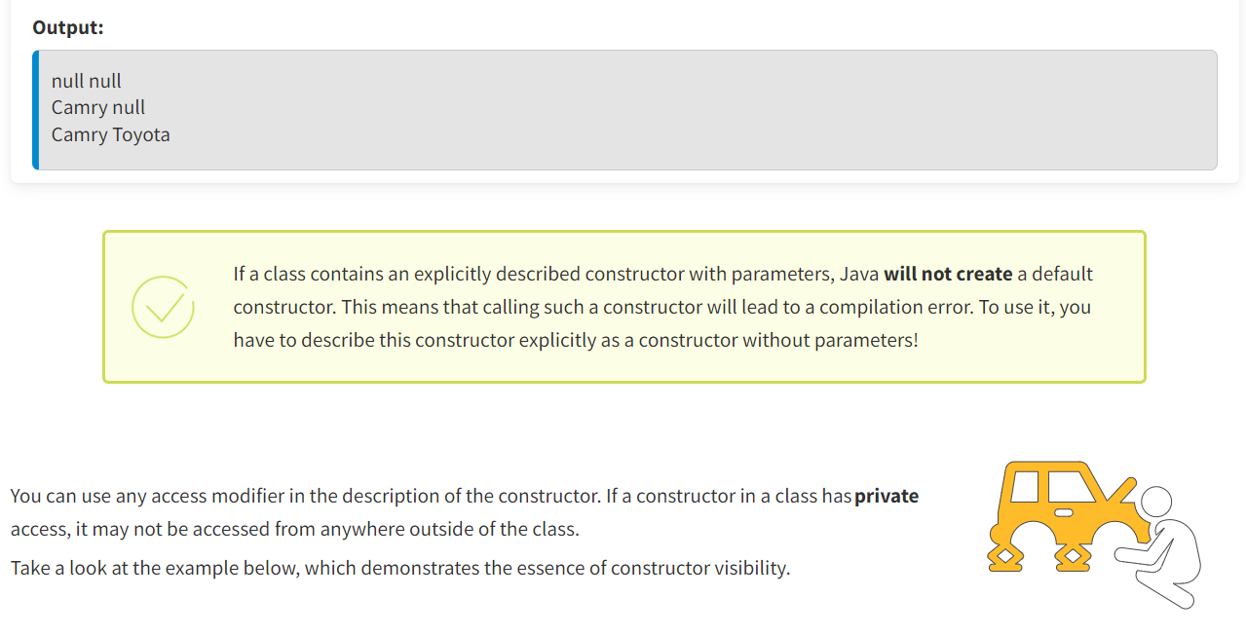

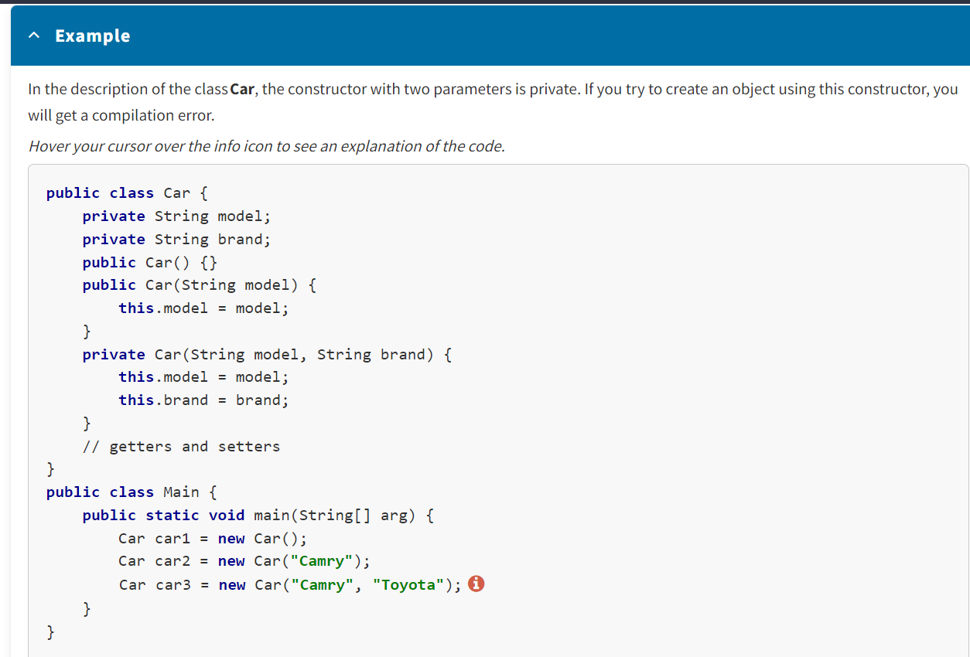

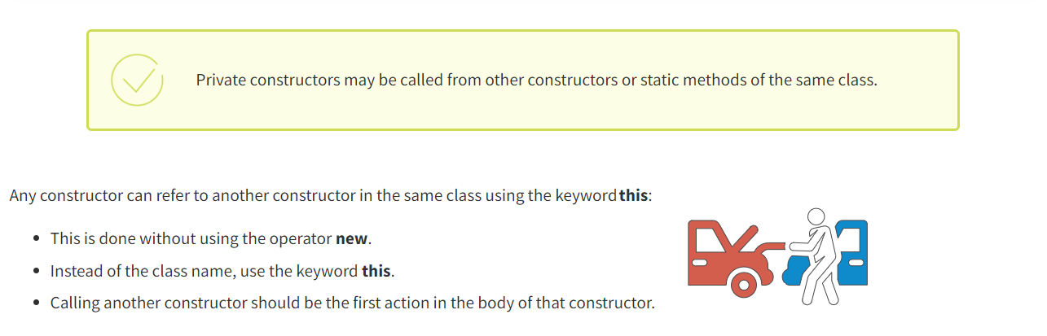

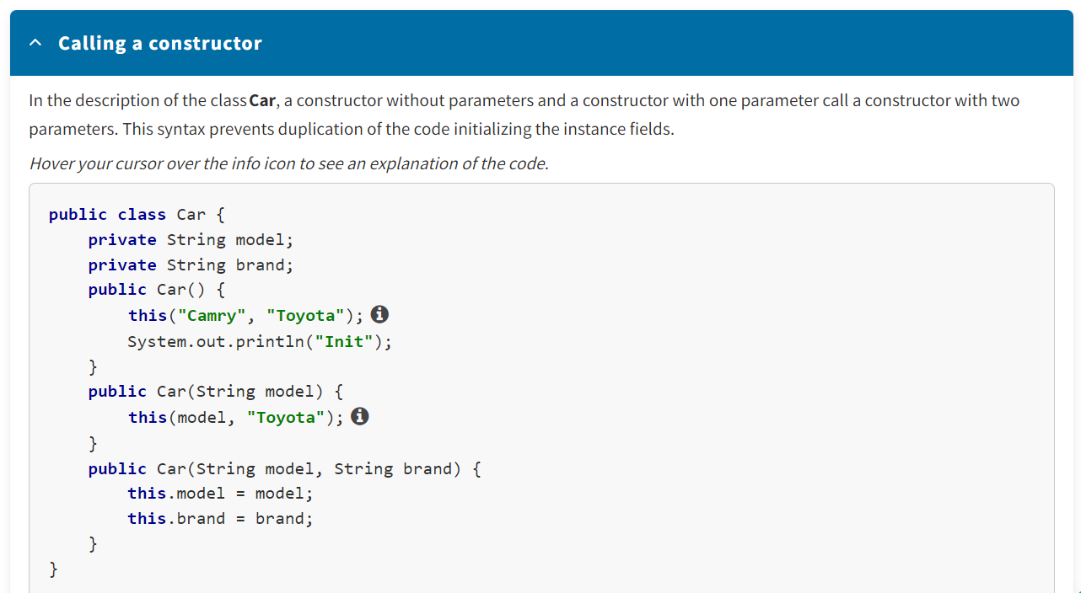

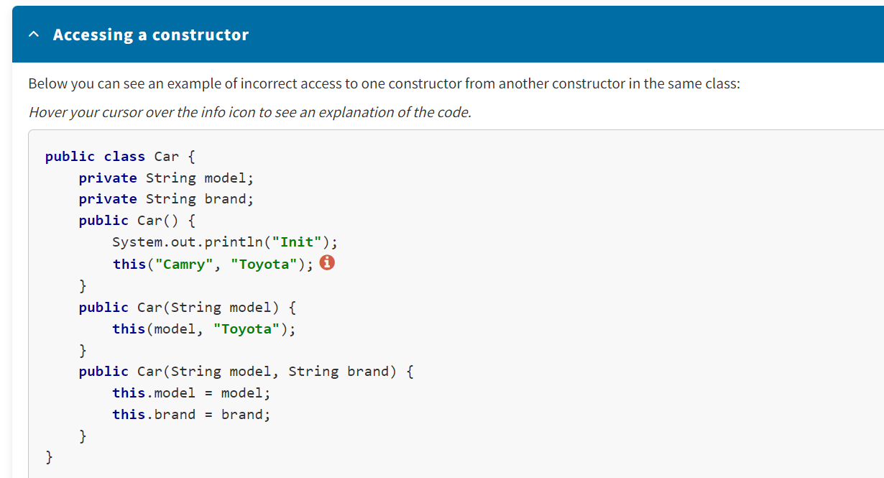

* Constructors are special methods defined in a class that initialize and return objects of the class where they are defined.
* All classes have constructors.
* There are two types of constructors: without parameters (default constructors) and with parameters (user-defined constructors).

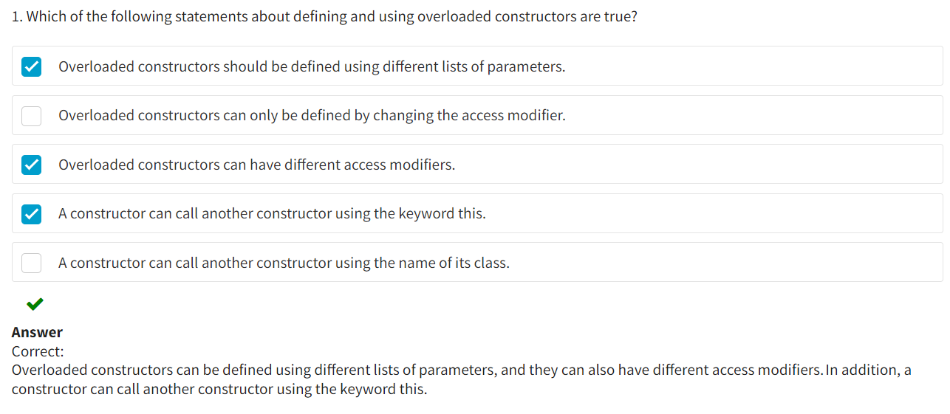

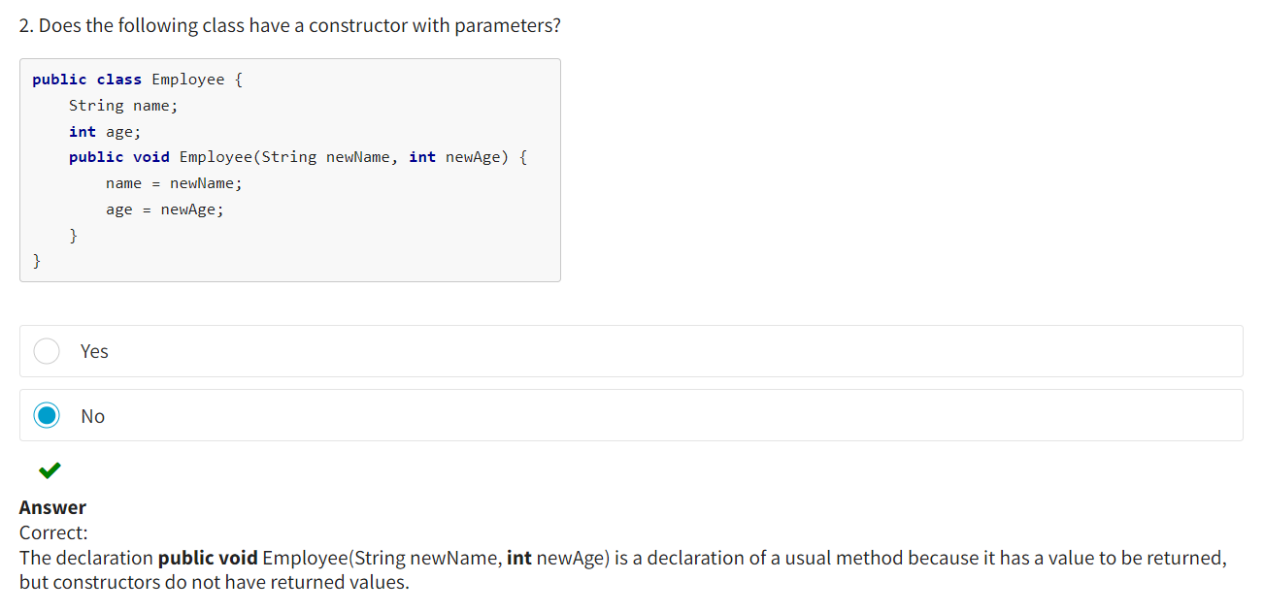

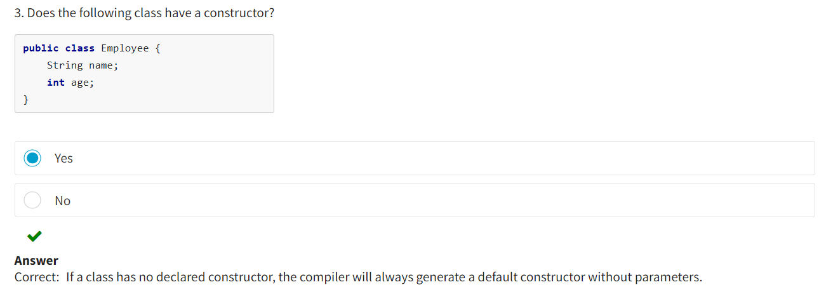

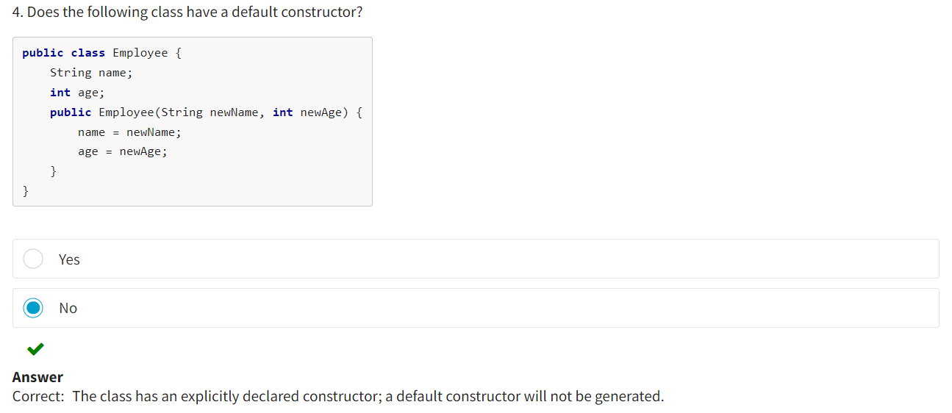

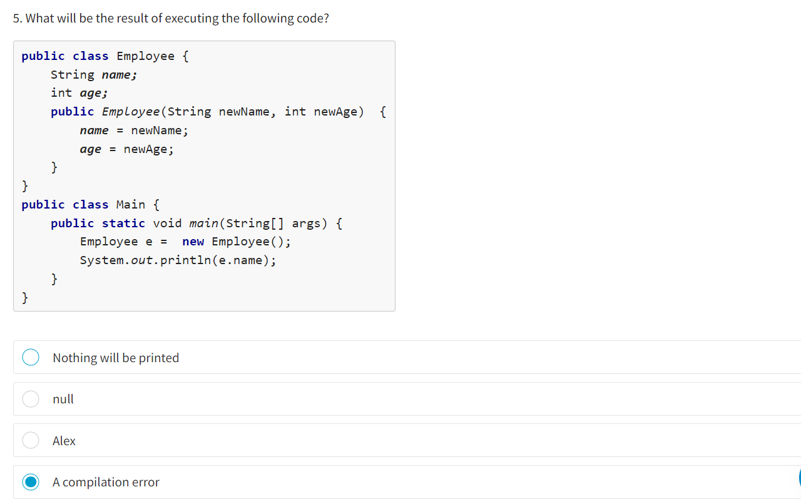

Correct:

In the method main(), a constructor is being called without parameters of the class Employee. While in the class, the constructor is declared with parameters. The compiler does not find a constructor without parameters and throws an error. There would be no error if the class were declared without constructors altogether. In that case, the compiler would create a default constructor without parameters.

Submit

**Initializers**

**Initializers** are special class structures used to initialize class fields (static) and instance fields. Class initialization starts with loading its description into random access memory.

The initialization process involves several steps:

* Automatic initialization of class fields
* Explicit initializers of class fields
* Static initializers
* Dynamic initializers/constructors

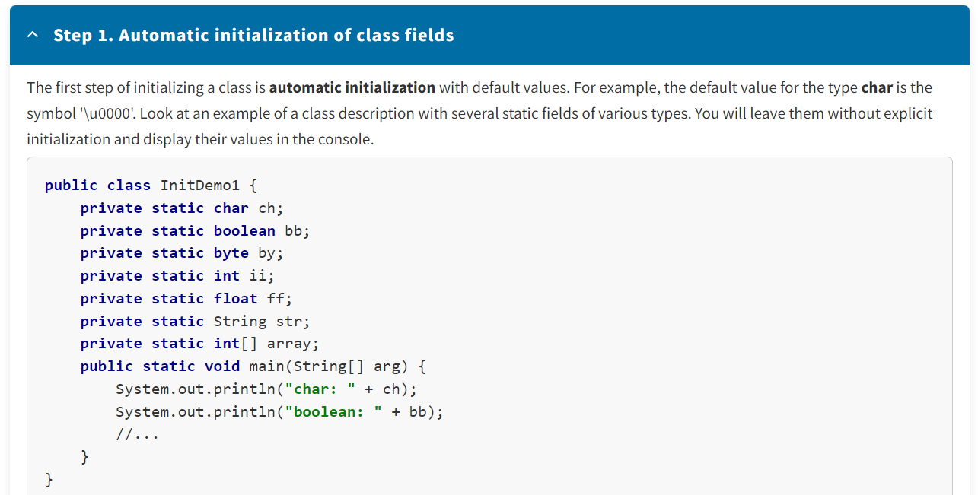

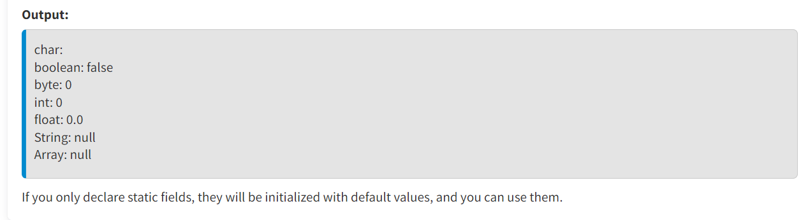

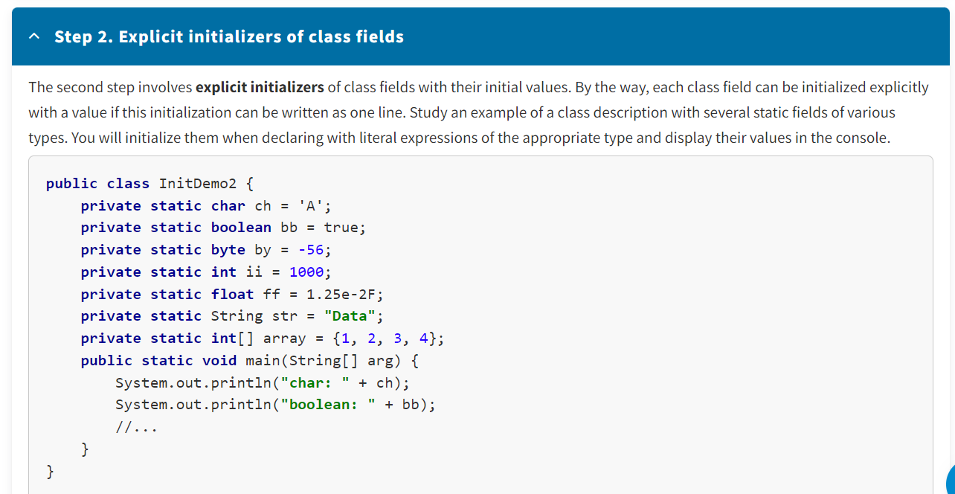

The Java compiler automatically generates the class initialization method (an internal method with the name **<clinit>**) for each class:

* The method is guaranteed to be called only once when the class is first used or mentioned.
* Initialization expressions for class fields are inserted into the class initialization method in the order in which they appear in the source code. As a result, previously declared fields of this class can be used in the initialization expression of a class field.

*Hover your cursor over the info icon to see an explanation of the code.*

**public class** InitDemo3 {

//...

**private static byte** by = 17;

**private static int** ii = 24 * by;

//...

}

In the initialization expression of a class field, you can access a static method. The advantage is that you can reuse this method's code as needed.

**public class** InitDemo4 {

**private static int** ii = initSt();

//...

**private static int** initSt() {

System.out.println(**"Init ii value"**);

**return** 1000;

}

//...

**public static void** main(String[] arg) {

System.out.println(**"Main"**);

System.out.println(**"int: "** + ii);

}

}

 Copy

**Output:**

Init ii value

Main

int: 1000

Please note: If a class is initialized with an entry point into a Java program, the method **main()** will be executed after the class fields are initialized.

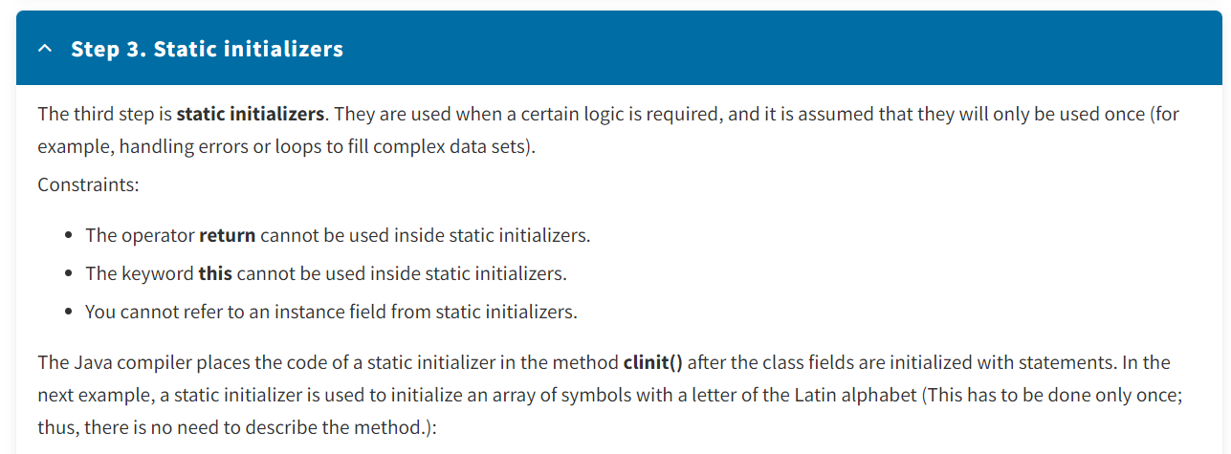

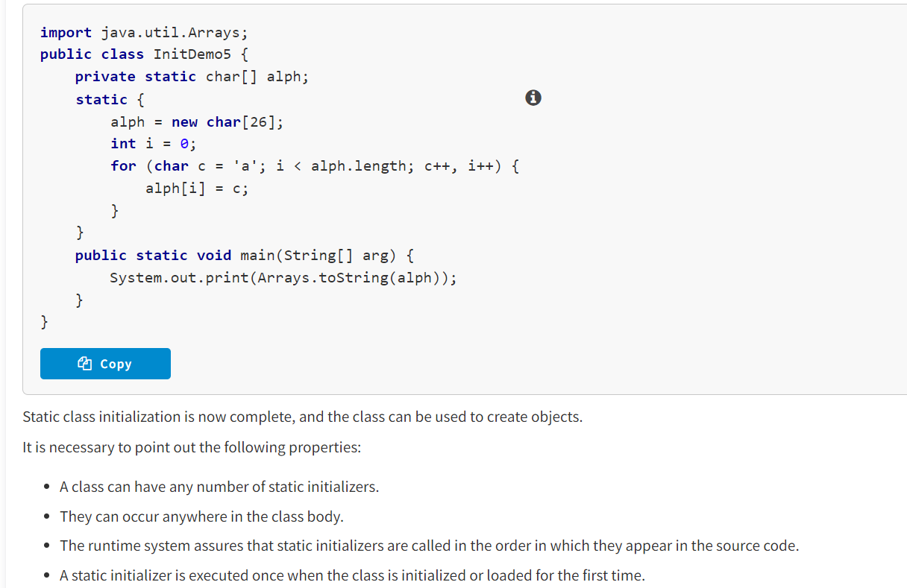

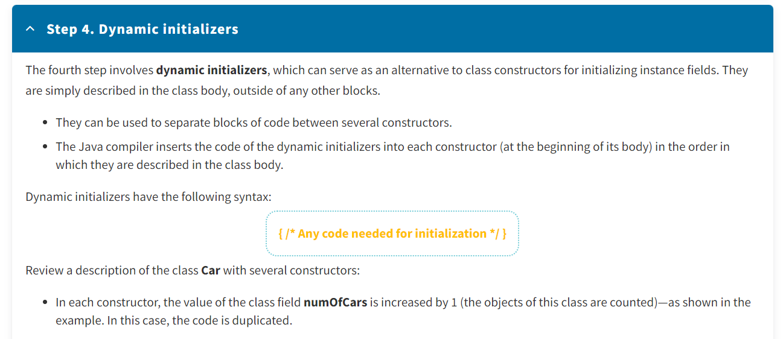

**public class** Car {

**private static int** numOfCars;

//...

**public** Car() {

//...

numOfCars++;

}

**public** Car(String model) {

//...

numOfCars++;

}

}

* To avoid duplication, you should move the common code from the constructors to the dynamic initializer, as shown in the example.

**public class** Car {

**private static int** numOfCars;

//...

{

numOfCars++;

}

**public** Car() {

//...

}

**public** Car(String model) {

//...

}

}

Dynamic initializers are only executed when a class object is created. Thus, dynamic initializers can be used to set the initial state of an object.

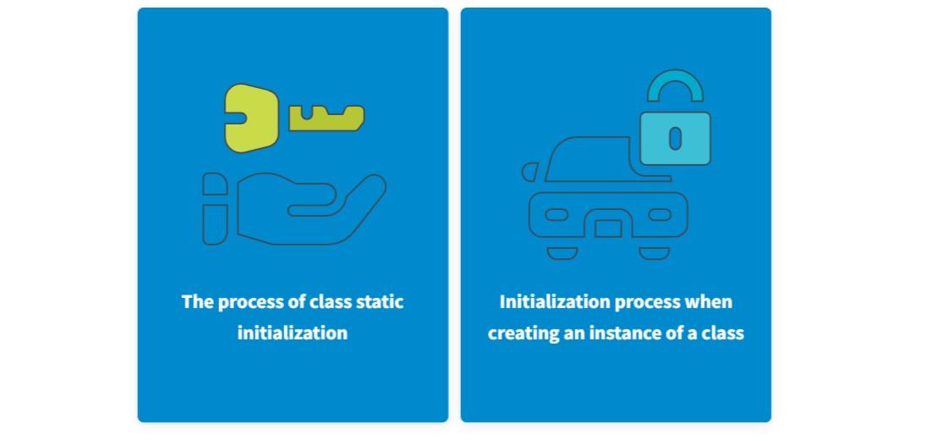

1. Initialization of static fields with default values.
2. Initialization of static fields with statements.
3. Execution of static initializers.
4. If a startup command specifies a class to run, its **main** method is executed. This method becomes an entry point to the program.
5. Recursive call and execution of the superclass constructors—parent classes.
6. Initializing the fields of the class instance with default values or initial values.
7. Execution of dynamic initializers.
8. Execution of the class constructor body.

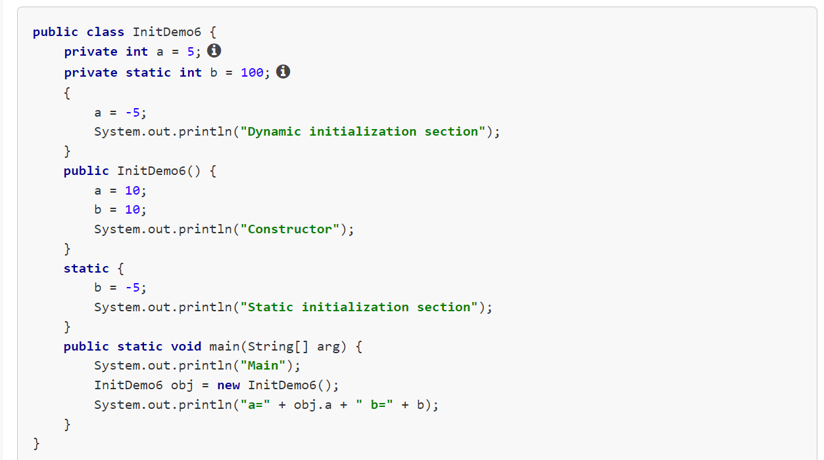

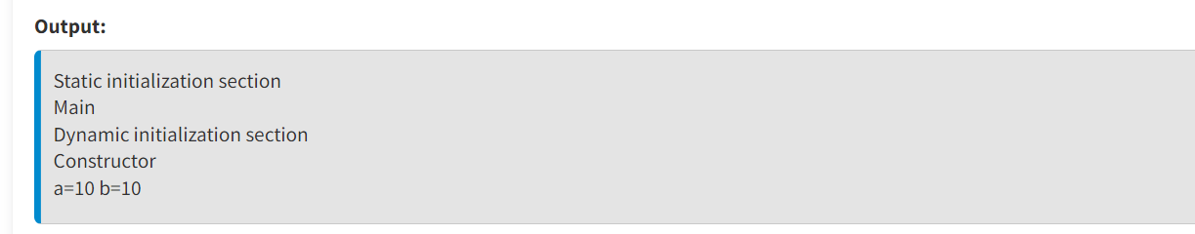

**Initialization of final Fields**

Fields marked by the keyword **final** are used to describe read-only properties of a class or object. As you know, after initialization, you cannot change the value of a **final** variable. Thus, this field should be initialized in one of three ways:

* In the same line where it is declared
* In each constructor
* In one of the dynamic initializers

This is because a **final** field can only be initialized once.

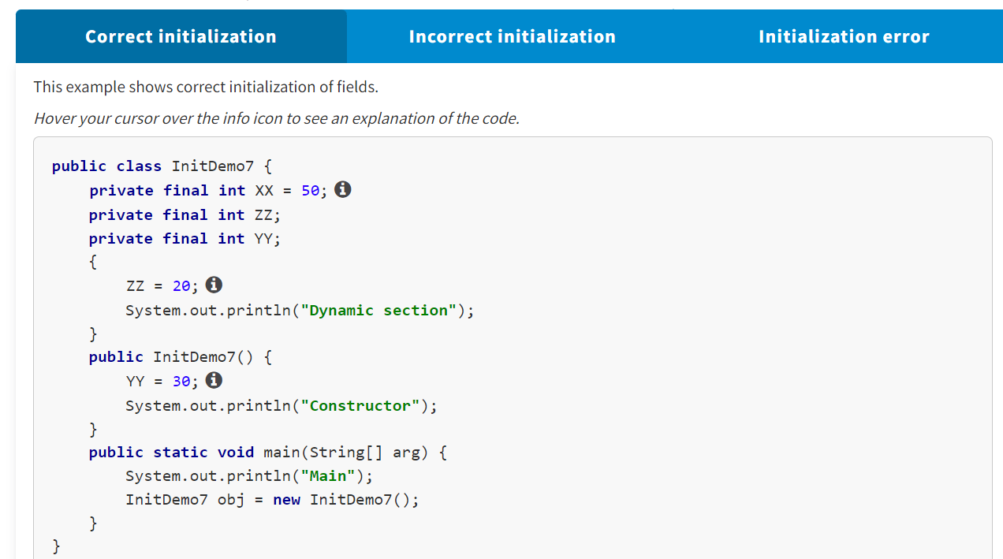

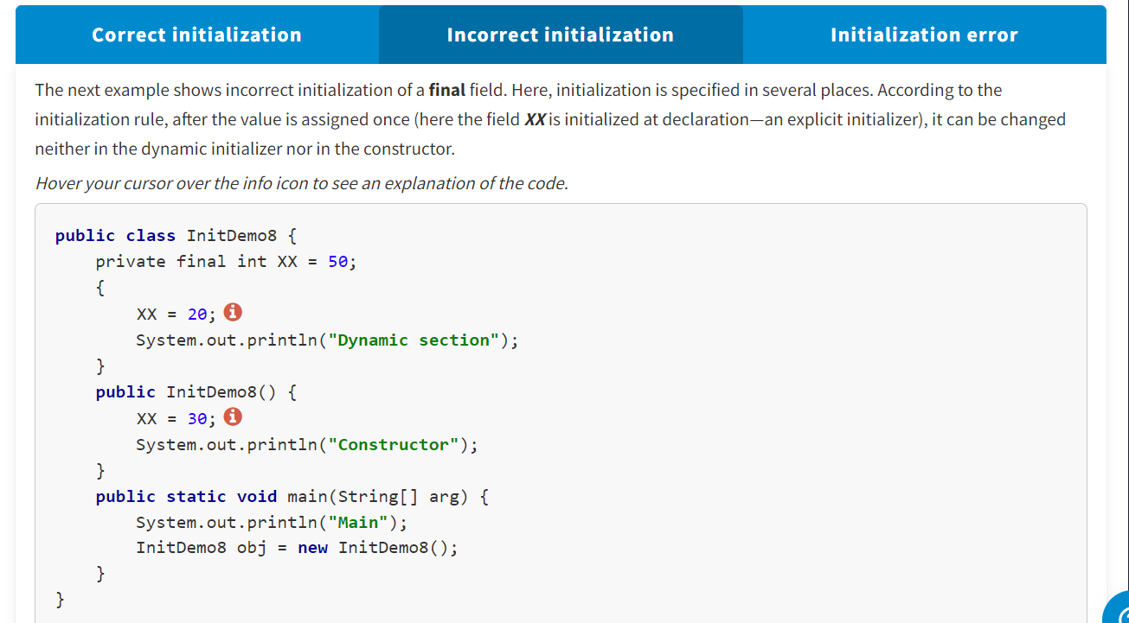

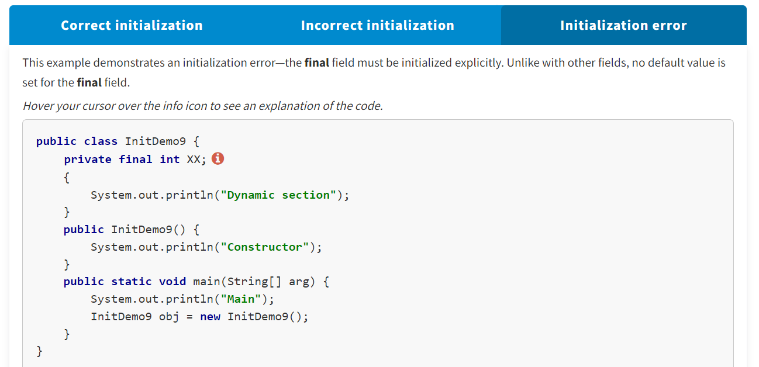

**Destructuring Objects**

In Java, there are no special methods or statements for deleting class objects—destructors. Thus, the developer does not control this process. Unused objects are destroyed by a special JVM component called a *garbage collector*.

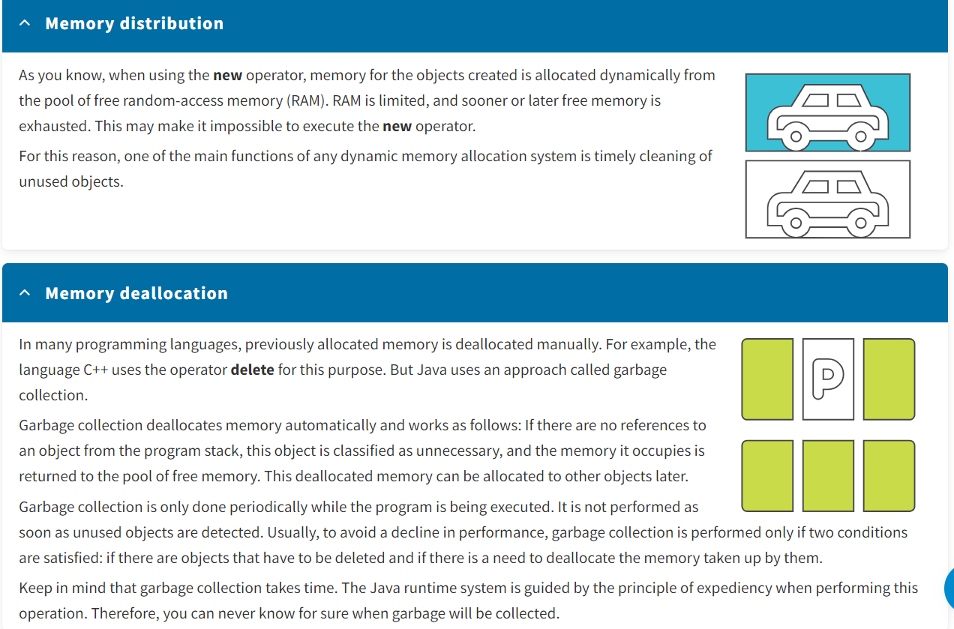

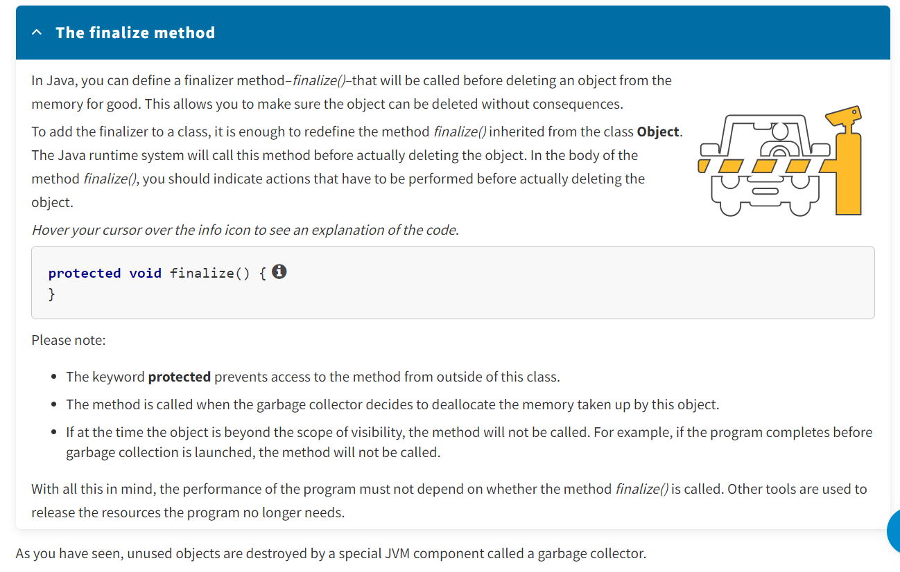

* Initializers are special class structures used to initialize class fields (static) and instance fields.
* A **final** instance field must be initialized, but only in one place: where it is declared, in a dynamic initializer, or in a constructor.
* Unused objects are destroyed by a special JVM component called a garbage collector.

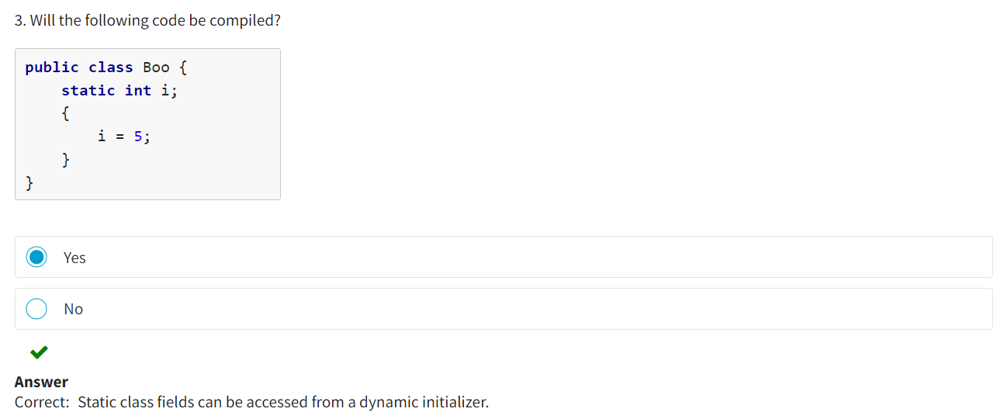

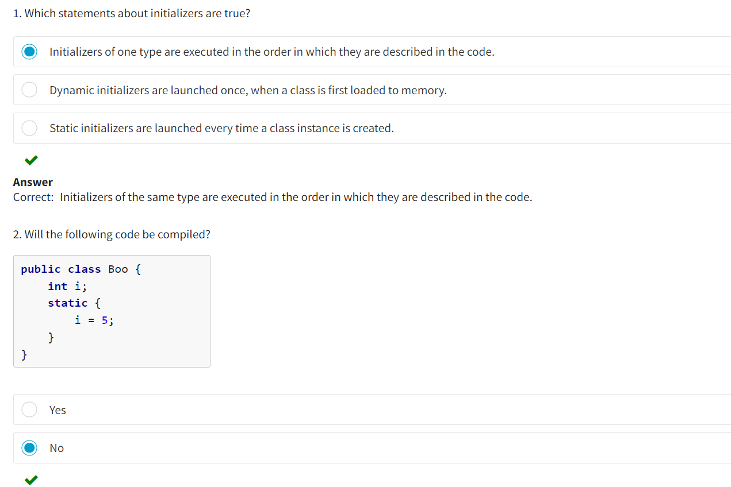

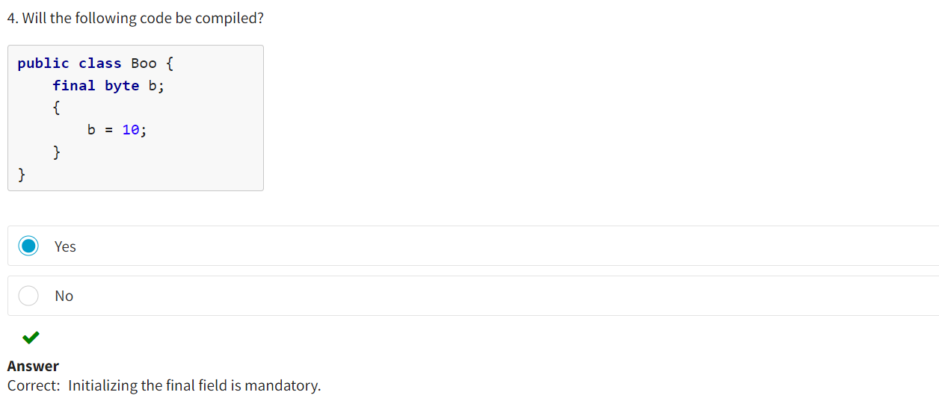

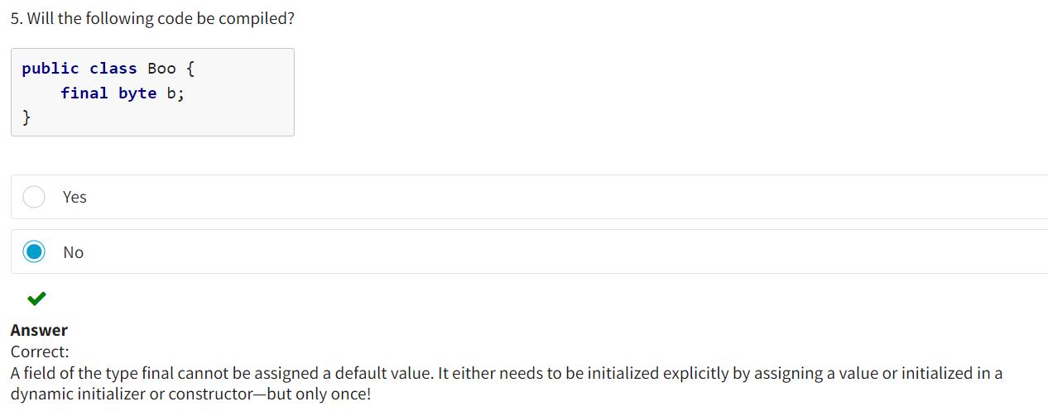

**The Concept of Packages**

In Java, **packages** are used to prevent conflicts with names; control access; make searching easier; and find and use classes, interfaces, lists, and annotations.

An ordinary compilation unit that has no package declaration (but has at least one other kind of declaration) is part of an unnamed package. The operator **package** placed at the beginning of the source program file defines a named package. In other words, it defines a namespace for the classes contained in this file. The action of the package **operator** designates the location of a file relative to the project root. For example:

**package** com.epam.eun.entity;

Thus, the program file will be placed in a subdirectory with the name **com.epam.eun.entity**. When this package is accessed from another package, the package name should be attached to the class name **com.epam.eun.entity.Student**.

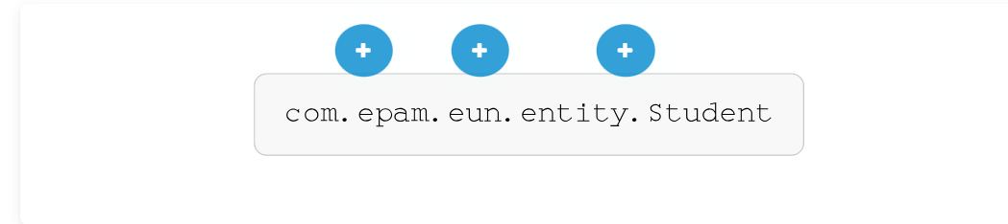

**com.epam**

This is the reverse of the software manufacturer or customer's internet domain name–for example, for epam.com, you will get com.epam.

**eun**

This is the project name (which is usually abbreviated)–for example, eun.

**entity.Student**

These packages define the application.

The general form of the file containing Java source code may be as follows:

* A single operator package (optional but highly recommended)
* Any number of import operators (optional)
* A single public class (optional)
* Any number of package classes (optional and not recommended)

When using classes, the complete package name of the package this class belongs to should be specified before the class name and separated by a period.

Arrangement of Packages :

Below you can find a non-exhaustive list of packages of a real application. From the package names, you can determine which classes they contain without looking inside. When creating a package, you should always be guided by a simple rule: Use a simple name that reflects the meaning, behavior logic, and functionality of the classes consolidated in it.

com.epam.eun  
com.epam.eun.administration.type  
com.epam.eun.administration.dbhelper  
com.epam.eun.common.type  
com.epam.eun.common.dbhelper.annboard  
com.epam.eun.common.dbhelper.course  
com.epam.eun.common.dbhelper.guestbook  
com.epam.eun.common.dbhelper.learnresult  
com.epam.eun.common.dbhelper.message  
com.epam.eun.common.dbhelper.news  
com.epam.eun.common.dbhelper.prepinfo  
com.epam.eun.common.dbhelper.statistic  
com.epam.eun.common.dbhelper.subjectmark  
com.epam.eun.common.dbhelper.subject  
com.epam.eun.common.dbhelper.test  
com.epam.eun.common.dbhelper.user  
com.epam.eun.common.menu  
com.epam.eun.common.object  
com.epam.eun.common.servlet  
com.epam.eun.common.tool  
com.epam.eun.consultation.type  
com.epam.eun.consultation.dbhelper  
com.epam.eun.consultation.object  
com.epam.eun.core.type  
com.epam.eun.core.dbhelper  
com.epam.eun.core.exception  
com.epam.eun.core.filter  
com.epam.eun.core.manager  
com.epam.eun.core.taglib

Application Packages :

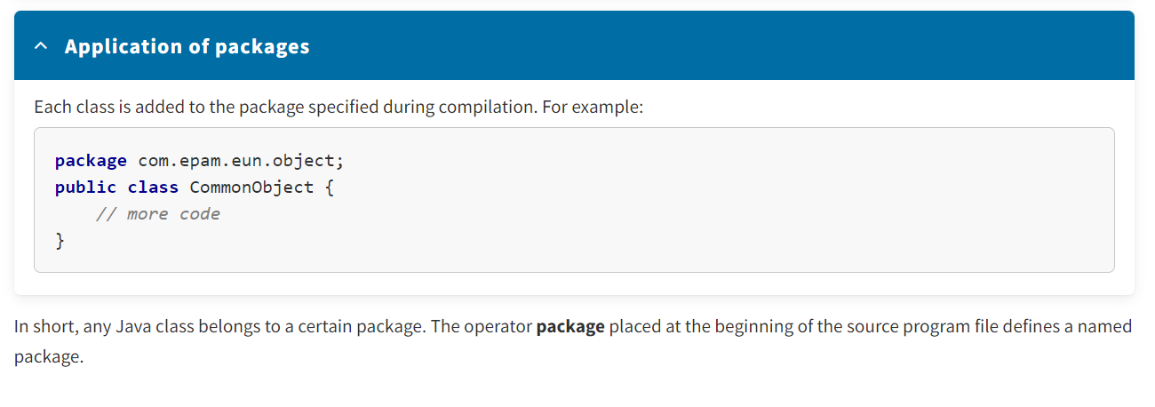

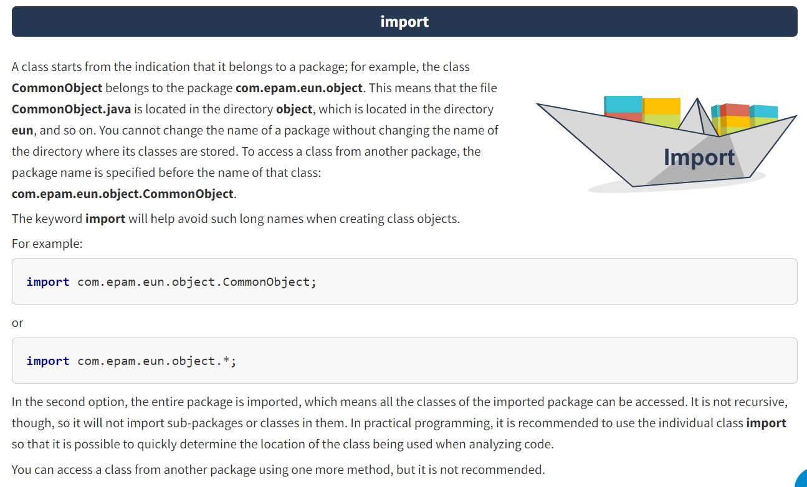

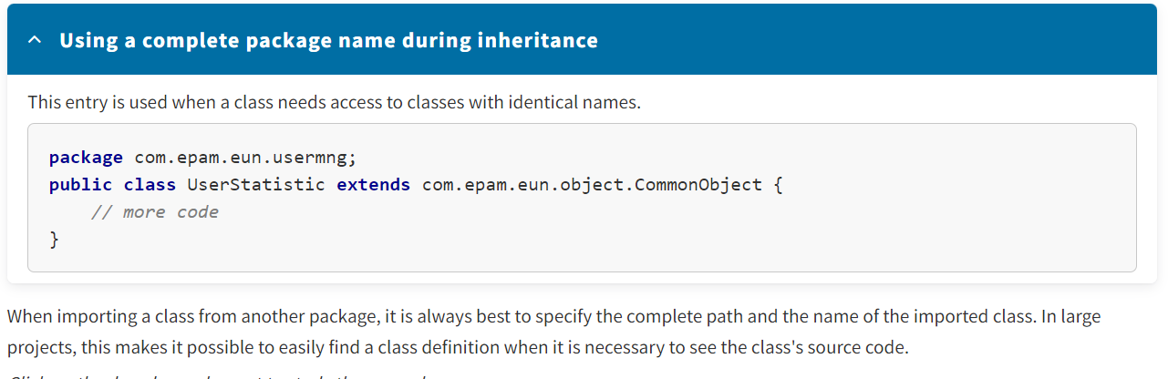

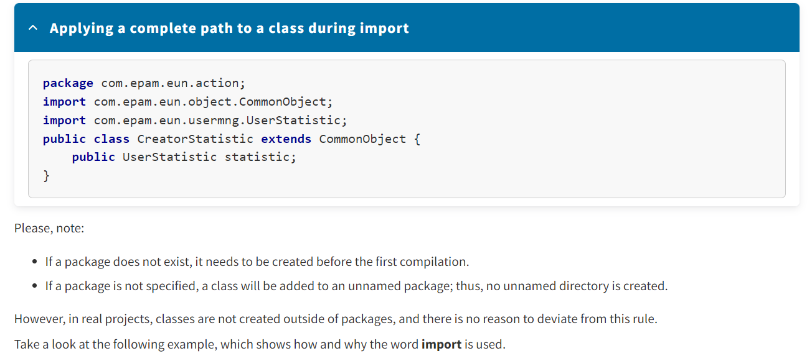

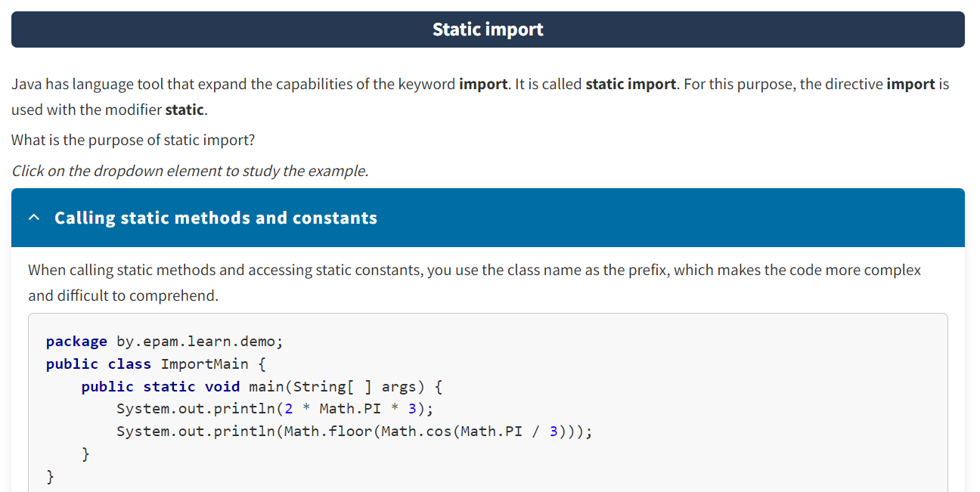

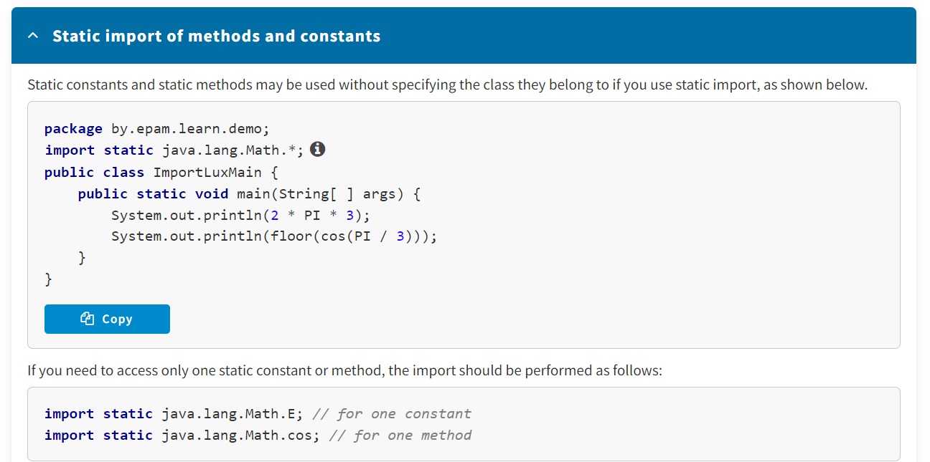

* In Java, **packages** are used to prevent conflicts with names; control access; make searching easier; and find and use classes, interfaces, lists, and annotations.
* The keyword **import** is used to get access to classes and interfaces from other packages and avoid long names when creating class objects.
* Static constants and static methods of a class can be used without specifying the class. This helps avoid code complexity and promotes quick comprehension.

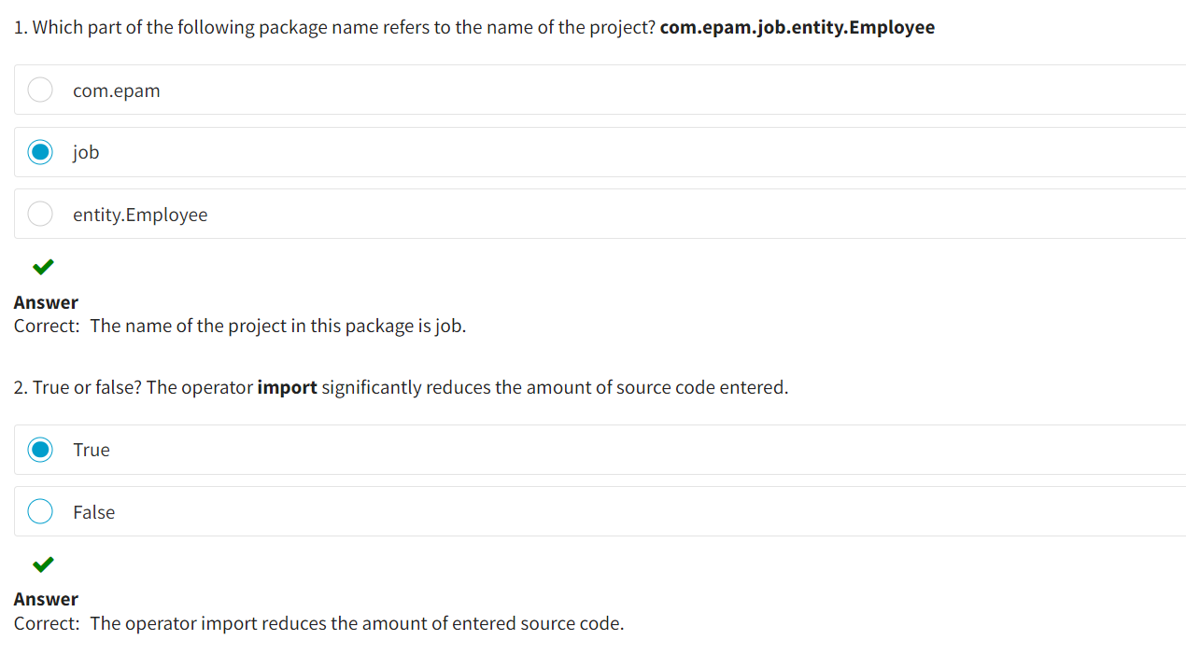

* OBJECT ORIENTED PROGRAMMING :
* **What Is Encapsulation?**
* **Encapsulation** is the consolidation of data and methods for working with data in one package, or "capsule," with the possibility of concealing it from the external environment (other objects).
* As you already know, data characterizing an object are called **instance variables**, and operations performed with these data are called **instance methods**. In a certain object (class instance), these fields have certain values. The set of field values defines the object's current **state**. Applying any method to an object can change its state.
* **What does encapsulation do?** Mainly, it forbids direct access to the fields of this class instance from other classes. Different parts of the program, as well as external programs, can access the object's data only by using the methods of this object. This means that you can change the way data is stored in a class while retaining the methods used to process this data. Thus, other objects will be able to cooperate with the objects of this class just as they did before the changes.

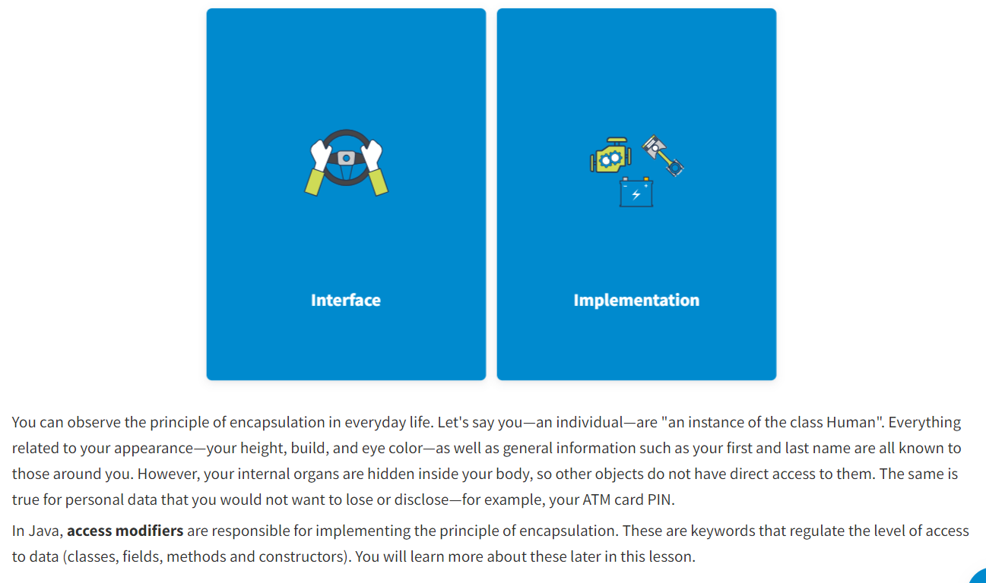

The interface includes everything related to the interaction of this object with any other objects.

The implementation means concealing all details not related to the process of the objects' interaction from other objects.

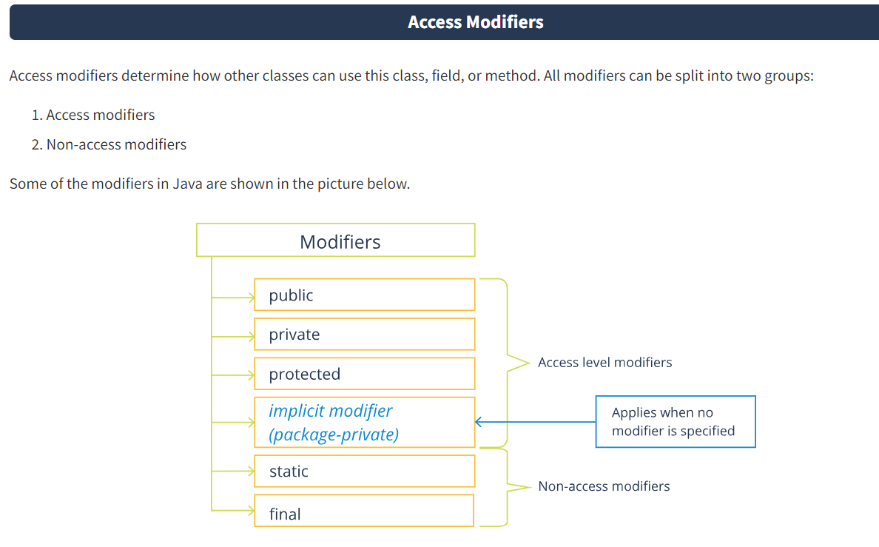

There are two levels of access control: the top level and the member level.

The **top level** includes:

* **public**
* **package-private**

The **member level** includes:

* **public**
* **protected**
* **package-private**
* **private**

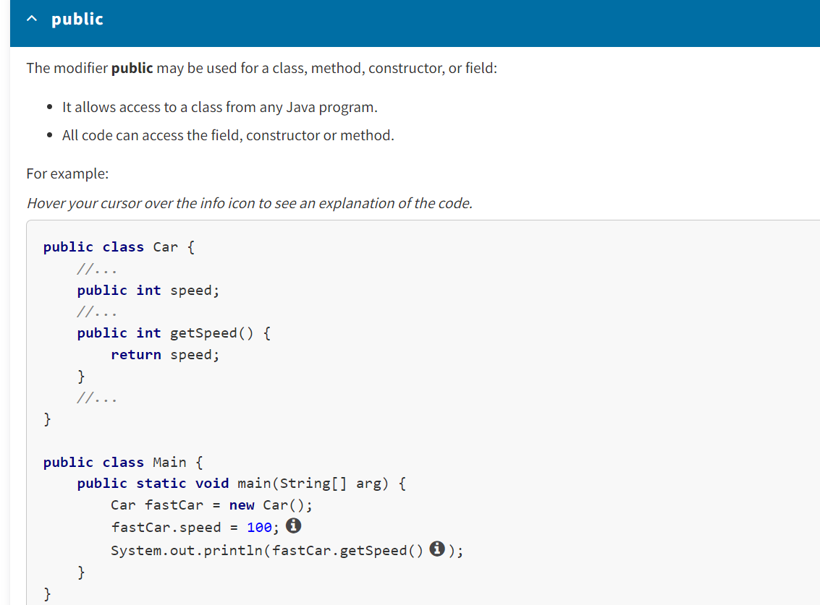

Private :

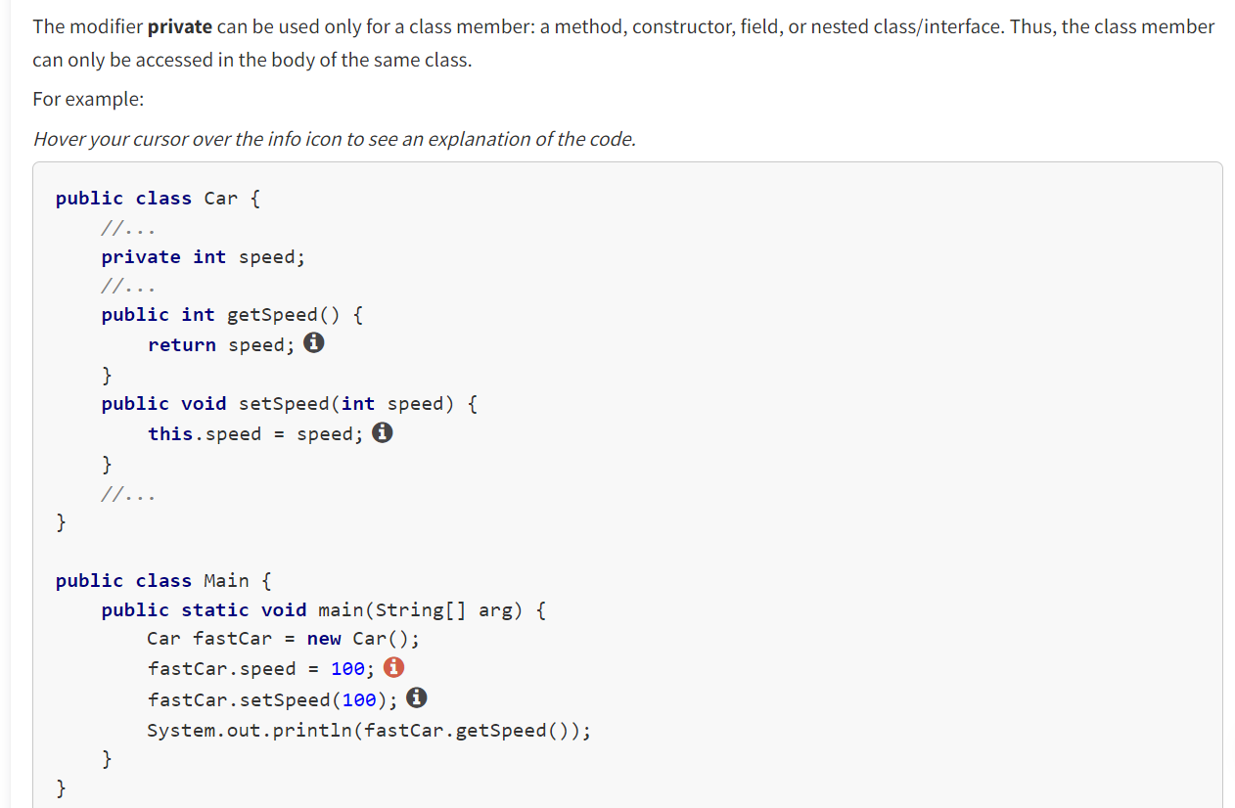

Protected :

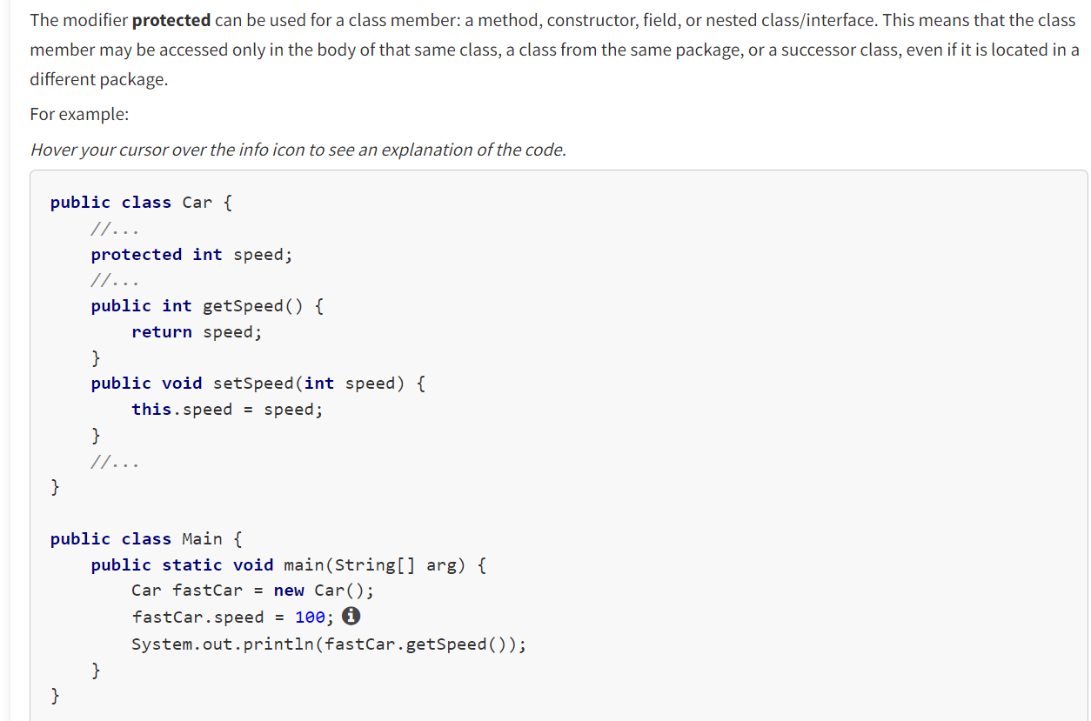

Package Private :

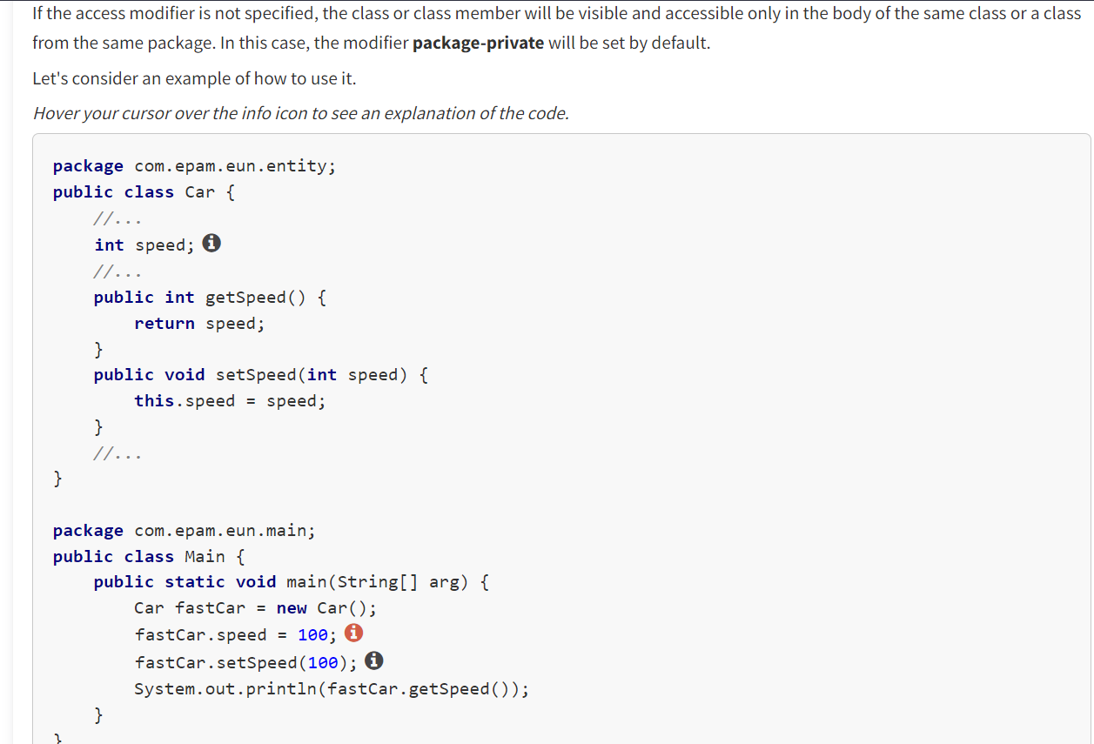

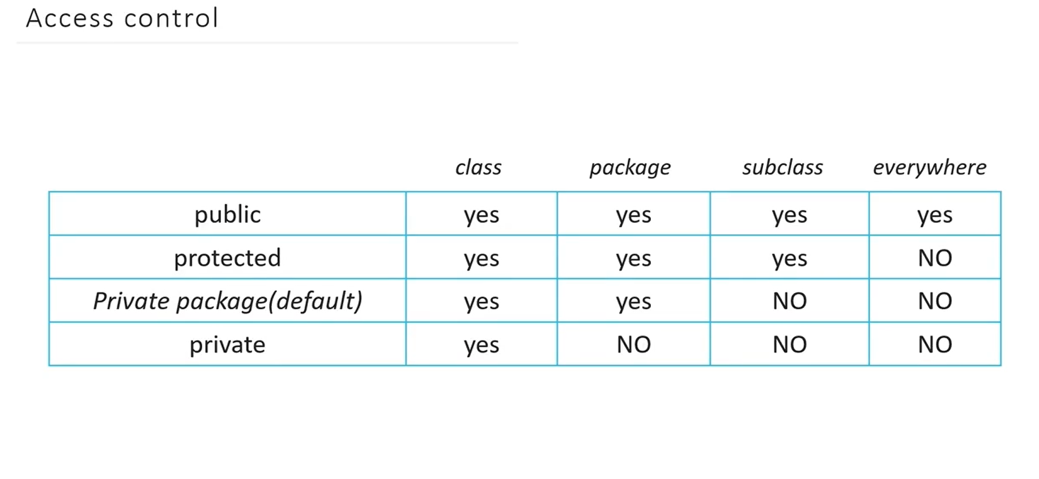

As you have seen, **public** is the widest modifier available. It grants access from any place in the program code, while **private** is the narrowest modifier, providing access only inside a specific class. For more information on access modifiers, refer to the [*official documentation.*](https://docs.oracle.com/javase/tutorial/java/javaOO/accesscontrol.html)

**Access Modifiers and Encapsulation**

Why is it not recommended to use only the modifier **public**? As an example, let's take the field ***yearManufactureCar***, which determines the year when a car was produced. If other classes have direct access to this field (according to the modifier ***public***), it is very likely that when the program is run, an incorrect value will be set for this field—for example, a year when cars were not yet invented. These data changes are undesirable. It is recommended to limit direct access to data as much as possible to protect it from undesired access from the outside (both to receive the value and change it). Using the modifier **private** guarantees that the data will not be distorted or changed incorrectly. Note that the principle of **encapsulation** corresponds to the idea of concealing data inside a certain visibility scope.

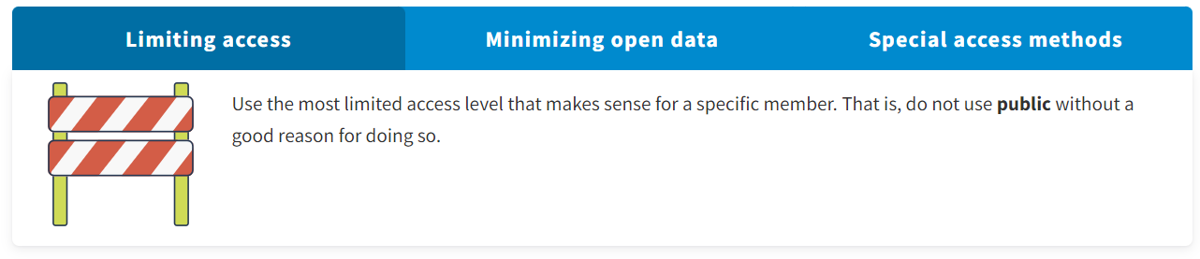

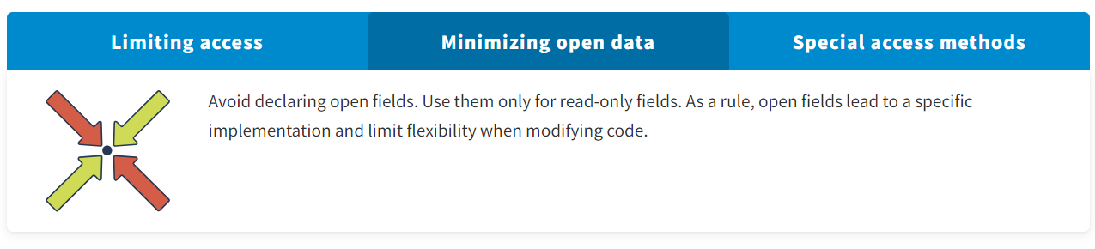

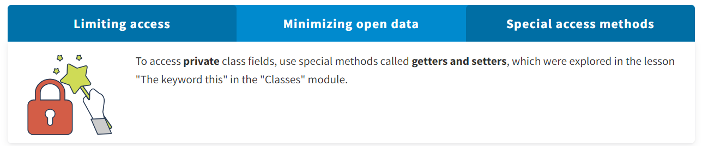

* Encapsulation prohibits direct access to the fields of a given class instance from other classes.
* In Java, access modifiers are responsible for implementing the principle of encapsulation. These are keywords that regulate access to data and code.

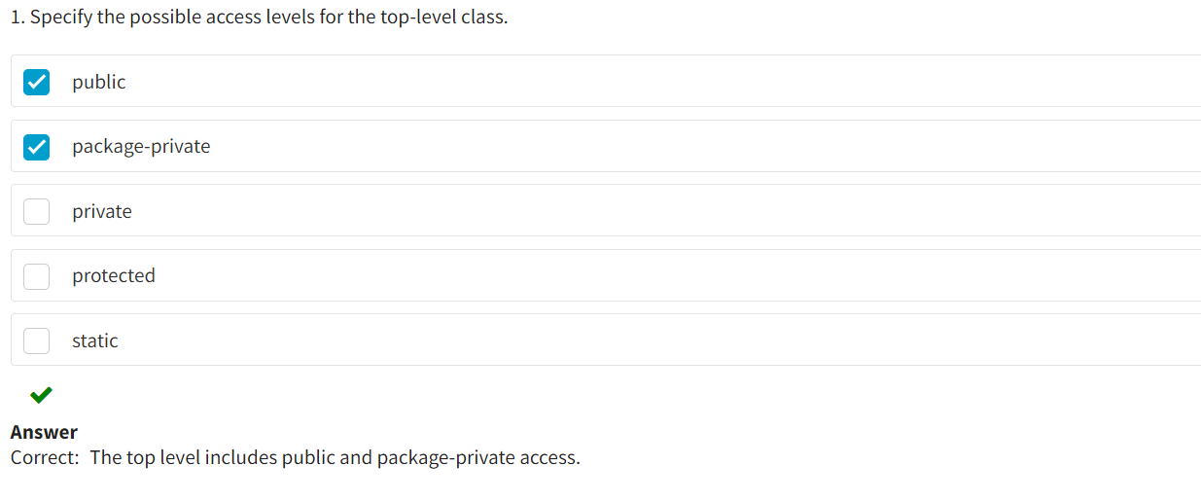

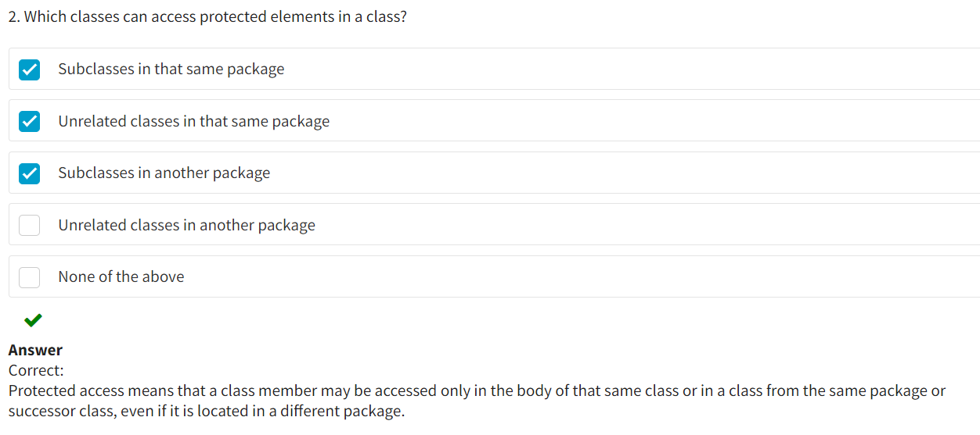

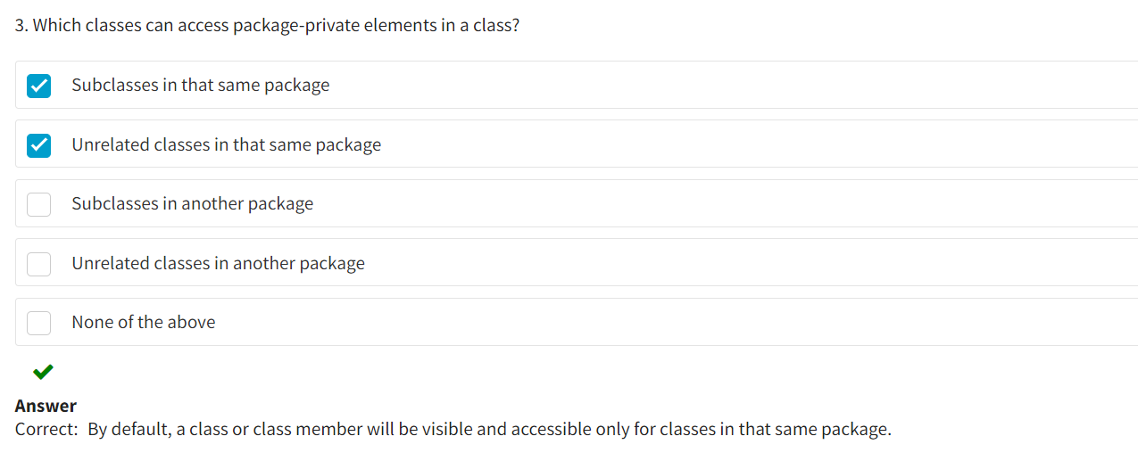

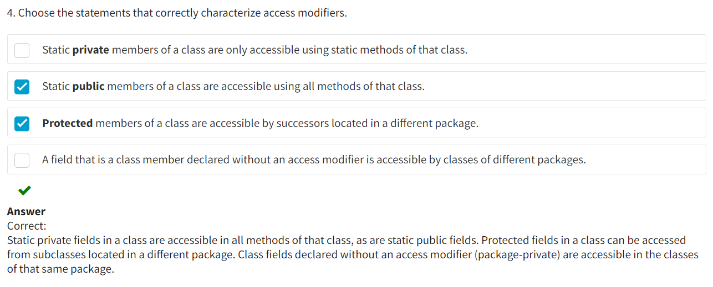

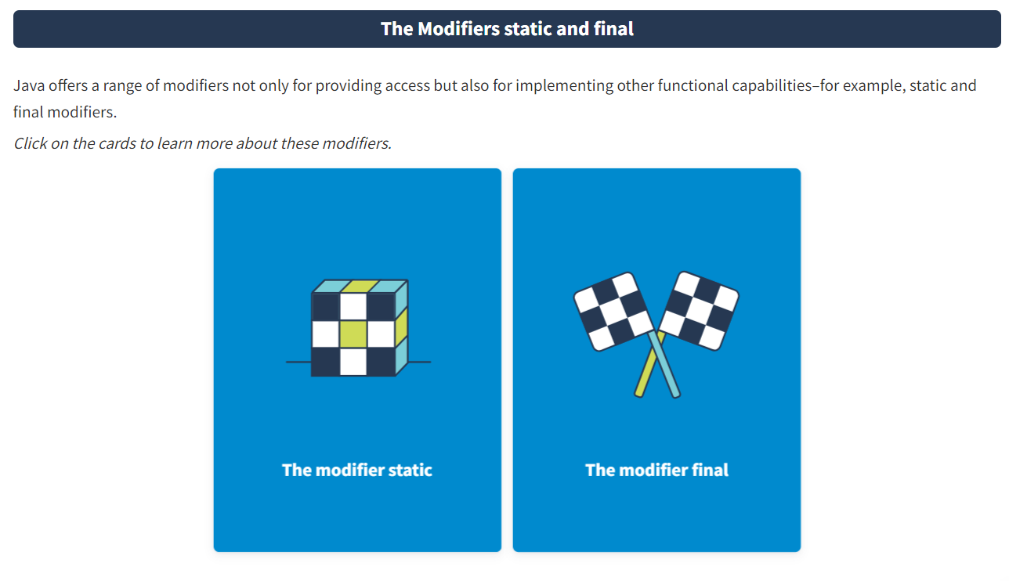

The modifier **static** is used to create methods and variables (fields) belonging to a class and not to an object.

The modifier **final** is used to define a final implementation of classes and methods, as well as invariability of variables and fields.

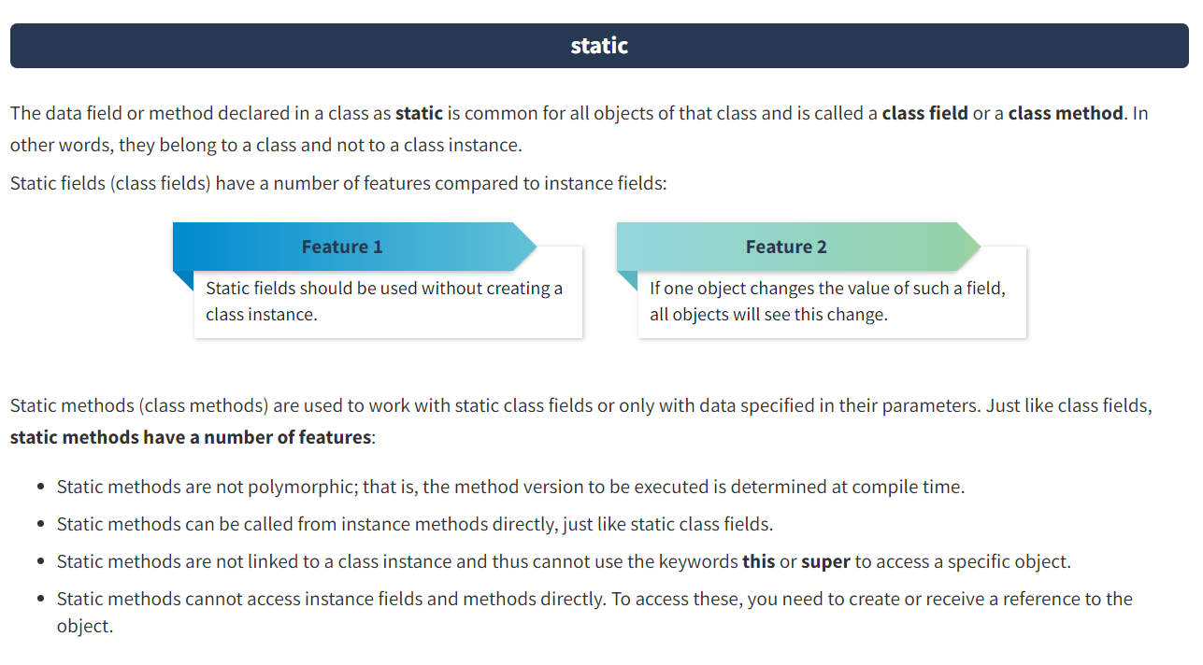

To **access** static fields and methods, it is enough to specify before them the name of the class where they are defined. Of course, you can access a static method also using a reference to an object since any class instance has access to the static members of the class. However, this access will be logically incorrect, make the code more difficult to understand, and lead to the corresponding warning—though it will not cause a compilation error.

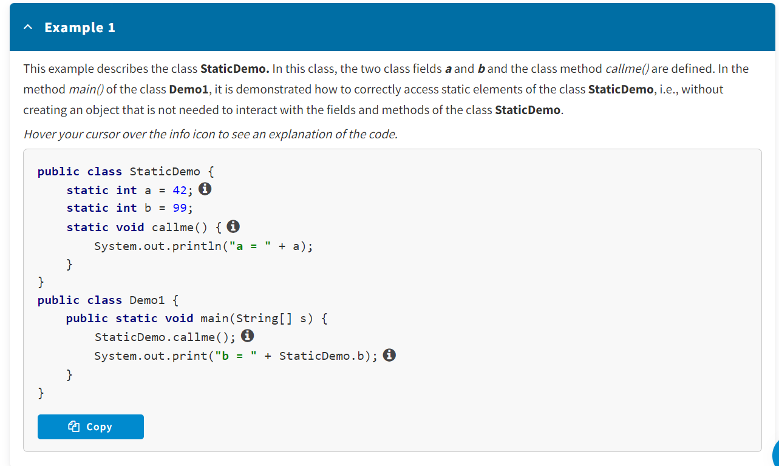

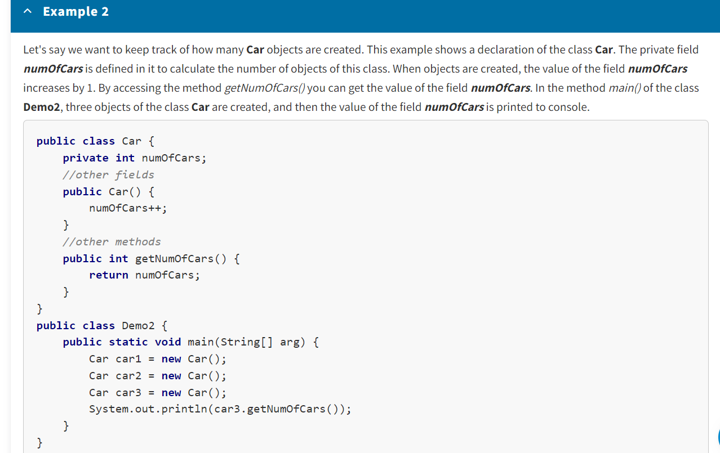

Output : 1

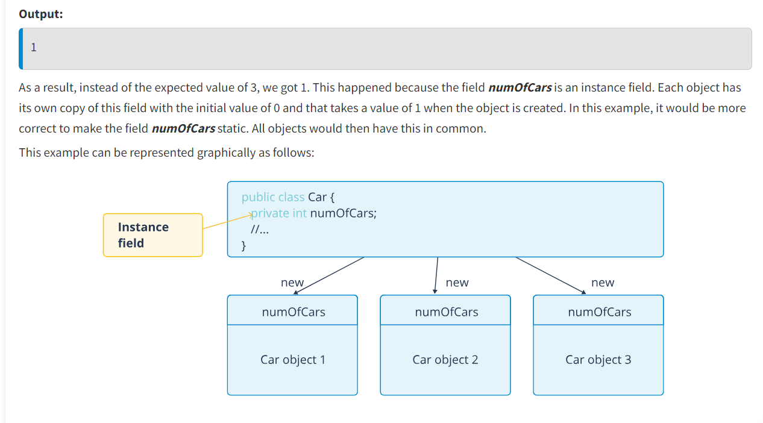

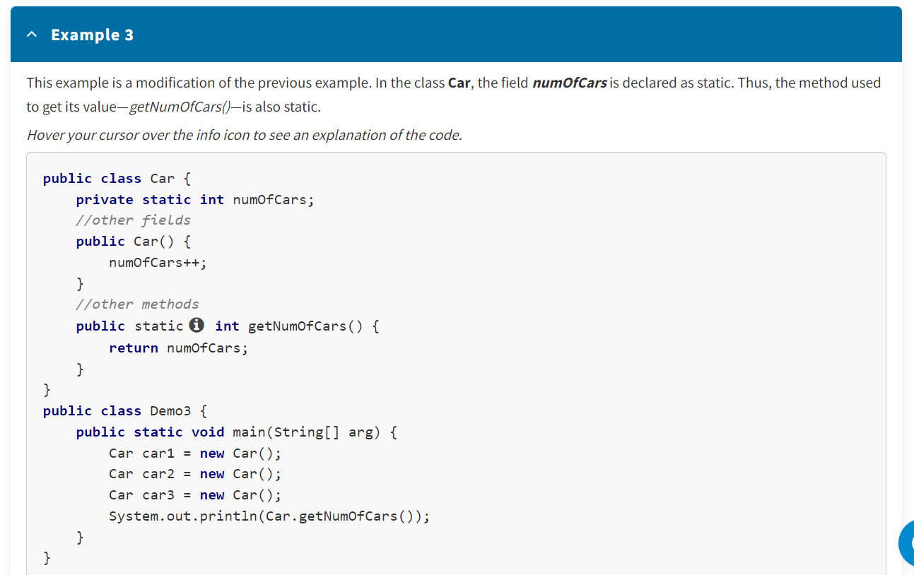

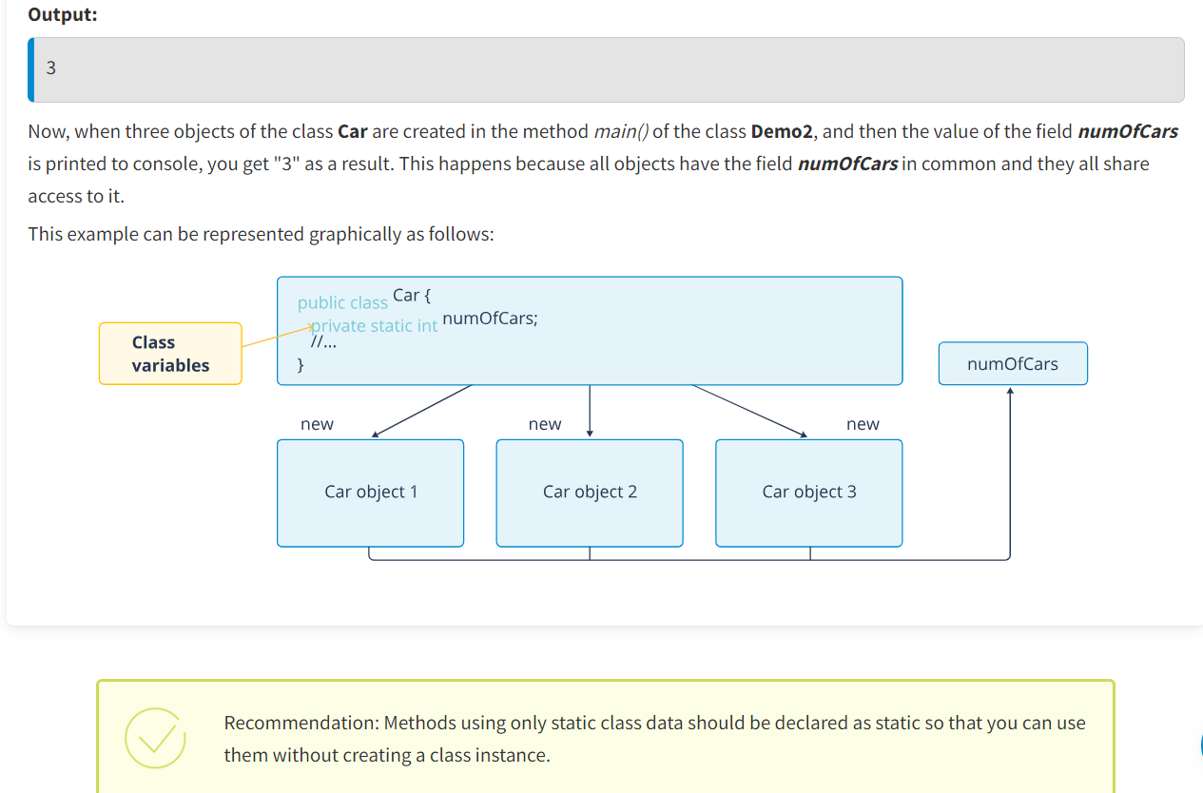

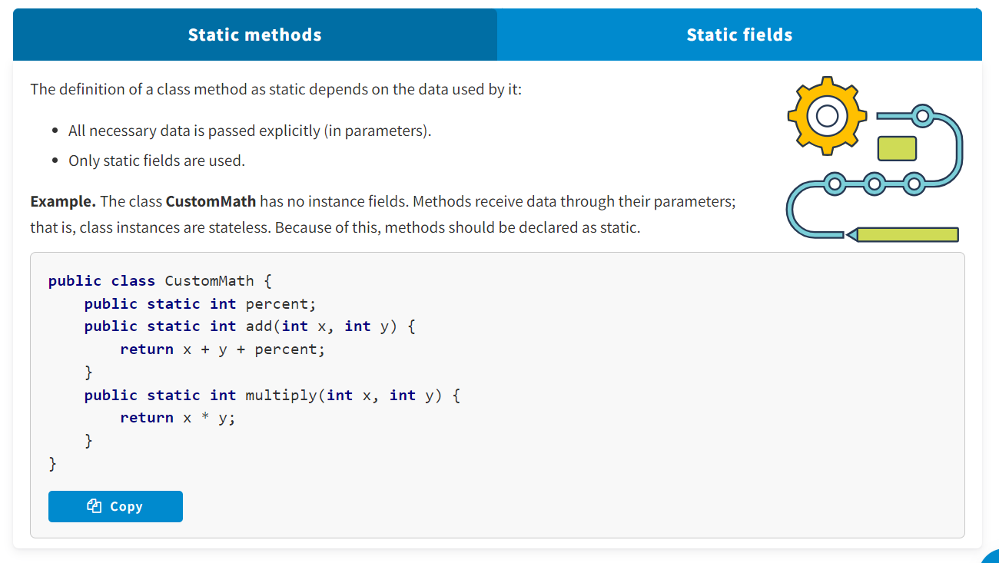

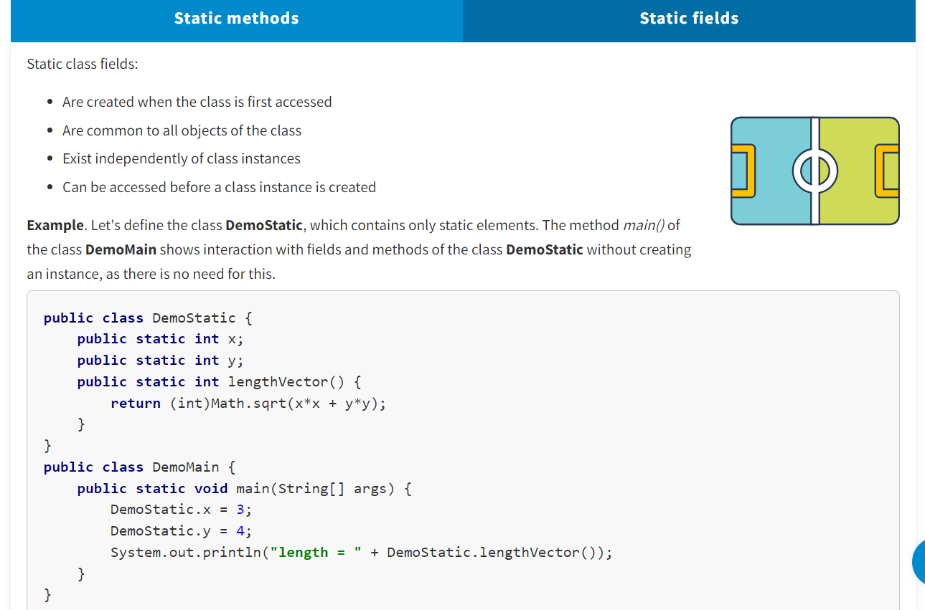

Recommendation: Methods that receive everything they need through parameters are auxiliary and should be declared as static.

Limitations for static methods:

* Static methods can directly invoke only static methods.
* Static methods can directly access only static fields or their own parameters.
* Static methods cannot be accessed using the references ***this*** and ***super*.**
* Static methods can be overloaded with non-static ones and vice versa.

**final**

The keyword **final** is a non-access modifier that applies to classes, methods, and variables, which makes them unchangeable (impossible to inherit or override). It can be used in a variety of contexts.

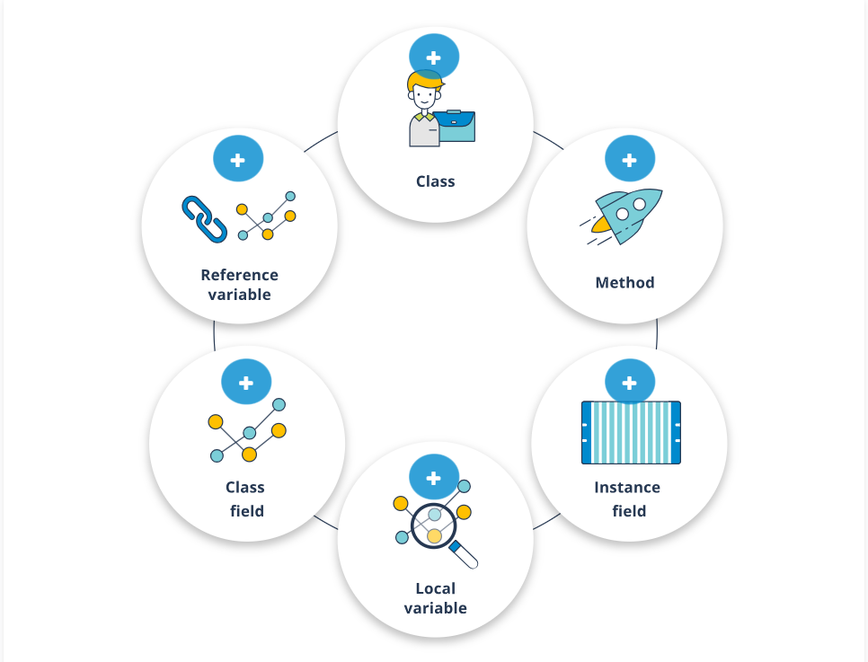

**Class**

A class declared with **final** cannot have successors.

**Method**

A method declared with **final** cannot be overridden, i.e., its body cannot be changed in the successor.

**Instance field**

An instance field declared as **final** is only initialized once: when declaring it, in the constructor, or in the initializer block.

**Local variable**

A local variable or method parameter declared with **final** cannot be changed.

**Class field**

For class fields, the modifier **final is often used with the modifier static** to make them constant.

**Reference variable**

To a reference variable declared as **final** cannot be assigned another object. However, the data inside the object can be changed.

Note the naming convention for constants. The names of constants are written in uppercase, and the words are separated with underscores ("_"), e.g., DISCOUNT, MAX_RANGE, MIN_WIDTH.

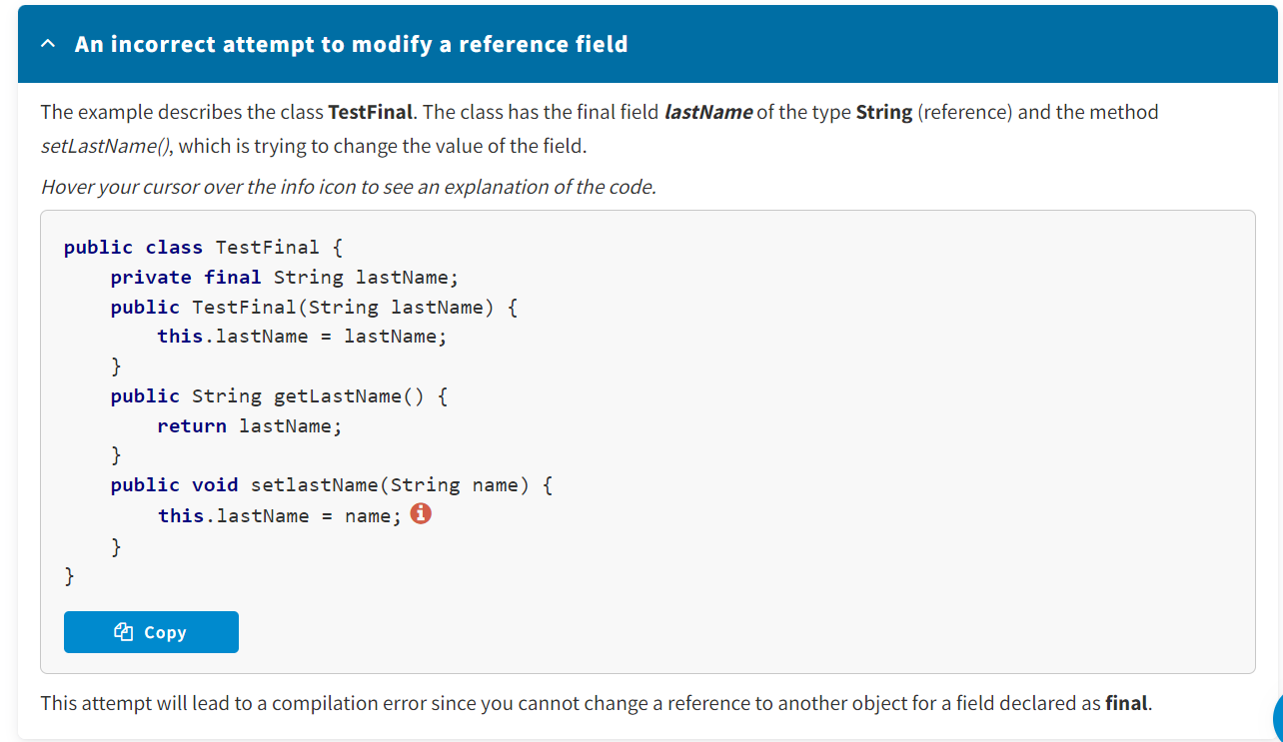

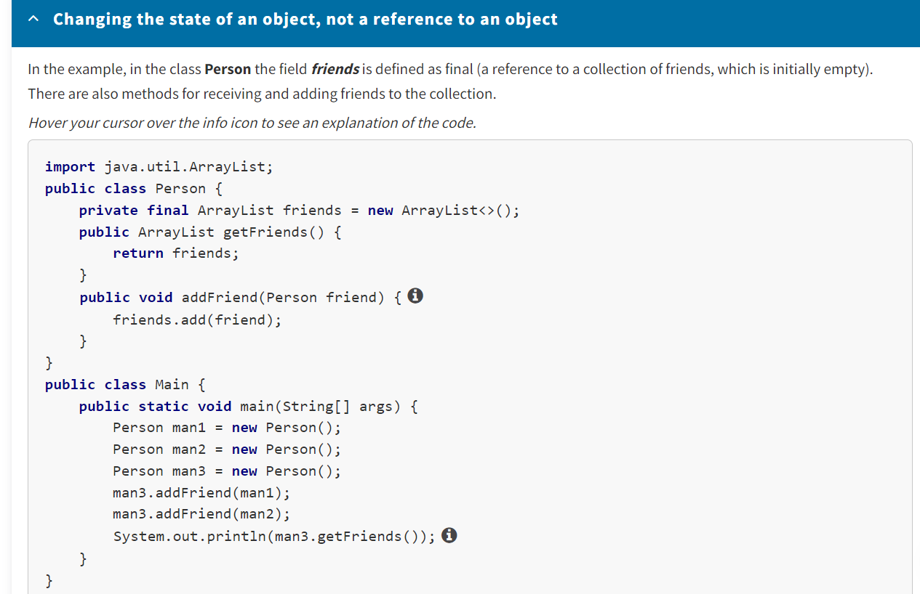

Since the method addFriend() does not change the reference and only changes the state of the collection, no error will occur.

* The modifier **static** is used to create methods and variables belonging to a class, not an object.
* The modifier **final** is used to define a final implementation of classes and methods, as well as invariability of variables and fields.

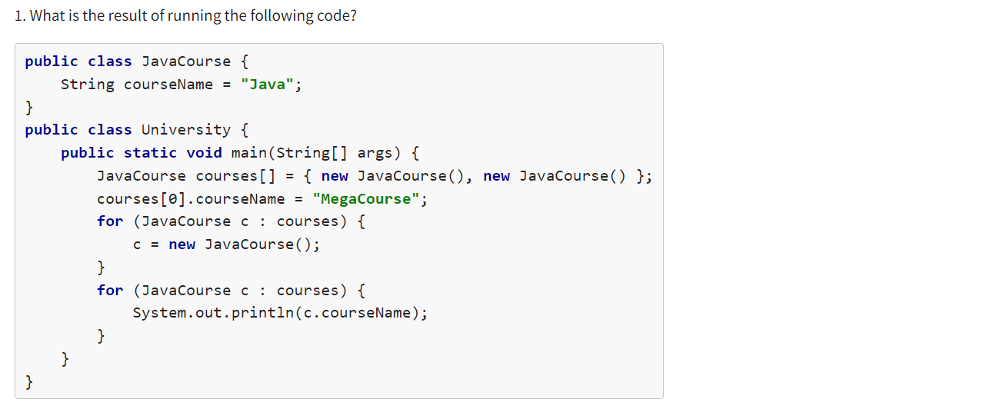

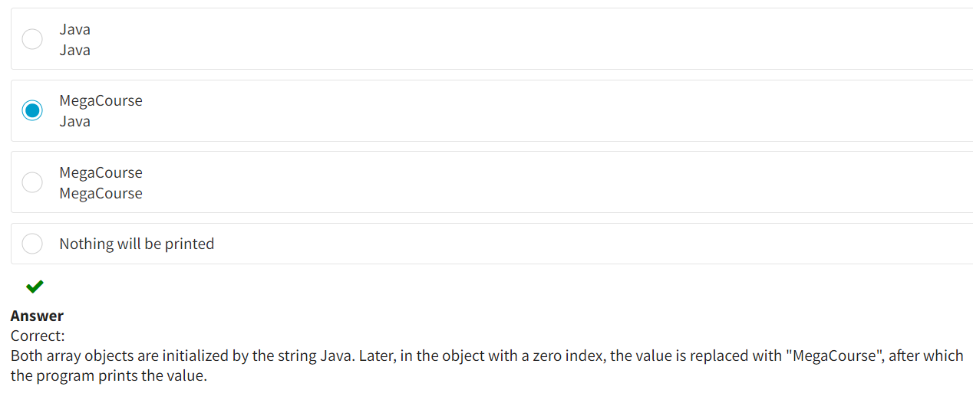

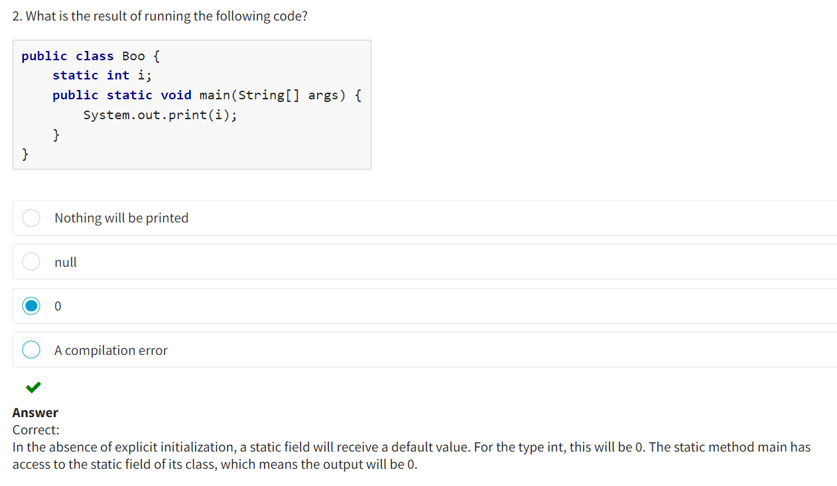

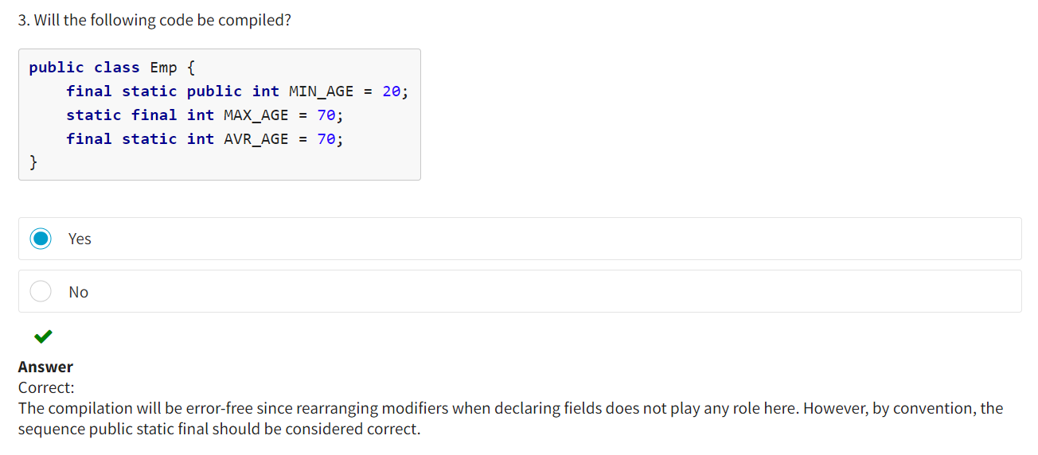

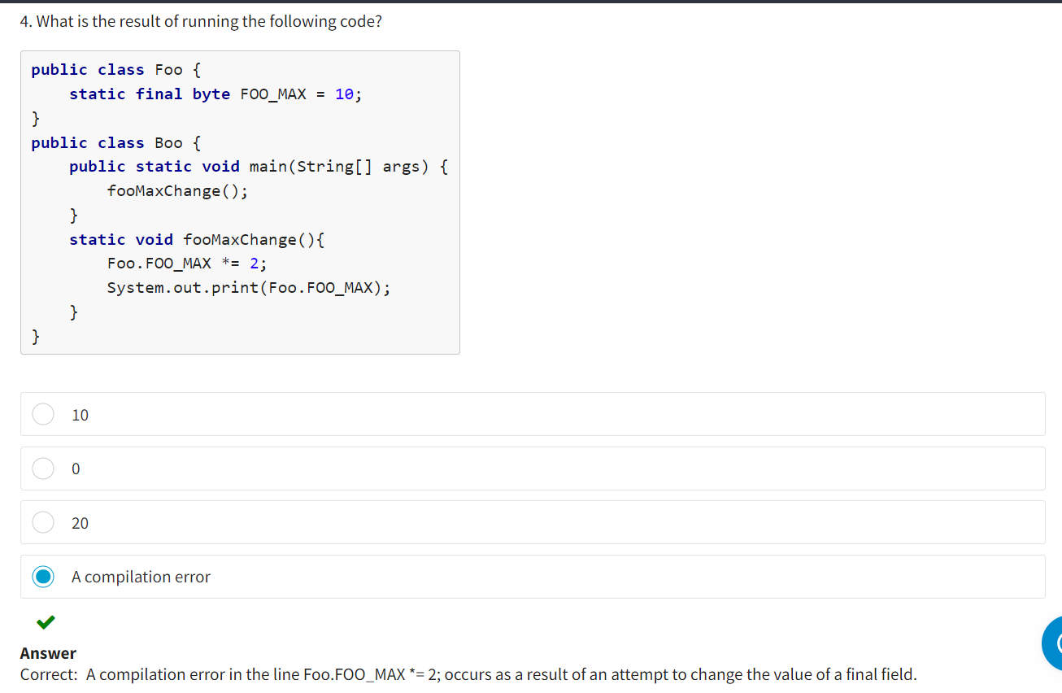

**Introduction**

In this lesson, you will explore one of the fundamental principles of OOP—inheritance. You will study the various types of inheritance and how to use it with different access rights. You will also discover superclasses and subclasses and find out the different capabilities of subclasses.

**The Concept of Inheritance**

**Inheritance** is a property that allows you to create a new class using an existing one with a partial or complete import of characteristics. Classes can then be arranged in a hierarchy that shows relationships of the type "is-a" (is a type/is a subtype). For example, "Car" is a subtype of "Vehicle."

Java uses the terms subclass and superclass for classes that are located in one inheritance branch.

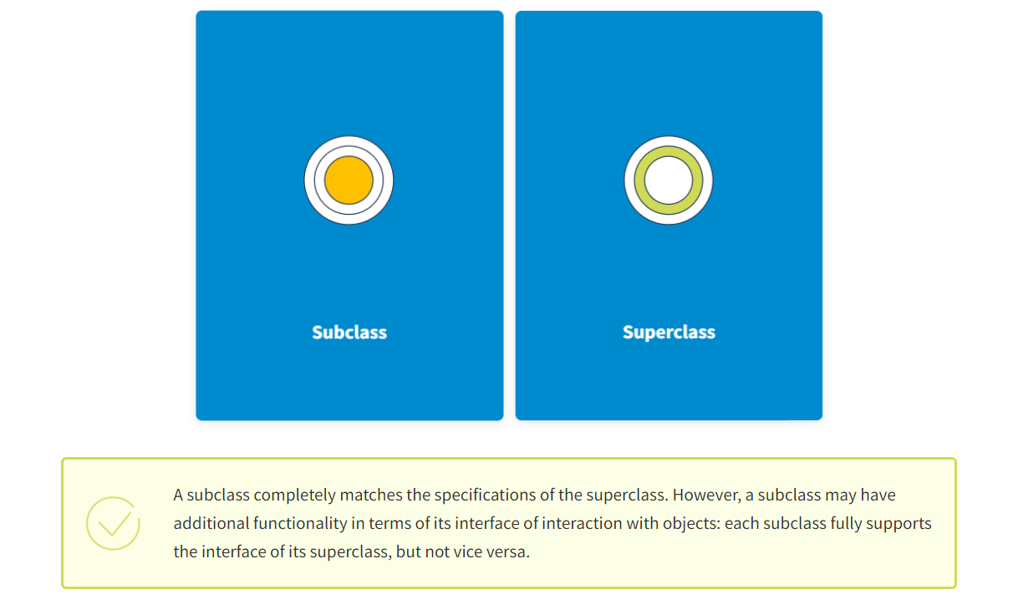

**A subclass** is a class that is inherited from or extends another class. A subclass can also be called a derivative or a child class.

**A superclass** is a class from which inheritance occurs. It can also be called a base or a parent class.

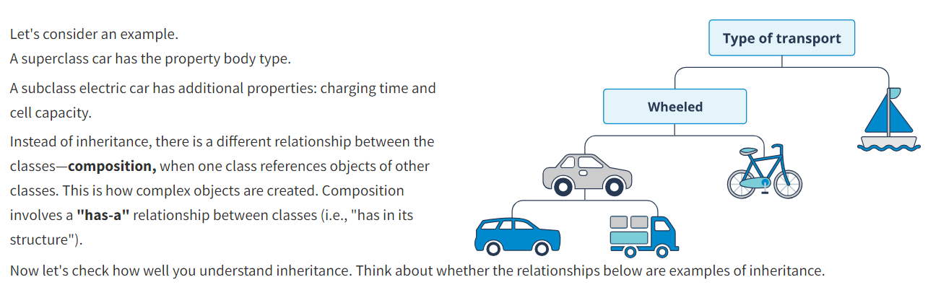

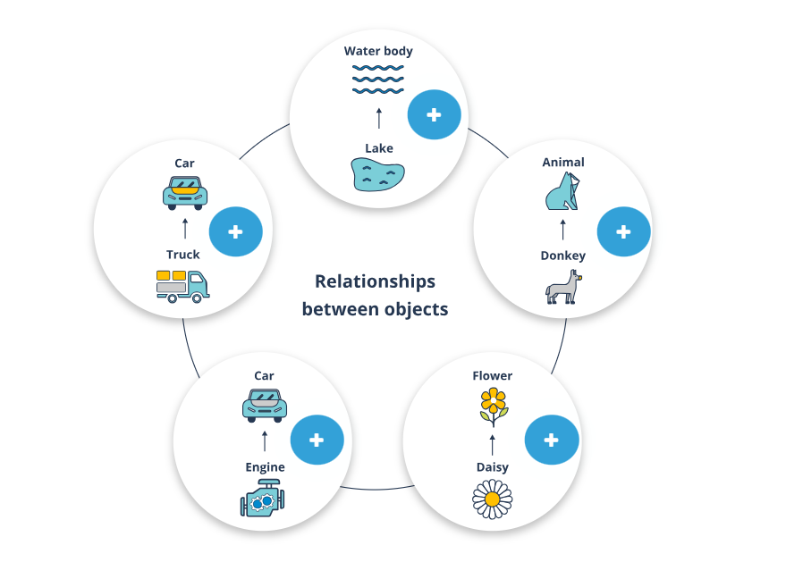

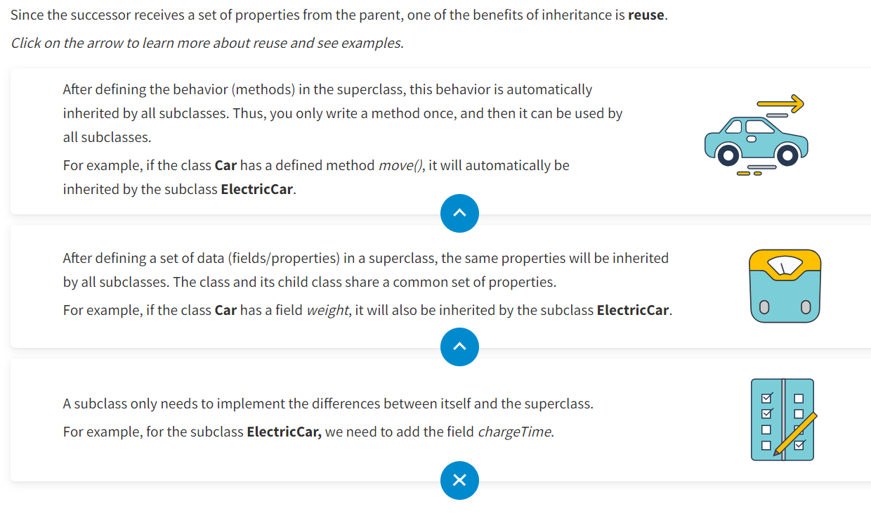

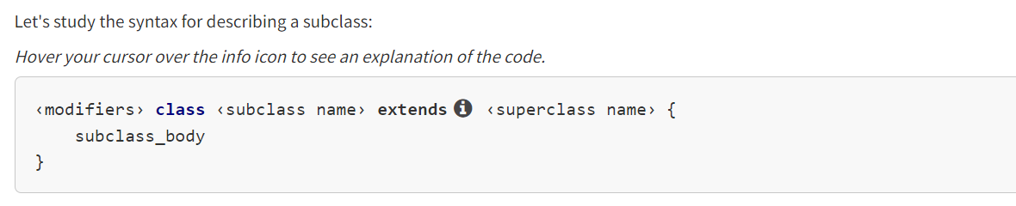

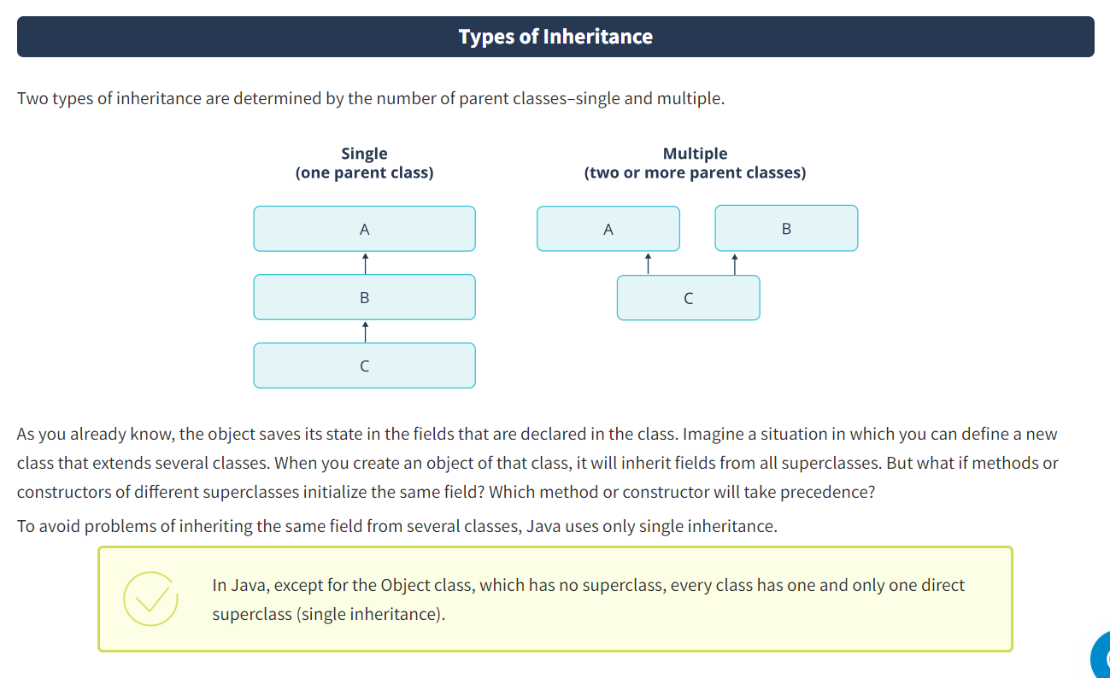

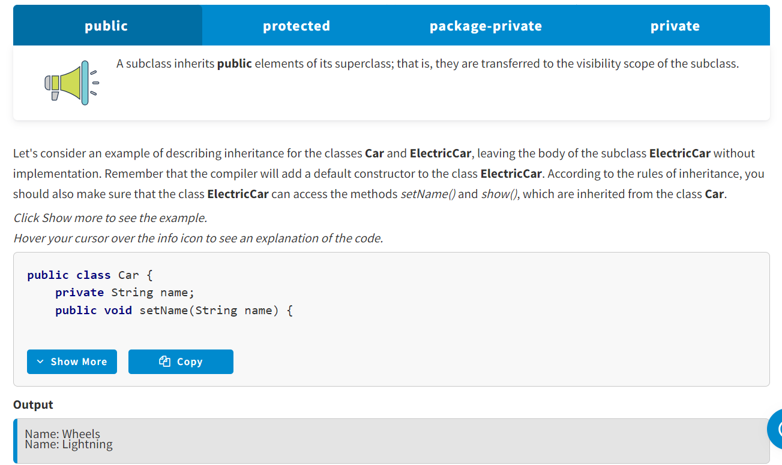

Protected : A subclass inherits **protected** elements of its superclass regardless of whether they are defined in one package or in different ones. This means they are transferred to the visibility scope of the subclass.

Package-Private: A subclass inherits **package-private** elements of its superclass only if they are defined in the same package; that is, they are transferred to the visibility scope of the subclass.

Private :

A subclass does not inherit **private** elements of its superclass; that is, they are not transferred to the visibility scope of the subclass. The subclass only interacts with such elements through the inherited methods.

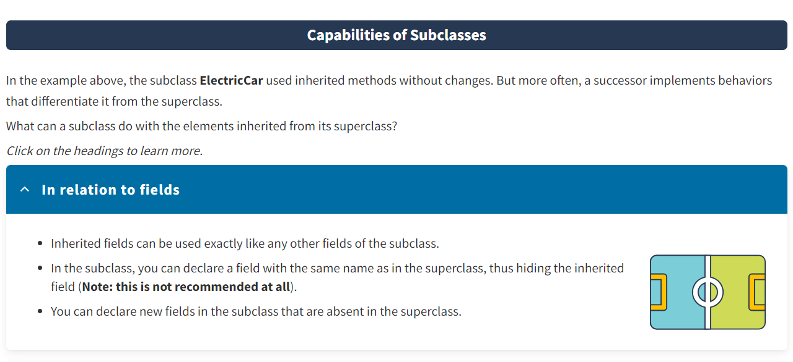

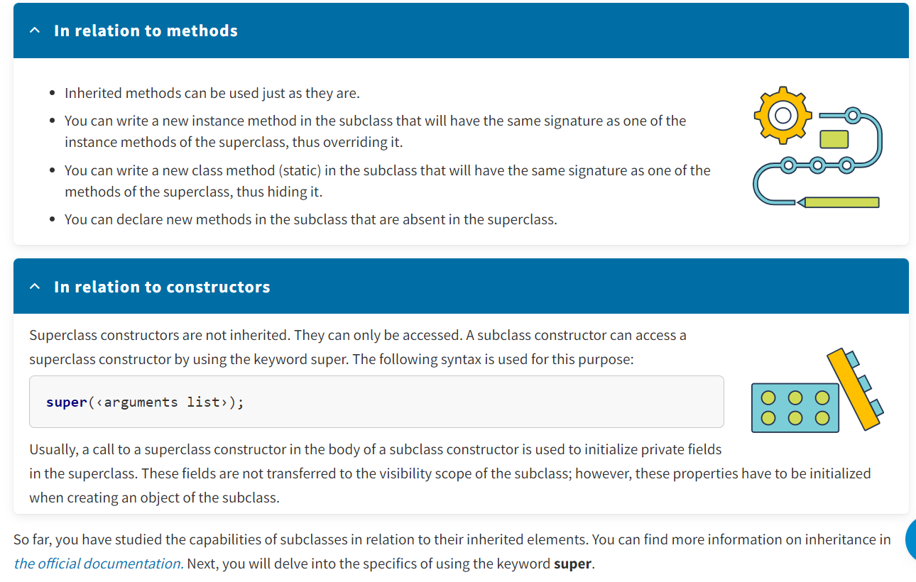

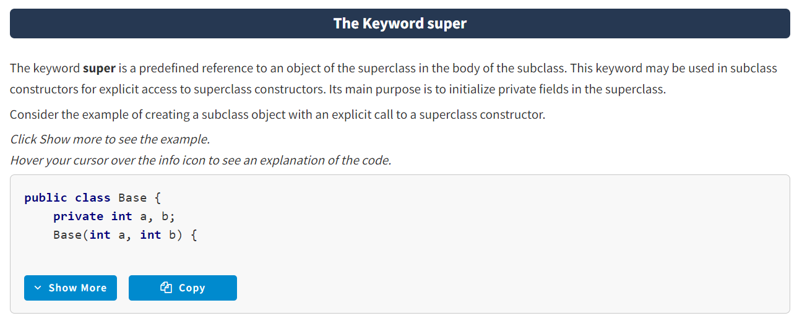

* Inheritance allows you to create a new class (subclass) based on an existing class (superclass) with a complete or partial import of its characteristics. The main benefit of inheritance is reuse.
* In Java, classes can have one and only one direct superclass (single inheritance).
* A subclass inherits **public** and **protected** elements from its superclass. **Package-private** elements of a superclass are inherited only if they are defined in the same package. A subclass does not inherit **private** elements from a superclass.
* Subclasses have various use cases for the elements they inherit—fields and methods.
* The keyword **super**may be used in subclass constructors to explicitly access superclass constructors and initialize private fields in the superclass.

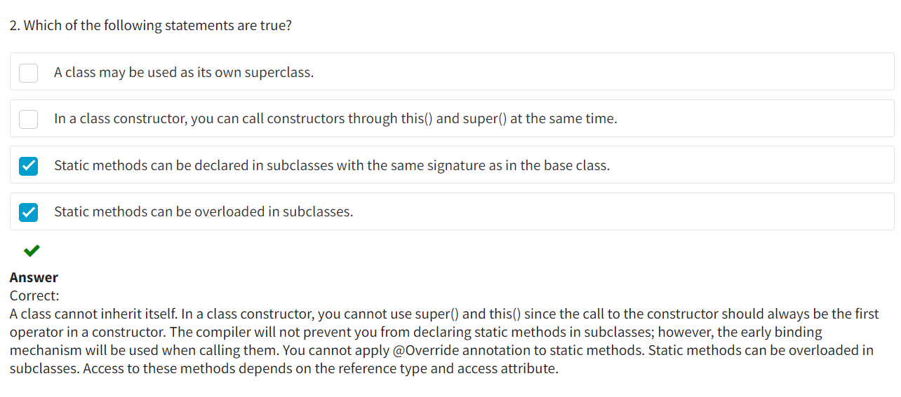

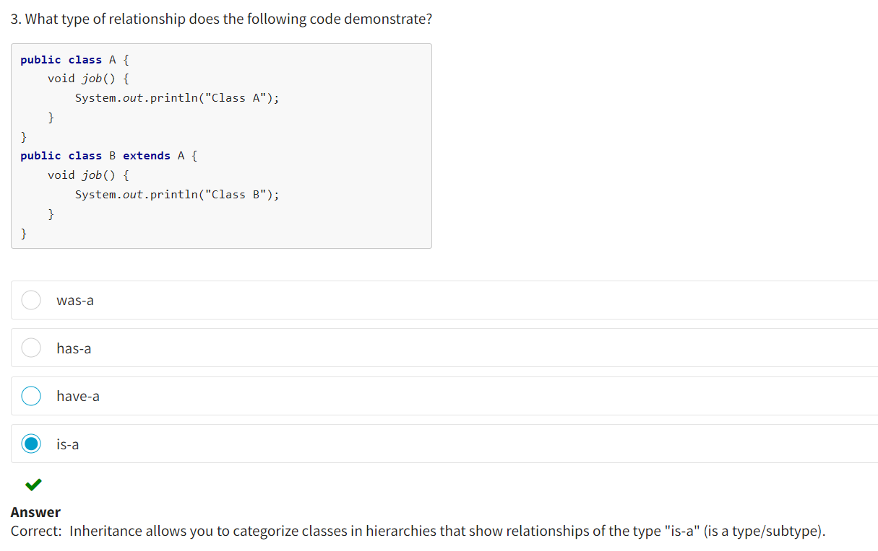

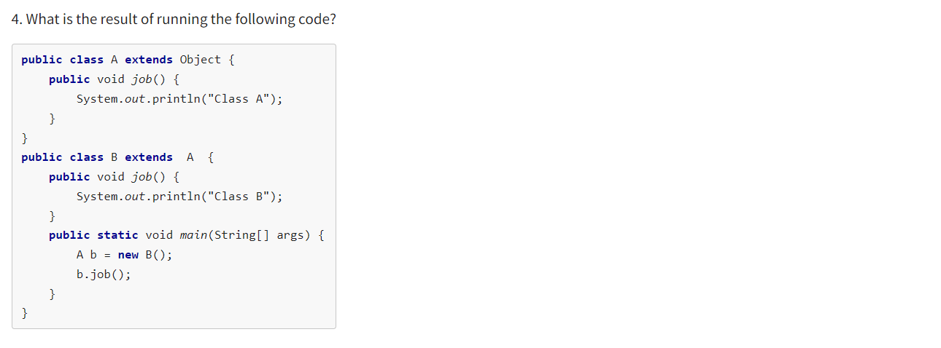

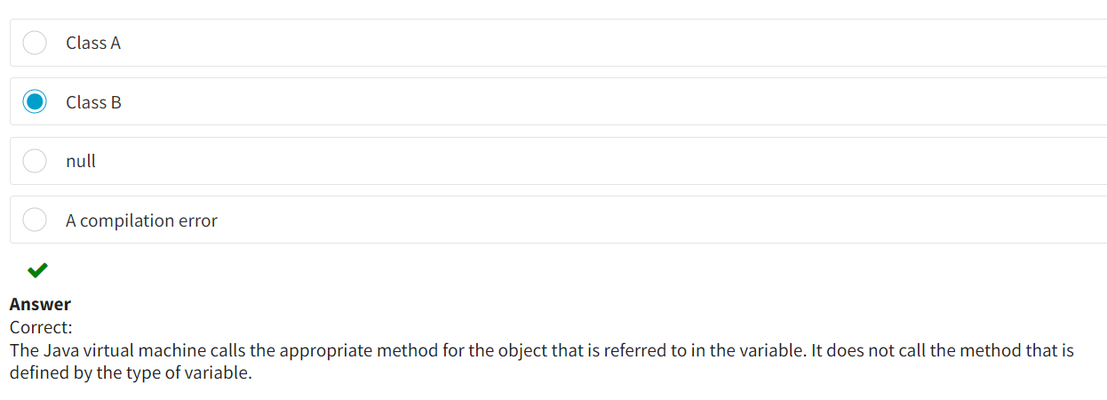

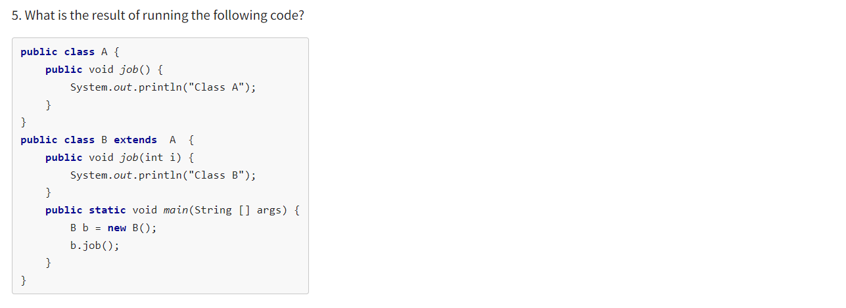

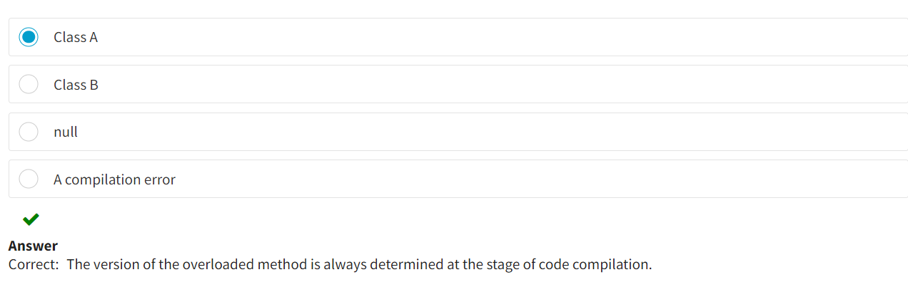

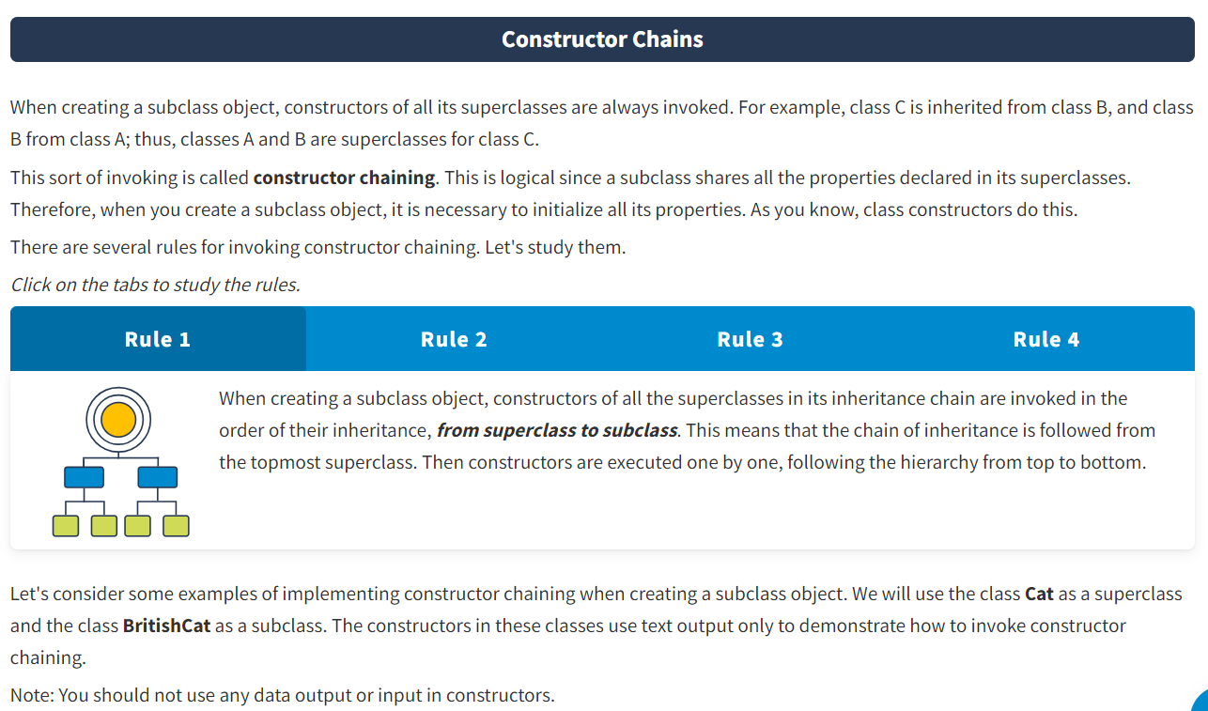

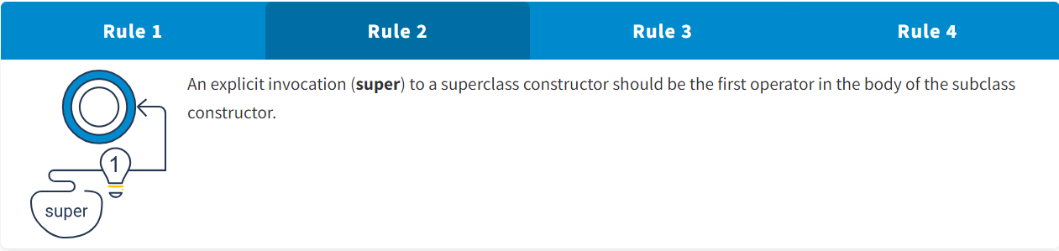

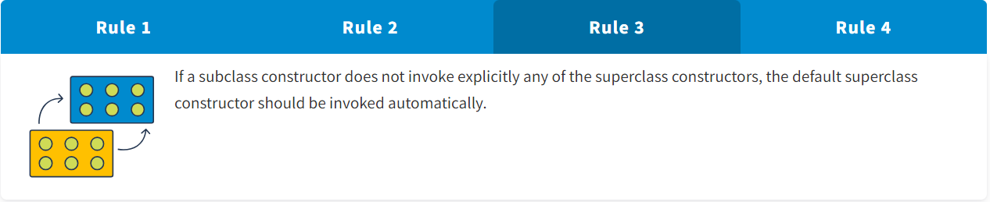

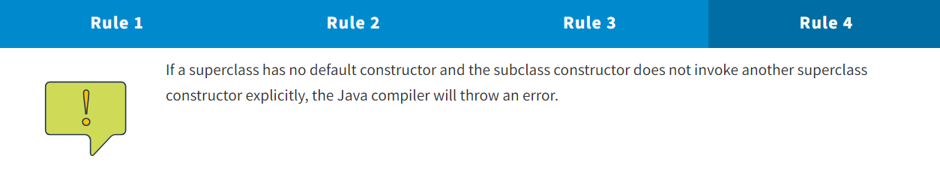

Let's consider some examples of implementing constructor chaining when creating a subclass object. We will use the class **Cat** as a superclass and the class **BritishCat** as a subclass. The constructors in these classes use text output only to demonstrate how to invoke constructor chaining.

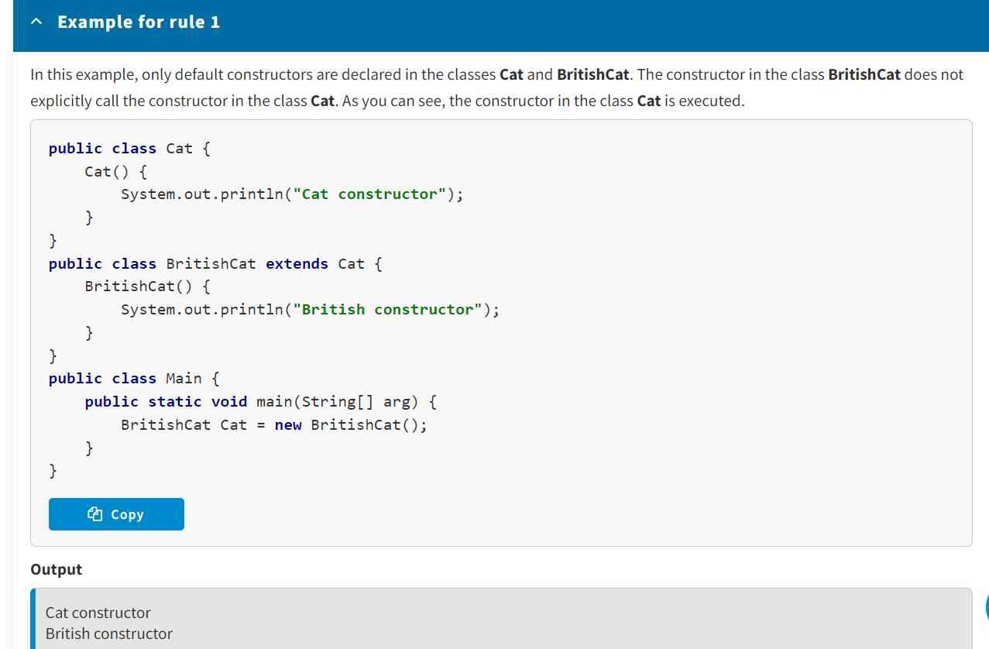

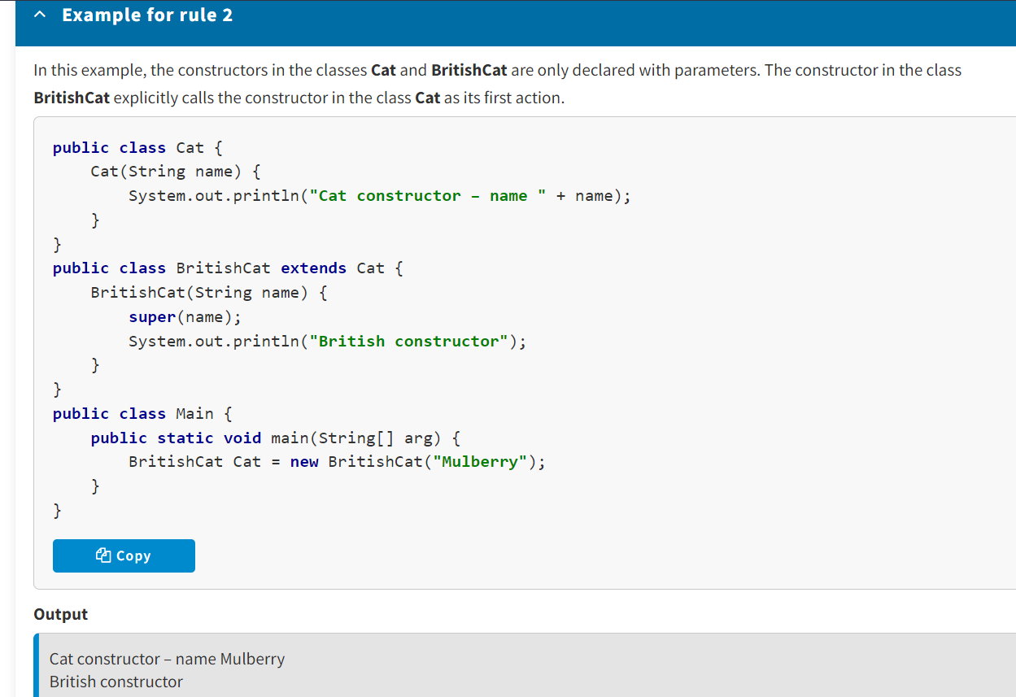

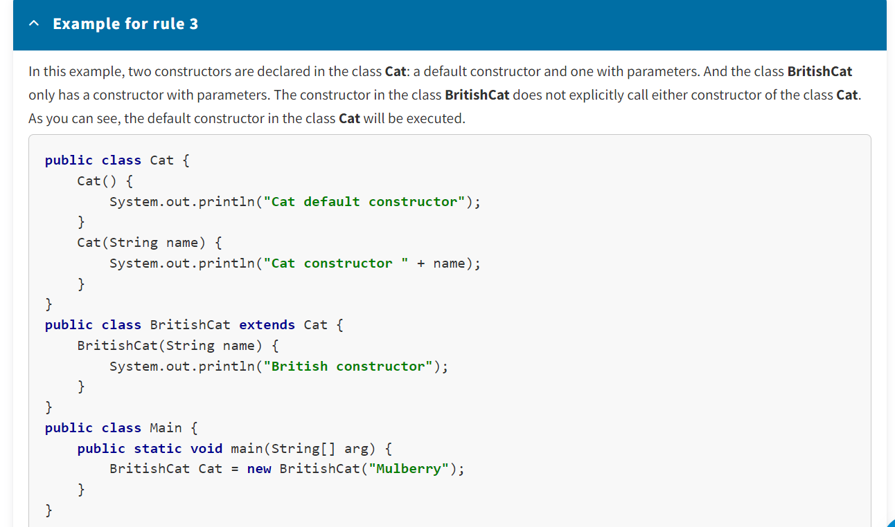

**Output**

Cat default constructor

British constructor

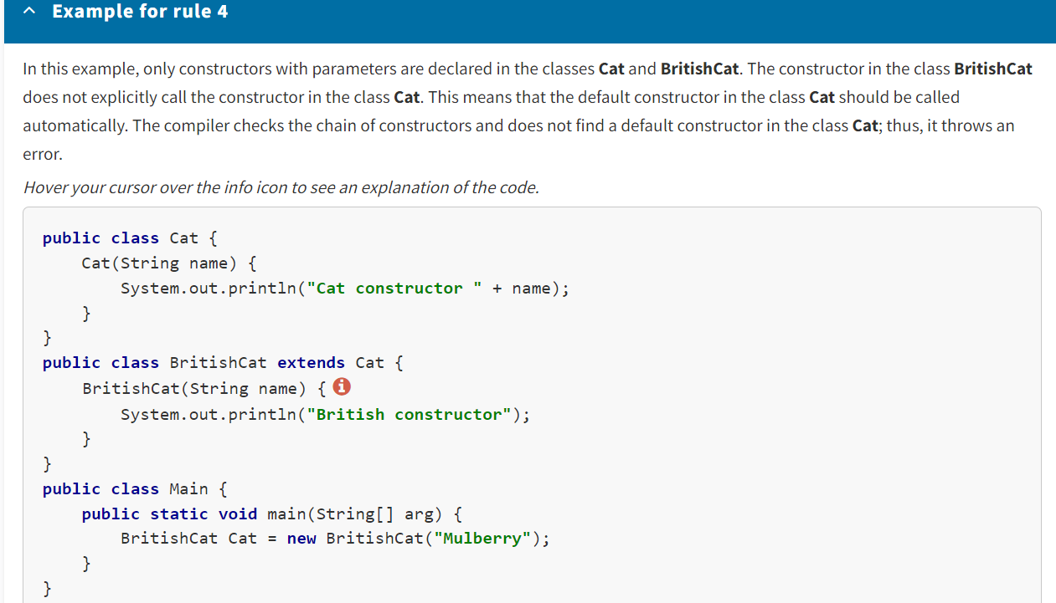

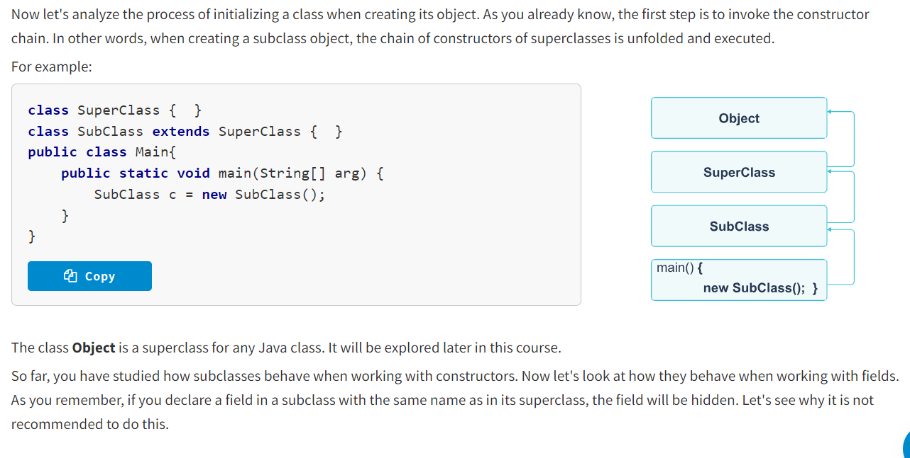

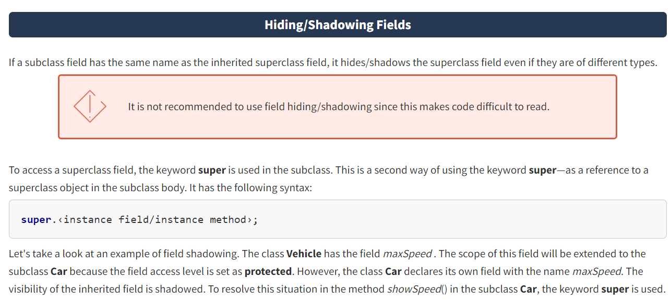

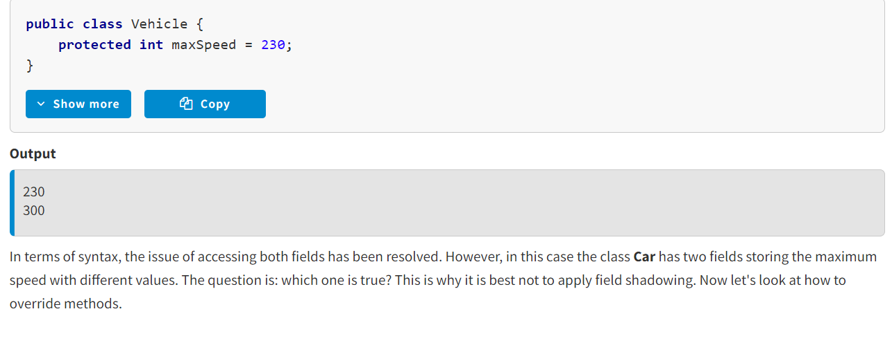

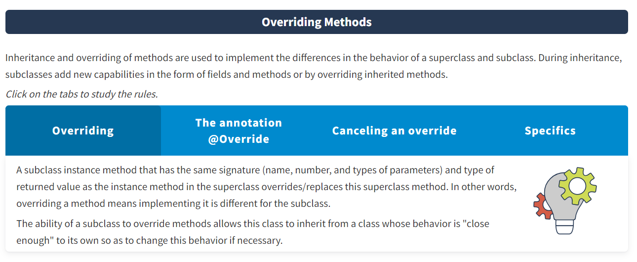

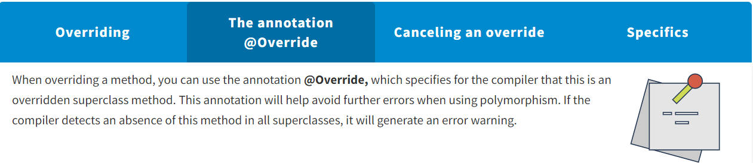

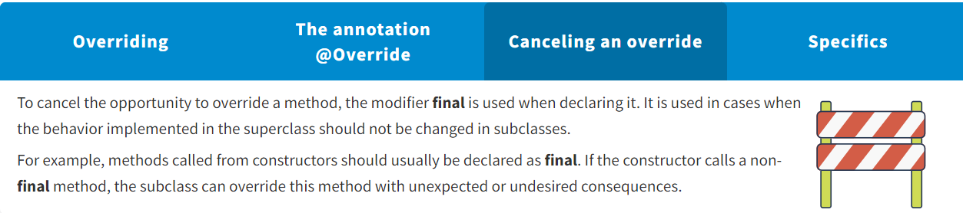

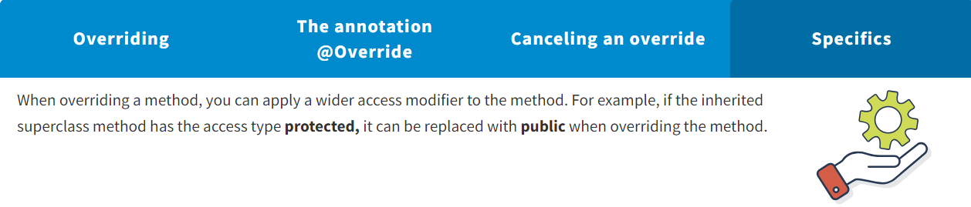

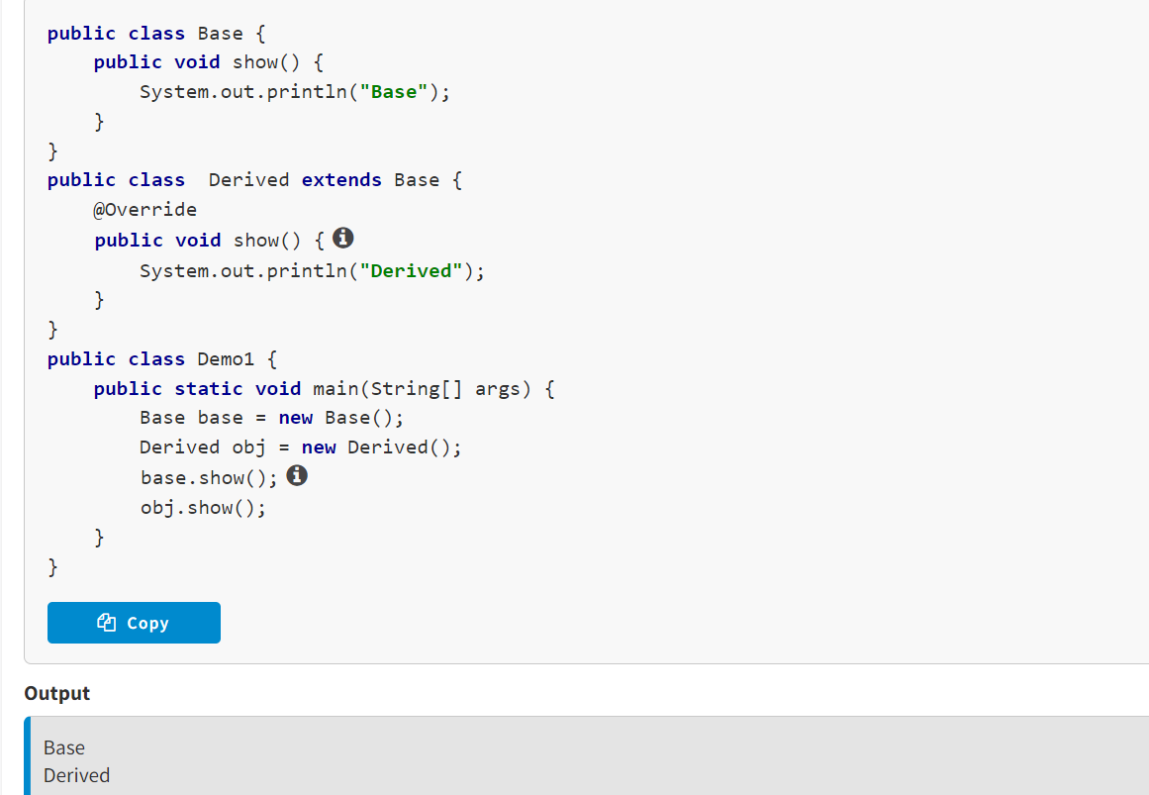

A subclass does not always need to completely replace the body of the inherited superclass method. Sometimes you only need to supplement it. To do this, when overriding the method, you can call the superclass method using the keyword **super**.

It is worth noting that if the chain of inheritance has more than two classes, the call through the keyword **super** always refers to the nearest/direct superclass.

In the following example, the method show() declared in the superclass **Base**and inherited by the subclass **Derived** is overridden as follows: First, the method show() of the superclass is called, and then additional actions are implemented. As a result, when the method show() is called at the object of the class **Derived**, all messages are printed, including the message of the method show() of the superclass.

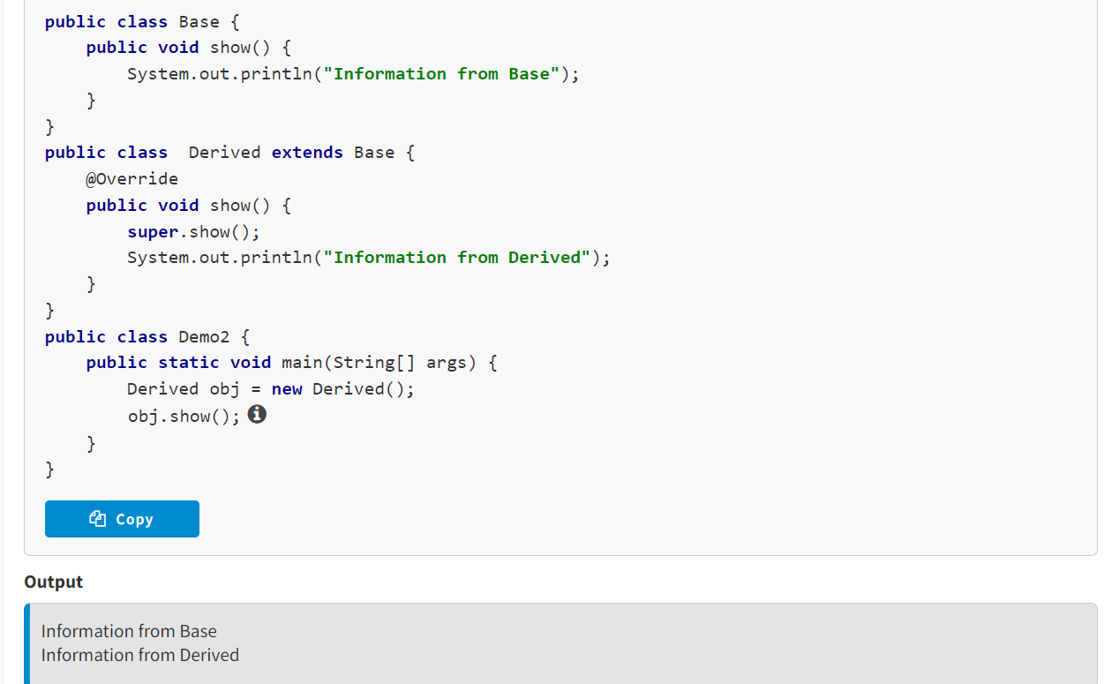

As you already know, elements with **protected**access are inherited by a subclass regardless of whether the superclass and its subclass are defined within one package or in different ones. However, if the superclass and subclass are located in different packages, the visibility scope of **protected**elements should only be limited by the subclass body. Outside of it, they will not be accessible. To make inherited **protected**methods accessible for use beyond the subclass body, when overriding this method, you can replace the access modifier with **public**.

In the following example, three classes in different packages are described. The superclass **Vehicle** is in the package com.model.basic_transport with a **protected** field maxSpeed and a **protected** instance method showSpeed(). When overriding the method showSpeed(), the subclass **Bicycle**in the package com.model.derived_transport changes the access modifier to **public**. In the third package, the class **Demo** com.model.test_transport creates objects of the classes **Vehicle**and **Bicycle**. Then the field maxSpeed is accessed, and the method showSpeed() is called at these objects.

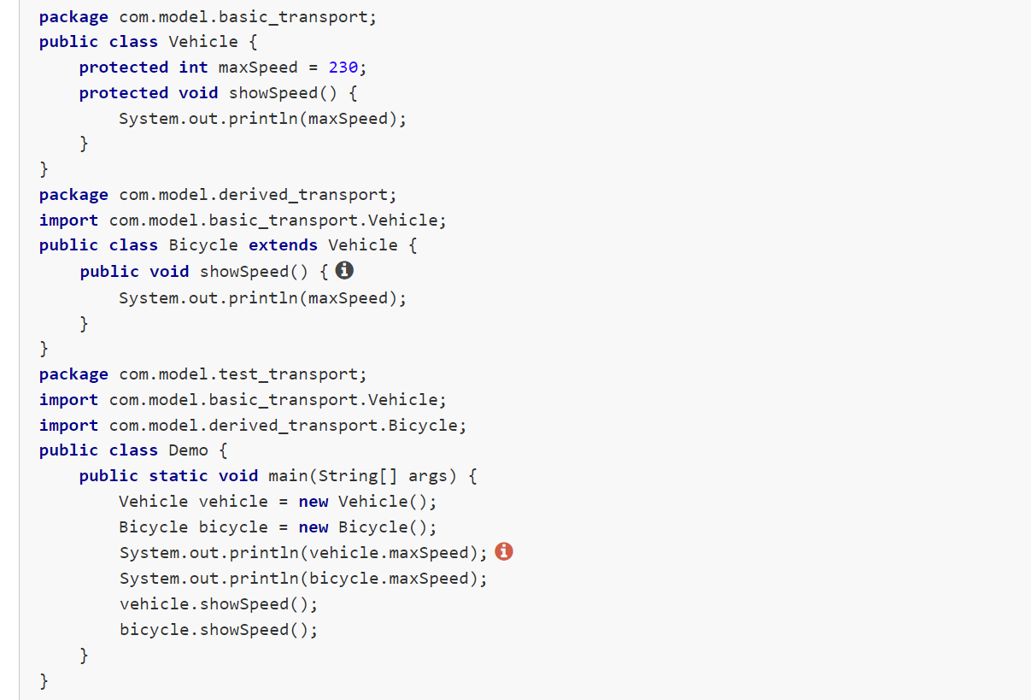

We got a compilation error in every case, except for when we called the method showSpeed() at the object of class **Bicycle**. This happened because **protected**elements of one class are not accessible from classes located in other packages.

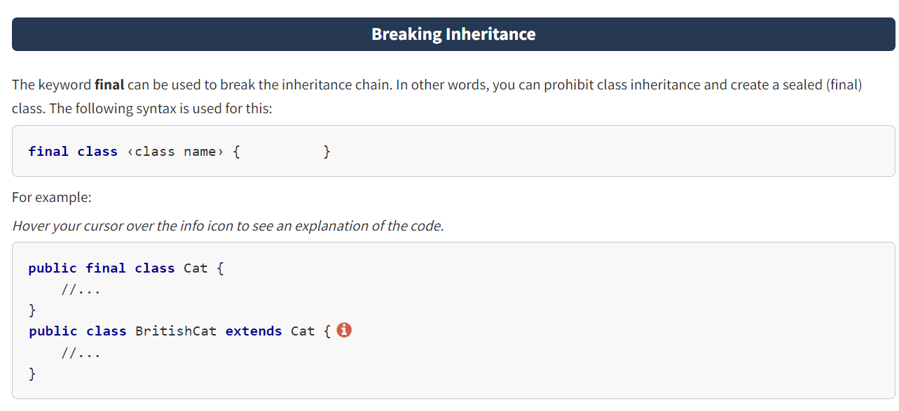

* When creating a subclass object, the constructors of all its superclasses are invoked. This is called constructor chaining. You also studied the rules for invoking superclasses as well as some examples of how to do this.
* Methods are inherited to implement differences in the behavior of a superclass and a subclass.
* It is not recommended to use field hiding since this makes code difficult to read.
* To disable a chain of inheritance, the keyword **final** is used.

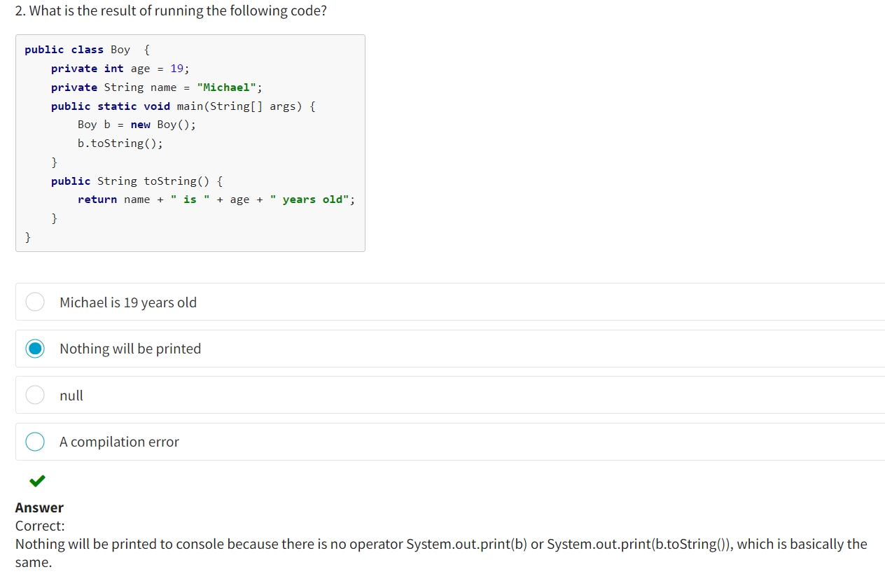

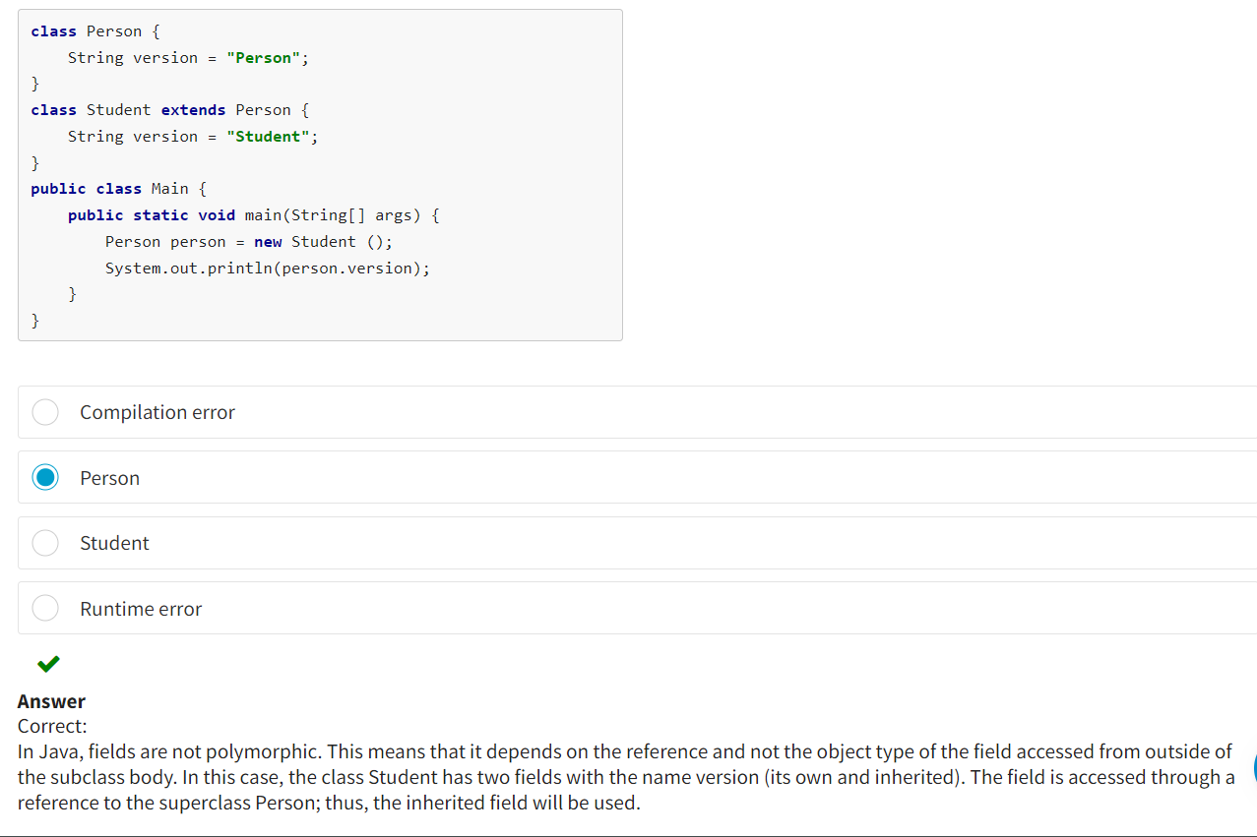

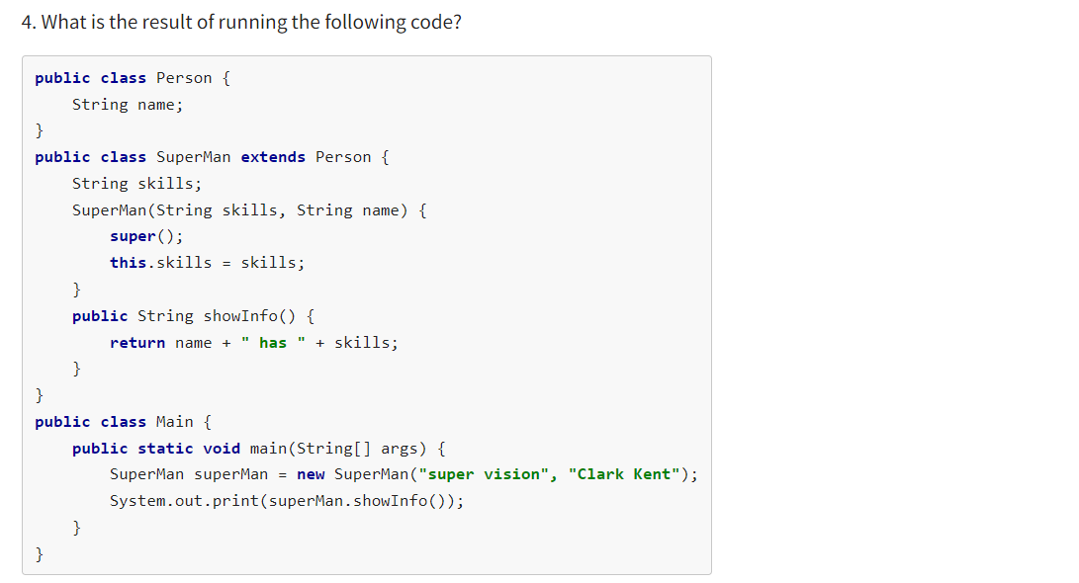

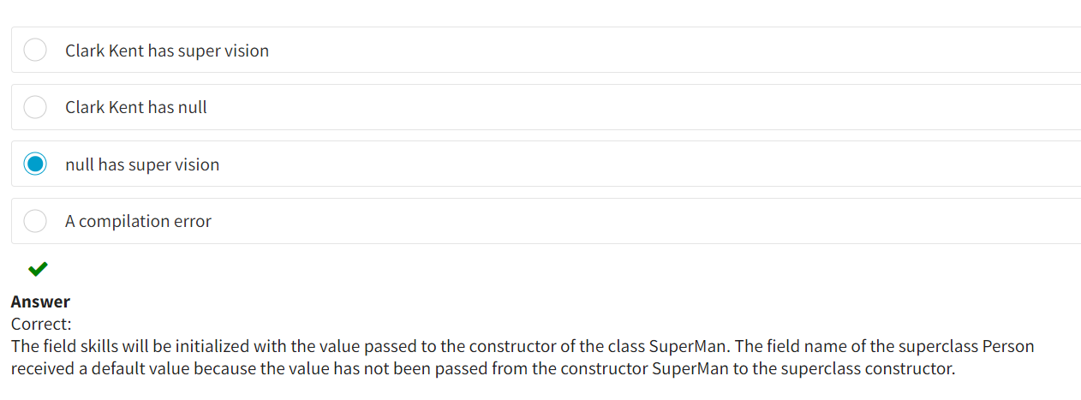

**Polymorphism**

Polymorphism is one of the fundamental notions in object-oriented programming, along with inheritance and encapsulation. In programming languages and type theory, polymorphism involves providing a single interface to entities (objects) of different types or using a single symbol to represent multiple different types.

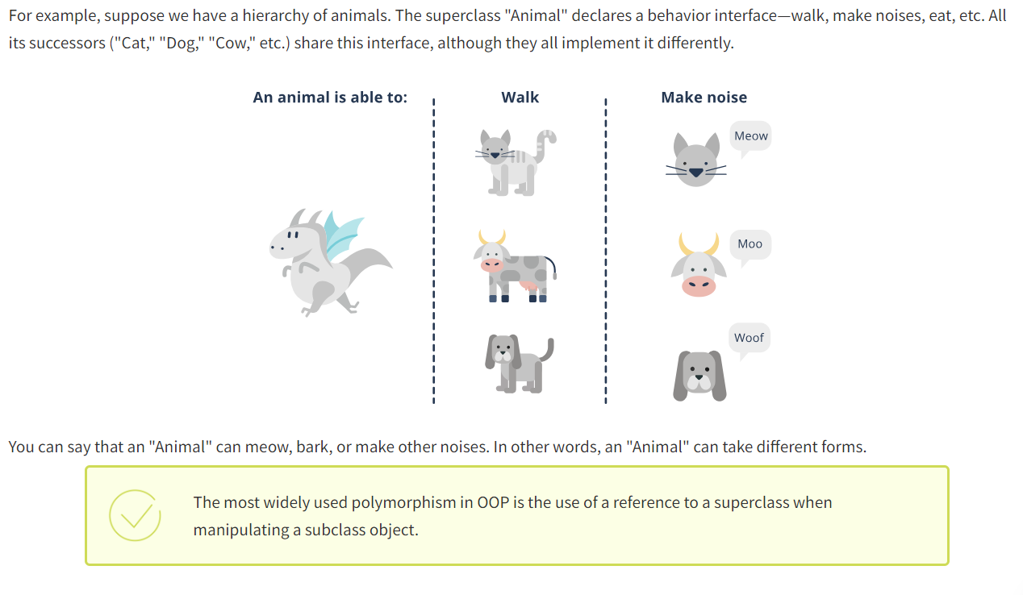

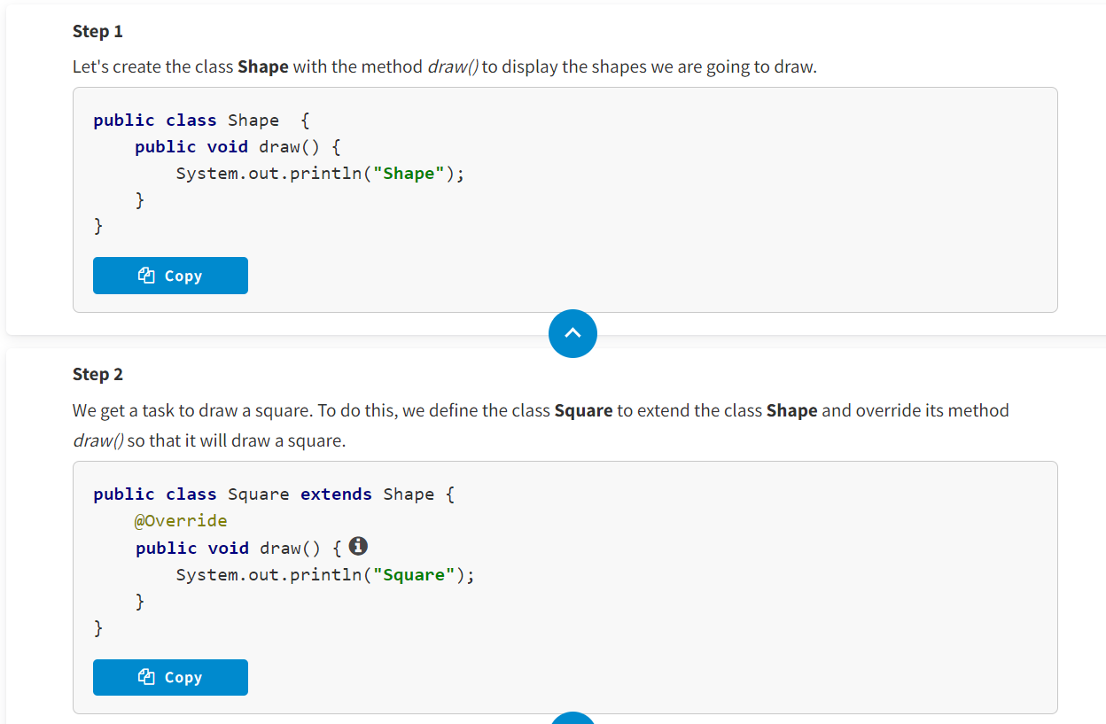

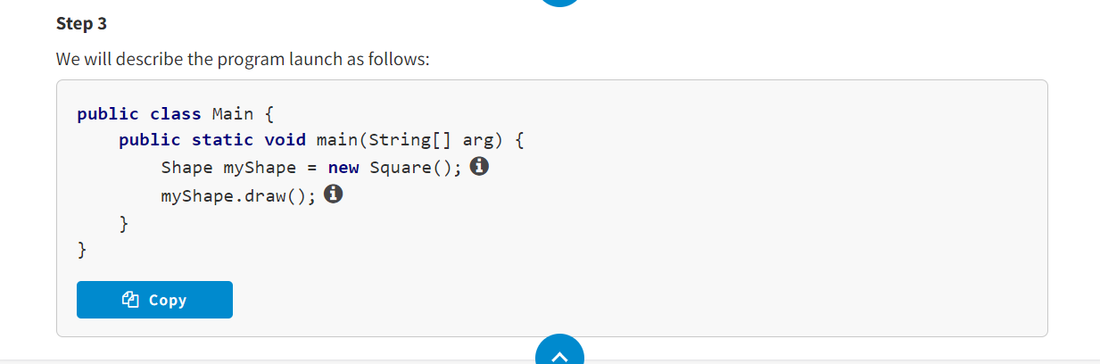

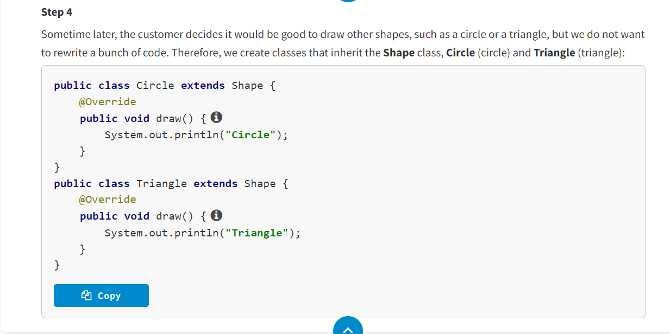

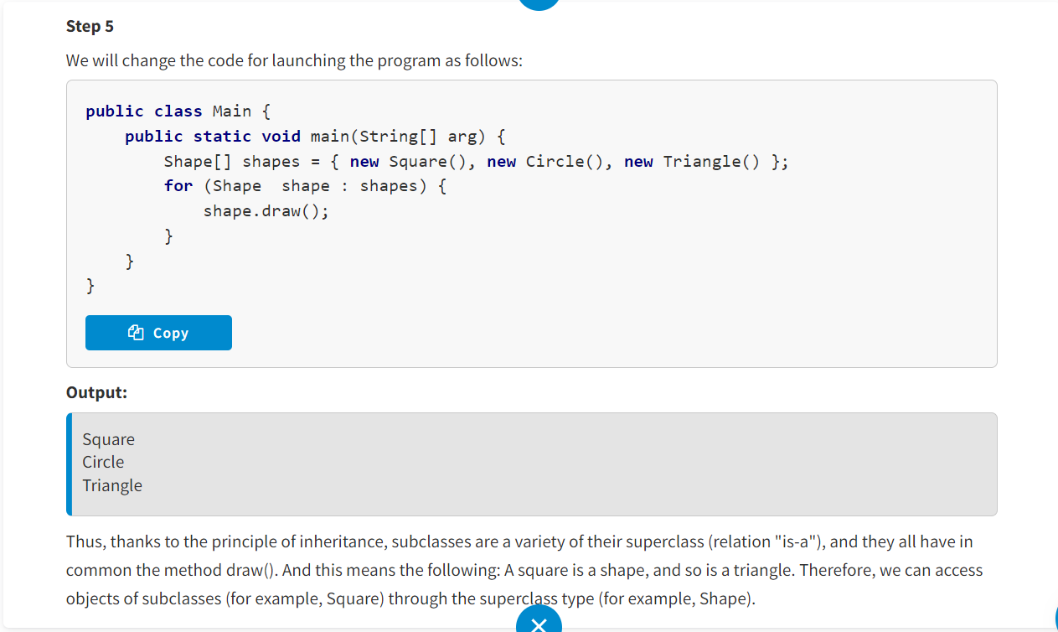

Using a reference to a superclass, you can access objects of any of its subclasses. Subclasses can define their own unique behavior and, at the same time, share the functionality of their superclasses.

Thanks to polymorphism, developers can create applications to work with objects in the future that are absent at the current development stage. Moreover, polymorphism can be different.

**Early and Late Binding**

Polymorphism can differ by when implementation is chosen:

* Statically—during compilation
* Dynamically—during execution

In Java, the mechanism for choosing implementation—defining the called method—is called **binding**. There are two types of method binding.

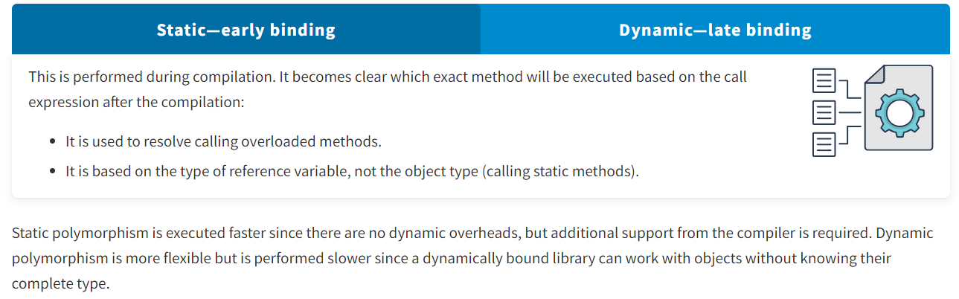

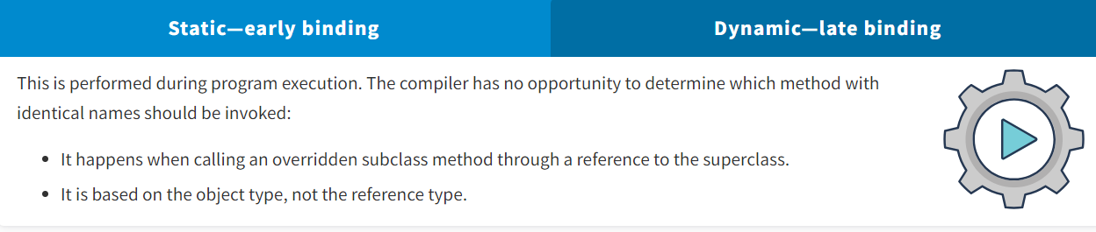

* The example describes three classes: **Figure** (as a superclass), **Rectangle**, and **Triangle** (as subclasses).
* The class **Figure** has two fields declared to store the dimensions of figures (*dim1* and *dim2*) as well as an implemented method to calculate the area of a figure *area()*.
* The shape of the figure is not known for the class **Figure**; therefore, the method returns 0.
* The subclasses **Rectangle** and **Triangle** override the method *area()* to calculate their area. The constructors of these classes pass their dimensions for storage to the fields *dim1* and *dim2:* **Rectangle**—width and height—and **Triangle**—base length and height.
* The class **FindAreas** creates three objects—one each for the classes **Figure**, **Rectangle**, and **Triangle**. It also creates a reference of the type **Figure**—*figref*. This reference accesses created objects one by one, and the method *area()* is called at it.

**public** **class** Figure {

**protected** **double** dim1;

**protected** **double** dim2;

Figure(**double** dim1, **double** dim2) {

**this**.dim1 = dim1;

**this**.dim2 = dim2;

}

**public** **double** area() {

System.out.print(**"Area of the figure not determined "**);

**return** 0.0;

}

}

**public** **class** Rectangle **extends** Figure {

Rectangle(**double** dim1, **double** dim2) {

**super**(dim1, dim2);

}

**public** **double** area() {

System.out.print(**"Area of the rectangle "**);

**return** dim1 * dim2;

}

}

**public** **class** Triangle **extends** Figure {

Triangle(**double** dim1, **double** dim2) {

**super**(dim1, dim2);

}

**public** **double** area() {

System.out.print(**"Area of the triangle "**);

**return** dim1 * dim2 / 2;

}

}

**public** **class** FindAreas {

**public** **static** **void** main(String[] args) {

Figure f = **new** Figure(10.0, 5.0);

Rectangle r = **new** Rectangle(9.0, 5.0);

Triangle t = **new** Triangle(10.0, 8.0);

Figure figref;

figref = r;

System.out.println( figref.area() );

figref = t;

System.out.println( figref.area() );

figref = f;

System.out.println( figref.area() );

}

}

**Output:**

Area of the rectangle 45.0

Area of the triangle 40.0

Area of the figure not determined 0.0

What you can see: The syntax of calling the method is the same in the three cases (*figref.area()*), while the result is different. This is because the variant of the method to be invoked is chosen during program execution and depends on the object type, not the type of reference to the object. The objects in the three cases are different; therefore, the method *area()* is implemented differently.

For static class methods, dynamic polymorphism cannot be applied since calling static elements is done by the reference type, not the object type, through which it is accessed . The version of the called static method is always determined at the compilation stage—early binding.

In the example, the superclass **Insurance** has the following elements:

* The static field ***LOW***
* A static method *getCategory()* that returns the name of the superclass
* An instance method *getPremium()* that returns the value of the field ***LOW***

The class **CarInsurance** is a subclass **Insurance** and has:

* Its own static field ***HIGH***
* The static method *getCategory(),* which is overridden and returns the name of the subclass
* The instance method *getPremium(),* which is overridden and returns the value of the field ***HIGH***

In the class **Main**, a reference to the superclass *current* is declared and initialized by the subclass object. Then, using the reference to the object and the subclass name, the static method *getCategory()* is called.

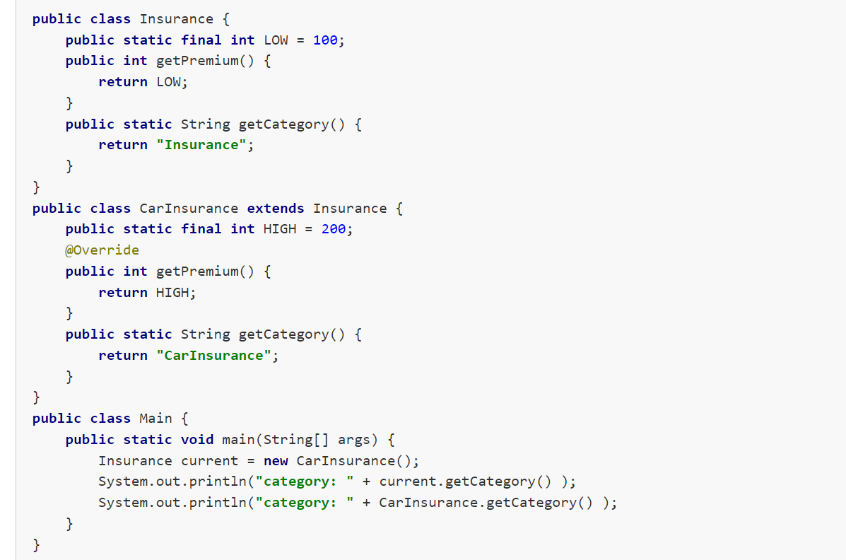

**Output:**

category: Insurance

category: CarInsurance

As you can see, calling an option of the static method depends on the type of reference to the object, not the object type. In the given case, the way the method *getCategory()* is called depends on the reference type of the object *current*, meaning the type **Insurance**.

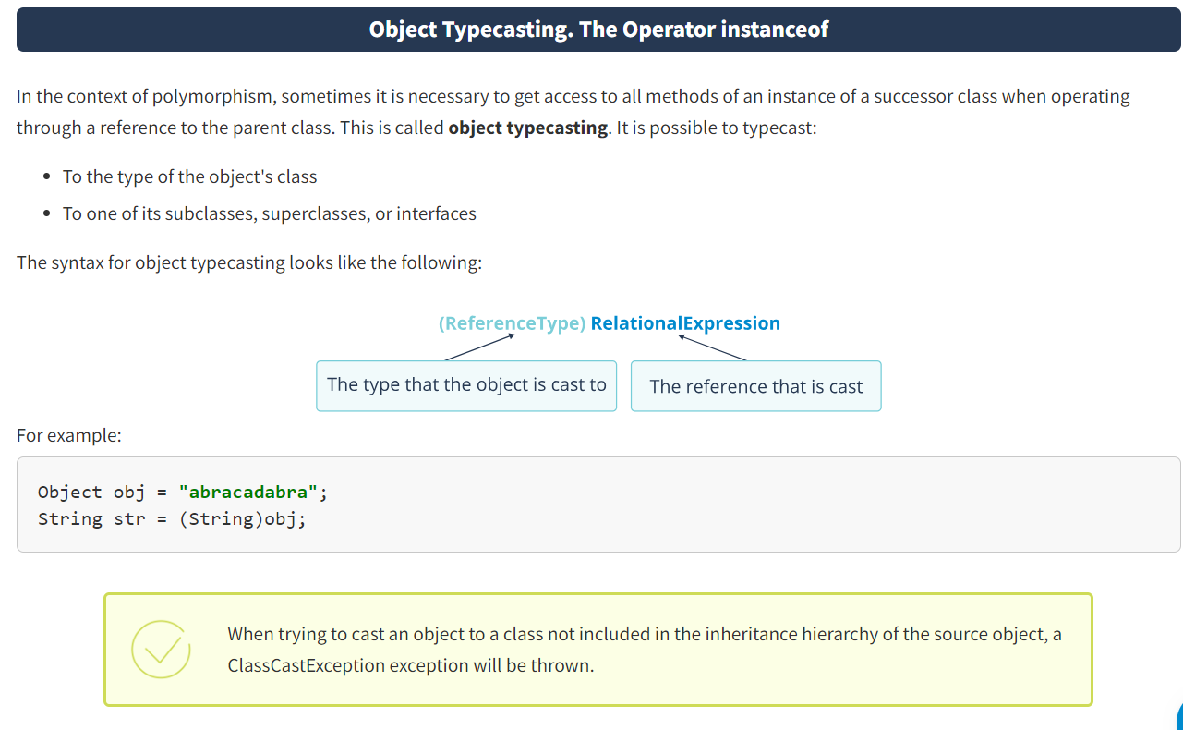

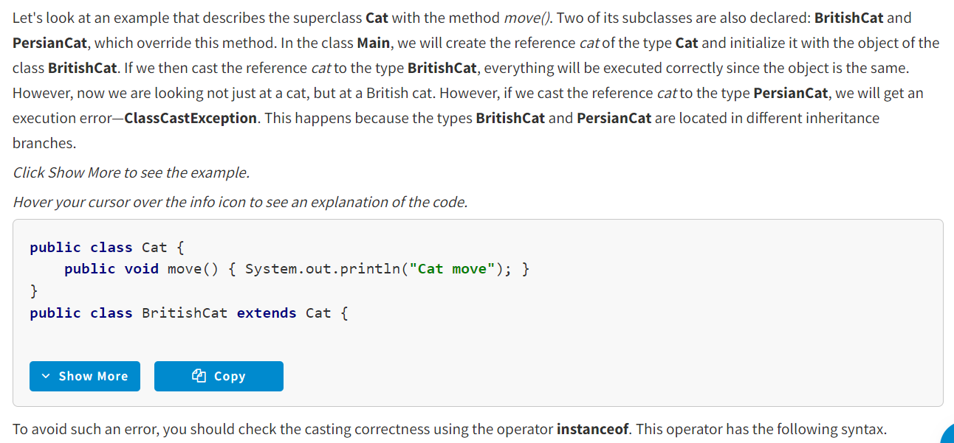

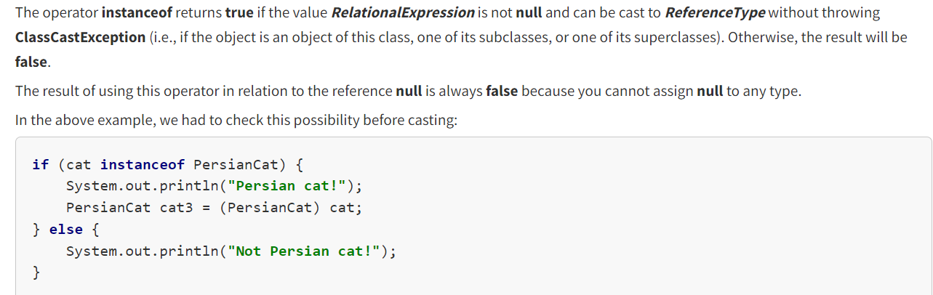

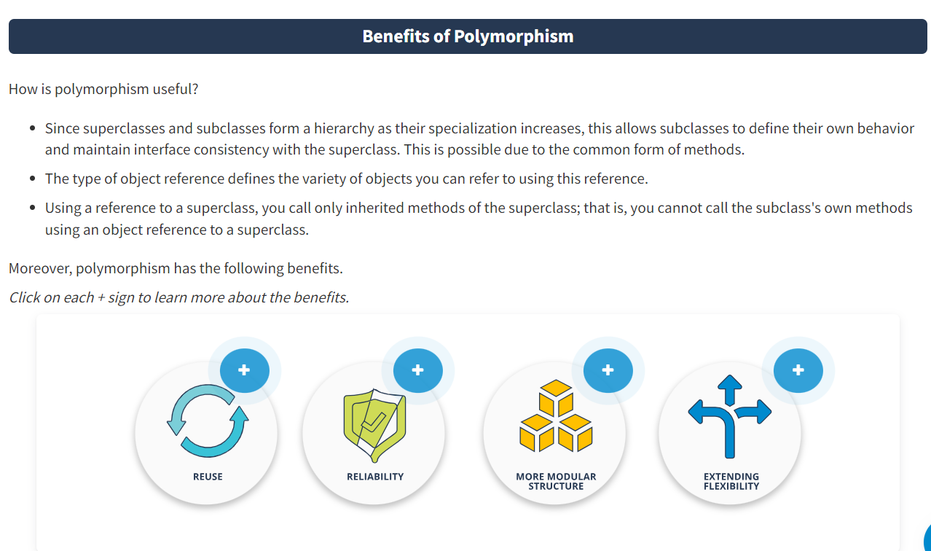

**Reuse**

If there is code that works with a supertype, it can also be used to work with the objects of subtypes. This allows you to substitute object implementation. Testing is based on this.

**Reliability**

The compiler performs checks related to the use of data types. This protects you from runtime errors due to incorrect use of various operations with different data types that are part of some family.

**More modular structure**

When designing program architecture, the developer can highlight components that they can later replace with other components, thus allowing the code to remain functional.

**Extending flexibility**

You can add new data types and apply them to the existing functional code.

* Polymorphism involves providing a single interface to entities of different types or using a single symbol to represent multiple different types.
* The most widely used polymorphism in OOP is the use of a reference to a superclass when manipulating a subclass object.
* Static binding is performed during compilation, and dynamic binding is used during program execution. Static polymorphism is executed faster since there are no dynamic overheads, but additional support from the compiler is required. Dynamic polymorphism is more flexible but is performed slower since a dynamically bound library can work with objects without knowing their complete type.
* Object typecasting involves receiving access to all methods of a successor class instance when operating it through a reference to the parent class. You can check the correctness of this casting using the operator **instanceof**.

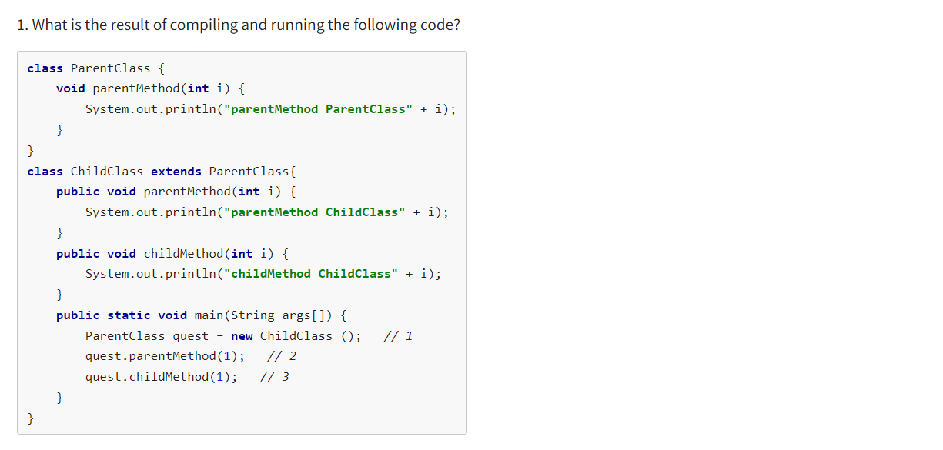

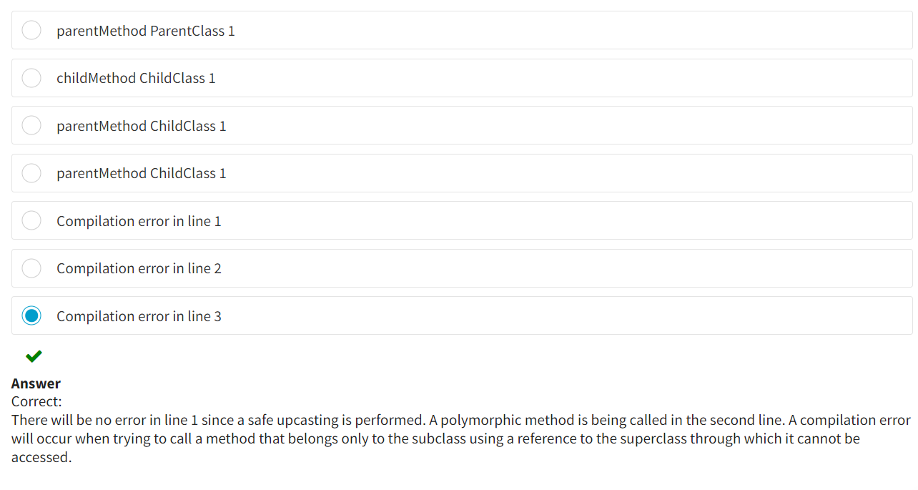

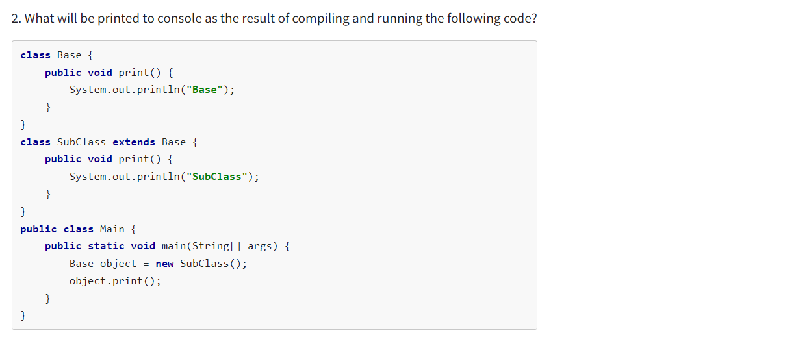

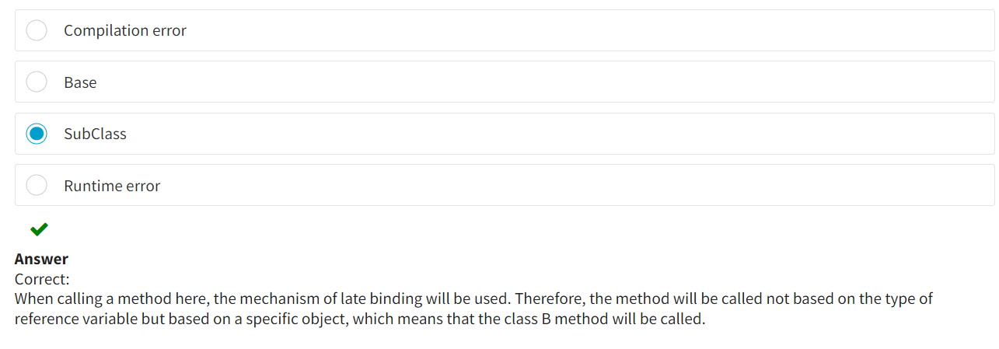

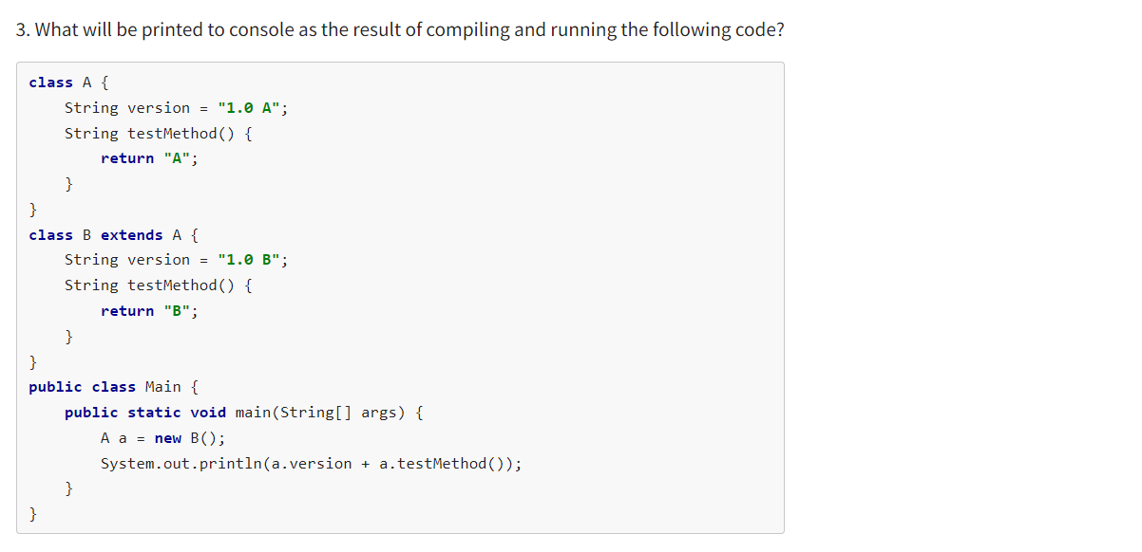

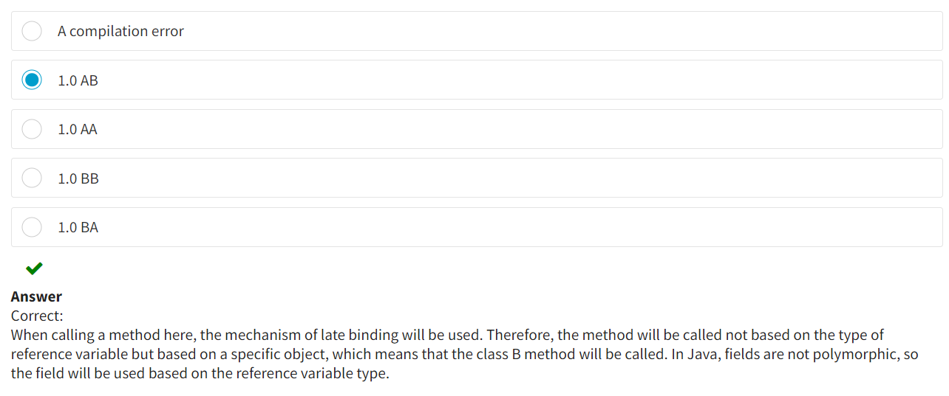

**Method Overloading and How to Resolve It**

If one class has two methods with the same name, their parameter lists should be different. These methods are considered **overloaded**.

Java distinguishes these methods by their **signature**—this includes **the name of the method and the number and types of parameters**. This allows two or more methods to be defined using the same name while having different parameters within one class.

This happens due to the need to perform similar actions with data of different types and amounts:

* The type of value returned is not considered when resolving overloaded methods.
* Static methods can be overloaded with non-static ones and vice versa (there are no limitations).

**public** **void** test(String s) {

s = **"abcd"**;

System.out.println(**"test(String)"**);

}

**public** **void** test(**double** dd) {

System.out.println(**"test(double)"**);

}

**public** **double** test(**int** i, **double** f) {

System.out.println(**"test(int, double)"**);

**return** i * f;

}

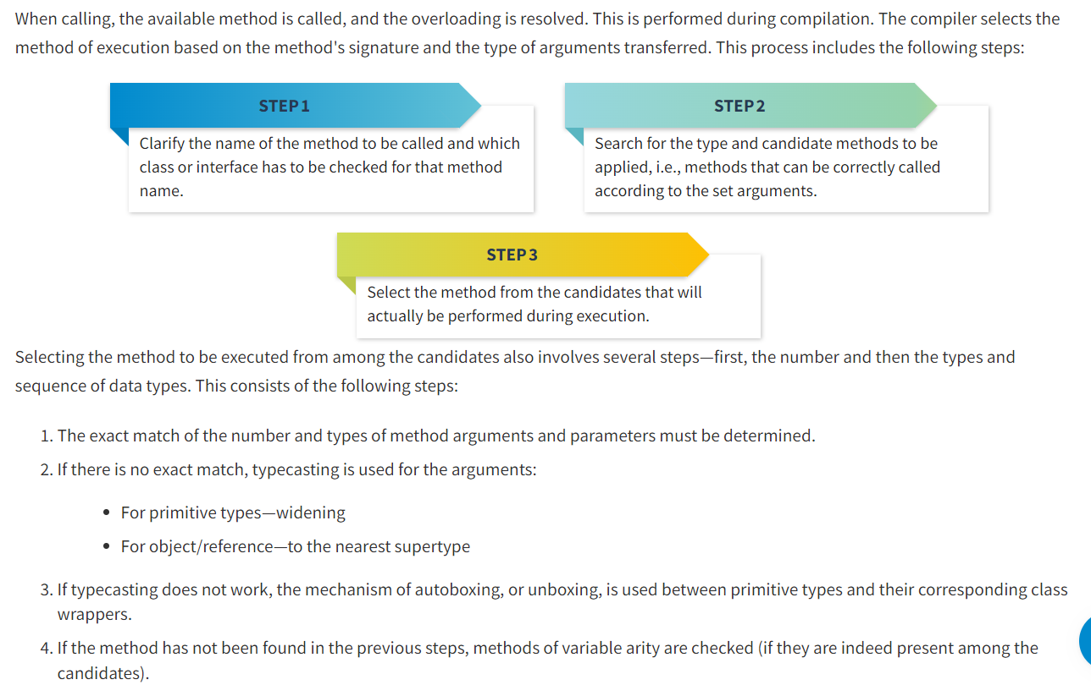

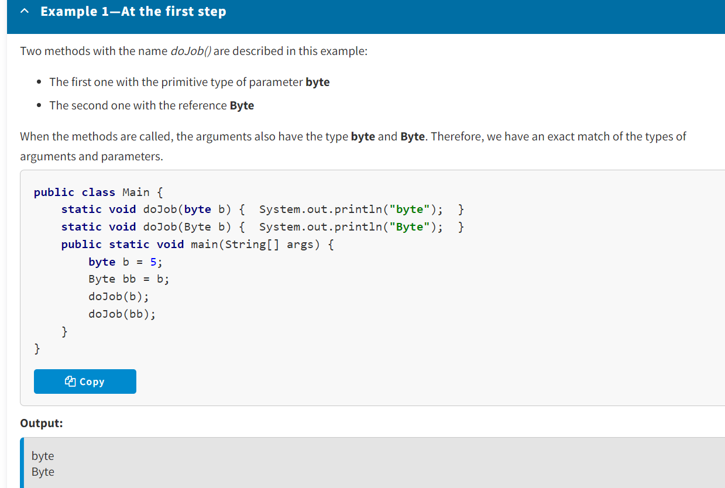

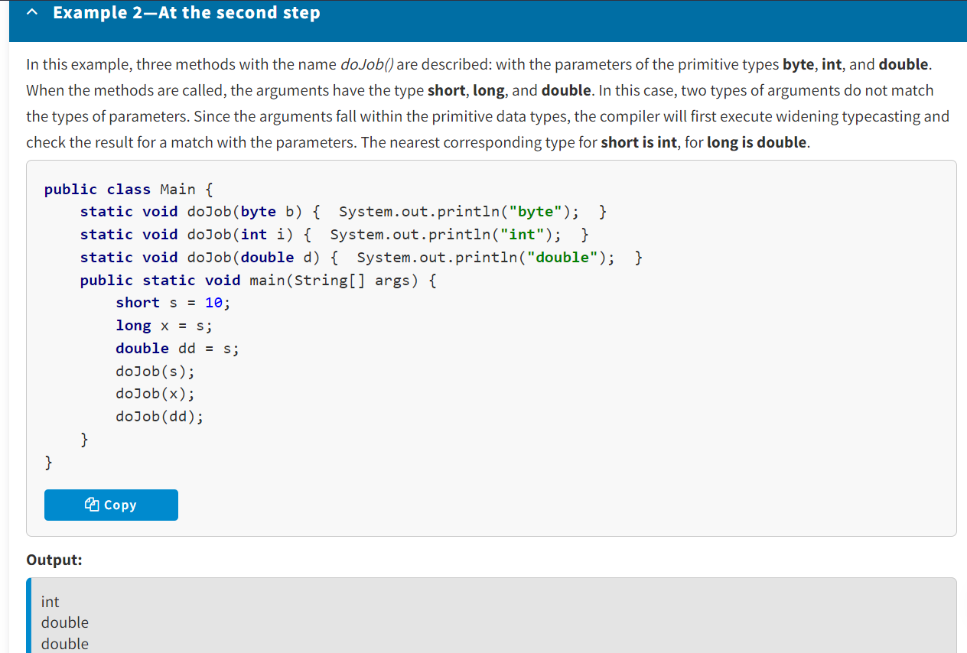

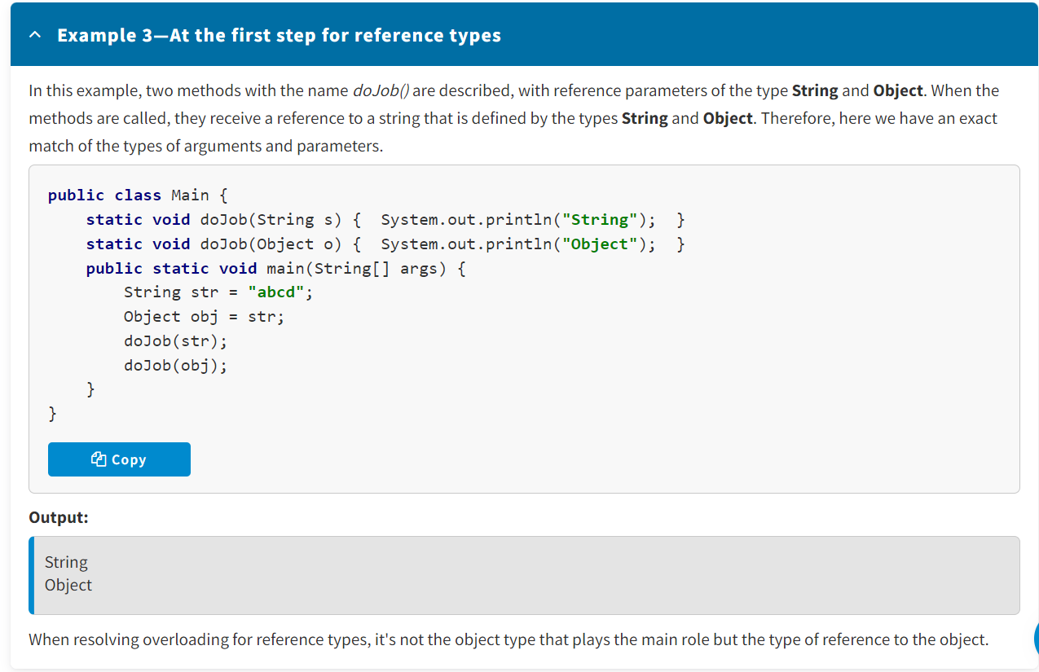

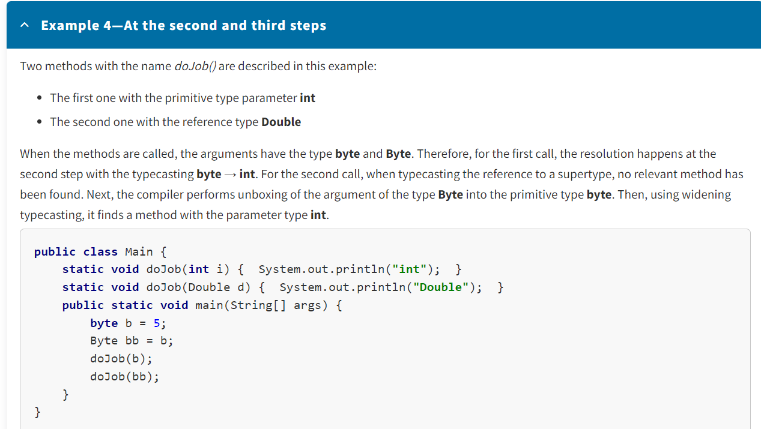

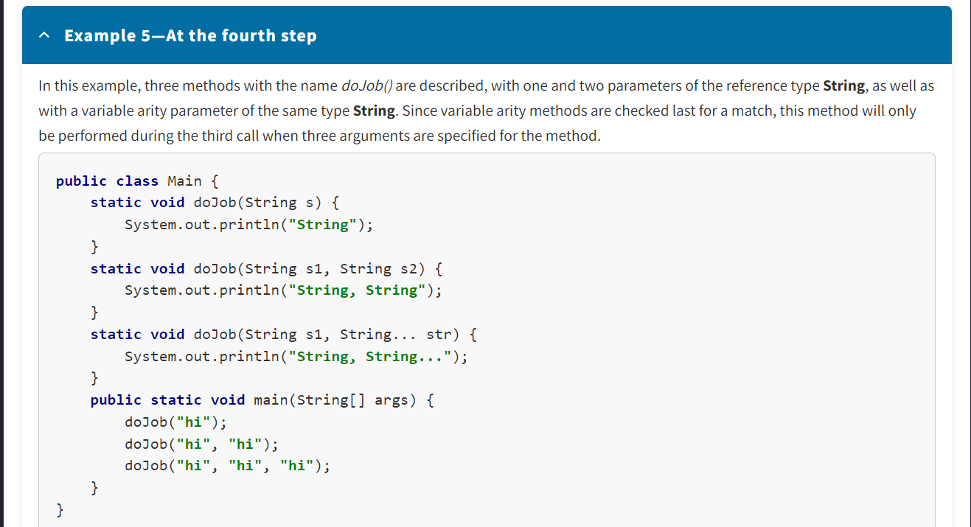

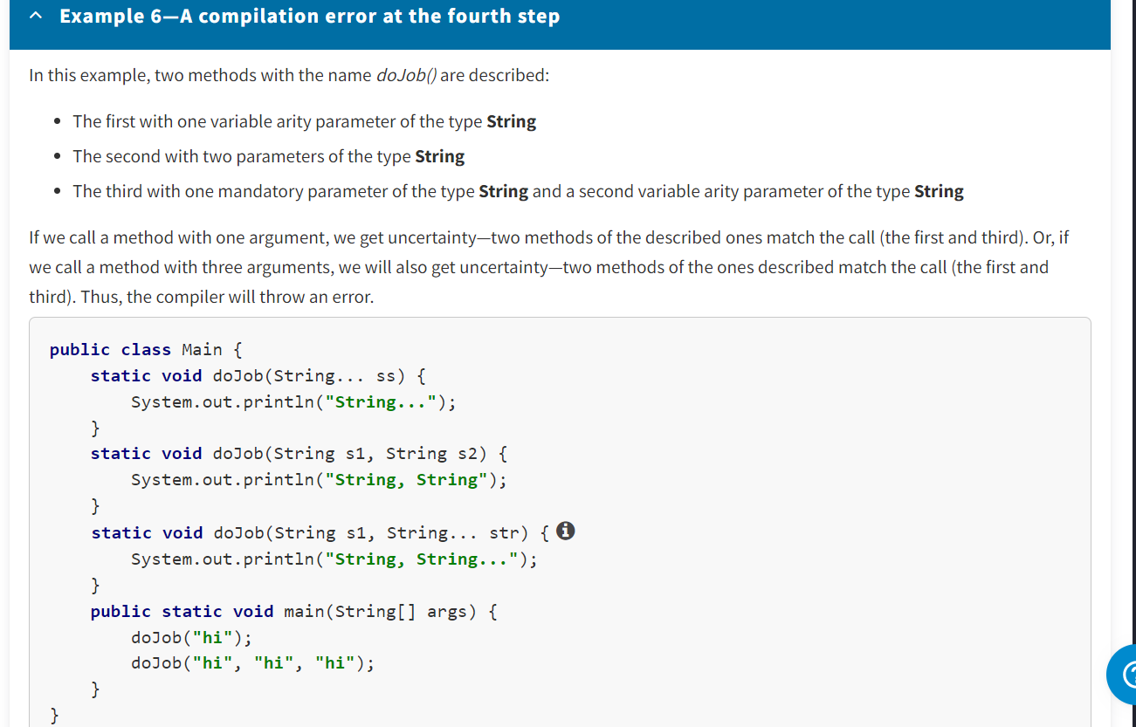

* If one class has two methods with the same name, their parameter lists should be different. These methods are overloaded.
* When calling, the appropriate method is called so the overloading is resolved. This is performed during compilation. The compiler selects the execution method based on the method's signature and the type of arguments passed. This process includes three steps.

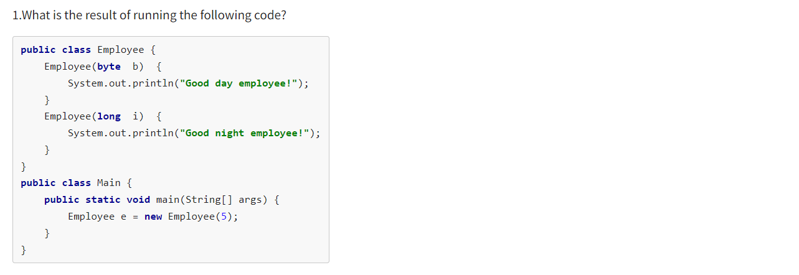

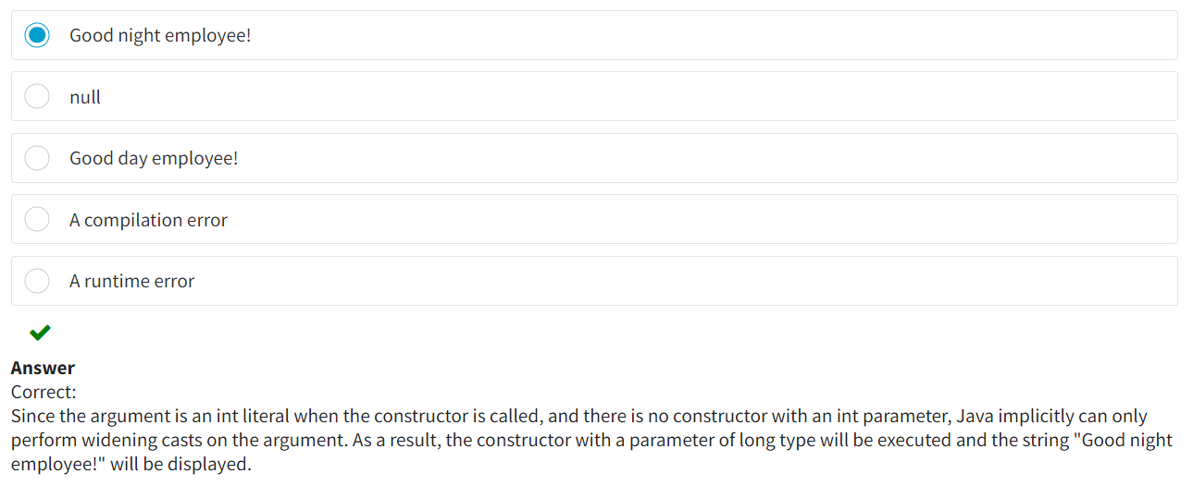

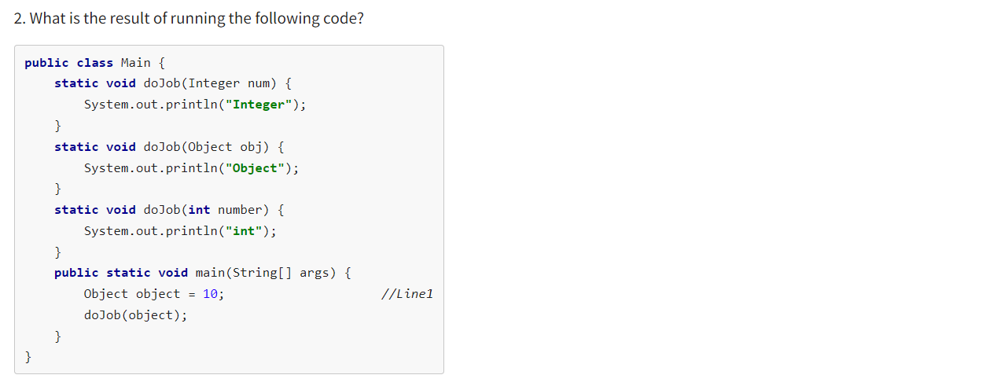

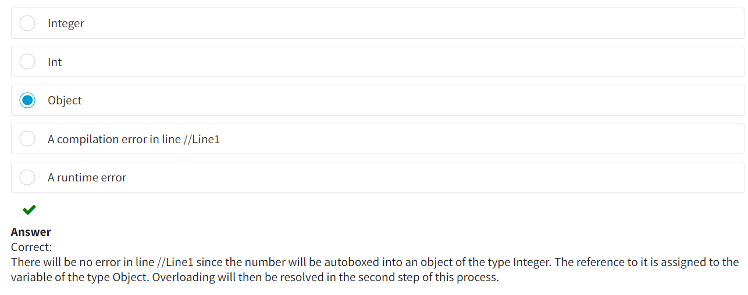

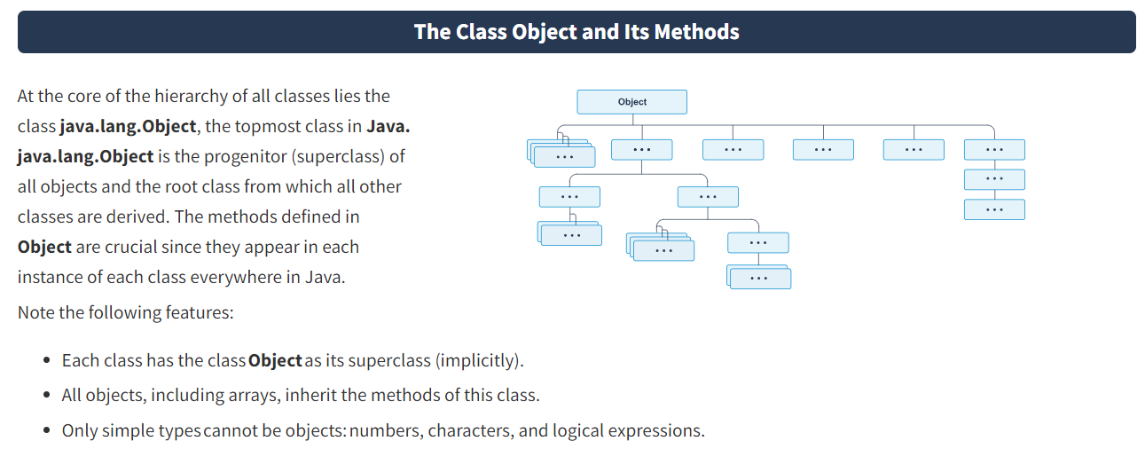

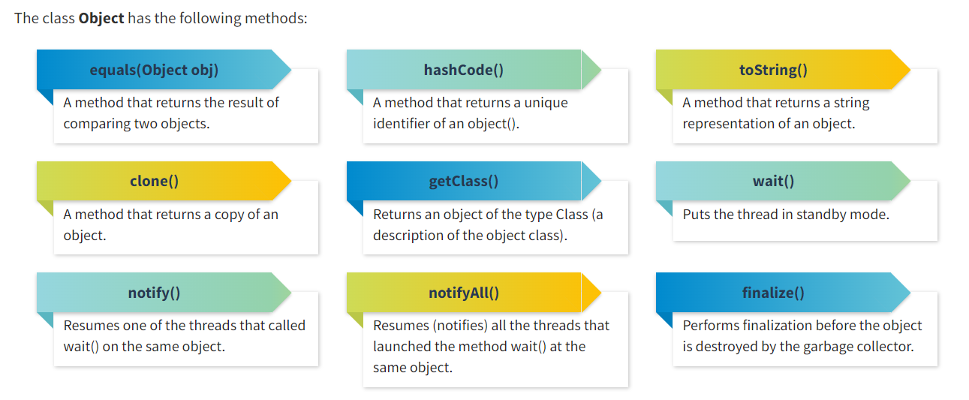

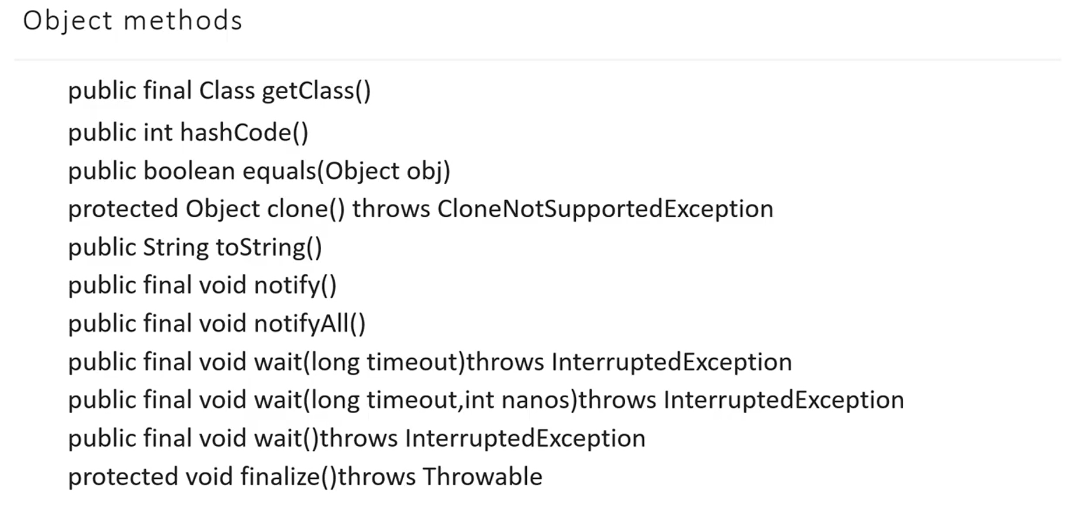

Methods such as *toString()*, *equals(Object obj)*, and *hashCode()* deserve more attention.

**The Method *toString()***

The method *toString()*, which returns a string representation of an object, is one of the most important methods in the class **Object**. For the class **Object**, this method returns a string that consists of the following:

* A class name
* A character "@"
* An unsigned hexadecimal representation of the object's hash code

If you look at the implementation of this method, we can see the following:

getClass().getName() + **"@"** + Integer.toHexString(hashCode())

The method *toString()* should return a short but informative representation of an object.  
This method should be overridden in all user classes.

The majority of the *toString()* methods return a string that includes the class name followed by the values of its fields in square brackets.

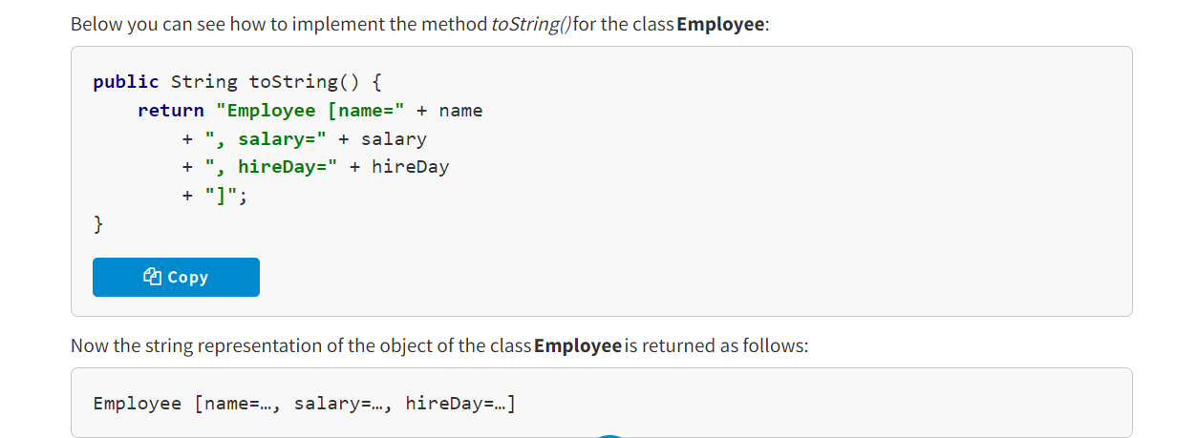

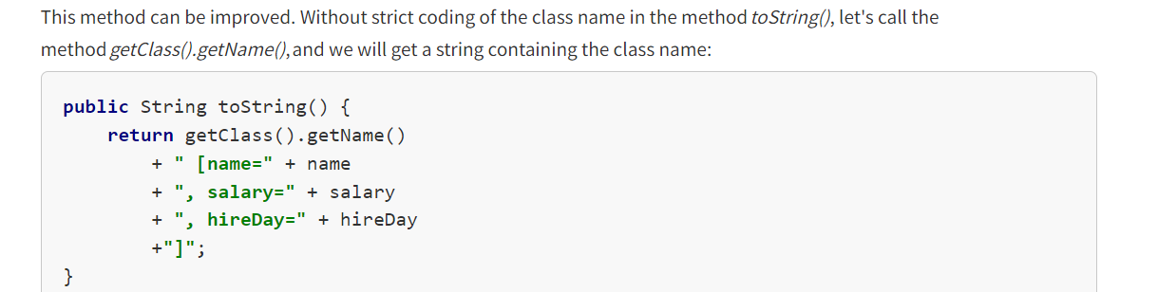

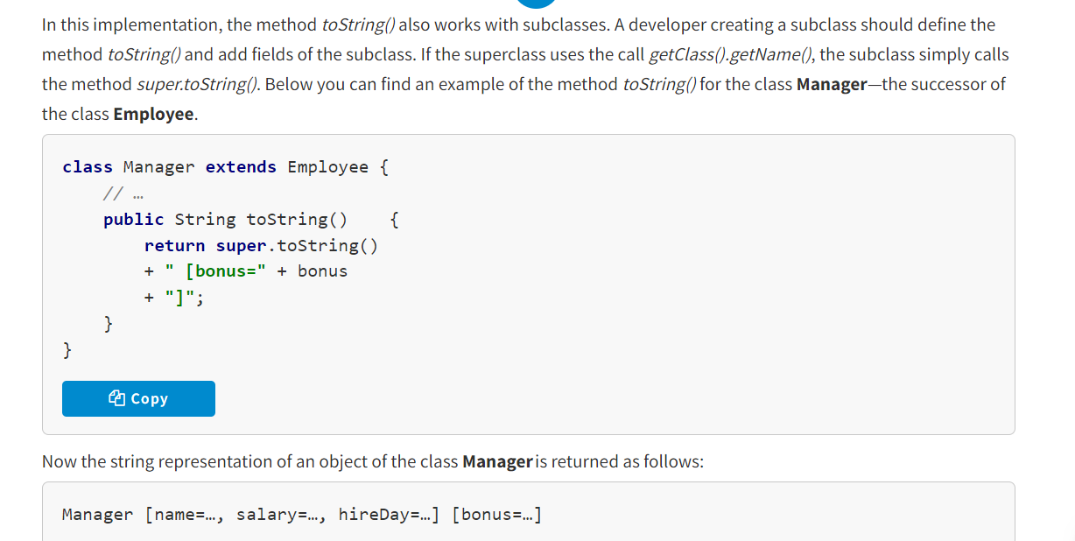

It is strongly recommended to override the method *toString()* in each class created.

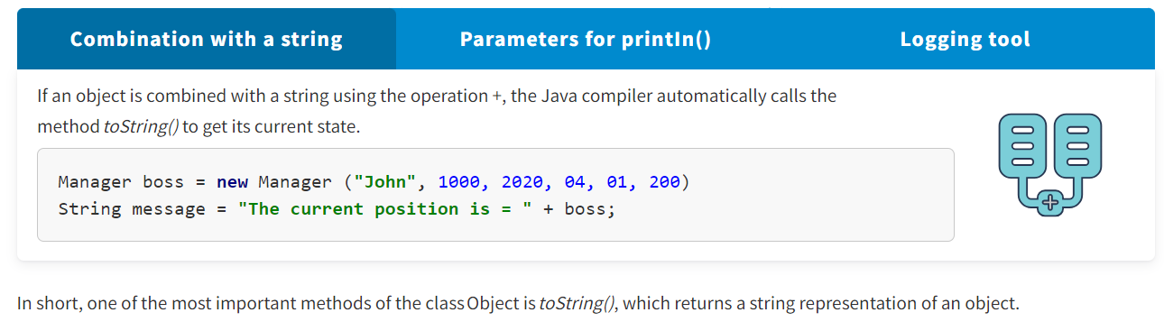

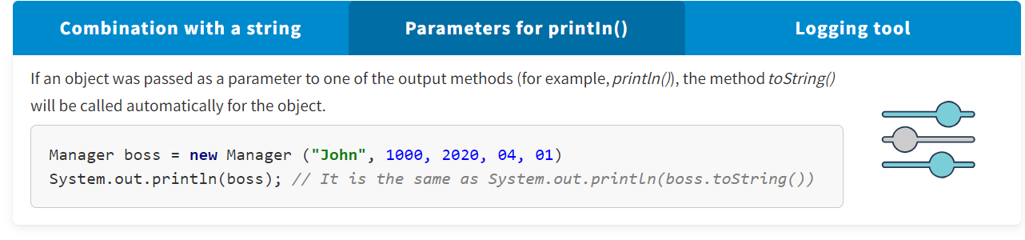

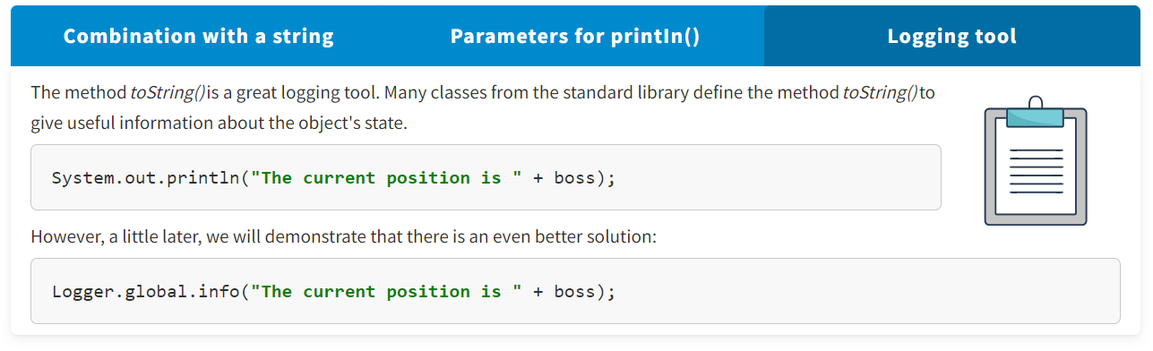

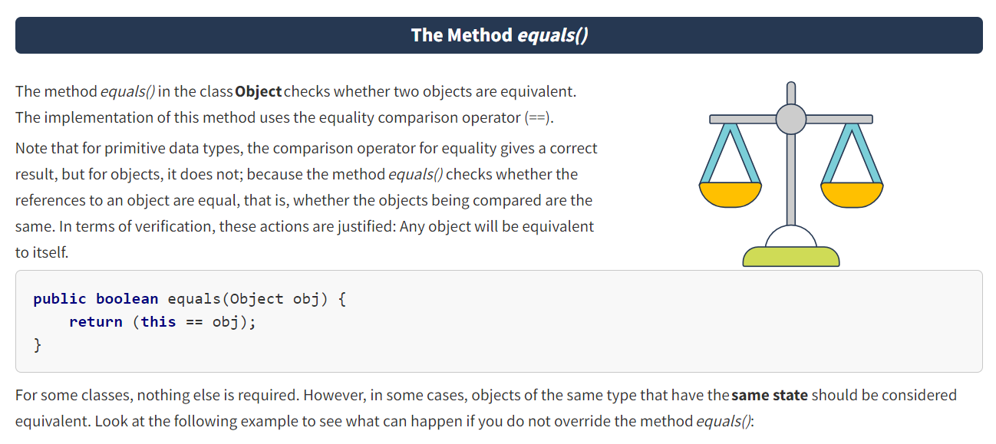

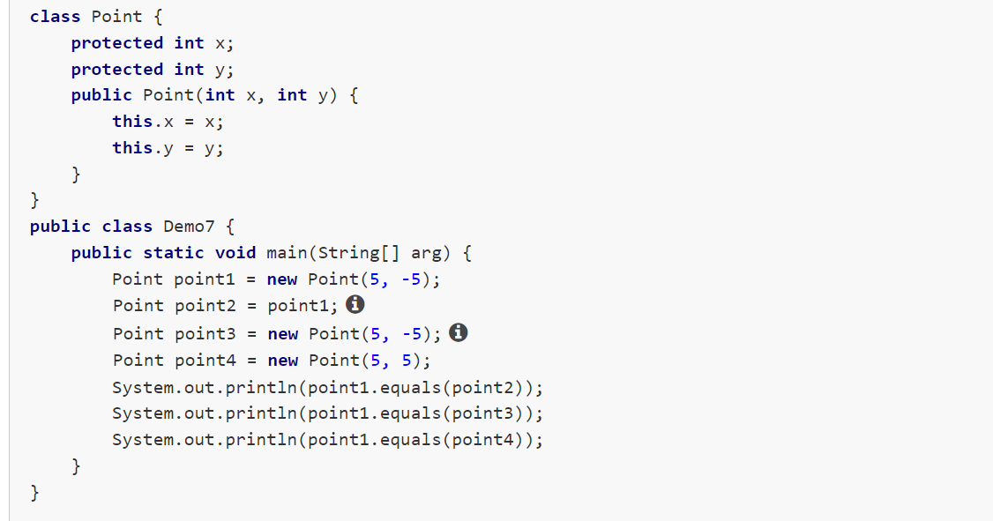

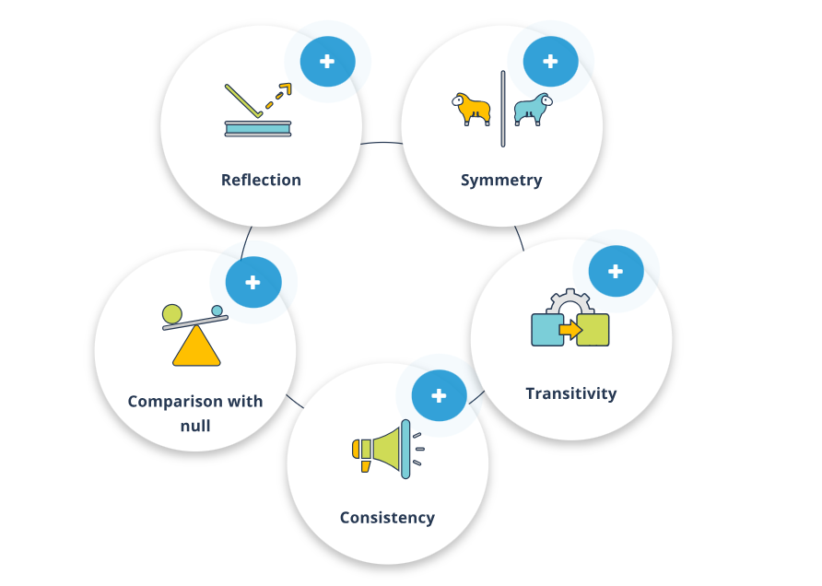

**Reflection**

If you take any value of the reference ***х*** not equal to null, the result of calling ***x.equals(х)*** should be ***true***.

**Symmetry**

If we take any values of the references ***х*** and ***у*** not equal to null, the result of calling ***x.equals(у)*** should be the same as the result of calling ***y.equals(х)***.

**Transitivity**

If we take any values of the references ***х***, ***у***, and ***z*** not equal to **null**, and the results of calling ***x.equals(у)*** and ***y.equals(z)*** are ***true***, then the result of calling ***x.equals(z)*** should also be ***true***.

**Consistency**

If we take any values of the references ***х*** and ***у*** not equal to null, then when calling ***x.equals(у)*** multiple times, the returned value (***true*** or ***false***) should always be the same. A situation when we have no information on the changes in the objects used to compare will be an exception.

**Comparison with null**

If we take any value of the reference ***х*** not equal to null, the result of calling ***x.equals(null)*** should be ***false***.

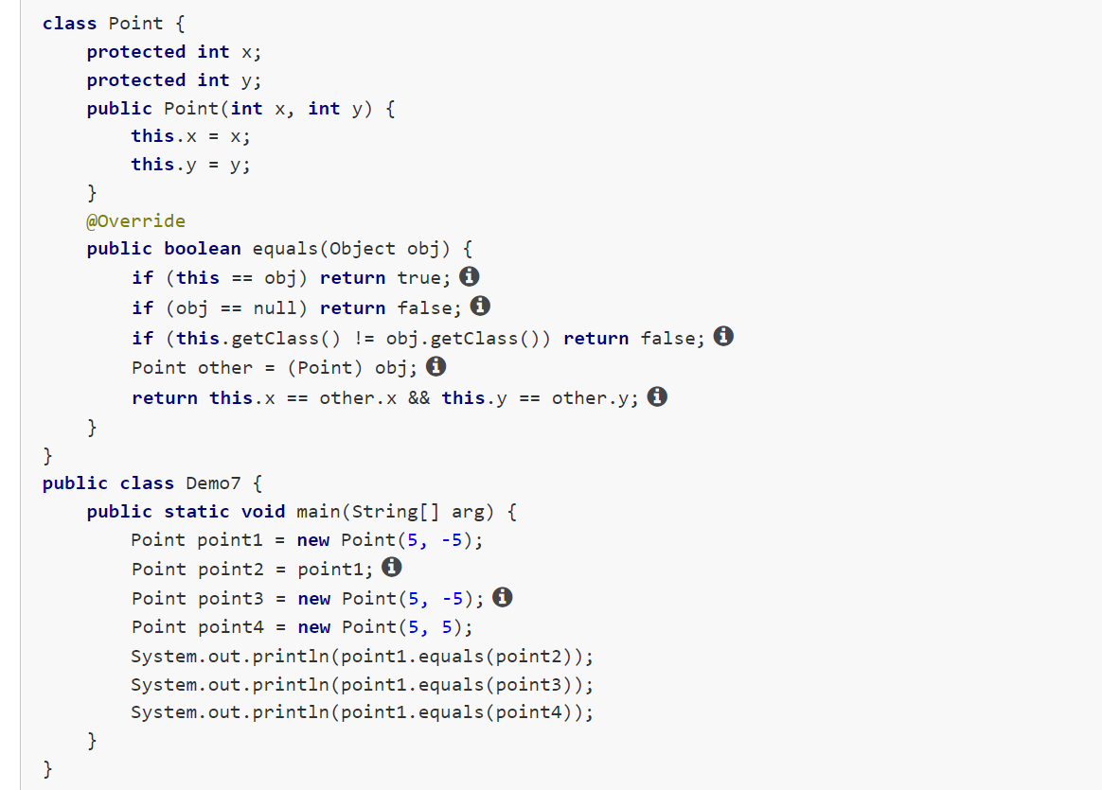

As you have seen, the method ***equals()*** in the class **Object** checks whether two objects are equivalent. Now you will explore some basic recommendations for creating this method.

Suppose an explicit parameter of the method ***equals()*** is called **obj**. Later **obj** will be cast to another type and written to the variable **other**.

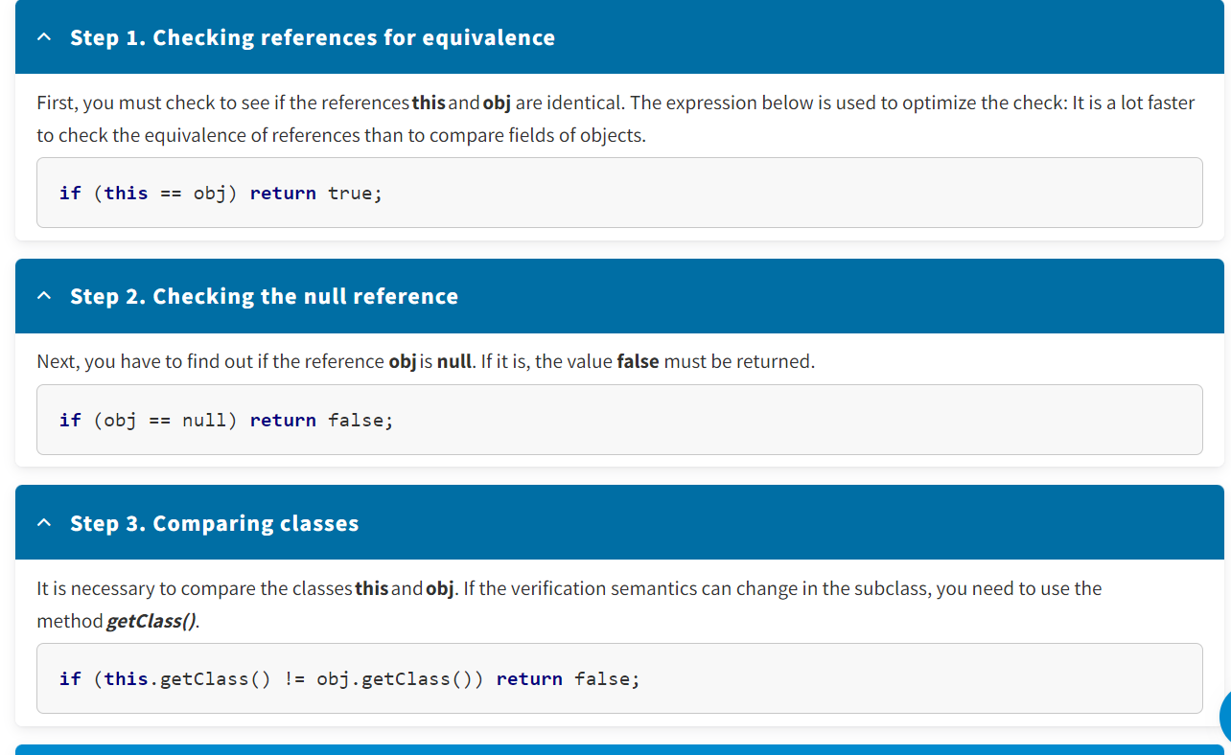

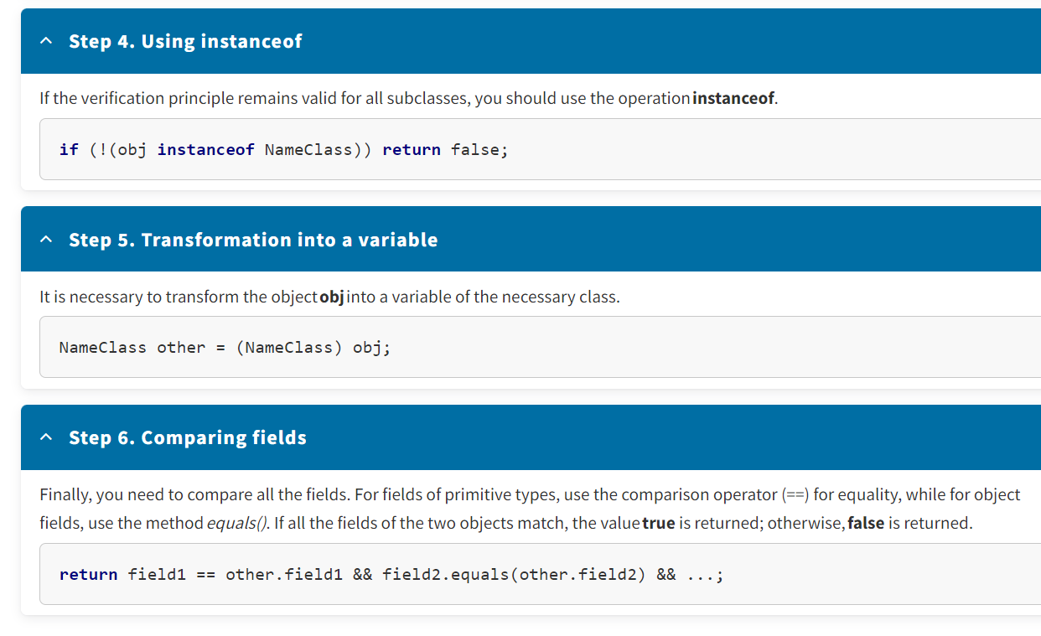

Important! If the method ***equals()*** is overridden in a subclass, you need to include the call **super.equals(other)** in it.

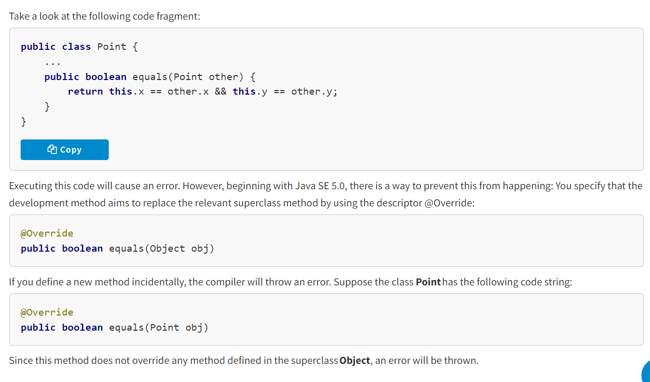

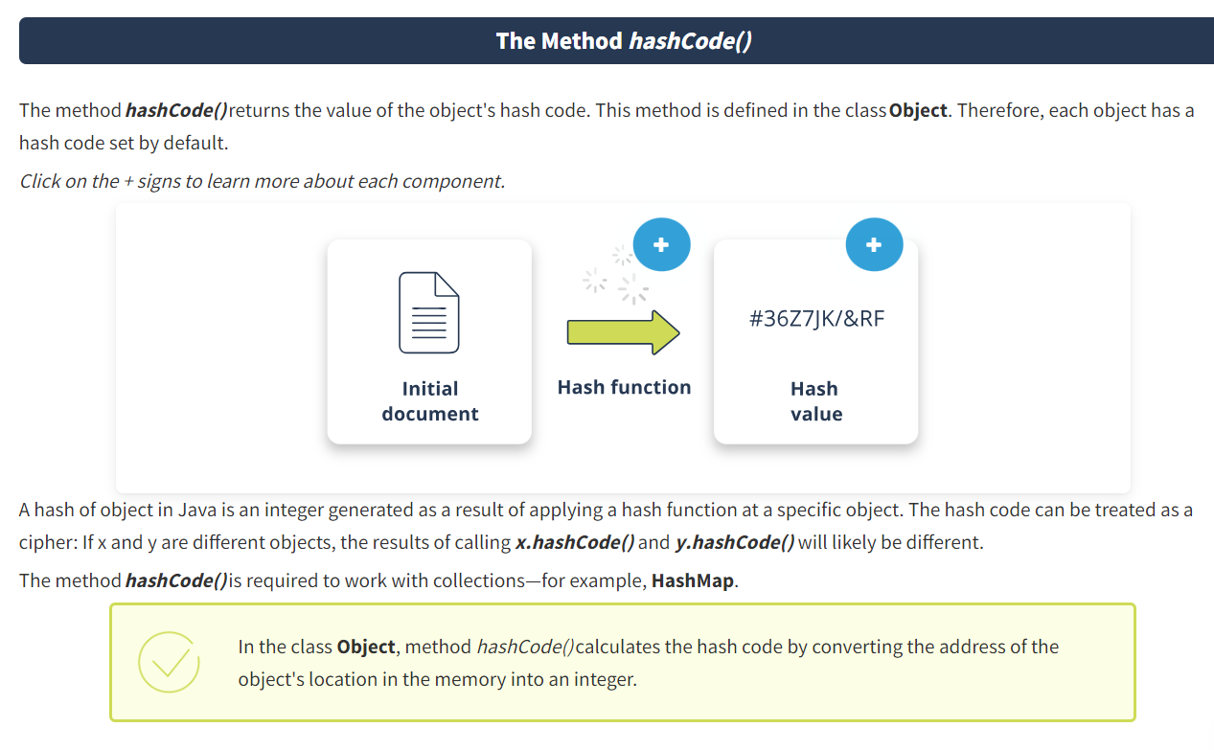

**Hash function**

**A hash function** is any function that can be used to map arbitrary-sized digital data to fixed-size digital data.

**Hash value**

**A hash value**—also known as a hash code, hash sum, or simply a hash—is the result of executing a hash function.

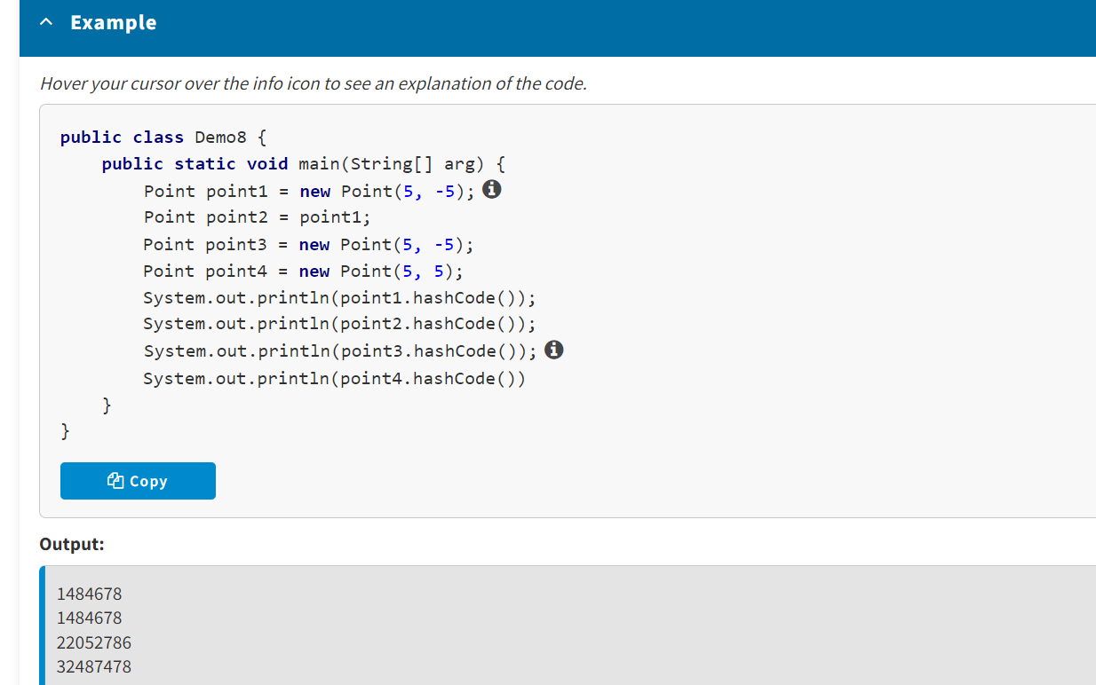

When overriding the method *hashCode()*, three rules should always be followed:

* When executing a Java application, if the method used to calculate the hash code is called at the same object several times, it should return the same value, unless the object has changed.
* When two objects are equal (i.e., the result of calling equals(Object) is true), calling the method used to calculate the hash code for each of the two objects should return **exactly the same** result.
* When two objects are not equal (i.e., the result of calling equals(Object) is false), calling the method used to calculate the hash code for each of the two objects should return **different** results.

The method *hashCode()* should return an integer (which can be negative)—a unique identifier that, in most cases, depends only on the values of the objects' properties. To ensure that different objects have unique hash codes, it is enough to combine the hash codes of the instance fields

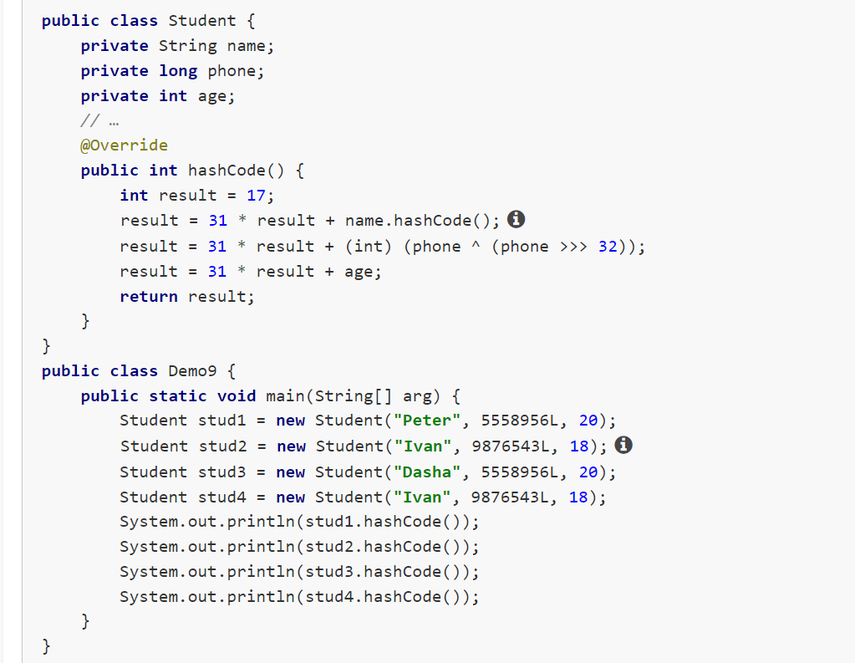

The methods *equals()* and *hashCode()* should be compatible: if *х.equals(у)* returns true, then the results of executing *x.hashCode()* and *y.hashCode()* should also match.

* Every class has the class Object as its superclass, and the class Object includes certain methods.
* The method *toString()* returns a string representation of an object.
* The method *equals()* checks whether two objects are equivalent.
* The method *hashCode()* returns the value of the object's hash code.

